UNITED STATES
SECURITIES AND EXCHANGE COMMISSION
WASHINGTON, D.C. 20549

FORM 8-K

CURRENT REPORT
PURSUANT TO SECTION 13 OR 15(d)
OF THE SECURITIES EXCHANGE ACT OF 1934
Date of report (Date of earliest event reported): May 12, 2022

P10, Inc.
(Exact name of registrant as specified in its charter)

Delaware |  | 001-40937 |  | 87-2908160
(State or other Jurisdiction  of Incorporation) |  | (Commission  File Number) |  | (IRS Employer  Identification No.)
4514 Cole Avenue, Suite 1600
Dallas, Texas 75205
(Address of principal executive offices and Zip Code)
(214) 865-7998
(Registrant’s telephone number, including area code)

Check the appropriate box below if the Form 8-K filing is intended to simultaneously satisfy the filing obligation of the registrant under any of the following provisions (see General Instruction A.2. below):

☐ | Written communications pursuant to Rule 425 under the Securities Act (17 CFR 230.425)

☐ | Soliciting material pursuant to Rule 14a-12 under the Exchange Act (17 CFR 240.14a-12)

☐ | Pre-commencement communications pursuant to Rule 14d-2(b) under the Exchange Act (17 CFR 240.14d-2(b))

☐ | Pre-commencement communications pursuant to Rule 13e-4(c) under the Exchange Act (17 CFR 240.13e-4(c))
Securities registered pursuant to Section 12(b) of the Act:

Title of each class |  | Trading  Symbol(s) |  | Name of each exchange  on which registered
Class A Common Stock, par value $0.001 per share |  | PX |  | New York Stock Exchange LLC
Series A Junior Participating Preferred Stock Purchase Rights
Indicate by check mark whether the registrant is an emerging growth company as defined in Rule 405 of the Securities Act of 1933 (§230.405 of this chapter) or Rule 12b-2 of the Securities Exchange Act of 1934 (§240.12b-2 of this chapter).
Emerging growth company ☒
If an emerging growth company, indicate by check mark if the registrant has elected not to use the extended transition period for complying with any new or revised financial accounting standards provided pursuant to Section 13(a) of the Exchange Act ☐

Item 2.02 | Results of Operations and Financial Condition.
On May 12, 2022, P10, Inc. (the “Company”) issued a press release and detailed presentation announcing its financial results for its first quarter ended March 31, 2022. A copy of the press release and presentation are furnished as Exhibit 99.1 to this Current Report on Form 8-K and are incorporated by reference into this Item 2.02 as if fully set forth herein.
The Company plans to host a conference call at 4:30 p.m. Eastern Time on Thursday, May 12, 2022, to discuss these results.
The information furnished by the Company pursuant to this Item 2.02, including Exhibit 99.1, shall not be deemed “filed” for purposes of Section 18 of the Securities Exchange Act of 1934, as amended (the “Exchange Act”) or otherwise subject to the liability of that section, and shall not be deemed to be incorporated by reference into any Company filing under the Securities Act of 1933, as amended, or the Exchange Act, regardless of any general incorporation language in such filing.

Item 7.01 | Regulation FD Disclosure
On May 12, 2022, the Company posted an investor presentation to its website at https://ir.p10alts.com/. A copy of the investor presentation is attached as Exhibit 99.2 to this Current Report on Form 8-K.
The information in this Current Report on Form 8-K, including Exhibit 99.2 attached hereto, is being furnished and shall not be deemed “filed” for the purposes of Section 18 of the Exchange, or otherwise subject to the liabilities of that Section, nor shall it be deemed subject to the requirements of amended Item 10 of Regulation S-K, nor shall it be deemed incorporated by reference into any filing of the Company under the Securities Act of 1933, as amended, or the Exchange Act, whether made before or after the date hereof, regardless of any general incorporation language in such filing. The furnishing of this information hereby shall not be deemed an admission as to the materiality of any such information.

Item 9.01 | Financial Statements and Exhibits

(d) Exhibits

Exhibit  No. |  | Description
99.1 |  | Press Release of P10, Inc., dated May 12, 2022 and Q1 2022 earnings presentation
99.2 |  | Q1 2022 Company Overview dated May 12, 2022
104 |  | Cover Page Interactive Data File (formatted as inline XBRL)

SIGNATURE
Pursuant to the requirements of the Securities Exchange Act of 1934, the registrant has duly caused this report to be signed on its behalf by the undersigned hereunto duly authorized.

 |  |  |  | P10, INC.
Date: May 12, 2022 |  |  |  | By: |  | /s/ Amanda Coussens
 |  |  |  |  |  | Amanda Coussens
 |  |  |  |  |  | Chief Financial Officer
Exhibit 99.1

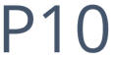
PRESS RELEASE
P10 Reports First Quarter 2022 Results
Results Driven by a 32% Increase in Year-Over-Year Revenue and a 34% Increase in Year-
Over-Year Fee Paying Assets Under Management. Company Implements Regular Quarterly Cash
Dividend of $.03 Per Share and Stock Repurchase Program
Dallas, Texas  May 12, 2022  P10, Inc. (NYSE: PX), a leading private markets solutions provider, today reported financial results for the first quarter ended March 31, 2022.
First Quarter 2022 Financial Highlights:

 |  |  | Fee Paying Assets Under Management: $17.6 billion, a 34% increase year-over-year.

 |  |  | Revenue: $43.3 million, a 32% increase year-over-year.

 |  |  | GAAP Net Income: $7.8 million, a 188% increase year-over-year.

 |  |  | Adjusted EBITDA: $22.5 million, a 31% increase year-over-year.

 |  |  | Adjusted Net Income: $22.3 million, an 84% increase year-over-year.

 |  |  | Fully diluted GAAP EPS: $.06, a 160% increase year-over-year.

 |  |  | Fully diluted ANI per share: $.18, a 65% increase year-over-year.

 |  |  | Declaration of Dividend
The Board of Directors of the Company has declared a quarterly cash dividend of $0.03 per share of Class A and Class B common stock, payable on June 20, 2022, to the holders of record as of the close of business on May 31, 2022.

 |  |  | Approval of Stock Buyback
The Company announced that its Board of Directors has authorized a stock buyback program pursuant to which P10 may purchase up to $20 million of P10s outstanding shares of Class A and Class B Common Stock, par value $0.001 per share. P10 intends to fund the program through available cash balances and future operating cash flows. These shares may be repurchased from time to time in the open market at prevailing market prices, in privately negotiated transactions, in block trades, in accordance with Rule 10b5-1 trading plans and/or through other legally permissible means. The timing and amount of any repurchases pursuant to the program will depend on various factors including, the market price of its Class A Common Stock, trading volume, ongoing assessment of P10s working capital needs, general market conditions, and other factors. The buyback program does not obligate P10 to acquire any particular amount of common stock and it may be terminated or amended by the Board of Directors at any time.

Robert Alpert, Chairman and Co-CEO, and Co-CEO Clark Webb said, In the first quarter, we performed well against our budget and demonstrated the unique qualities of our business model. Our revenues are primarily composed of management fees on long-term, locked-up capital while carry stays with the investment teams. The result is a more predictable model that benefits from multiple vintages and a diversified set of investment solutions. The announcement of a regular cash dividend and a stock repurchase program reflects the beauty of our business model, with strong cash flow and nearly infinite returns on capital. We are well positioned for continued growth.
A presentation of the first quarter financials may be accessed HERE and is available on the Companys website.
Conference Call Details:
The company will host a conference call at 4:30 p.m. Eastern Time on Thursday, May 12, 2022. The call will be webcast live and may be accessed HERE
All participants joining by telephone should dial one of the following numbers, followed by the Participant Code provided:

U.S. (toll free): |  | 1-844-200-6205
U.S. (local): |  | 1-646-904-5544
Canada (local): |  | 1-226-828-7575
All other locations: |  | +1-929-526-1599
Participant Access Code: |  | 947750
For those unable to participate in the live call, a replay will be made available on P10s investor relations page.
About P10
P10 is a leading multi-asset class private markets solutions provider in the alternative asset management industry. P10s mission is to provide its investors differentiated access to a broad set of investment solutions that address their diverse investment needs within private markets. As of March 31, 2022, P10 has a global investor base of over 2,500 investors across 49 states, 53 countries and six continents, which includes some of the worlds largest pension funds, endowments, foundations, corporate pensions and financial institutions. Visit www.p10alts.com.
Forward Looking Statements
Some of the statements in this release may constitute forward-looking statements within the meaning of Section 27A of the Securities Act of 1933, Section 21E of the Securities Exchange Act of 1934 and the Private Securities Litigation Reform Act of 1995. Words such as will, expect, believe, estimate, continue, anticipate, intend, plan and similar expressions are intended to identify these forward-looking statements. Forward-looking statements discuss managements current expectations and projections relating to our financial position, results of operations, plans, objectives, future performance, and business. The inclusion of any forward-looking information in this release should not be regarded as a representation that the future plans, estimates or expectations

contemplated will be achieved. Forward-looking statements are subject to various risks, uncertainties, and assumptions. Forward-looking statements reflect managements current plans, estimates and expectations and are inherently uncertain. All forward-looking statements are subject to known and unknown risks, uncertainties and other important factors that may cause actual results to be materially different, including risks relating to: global and domestic market and business conditions; successful execution of business and growth strategies and regulatory factors relevant to our business; changes in our tax status; our ability to maintain our fee structure; our ability to attract and retain key employees; our ability to manage our obligations under our debt agreements; as well as assumptions relating to our operations, financial results, financial condition, business prospects, growth strategy; and our ability to manage the effects of events outside of our control. The foregoing list of factors is not exhaustive. For more information regarding these risks and uncertainties as well as additional risks that we face, you should refer to the Risk Factors included in our annual report on Form 10-K for the year ended December 31, 2021, filed with the U.S. Securities and Exchange Commission (SEC) on March 21, 2022, and in our subsequent reports filed from time to time with the SEC. The forward-looking statements included in this release are made only as of the date hereof. We undertake no obligation to update or revise any forward-looking statement as a result of new information or future events, except as otherwise required by law.
Use of Non-GAAP Financial Measures by P10, Inc.
The non-GAAP financial measures contained in this press release (including, without limitation, Adjusted EBITDA, Adjusted Net Income and fee-paying assets under management) are not GAAP measures of the Companys financial performance or liquidity and should not be considered as alternatives to net income (loss) as a measure of financial performance or cash flows from operations as measures of liquidity, or any other performance measure derived in accordance with GAAP. A reconciliation of such non-GAAP measures is included in the presentation of the first quarter 2022 financials. The Company believes the presentation of these non-GAAP measures provide useful additional information to investors because it provides better comparability of ongoing operating performance to prior periods. It is reasonable to expect that one or more excluded items will occur in future periods, but the amounts recognized can vary significantly from period to period. Fee paying assets under management reflects the assets from which we earn management and advisory fees. Our vehicles typically earn management and advisory fees based on committed capital, and in certain cases, net invested capital, depending on the fee terms. Management and advisory fees based on committed capital are not affected by market appreciation or depreciation. You are encouraged to evaluate each adjustment to non-GAAP financial measures and the reasons management considers it appropriate for supplemental analysis. Our presentation of these measures should not be construed as an inference that our future results will be unaffected by unusual or non-recurring items.

Ownership Limitations
P10s Certificate of Incorporation contains certain provisions for the protection of tax benefits relating to P10s net operating losses. Such provisions generally void transfers of shares that would result in the creation of a new 4.99% shareholder or result in an existing 4.99% shareholder acquiring additional shares of P10.
P10 Press and Investor Contact:
info@p10alts.com

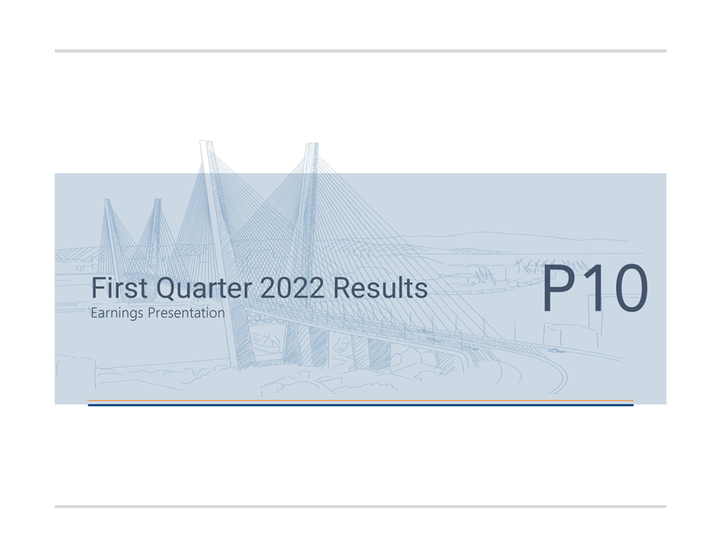
First Quarter 2022 Results Earnings Presentation

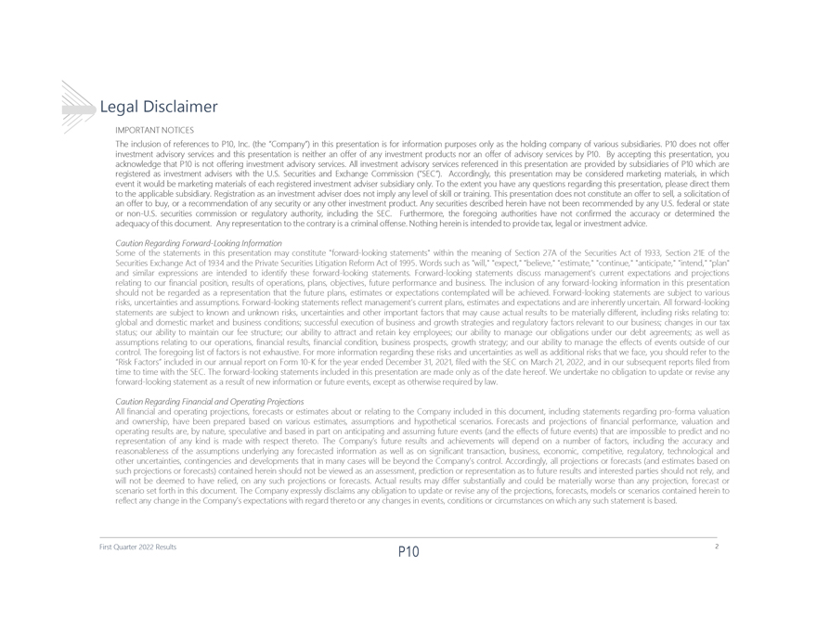
Legal Disclaimer IMPORTANTNOTICES TheinclusionofreferencestoP10,Inc.(theCompany)inthispresentationisforinformationpurposesonlyastheholdingcompanyofvarioussubsidiaries.P10doesnotoffer investmentadvisoryservicesandthispresentationisneitheranofferofanyinvestmentproductsnoranofferofadvisoryservicesbyP10.Byacceptingthispresentation,you acknowledgethatP10isnotofferinginvestmentadvisoryservices.AllinvestmentadvisoryservicesreferencedinthispresentationareprovidedbysubsidiariesofP10whichare registeredasinvestmentadviserswiththeU.S.SecuritiesandExchangeCommission(SEC). Accordingly,thispresentationmaybeconsideredmarketingmaterials,inwhich eventitwouldbemarketingmaterialsofeachregisteredinvestmentadvisersubsidiaryonly.Totheextentyouhaveanyquestionsregardingthispresentation,pleasedirectthem totheapplicablesubsidiary.Registrationasaninvestmentadviserdoesnotimplyanylevelofskillortraining.Thispresentationdoesnotconstituteanoffertosell,asolicitationof anoffertobuy,orarecommendationofanysecurityoranyotherinvestmentproduct.AnysecuritiesdescribedhereinhavenotbeenrecommendedbyanyU.S.federalorstate ornon-U.S.securitiescommissionorregulatoryauthority,includingtheSEC. Furthermore,theforegoingauthoritieshavenotconfirmedtheaccuracyordeterminedthe adequacyofthisdocument.Anyrepresentationtothecontraryisacriminaloffense.Nothinghereinisintendedtoprovidetax,legalorinvestmentadvice. CautionRegardingForward-LookingInformation Someofthestatementsinthispresentationmayconstituteforward-lookingstatementswithinthemeaningofSection27AoftheSecuritiesActof1933,Section21Eofthe SecuritiesExchangeActof1934andthePrivateSecuritiesLitigationReformActof1995.Wordssuchaswill,expect,believe,estimate,continue,anticipate,intend,plan andsimilarexpressionsareintendedtoidentifytheseforward-lookingstatements.Forward-lookingstatementsdiscussmanagementscurrentexpectationsandprojections relatingtoourfinancialposition,resultsofoperations,plans,objectives,futureperformanceandbusiness.Theinclusionofanyforward-lookinginformationinthispresentation shouldnotberegardedasarepresentationthatthefutureplans,estimatesorexpectationscontemplatedwillbeachieved.Forward-lookingstatementsaresubjecttovarious risks,uncertaintiesandassumptions.Forward-lookingstatementsreflectmanagementscurrentplans,estimatesandexpectationsandareinherentlyuncertain.Allforward-looking statementsaresubjecttoknownandunknownrisks,uncertaintiesandotherimportantfactorsthatmaycauseactualresultstobemateriallydifferent,includingrisksrelatingto: globalanddomesticmarketandbusinessconditions;successfulexecutionofbusinessandgrowthstrategiesandregulatoryfactorsrelevanttoourbusiness;changesinourtax status;ourabilitytomaintainourfeestructure;ourabilitytoattractandretainkeyemployees;ourabilitytomanageourobligationsunderourdebtagreements;aswellas assumptionsrelatingtoouroperations,financialresults,financialcondition,businessprospects,growthstrategy;andourabilitytomanagetheeffectsofeventsoutsideofour control.Theforegoinglistoffactorsisnotexhaustive.Formoreinformationregardingtheserisksanduncertaintiesaswellasadditionalrisksthatweface,youshouldrefertothe RiskFactorsincludedinourannualreportonForm10-KfortheyearendedDecember31,2021,filedwiththeSEConMarch21,2022,andinoursubsequentreportsfiledfrom timetotimewiththeSEC.Theforward-lookingstatementsincludedinthispresentationaremadeonlyasofthedatehereof.Weundertakenoobligationtoupdateorreviseany forward-lookingstatementasaresultofnewinformationorfutureevents,exceptasotherwiserequiredbylaw. CautionRegardingFinancialandOperatingProjections Allfinancialandoperatingprojections,forecastsorestimatesaboutorrelatingtotheCompanyincludedinthisdocument,includingstatementsregardingpro-formavaluation andownership,havebeenpreparedbasedonvariousestimates,assumptionsandhypotheticalscenarios.Forecastsandprojectionsoffinancialperformance,valuationand operatingresultsare,bynature,speculativeandbasedinpartonanticipatingandassumingfutureevents(andtheeffectsoffutureevents)thatareimpossibletopredictandno representationofanykindismadewithrespectthereto.TheCompanysfutureresultsandachievementswilldependonanumberoffactors,includingtheaccuracyand reasonablenessoftheassumptionsunderlyinganyforecastedinformationaswellasonsignificanttransaction,business,economic,competitive,regulatory,technologicaland otheruncertainties,contingenciesanddevelopmentsthatinmanycaseswillbebeyondtheCompanyscontrol.Accordingly,allprojectionsorforecasts(andestimatesbasedon suchprojectionsorforecasts)containedhereinshouldnotbeviewedasanassessment,predictionorrepresentationastofutureresultsandinterestedpartiesshouldnotrely,and willnotbedeemedtohaverelied,onanysuchprojectionsorforecasts.Actualresultsmaydiffersubstantiallyandcouldbemateriallyworsethananyprojection,forecastor scenariosetforthinthisdocument.TheCompanyexpresslydisclaimsanyobligationtoupdateorreviseanyoftheprojections,forecasts,modelsorscenarioscontainedhereinto reflectanychangeintheCompanysexpectationswithregardtheretooranychangesinevents,conditionsorcircumstancesonwhichanysuchstatementisbased. First Quarter 2022 Results 2

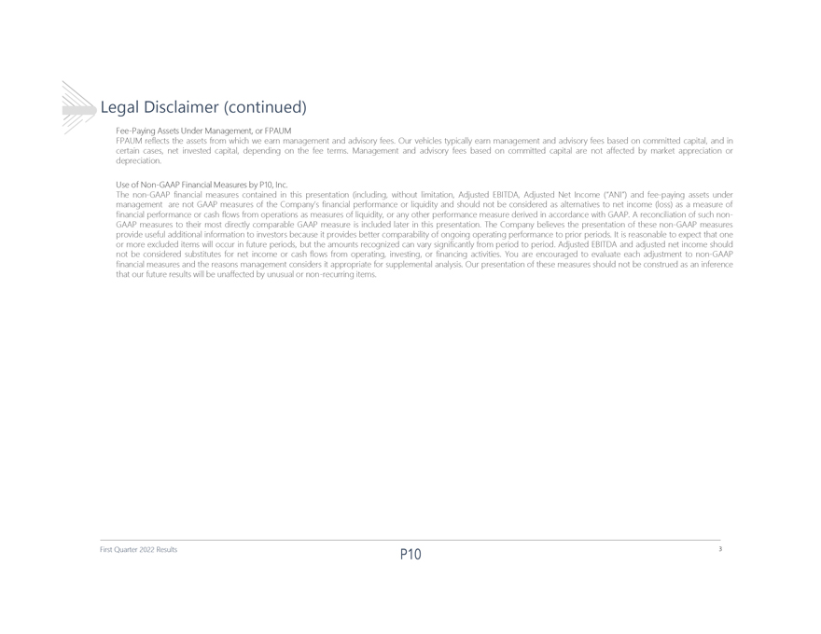
Legal Disclaimer (continued) Fee-PayingAssetsUnderManagement,orFPAUM FPAUMreflectstheassetsfromwhichweearnmanagementandadvisoryfees.Ourvehiclestypicallyearnmanagementandadvisoryfeesbasedoncommittedcapital,andin certaincases,netinvestedcapital,dependingonthefeeterms.Managementandadvisoryfeesbasedoncommittedcapitalarenotaffectedbymarketappreciationor depreciation. UseofNon-GAAPFinancialMeasuresbyP10,Inc. Thenon-GAAPfinancialmeasurescontainedinthispresentation(including,withoutlimitation,AdjustedEBITDA,AdjustedNetIncome(ANI)andfee-payingassetsunder managementarenotGAAPmeasuresoftheCompanysfinancialperformanceorliquidityandshouldnotbeconsideredasalternativestonetincome(loss)asameasureof financialperformanceorcashflowsfromoperationsasmeasuresofliquidity,oranyotherperformancemeasurederivedinaccordancewithGAAP.Areconciliationofsuchnon-GAAPmeasurestotheirmostdirectlycomparableGAAPmeasureisincludedlaterinthispresentation.TheCompanybelievesthepresentationofthesenon-GAAPmeasures provideusefuladditionalinformationtoinvestorsbecauseitprovidesbettercomparabilityofongoingoperatingperformancetopriorperiods.Itisreasonabletoexpectthatone ormoreexcludeditemswilloccurinfutureperiods,buttheamountsrecognizedcanvarysignificantlyfromperiodtoperiod.AdjustedEBITDAandadjustednetincomeshould notbeconsideredsubstitutesfornetincomeorcashflowsfromoperating,investing,orfinancingactivities.Youareencouragedtoevaluateeachadjustmenttonon-GAAP financialmeasuresandthereasonsmanagementconsidersitappropriateforsupplementalanalysis.Ourpresentationofthesemeasuresshouldnotbeconstruedasaninference thatourfutureresultswillbeunaffectedbyunusualornon-recurringitems. First Quarter 2022 Results 3

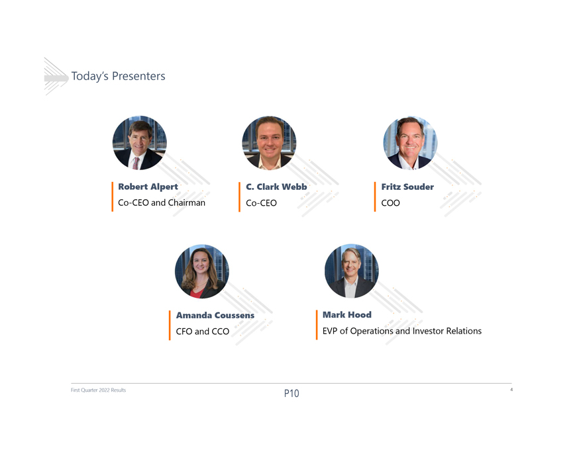
Todays Presenters Robert Alpert C. Clark Webb Fritz Souder Co-CEO and Chairman Co-CEO COO Amanda Coussens Mark Hood CFO and CCO EVP of Operations and Investor Relations First Quarter 2022 Results 4

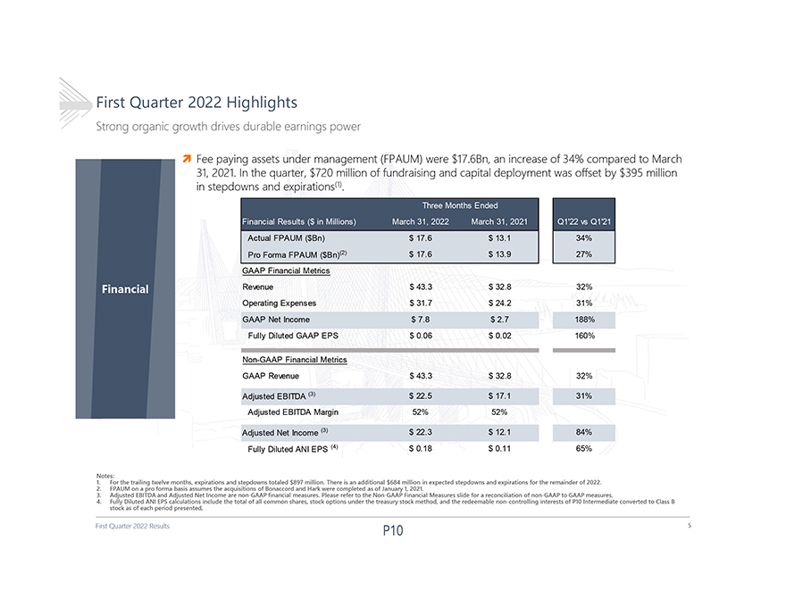
First Quarter 2022 Results First Quarter 2022 Highlights Strong organic growth drives durable earnings power 5 Financial Notes: 1. For the trailing twelve months, expirations and stepdowns totaled $897 million. There is an additional $684 million in expected stepdowns and expirations for the remainder of 2022. 2. FPAUM on a pro forma basis assumes the acquisitions of Bonaccord and Hark were completed as of January 1, 2021. 3. Adjusted EBITDA and Adjusted Net Income are non-GAAP financial measures. Please refer to the Non-GAAP Financial Measures slide for a reconciliation of non-GAAP to GAAP measures. 4. Fully Diluted ANI EPS calculations include the total of all common shares, stock options under the treasury stock method, and the redeemable non-controlling interests of P10 Intermediate converted to Class B stock as of each period presented. Fee paying assets under management (FPAUM) were $17.6Bn, an increase of 34% compared to March 31, 2021. In the quarter, $720 million of fundraising and capital deployment was offset by $395 million in stepdowns and expirations(1). Three Months Ended Financial Results ($ in Millions) March 31, 2022 March 31, 2021 Q122 vs Q121 Actual FPAUM ($Bn) $ 17.6 $ 13.1 34% Pro Forma FPAUM ($Bn)(2) $ 17.6 $ 13.9 27% GAAP Financial Metrics Revenue $ 43.3 $ 32.8 32% Operating Expenses $ 31.7 $ 24.2 31% GAAP Net Income $ 7.8 $ 2.7 188% Fully Diluted GAAP EPS $ 0.06 $ 0.02 160% Non-GAAP Financial Metrics GAAP Revenue $ 43.3 $ 32.8 32% Adjusted EBITDA (3) $ 22.5 $ 17.1 31% Adjusted EBITDA Margin 52% 52% Adjusted Net Income (3) $ 22.3 $ 12.1 84% Fully Diluted ANI EPS (4) $ 0.18 $ 0.11 65%

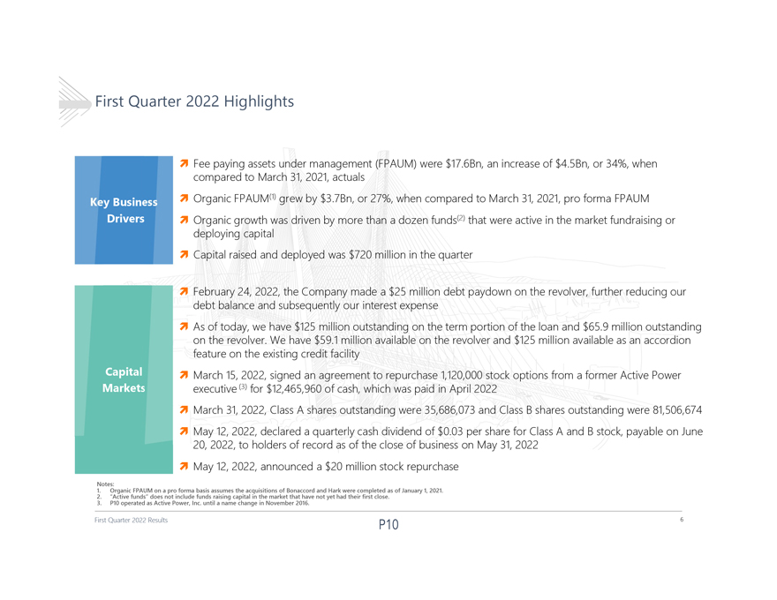
First Quarter 2022 Highlights ï¬ Fee paying assets under management (FPAUM) were $17.6Bn, an increase of $4.5Bn, or 34%, when compared to March 31, 2021, actuals ï¬ Organic FPAUM(1) grew by $3.7Bn, or 27%, when compared to March 31, 2021, pro forma FPAUM ï¬ Organic growth was driven by more than a dozen funds(2) that were active in the market fundraising or deploying capitalï¬ Capital raised and deployed was $720 million in the quarter ï¬ February 24, 2022, the Company made a $25 million debt paydown on the revolver, further reducing our debt balance and subsequently our interest expenseï¬ As of today, we have $125 million outstanding on the term portion of the loan and $65.9 million outstanding on the revolver. We have $59.1 million available on the revolver and $125 million available as an accordion feature on the existing credit facility ï¬ March 15, 2022, signed an agreement to repurchase 1,120,000 stock options from a former Active Power executive(3) for $12,465,960 of cash, which was paid in April 2022ï¬ March 31, 2022, Class A shares outstanding were 35,686,073 and Class B shares outstanding were 81,506,674ï¬ May 12, 2022, declared a quarterly cash dividend of $0.03 per share for Class A and B stock, payable on June 20, 2022, to holders of record as of the close of business on May 31, 2022ï¬ May 12, 2022, announced a $20 million stock repurchase 1. Notes: Organic FPAUM on a pro forma basis assumes the acquisitions of Bonaccord and Hark were completed as of January 1, 2021. 2. 3. Active P10 operated funds as does Active not Power, include Inc. funds until raising a name capital change in the in November market that 2016. have not yet had their first close. First Quarter 2022 Results 6

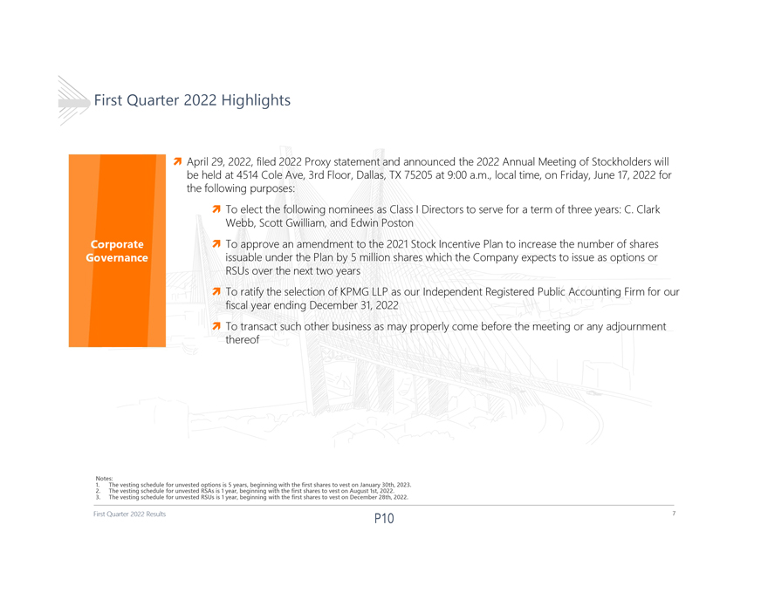
First Quarter 2022 Highlights ï¬ April 29, 2022, filed 2022 Proxy statement and announced the 2022 Annual Meeting of Stockholders will be held at 4514 Cole Ave, 3rd Floor, Dallas, TX 75205 at 9:00 a.m., local time, on Friday, June 17, 2022 for the following purposes: ï¬ To elect the following nominees as Class I Directors to serve for a term of three years: C. Clark Webb, Scott Gwilliam, and Edwin Poston ï¬ To approve an amendment to the 2021 Stock Incentive Plan to increase the number of shares issuable under the Plan by 5 million shares which the Company expects to issue as options or RSUs over the next two yearsï¬ To ratify the selection of KPMG LLP as our Independent Registered Public Accounting Firm for our fiscal year ending December 31, 2022ï¬ To transact such other business as may properly come before the meeting or any adjournment thereof 1. Notes: The vesting schedule for unvested options is 5 years, beginning with the first shares to vest on January 30th, 2023. 2. 3. The The vesting vesting schedule schedule for for unvested unvested RSAs RSUs is is 11 year, year, beginning beginning with with the the first first shares shares to to vest vest on on August December 1st, 28th, 2022. 2022. First Quarter 2022 Results 7

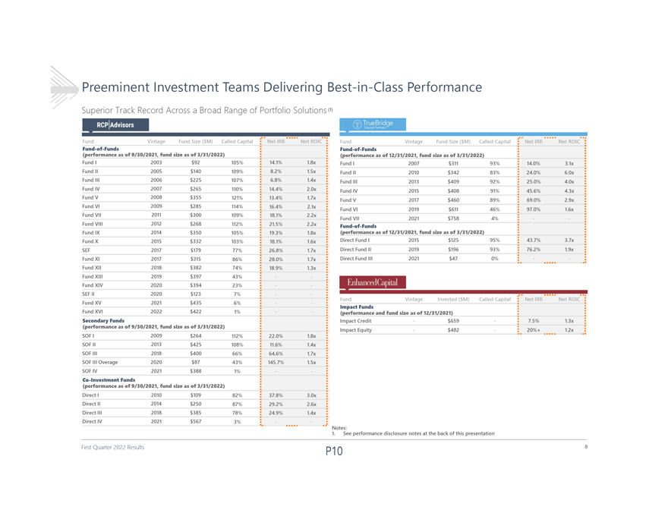
Preeminent Investment Teams Delivering Best-in-Class Performance Superior Track Record Across a Broad Range of Portfolio Solutions(1) Fund Vintage Fund Size ($M) Called Capital Net IRR Net ROIC Fund Vintage Fund Size ($M) Called Capital Net IRR Net ROIC Fund-of-Funds Fund-of-Funds (performance as of 9/30/2021, fund size as of 3/31/2022) (performance as of 12/31/2021, fund size as of 3/31/2022) Fund I 2003 $92 105% 14.1% 1.8x Fund I 2007 $311 93% 14.0% 3.1x Fund II 2005 $140 109% 8.2% 1.5x Fund II 2010 $342 83% 24.0% 6.0x Fund III 2006 $225 107% 6.8% 1.4x Fund III 2013 $409 92% 25.0% 4.0x Fund IV 2007 $265 110% 14.4% 2.0x Fund IV 2015 $408 91% 45.6% 4.3x Fund V 2008 $355 121% 13.4% 1.7x Fund V 2017 $460 89% 69.0% 2.9x Fund VI 2009 $285 114% 16.4% 2.1x Fund VII 2011 $300 Fund VI 2019 $611 46% 97.0% 1.6x 109% 18.1% 2.2x Fund VIII 2012 $268 112% 21.5% 2.2x Fund VII 2021 $758 4%  Fund-of-Funds Fund IX 2014 $350 105% 19.3% 1.8x (performance as of 12/31/2021, fund size as of 3/31/2022) Fund X 2015 $332 103% 18.1% 1.6x Direct Fund I 2015 $125 95% 43.7% 3.7x SEF 2017 $179 77% 26.8% 1.7x Direct Fund II 2019 $196 93% 76.2% 1.9x Fund XI 2017 $315 86% 28.0% 1.7x Direct Fund III 2021 $47 0% Fund XII 2018 $382 74% 18.9% 1.3x Fund XIII 2019 $397 43% Fund XIV 2020 $394 23%-SEF II 2020 $123 7%  Fund Vintage Invested ($M) Called Capital Net IRR Net ROIC Fund XV 2021 $435 6%  Impact Funds Fund XVI 2022 $422 1%  (performance and fund size as of 12/31/2021) Secondary Funds Impact Credit$6597.5% 1.3x (performance as of 9/30/2021, fund size as of 3/31/2022) SOF I 2009 $264 Impact Equity$48220%+ 1.2x 112% 22.0% 1.8x SOF II 2013 $425 108% 11.6% 1.4x SOF III 2018 $400 66% 64.6% 1.7x SOF III Overage 2020 $87 43% 145.7% 1.5x SOF IV 2021 $388 1%  Co-Investment Funds (performance as of 9/30/2021, fund size as of 3/31/2022) Direct I 2010 $109 82% 37.8% 3.0x Direct II 2014 $250 87% 29.2% 2.6x Direct III 2018 $385 78% 24.9% 1.4x Direct IV 2021 $567 3%  1. Notes: See performance disclosure notes at the back of this presentation First Quarter 2022 Results 8

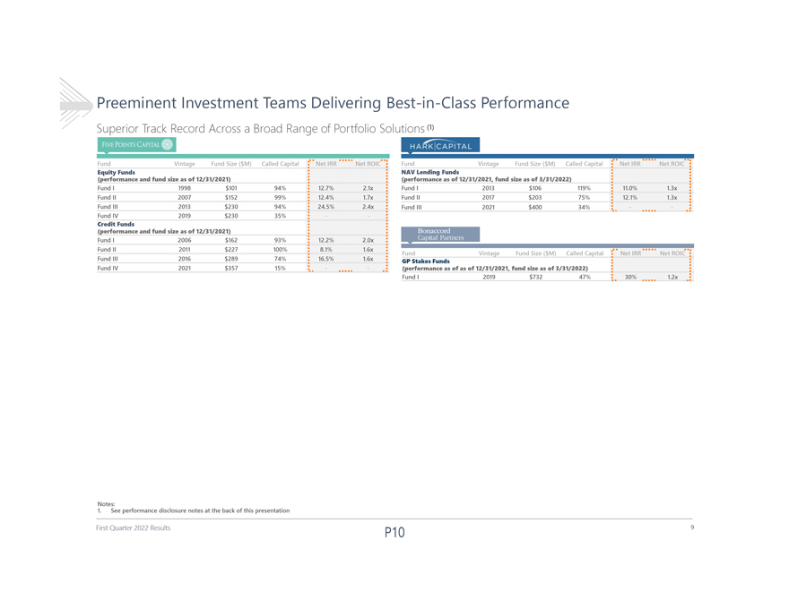
Preeminent Investment Teams Delivering Best-in-Class Performance Superior Track Record Across a Broad Range of Portfolio Solutions(1) Fund Vintage Fund Size ($M) Called Capital Net IRR Net ROIC Fund Vintage Fund Size ($M) Called Capital Net IRR Net ROIC Equity Funds NAV Lending Funds (performance and fund size as of 12/31/2021) (performance as of 12/31/2021, fund size as of 3/31/2022) Fund I 1998 $101 94% 12.7% 2.1x Fund I 2013 $106 119% 11.0% 1.3x Fund II 2007 $152 99% 12.4% 1.7x Fund II 2017 $203 75% 12.1% 1.3x Fund III 2013 $230 94% 24.5% 2.4x Fund III 2021 $400 34% Fund IV 2019 $230 35%  Credit Funds (performance and fund size as of 12/31/2021) Fund I 2006 $162 93% 12.2% 2.0x Fund II 2011 $227 100% 8.1% 1.6x Fund Vintage Fund Size ($M) Called Capital Net IRR Net ROIC Fund III 2016 $289 74% 16.5% 1.6x GP Stakes Funds Fund IV 2021 $357 15%  (performance as of as of 12/31/2021, fund size as of 3/31/2022) Fund I 2019 $732 47% 30% 1.2x 1. Notes: See performance disclosure notes at the back of this presentation First Quarter 2022 Results 9

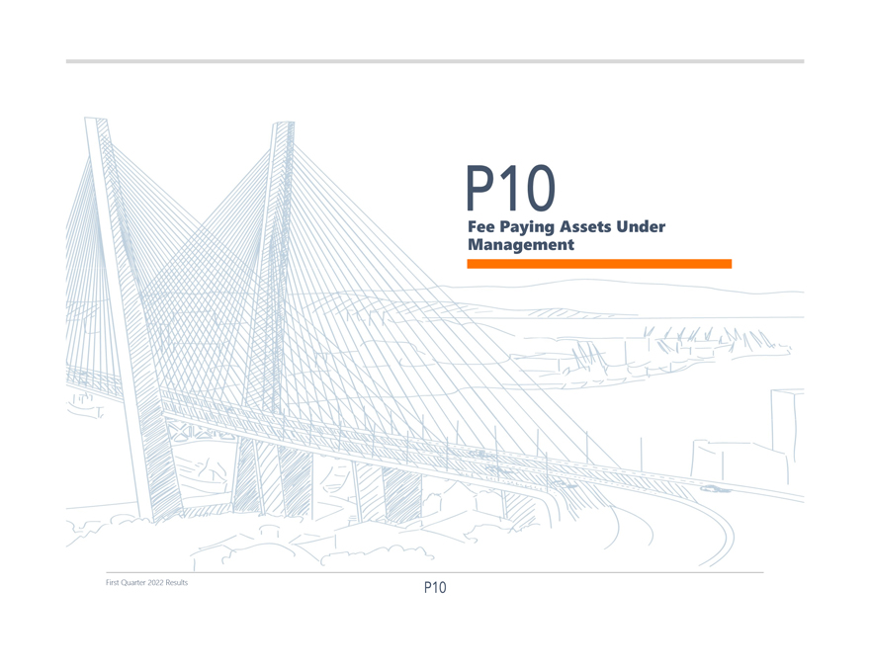
Fee Management Paying Assets Under First Quarter 2022 Results

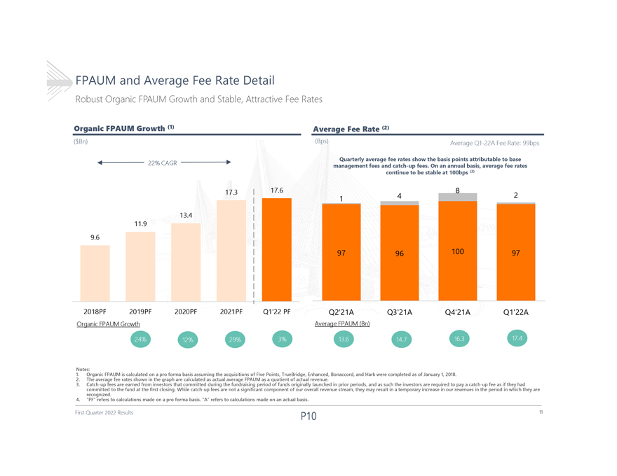
FPAUM and Average Fee Rate Detail Robust Organic FPAUM Growth and Stable, Attractive Fee Rates Organic FPAUM Growth (1) Average Fee Rate (2) ($Bn) (Bps) Average Q1-22A Fee Rate: 99bps Quarterly average fee rates show the basis points attributable to base 22% CAGR management fees and catch-up fees. On an annual basis, average fee rates continue to be stable at 100bps (3) 17.3 17.6 8 1 4 2 13.4 11.9 9.6 97 96 100 97 2018PF 2019PF 2020PF 2021PF Q122 PF Q221A Q321A Q421A Q122A Organic FPAUM Growth Average FPAUM (Bn) 1. Notes: Organic FPAUM is calculated on a pro forma basis assuming the acquisitions of Five Points, TrueBridge, Enhanced, Bonaccord, and Hark were completed as of January 1, 2018. 2. 3. The Catch-up average fees fee are rates earned shown from in investors the graph that are committed calculated as during actual the average fundraising FPAUM period as a quotient of funds of originally actual revenue. launched in prior periods, and as such the investors are required to pay a catch-up fee as if they had committed recognized. to the fund at the first closing. While catch-up fees are not a significant component of our overall revenue stream, they may result in a temporary increase in our revenues in the period in which they are 4. PF refers to calculations made on a pro forma basis. A refers to calculations made on an actual basis. First Quarter 2022 Results 11

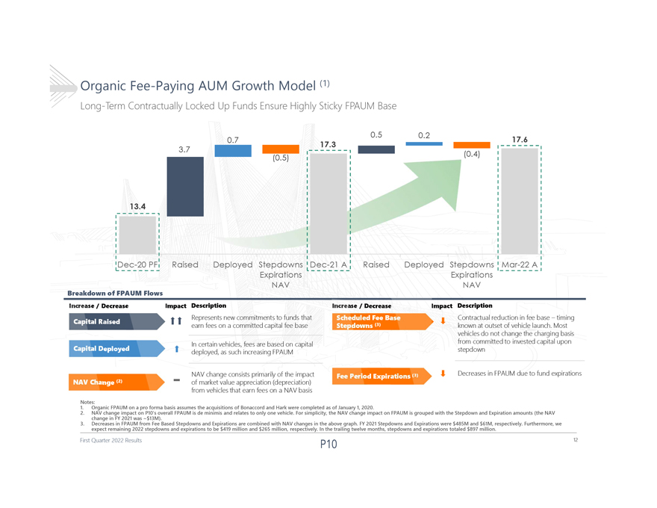
Organic Fee-Paying AUM Growth Model (1) Long-Term Contractually Locked Up Funds Ensure Highly Sticky FPAUM Base 0.5 0.2 0.7 17.6 17.3 3.7 (0.5) (0.4) 13.4 Dec-20 PF Raised DeployedStepdowns Dec-21 A Raised DeployedStepdowns Mar-22 A Expirations Expirations Breakdown of FPAUM Flows NAV NAV Decreas mpact Description ecrease Impact Description Represents new commitments to funds that Contractual reduction in fee base timing earn fees on a committed capital fee base known at outset of vehicle launch. Most vehicles do not change the charging basis In certain vehicles, fees are based on capital from committed to invested capital upon deployed, as such increasing FPAUM stepdown NAV change consists primarily of the impact Decreases in FPAUM due to fund expirations of market value appreciation (depreciation) from vehicles that earn fees on a NAV basis 1. Notes: Organic FPAUM on a pro forma basis assumes the acquisitions of Bonaccord and Hark were completed as of January 1, 2020. 2. change NAV change in FY impact 2021 was on ~$13M). P10s overall FPAUM is de minimis and relates to only one vehicle. For simplicity, the NAV change impactonFPAUM is grouped with the Stepdown and Expiration amounts (the NAV 3. expect Decreases remaining in FPAUM 2022 from stepdowns Fee Based and Stepdowns expirations and to Expirations be $419 million are combined and $265 with million, NAV respectively. changes in In the the above trailing graph. twelve FY 2021 months, Stepdowns stepdowns and and Expirations expirations were totaled $485M $897 and million. $61M, respectively. Furthermore, we First Quarter 2022 Results 12

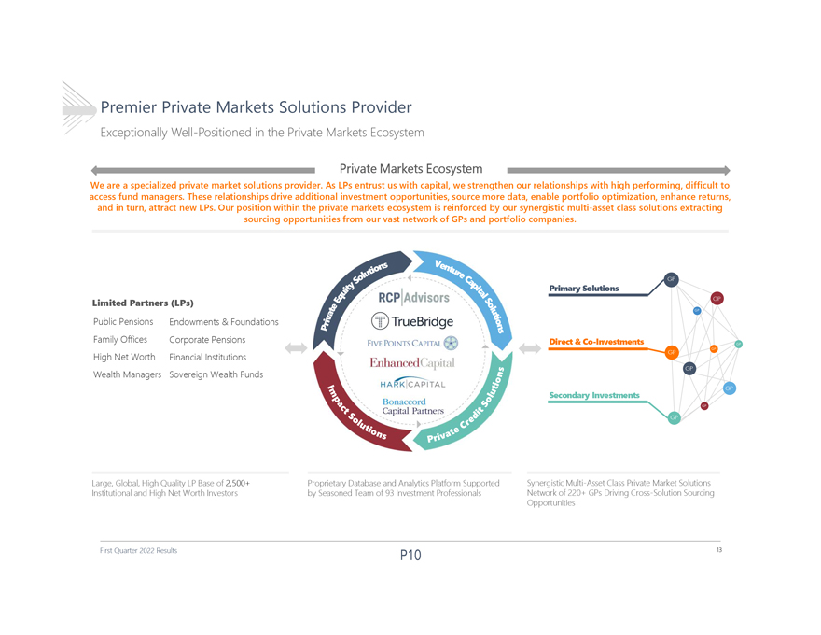
Premier Private Markets Solutions Provider Exceptionally Well-Positioned in the Private Markets Ecosystem Private Markets Ecosystem We are a specialized private market solutions provider. As LPs entrust us with capital, we strengthen our relationships with high performing, difficult to access fund managers. These relationships drive additional investment opportunities, source more data, enable portfolio optimization, enhance returns, and in turn, attract new LPs. Our position within the private markets ecosystem is reinforced by our synergistic multi-asset class solutions extracting sourcing opportunities from our vast network of GPs and portfolio companies. Primary Solutions Limited Partners (LPs) Public Pensions Endowments & Foundations Family Offices Corporate Pensions Direct & Co-Investments High Net Worth Financial Institutions Wealth Managers Sovereign Wealth Funds Secondary Investments Large, Global, High Quality LP Base of 2,500+ Proprietary Database and Analytics Platform Supported Synergistic Multi-Asset Class Private Market Solutions Institutional and High Net Worth Investors by Seasoned Team of 93 Investment Professionals Network of 220+ GPs Driving Cross-Solution Sourcing Opportunities First Quarter 2022 Results 13

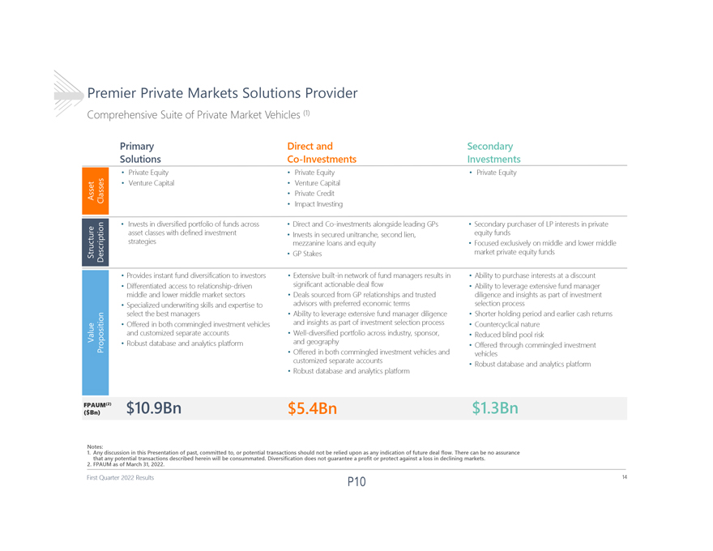
Premier Private Markets Solutions Provider Comprehensive Suite of Private Market Vehicles (1) Primary Direct and Secondary Solutions Co-Investments Investments  Private Equity  Private Equity  Private Equity  Venture Capital  Venture Capital  Private Credit  Impact Investing  Invests in diversified portfolio of funds across  Direct and Co-investments alongside leading GPs  Secondary purchaser of LP interests in private asset classes with defined investment  Invests in secured unitranche, second lien, equity funds strategies mezzanine loans and equity  Focused exclusively on middle and lower middle  GP Stakes market private equity funds  Provides instant fund diversification to investors  Extensive built-in network of fund managers results in  Ability to purchase interests at a discount  Differentiated access to relationship-driven significant actionable deal flow  Ability to leverage extensive fund manager middle and lower middle market sectors  Deals sourced from GP relationships and trusted diligence and insights as part of investment  Specialized underwriting skills and expertise to advisors with preferred economic terms selection process select the best managers  Ability to leverage extensive fund manager diligence  Shorter holding period and earlier cash returns  Offered in both commingled investment vehicles and insights as part of investment selection process  Countercyclical nature and customized separate accounts  Well-diversified portfolio across industry, sponsor,  Reduced blind pool risk  Robust database and analytics platform and geography Offered through commingled investment   Offered in both commingled investment vehicles and vehicles customized separate accounts  Robust database and analytics platform  Robust database and analytics platform FPAUM(2) $10.9Bn $5.4Bn $1.3Bn ($Bn) Notes: 1.Any discussion in this Presentation of past, committed to, or potential transactions should not be relied upon as any indicationof future deal flow. There can be no assurance 2.FPAUM that any as potential of March transactions 31, 2022. described herein will be consummated. Diversification does not guarantee a profit or protect against a loss in declining markets. First Quarter 2022 Results 14

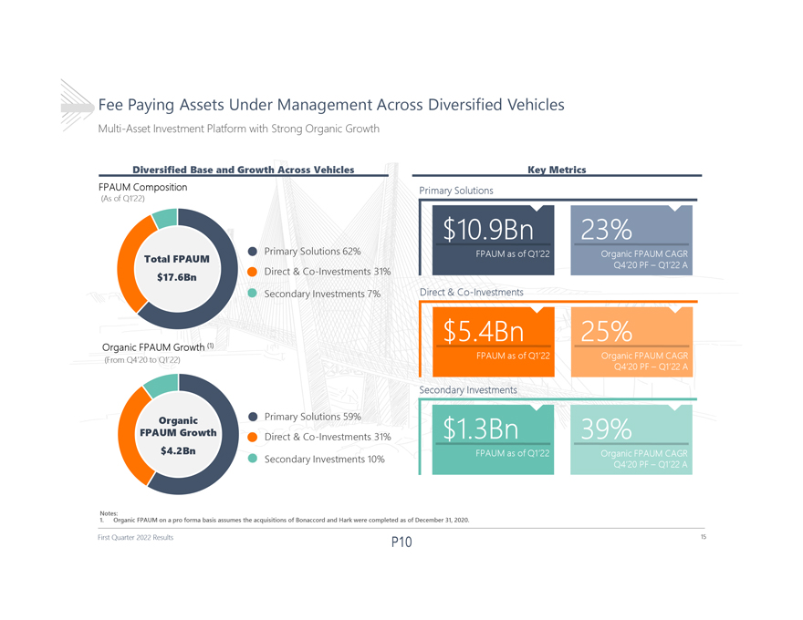
Fee Paying Assets Under Management Across Diversified Vehicles Multi-Asset Investment Platform with Strong Organic Growth Diversified Base and Growth Across Vehicles Key Metrics FPAUM Composition Primary Solutions (As of Q122) Primary Solutions62% Total FPAUM Direct & Co-Investments 31% $17.6Bn Secondary Investments 7% Direct & Co-Investments Organic FPAUM Growth (1) (From Q420 to Q122) Secondary Investments Organic Primary Solutions59% FPAUM Growth Direct & Co-Investments 31% $4.2Bn Secondary Investments 10% 1. Notes: Organic FPAUM on a pro forma basis assumes the acquisitions of Bonaccord and Hark were completed as of December 31, 2020. First Quarter 2022 Results 15

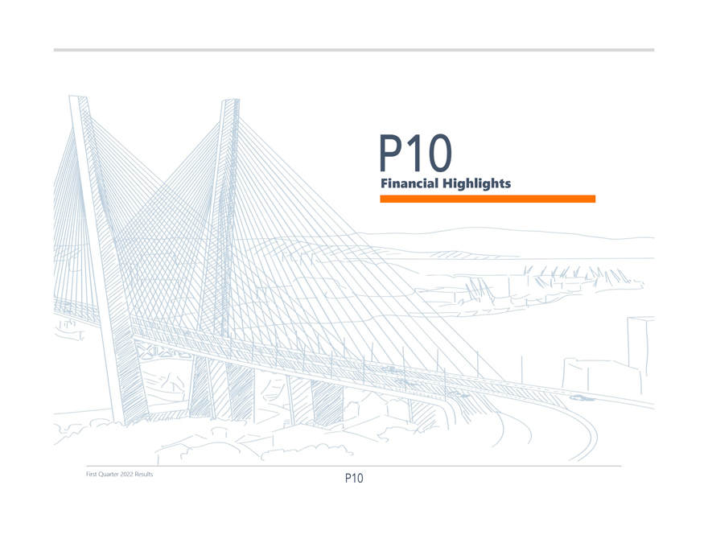
Financial Highlights First Quarter 2022 Results

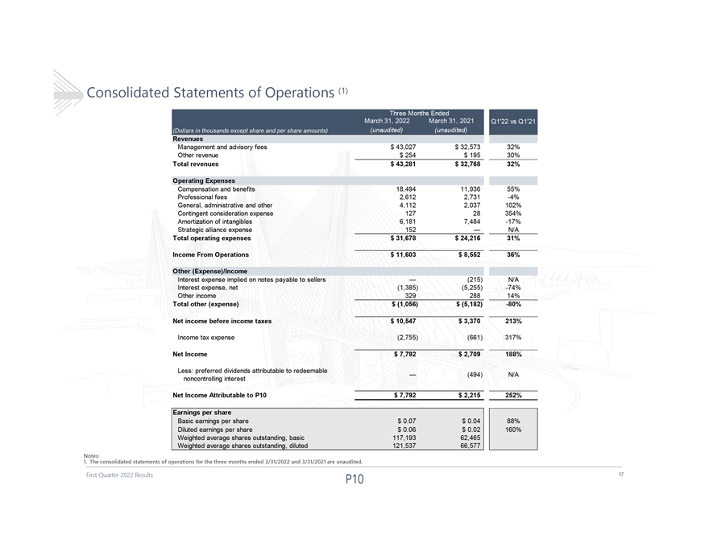
Consolidated Statements of Operations (1) Revenues Management and advisory fees $ 43,027 $ 32,573 32% Other revenue $ 254 $ 195 30% Total revenues $ 43,281 $ 32,768 32% Operating Expenses Compensation and benefits 18,494 11,936 55% Professional fees 2,612 2,731 -4% General, administrative and other 4,112 2,037 102% Contingent consideration expense 127 28 354% Amortization of intangibles 6,181 7,484 -17% Strategic alliance expense 152  N/A Total operating expenses $ 31,678 $ 24,216 31% Income From Operations $ 11,603 $ 8,552 36% Other (Expense)/Income Interest expense implied on notes payable to sellers  (215) N/A Interest expense, net (1,385) (5,255) -74% Other income 329 288 14% Total other (expense) $ (1,056) $ (5,182) -80% Net income before income taxes $ 10,547 $ 3,370 213% Income tax expense (2,755) (661) 317% Net Income $ 7,792 $ 2,709 188% Less: preferred dividends attributable to redeemable  (494) N/A noncontrolling interest Net Income Attributable to P10 $ 7,792 $ 2,215 252% Earnings per share Basic earnings per share $ 0.07 $ 0.04 88% Diluted earnings per share $ 0.06 $ 0.02 160% Weighted average shares outstanding, basic 117,193 62,465 Weighted average shares outstanding, diluted 121,537 66,577 1.The Notes: consolidated statements of operations for the three months ended 3/31/2022 and 3/31/2021 are unaudited. First Quarter 2022 Results 17

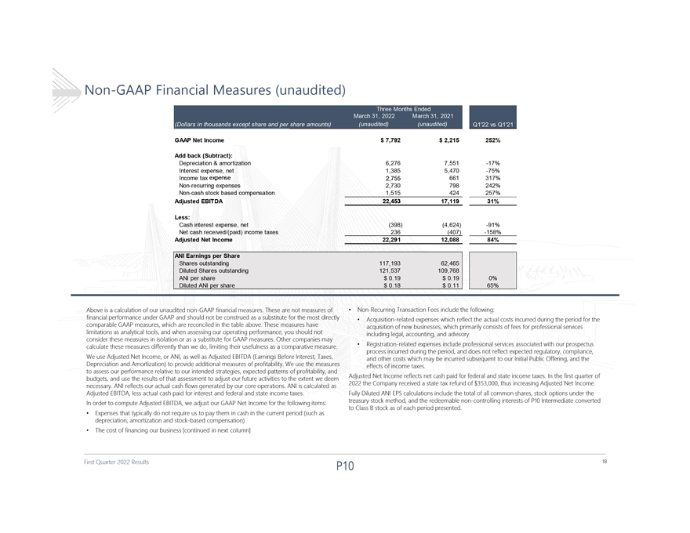
Non-GAAP Financial Measures (unaudited) GAAP Net Income $ 7,792 $ 2,215 252% Add back (Subtract): Depreciation & amortization 6,276 7,551 -17% Interest expense, net 1,385 5,470 -75% Income tax expense 2,755 661 317% Non-recurring expenses 2,730 798 242% Non-cash stock based compensation 1,515 424 257% Adjusted EBITDA 22,453 17,119 31% Less: Cash interest expense, net (398) (4,624) -91% Net cash received/(paid) income taxes 236 (407) -158% Adjusted Net Income 22,291 12,088 84% ANI Earnings per Share Shares outstanding 117,193 62,465 Diluted Shares outstanding 121,537 109,768 ANI per share $ 0.19 $ 0.19 0% Diluted ANI per share $ 0.18 $ 0.11 65% Above is a calculation of our unaudited non-GAAP financial measures. These are not measures of  Non-Recurring Transaction Fees include the following: financial performance under GAAP and should not be construed as a substitute for the most directly  Acquisition-related expenses which reflect the actual costs incurred during the period for the comparable GAAP measures, which are reconciled in the table above. These measures have acquisition of new businesses, which primarily consists of fees for professional services limitations as analytical tools, and when assessing our operating performance, you should not including legal, accounting, and advisory consider these measures in isolation or as a substitute for GAAP measures. Other companies may calculate these measures differently than we do, limiting their usefulness as a comparative measure.  Registration-related expenses include professional services associated with our prospectus process incurred during the period, and does not reflect expected regulatory, compliance, We use Adjusted Net Income, or ANI, as well as Adjusted EBITDA (Earnings Before Interest, Taxes, and other costs which may be incurred subsequent to our Initial Public Offering, and the Depreciation and Amortization) to provide additional measures of profitability. We use the measures effects of income taxes. to assess our performance relative to our intended strategies, expected patterns of profitability, and budgets, and use the results of that assessment to adjust our future activities to the extent we deem Adjusted Net Income reflects net cash paid for federal and state income taxes. In the first quarter of necessary. ANI reflects our actual cash flows generated by our core operations. ANI is calculated as 2022 the Company received a state tax refund of $353,000, thus increasing Adjusted Net Income. Adjusted EBITDA, less actual cash paid for interest and federal and state income taxes. Fully Diluted ANI EPS calculations include the total of all common shares, stock options under the In order to compute Adjusted EBITDA, we adjust our GAAP Net Income for the following items: treasury stock method, and the redeemable non-controlling interests of P10 Intermediate converted  to Class B stock as of each period presented. Expenses that typically do not require us to pay them in cash in the current period (such as depreciation, amortization and stock-based compensation)  The cost of financing our business [continued in next column] First Quarter 2022 Results 18

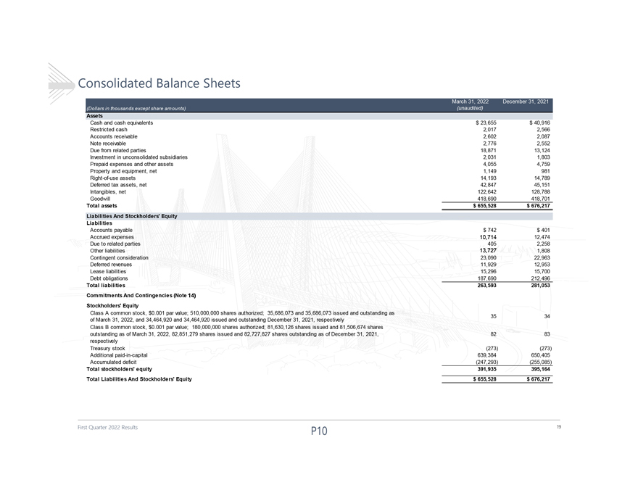
Consolidated Balance Sheets Assets Cash and cash equivalents $ 23,655 $ 40,916 Restricted cash 2,017 2,566 Accounts receivable 2,602 2,087 Note receivable 2,776 2,552 Due from related parties 18,871 13,124 Investment in unconsolidated subsidiaries 2,031 1,803 Prepaid expenses and other assets 4,055 4,759 Property and equipment, net 1,149 981 Right-of-use assets 14,193 14,789 Deferred tax assets, net 42,847 45,151 Intangibles, net 122,642 128,788 Goodwill 418,690 418,701 Total assets $ 655,528 $ 676,217 Liabilities And Stockholders Equity Liabilities Accounts payable $ 742 $ 401 Accrued expenses 10,714 12,474 Due to related parties 405 2,258 Other liabilities 13,727 1,808 Contingent consideration 23,090 22,963 Deferred revenues 11,929 12,953 Lease liabilities 15,296 15,700 Debt obligations 187,690 212,496 Total liabilities 263,593 281,053 Commitments And Contingencies (Note 14) Stockholders Equity Class A common stock, $0.001 par value; 510,000,000 shares authorized; 35,686,073 and 35,686,073 issued and outstanding as 35 34 of March 31, 2022, and 34,464,920 and 34,464,920 issued and outstanding December 31, 2021, respectively Class B common stock, $0.001 par value; 180,000,000 shares authorized; 81,630,126 shares issued and 81,506,674 shares outstanding as of March 31, 2022, 82,851,279 shares issued and 82,727,827 shares outstanding as of December 31, 2021, 82 83 respectively Treasury stock (273) (273) Additional paid-in-capital 639,384 650,405 Accumulated deficit (247,293) (255,085) Total stockholders equity 391,935 395,164 Total Liabilities And Stockholders Equity $ 655,528 $ 676,217 First Quarter 2022 Results 19

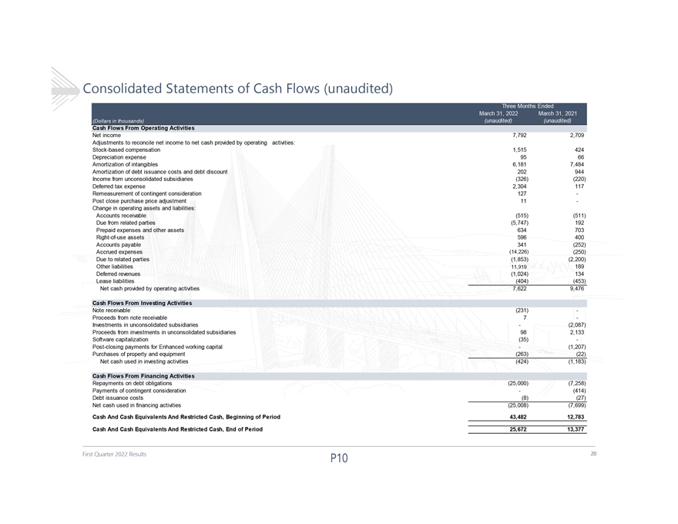
Consolidated Statements of Cash Flows (unaudited) Cash Flows From Operating Activities Net income 7,792 2,709 Adjustments to reconcile net income to net cash provided by operating activities: Stock-based compensation 1,515 424 Depreciation expense 95 66 Amortization of intangibles 6,181 7,484 Amortization of debt issuance costs and debt discount 202 944 Income from unconsolidated subsidiaries (326) (220) Deferred tax expense 2,304 117 Remeasurement of contingent consideration 127 -Post close purchase price adjustment 11 -Change in operating assets and liabilities: Accounts receivable (515) (511) Due from related parties (5,747) 192 Prepaid expenses and other assets 634 703 Right-of-use assets 596 400 Accounts payable 341 (252) Accrued expenses (14,226) (250) Due to related parties (1,853) (2,200) Other liabilities 11,919 189 Deferred revenues (1,024) 134 Lease liabilities (404) (453) Net cash provided by operating activities 7,622 9,476 Cash Flows From Investing Activities Note receivable (231) -Proceeds from note receivable 7 -Investments in unconsolidated subsidiaries(2,087) Proceeds from investments in unconsolidated subsidiaries 98 2,133 Software capitalization (35) -Post-closing payments for Enhanced working capital(1,207) Purchases of property and equipment (263) (22) Net cash used in investing activities (424) (1,183) Cash Flows From Financing Activities Repayments on debt obligations (25,000) (7,258) Payments of contingent consideration(414) Debt issuance costs (8) (27) Net cash used in financing activities (25,008) (7,699) Cash And Cash Equivalents And Restricted Cash, Beginning of Period 43,482 12,783 Cash And Cash Equivalents And Restricted Cash, End of Period 25,672 13,377 First Quarter 2022 Results 20

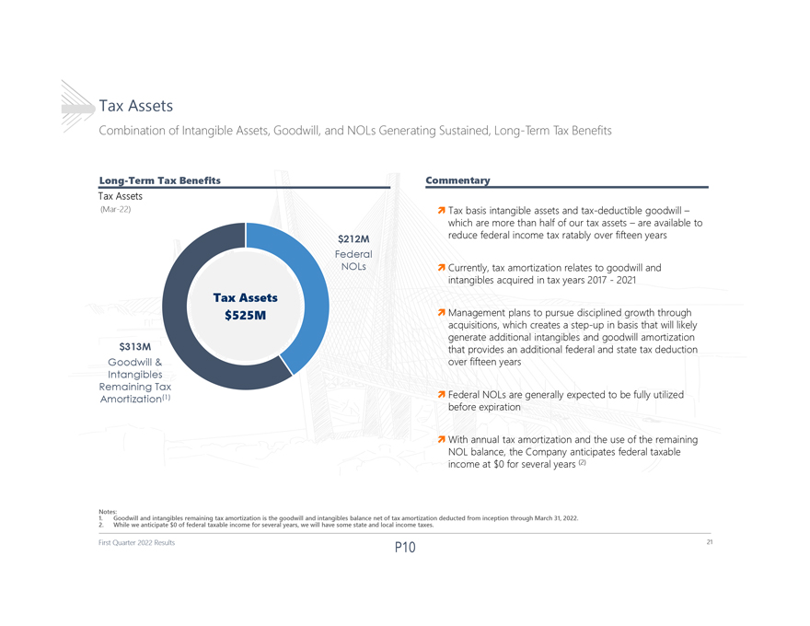
Tax Assets Combination of Intangible Assets, Goodwill, and NOLs Generating Sustained, Long-Term Tax Benefits Long-Term Tax Benefits Commentary Tax Assets (Mar-22)ï¬Tax basis intangible assets and tax-deductible goodwill which are more than half of our tax assets are available to $212M reduce federal income tax ratably over fifteen years Federal NOLsï¬Currently, tax amortization relates to goodwill and intangibles acquired in tax years 2017 -2021 Tax Assets $525Mï¬Management plans to pursue disciplined growth through acquisitions, which creates a step-up in basis that will likely generate additional intangibles and goodwill amortization $313M that provides an additional federal and state tax deduction Goodwill & over fifteen years Intangibles Remaining Tax Amortization(1)ï¬Federal NOLs are generally expected to be fully utilized before expiration ï¬With annual tax amortization and the use of the remaining NOL balance, the Company anticipates federal taxable income at $0 for several years (2) 1. Notes: Goodwill and intangibles remaining tax amortization is the goodwill and intangibles balance net of tax amortization deducted from inception through March 31, 2022. 2. While we anticipate $0 of federal taxable income for several years, we will have some state and local income taxes. First Quarter 2022 Results 21

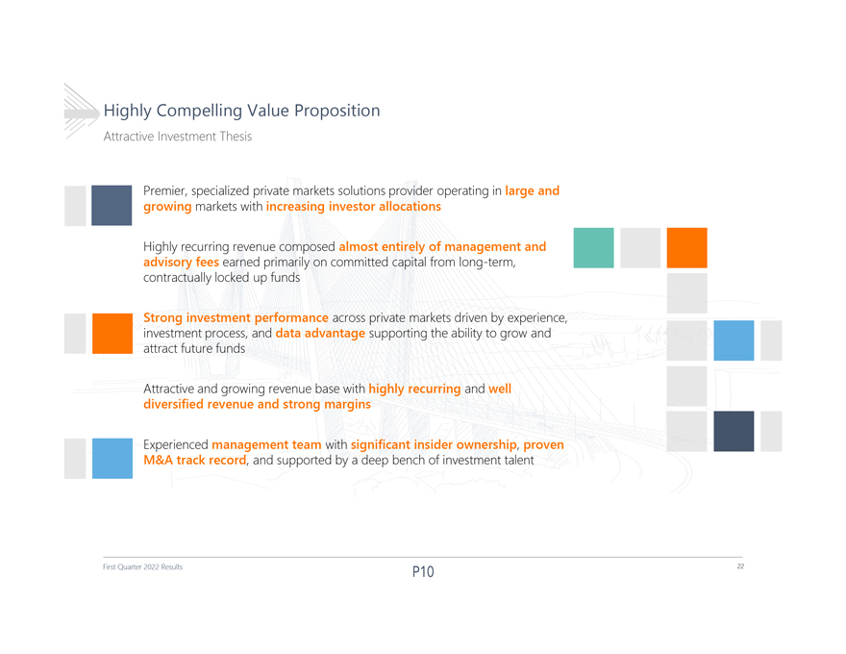
Highly Compelling Value Proposition Attractive Investment Thesis Premier, specialized private markets solutions provider operating in large and growing markets with increasing investor allocations Highly recurring revenue composed almost entirely of management and advisory fees earned primarily on committed capital from long-term, contractually locked up funds Strong investment performance across private markets driven by experience, investment process, and data advantage supporting the ability to grow and attract future funds Attractive and growing revenue base with highly recurring and well diversified revenue and strong margins Experienced management team with significant insider ownership, proven M&A track record, and supported by a deep bench of investment talent First Quarter 2022 Results 22

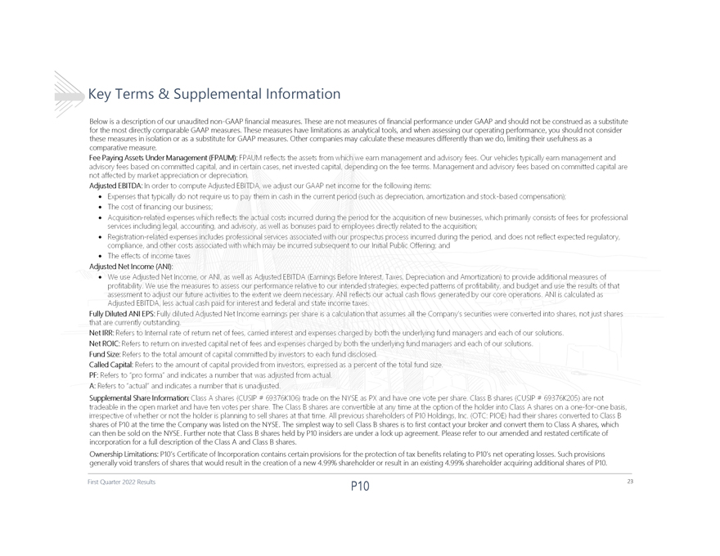
Key Terms & Supplemental Information Below is a description of our unaudited non-GAAP financial measures. These are not measures of financial performance under GAAP and should not be construed as a substitute for the most directly comparable GAAP measures. These measures have limitations as analytical tools, and when assessing our operating performance, you should not consider these measures in isolation or as a substitute for GAAP measures. Other companies may calculate these measures differently than we do, limiting their usefulness as a comparative measure. shares of P10 at the time the Company was listed on the NYSE. The simplest way to sell Class B shares is to first contact your broker and convert them to Class A shares, which can then be sold on the NYSE. Further note that Class B shares held by P10 insiders are under a lock up agreement. Please refer to our amended and restated certificate of incorporation for a full description of the Class A and Class B shares. Ownership Limitations: P10s Certificate of Incorporation contains certain provisions for the protection of tax benefits relating to P10s net operating losses. Such provisions generally void transfers of shares that would result in the creation of a new 4.99% shareholder or result in an existing 4.99% shareholder acquiring additional shares of P10. First Quarter 2022 Results 23

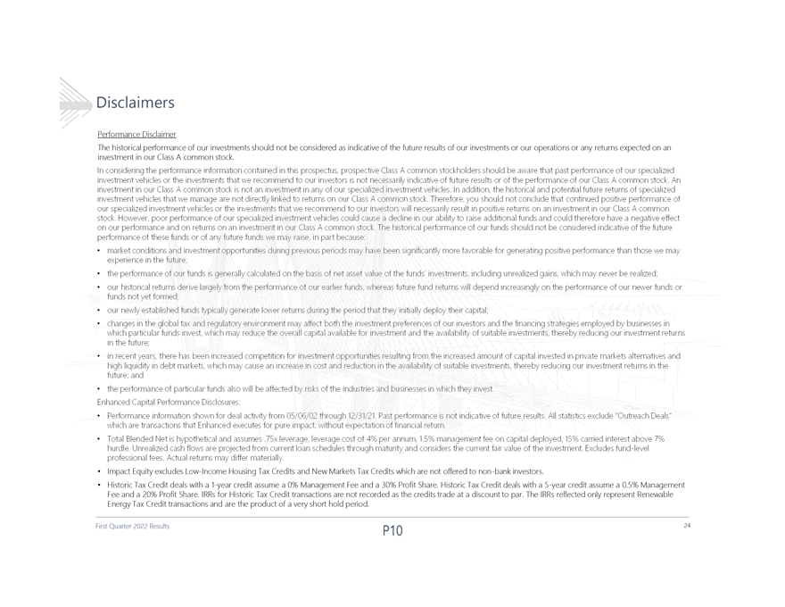
Disclaimers Performance Disclaimer The historical performance of our investments should not be considered as indicative of the future results of our investmentsorour operations or any returns expected on an investment in our Class A common stock.  Impact Equity excludes Low-Income Housing Tax Credits and New Markets Tax Credits which are not offered to non-bank investors.  Historic Tax Credit deals with a 1-year credit assume a 0% Management Fee and a 30% Profit Share. Historic Tax Credit deals witha 5-year credit assume a 0.5% Management Fee and a 20% Profit Share. IRRs for Historic Tax Credit transactions are not recorded as the credits trade at a discount to par. The IRRs reflected only represent Renewable Energy Tax Credit transactions and are the product of a very short hold period. First Quarter 2022 Results 24

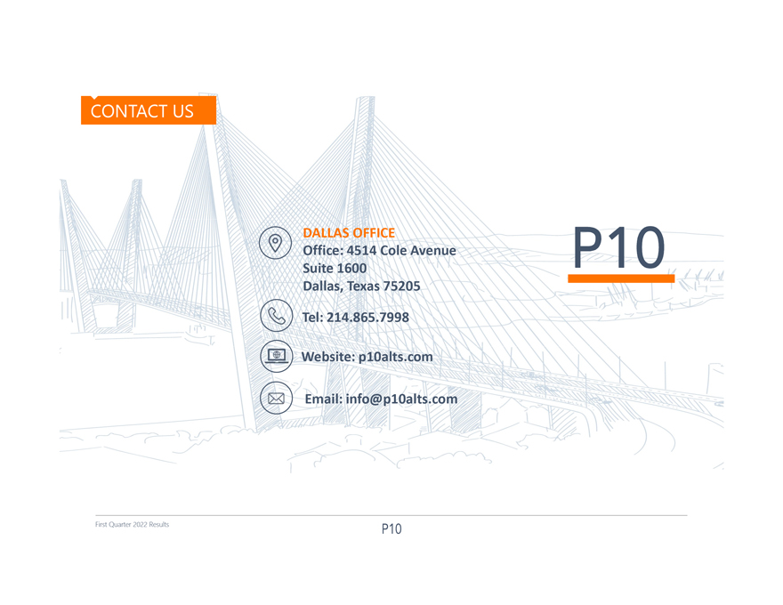
DALLAS OFFICE Office: 4514 Cole Avenue Suite 1600 Dallas, Texas 75205 Tel: 214.865.7998 Website: p10alts.com Email:info@p10alts.com First Quarter 2022 Results
Exhibit 99.2

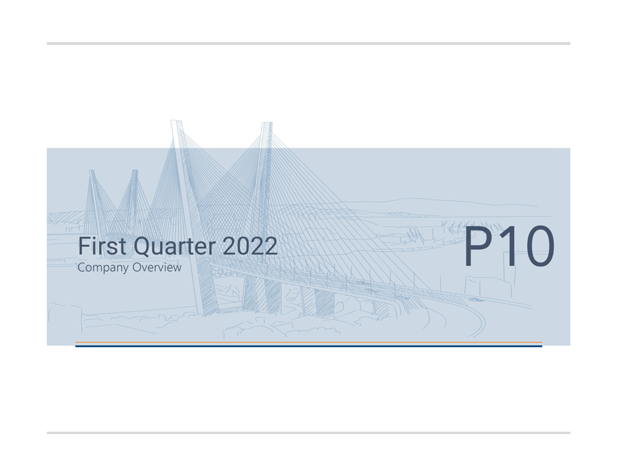
First Quarter 2022 Company Overview

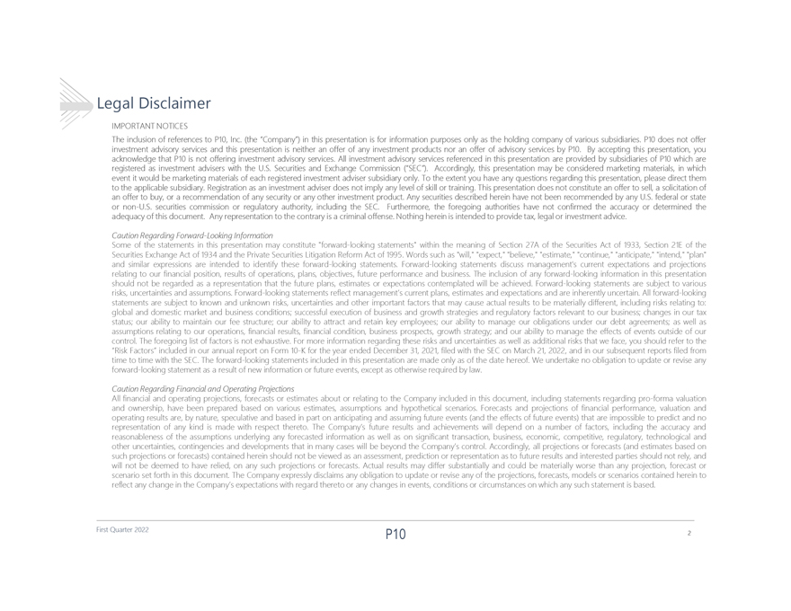
Legal Disclaimer IMPORTANTNOTICES TheinclusionofreferencestoP10,Inc.(theCompany)inthispresentationisforinformationpurposesonlyastheholdingcompanyofvarioussubsidiaries.P10doesnotoffer investmentadvisoryservicesandthispresentationisneitheranofferofanyinvestmentproductsnoranofferofadvisoryservicesbyP10.Byacceptingthispresentation,you acknowledgethatP10isnotofferinginvestmentadvisoryservices.AllinvestmentadvisoryservicesreferencedinthispresentationareprovidedbysubsidiariesofP10whichare registeredasinvestmentadviserswiththeU.S.SecuritiesandExchangeCommission(SEC). Accordingly,thispresentationmaybeconsideredmarketingmaterials,inwhich eventitwouldbemarketingmaterialsofeachregisteredinvestmentadvisersubsidiaryonly.Totheextentyouhaveanyquestionsregardingthispresentation,pleasedirectthem totheapplicablesubsidiary.Registrationasaninvestmentadviserdoesnotimplyanylevelofskillortraining.Thispresentationdoesnotconstituteanoffertosell,asolicitationof anoffertobuy,orarecommendationofanysecurityoranyotherinvestmentproduct.AnysecuritiesdescribedhereinhavenotbeenrecommendedbyanyU.S.federalorstate ornon-U.S.securitiescommissionorregulatoryauthority,includingtheSEC. Furthermore,theforegoingauthoritieshavenotconfirmedtheaccuracyordeterminedthe adequacyofthisdocument.Anyrepresentationtothecontraryisacriminaloffense.Nothinghereinisintendedtoprovidetax,legalorinvestmentadvice. CautionRegardingForward-LookingInformation Someofthestatementsinthispresentationmayconstituteforward-lookingstatementswithinthemeaningofSection27AoftheSecuritiesActof1933,Section21Eofthe SecuritiesExchangeActof1934andthePrivateSecuritiesLitigationReformActof1995.Wordssuchaswill,expect,believe,estimate,continue,anticipate,intend,plan andsimilarexpressionsareintendedtoidentifytheseforward-lookingstatements.Forward-lookingstatementsdiscussmanagementscurrentexpectationsandprojections relatingtoourfinancialposition,resultsofoperations,plans,objectives,futureperformanceandbusiness.Theinclusionofanyforward-lookinginformationinthispresentation shouldnotberegardedasarepresentationthatthefutureplans,estimatesorexpectationscontemplatedwillbeachieved.Forward-lookingstatementsaresubjecttovarious risks,uncertaintiesandassumptions.Forward-lookingstatementsreflectmanagementscurrentplans,estimatesandexpectationsandareinherentlyuncertain.Allforward-looking statementsaresubjecttoknownandunknownrisks,uncertaintiesandotherimportantfactorsthatmaycauseactualresultstobemateriallydifferent,includingrisksrelatingto: globalanddomesticmarketandbusinessconditions;successfulexecutionofbusinessandgrowthstrategiesandregulatoryfactorsrelevanttoourbusiness;changesinourtax status;ourabilitytomaintainourfeestructure;ourabilitytoattractandretainkeyemployees;ourabilitytomanageourobligationsunderourdebtagreements;aswellas assumptionsrelatingtoouroperations,financialresults,financialcondition,businessprospects,growthstrategy;andourabilitytomanagetheeffectsofeventsoutsideofour control.Theforegoinglistoffactorsisnotexhaustive.Formoreinformationregardingtheserisksanduncertaintiesaswellasadditionalrisksthatweface,youshouldrefertothe RiskFactorsincludedinourannualreportonForm10-KfortheyearendedDecember31,2021,filedwiththeSEConMarch21,2022,andinoursubsequentreportsfiledfrom timetotimewiththeSEC.Theforward-lookingstatementsincludedinthispresentationaremadeonlyasofthedatehereof.Weundertakenoobligationtoupdateorreviseany forward-lookingstatementasaresultofnewinformationorfutureevents,exceptasotherwiserequiredbylaw. CautionRegardingFinancialandOperatingProjections Allfinancialandoperatingprojections,forecastsorestimatesaboutorrelatingtotheCompanyincludedinthisdocument,includingstatementsregardingpro-formavaluation andownership,havebeenpreparedbasedonvariousestimates,assumptionsandhypotheticalscenarios.Forecastsandprojectionsoffinancialperformance,valuationand operatingresultsare,bynature,speculativeandbasedinpartonanticipatingandassumingfutureevents(andtheeffectsoffutureevents)thatareimpossibletopredictandno representationofanykindismadewithrespectthereto.TheCompanysfutureresultsandachievementswilldependonanumberoffactors,includingtheaccuracyand reasonablenessoftheassumptionsunderlyinganyforecastedinformationaswellasonsignificanttransaction,business,economic,competitive,regulatory,technologicaland otheruncertainties,contingenciesanddevelopmentsthatinmanycaseswillbebeyondtheCompanyscontrol.Accordingly,allprojectionsorforecasts(andestimatesbasedon suchprojectionsorforecasts)containedhereinshouldnotbeviewedasanassessment,predictionorrepresentationastofutureresultsandinterestedpartiesshouldnotrely,and willnotbedeemedtohaverelied,onanysuchprojectionsorforecasts.Actualresultsmaydiffersubstantiallyandcouldbemateriallyworsethananyprojection,forecastor scenariosetforthinthisdocument.TheCompanyexpresslydisclaimsanyobligationtoupdateorreviseanyoftheprojections,forecasts,modelsorscenarioscontainedhereinto reflectanychangeintheCompanysexpectationswithregardtheretooranychangesinevents,conditionsorcircumstancesonwhichanysuchstatementisbased. First Quarter 2022 2

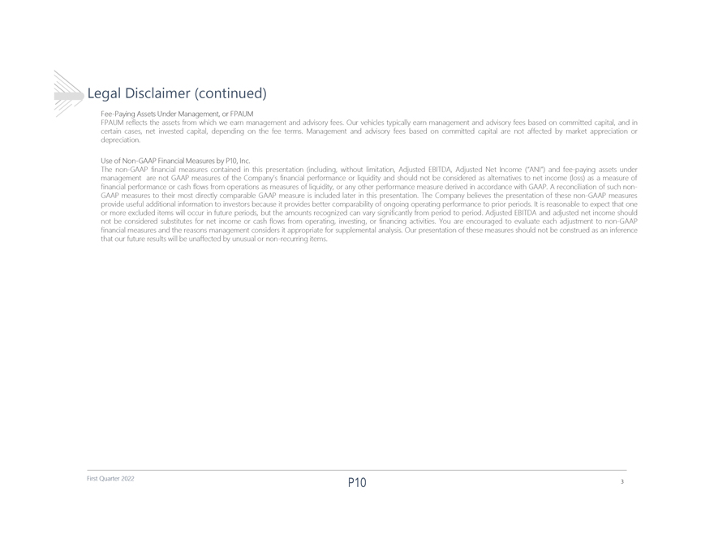
Legal Disclaimer (continued) Fee-PayingAssetsUnderManagement,orFPAUM FPAUMreflectstheassetsfromwhichweearnmanagementandadvisoryfees.Ourvehiclestypicallyearnmanagementandadvisoryfeesbasedoncommittedcapital,andin certaincases,netinvestedcapital,dependingonthefeeterms.Managementandadvisoryfeesbasedoncommittedcapitalarenotaffectedbymarketappreciationor depreciation. UseofNon-GAAPFinancialMeasuresbyP10,Inc. Thenon-GAAPfinancialmeasurescontainedinthispresentation(including,withoutlimitation,AdjustedEBITDA,AdjustedNetIncome(ANI)andfee-payingassetsunder managementarenotGAAPmeasuresoftheCompanysfinancialperformanceorliquidityandshouldnotbeconsideredasalternativestonetincome(loss)asameasureof financialperformanceorcashflowsfromoperationsasmeasuresofliquidity,oranyotherperformancemeasurederivedinaccordancewithGAAP.Areconciliationofsuchnon-GAAPmeasurestotheirmostdirectlycomparableGAAPmeasureisincludedlaterinthispresentation.TheCompanybelievesthepresentationofthesenon-GAAPmeasures provideusefuladditionalinformationtoinvestorsbecauseitprovidesbettercomparabilityofongoingoperatingperformancetopriorperiods.Itisreasonabletoexpectthatone ormoreexcludeditemswilloccurinfutureperiods,buttheamountsrecognizedcanvarysignificantlyfromperiodtoperiod.AdjustedEBITDAandadjustednetincomeshould notbeconsideredsubstitutesfornetincomeorcashflowsfromoperating,investing,orfinancingactivities.Youareencouragedtoevaluateeachadjustmenttonon-GAAP financialmeasuresandthereasonsmanagementconsidersitappropriateforsupplementalanalysis.Ourpresentationofthesemeasuresshouldnotbeconstruedasaninference thatourfutureresultswillbeunaffectedbyunusualornon-recurringitems. First Quarter 2022 3

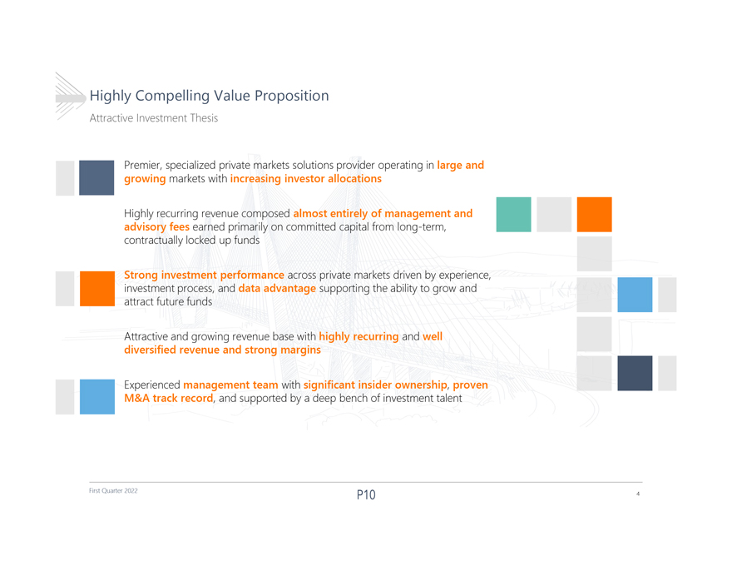
Highly Compelling Value Proposition Attractive Investment Thesis Premier, specialized private markets solutions provider operating in large and growing markets with increasing investor allocations Highly recurring revenue composed almost entirely of management and advisory fees earned primarily on committed capital from long-term, contractually locked up funds Strong investment performance across private markets driven by experience, investment process, and data advantage supporting the ability to grow and attract future funds Attractive and growing revenue base with highly recurring and well diversified revenue and strong margins Experienced management team with significant insider ownership, proven M&A track record, and supported by a deep bench of investment talent First Quarter 2022 4

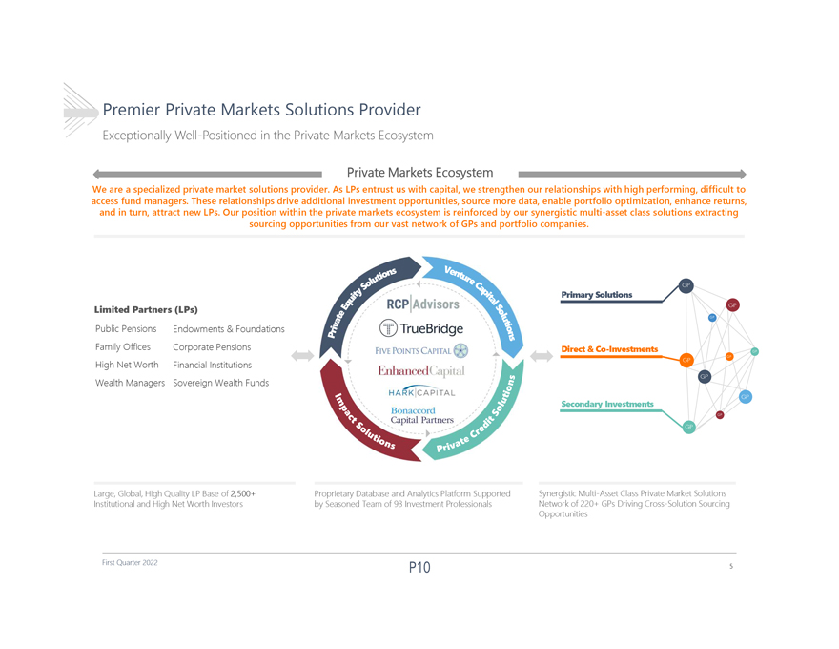
Premier Private Markets Solutions Provider Exceptionally Well-Positioned in the Private Markets Ecosystem Private Markets Ecosystem We are a specialized private market solutions provider. As LPs entrust us with capital, we strengthen our relationships with high performing, difficult to access fund managers. These relationships drive additional investment opportunities, source more data, enable portfolio optimization, enhance returns, and in turn, attract new LPs. Our position within the private markets ecosystem is reinforced by our synergistic multi-asset class solutions extracting sourcing opportunities from our vast network of GPs and portfolio companies. Primary Solutions Limited Partners (LPs) Public Pensions Endowments & Foundations Family Offices Corporate Pensions Direct & Co-Investments High Net Worth Financial Institutions Wealth Managers Sovereign Wealth Funds Secondary Investments Large, Global, High Quality LP Base of 2,500+ Proprietary Database and Analytics Platform Supported Synergistic Multi-Asset Class Private Market Solutions Institutional and High Net Worth Investors by Seasoned Team of 93 Investment Professionals Network of 220+ GPs Driving Cross-Solution Sourcing Opportunities First Quarter 2022 5

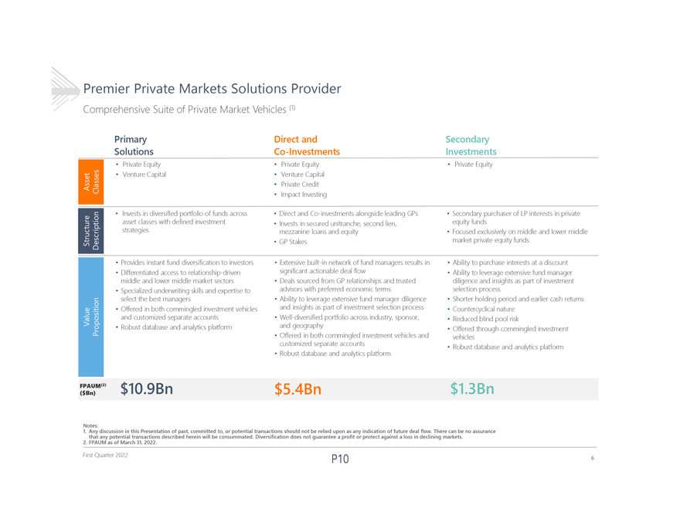
Premier Private Markets Solutions Provider Comprehensive Suite of Private Market Vehicles (1) Primary Direct and Secondary Solutions Co-Investments Investments  Private Equity  Private Equity  Private Equity  Venture Capital  Venture Capital  Private Credit  Impact Investing  Invests in diversified portfolio of funds across  Direct and Co-investments alongside leading GPs  Secondary purchaser of LP interests in private asset classes with defined investment  Invests in secured unitranche, second lien, equity funds strategies mezzanine loans and equity  Focused exclusively on middle and lower middle  GP Stakes market private equity funds  Provides instant fund diversification to investors  Extensive built-in network of fund managers results in  Ability to purchase interests at a discount  Differentiated access to relationship-driven significant actionable deal flow  Ability to leverage extensive fund manager middle and lower middle market sectors  Deals sourced from GP relationships and trusted diligence and insights as part of investment  Specialized underwriting skills and expertise to advisors with preferred economic terms selection process select the best managers  Ability to leverage extensive fund manager diligence  Shorter holding period and earlier cash returns  Offered in both commingled investment vehicles and insights as part of investment selection process  Countercyclical nature and customized separate accounts  Well-diversified portfolio across industry, sponsor,  Reduced blind pool risk  Robust database and analytics platform and geography Offered through commingled investment   Offered in both commingled investment vehicles and vehicles customized separate accounts  Robust database and analytics platform  Robust database and analytics platform FPAUM(2) $10.9Bn $5.4Bn $1.3Bn ($Bn) 1.Any Notes: discussion in this Presentation of past, committed to, or potential transactions should not be relied upon as any indicationof future deal flow. There can be no assurance 2.FPAUM that any as potential of March transactions 31, 2022. described herein will be consummated. Diversification does not guarantee a profit or protect against a loss in declining markets. First Quarter 2022 6

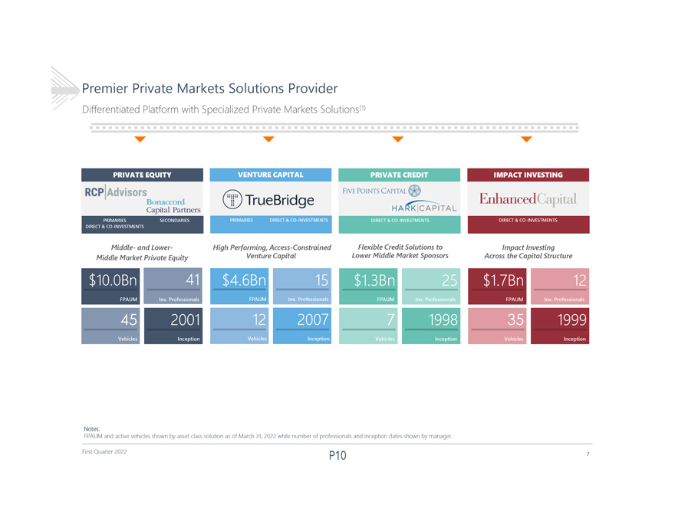
Premier Private Markets Solutions Provider Differentiated Platform with Specialized Private Markets Solutions(1) PRIVATE EQUITY VENTURE CAPITAL PRIVATE CREDIT IMPACT INVESTING PRIMARIES SECONDARIES PRIMARIES DIRECT & CO-INVESTMENTS DIRECT & CO-INVESTMENTS DIRECT & CO-INVESTMENTS DIRECT & CO-INVESTMENTS Middle- and Lower- High Performing, Access-Constrained Flexible Credit Solutions to Impact Investing Middle Market Private Equity Venture Capital Lower Middle Market Sponsors Across the Capital Structure $10.0B n 41 $4.6Bn 15 $1.3Bn 25 $1.7Bn 12 FPAUM Inv. Professionals FPAUM Inv. Professionals FPAUM Inv. Professionals FPAUM Inv. Professionals 45 2001 12 2007 7 1998 35 1999 Vehicles Inception Vehicles Inception Vehicles Inception Vehicles Inception Notes: FPAUM and active vehicles shown by asset class solution as of March 31, 2022 while number of professionals and inception dates shown by manager. First Quarter 2022 7

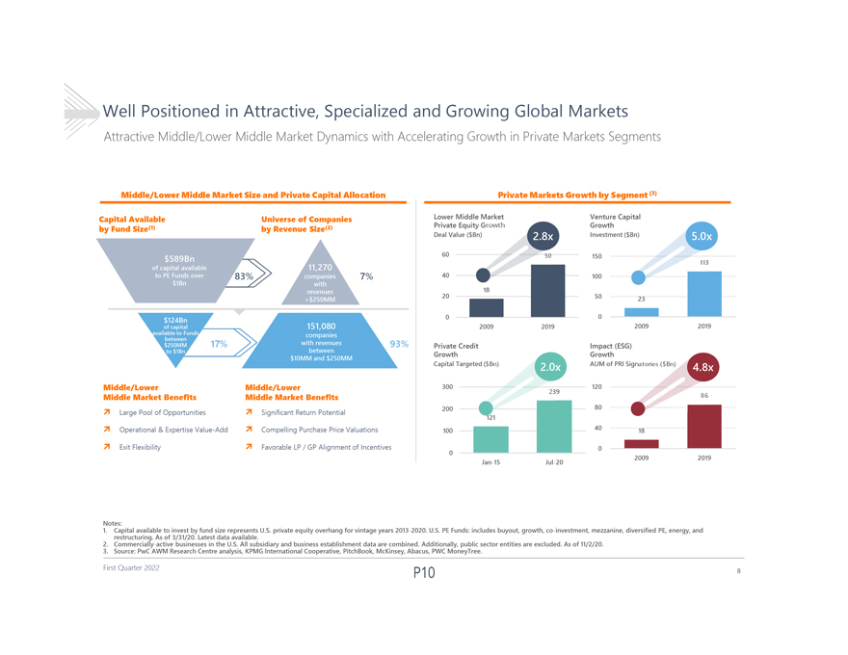
Well Positioned in Attractive, Specialized and Growing Global Markets Attractive Middle/Lower Middle Market Dynamics with Accelerating Growth in Private Markets Segments Middle/Lower Middle Market Size and Private Capital Allocation Private Markets Growth by Segment(3) Capital Available Universe of Companies Lower Middle Market Venture Capital by Fund Size(1) by Revenue Size(2) Private Equity Growth Growth Deal Value ($Bn) Investment($Bn 60 150 3 40 83% 7% 100 18 20 50 23 0 0 2009 2019 2009 2019 17% 93% Private Credit Impact (ESG) Growth Growth Capital Targeted ( AUM of PRI Sign Middle/Lower Middle/Lower 300 120 9 Middle Market Benefits Middle Market Benefits6 200 80 ï Large Pool of Opportunitiesï Significant Return Potential 121 ï Operational & Expertise Value-Addï Compelling Purchase Price Valuations 100 40 18ï Exit Flexibilityï Favorable LP / GP Alignment of Incentives 0 0 2009 2019 Jan-15 Jul-20 Notes: 1. Capital available to invest by fund size represents U.S. private equity overhang for vintage years 2013-2020. U.S. PE Funds: includes buyout, growth, co-investment, mezzanine, diversified PE, energy, and 2. Commercially-active restructuring. As of 3/31/20. businesses Latest in the data U.S. available. All subsidiary and business establishment data are combined. Additionally, public sector entities are excluded. As of 11/2/20. 3. Source: PwC AWM Research Centre analysis, KPMG International Cooperative, PitchBook, McKinsey, Abacus, PWC MoneyTree. First Quarter 2022 8

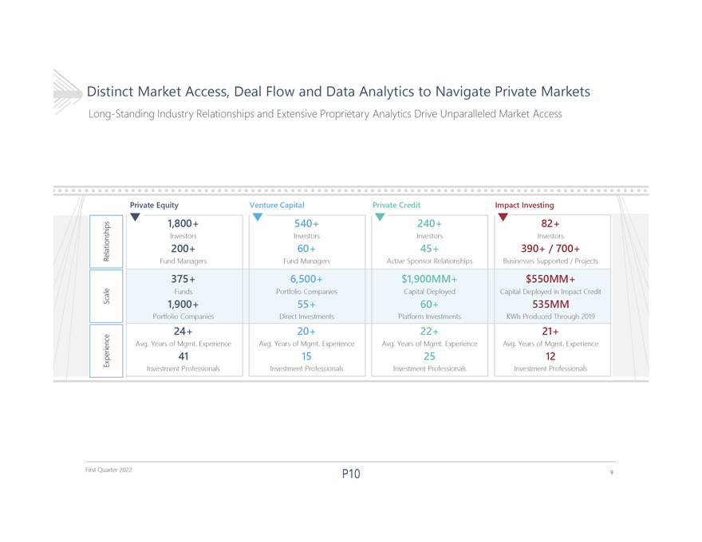
Distinct Market Access, Deal Flow and Data Analytics to Navigate Private Markets Long-Standing Industry Relationships and Extensive Proprietary Analytics Drive Unparalleled Market Access Private Equity Venture Capital Private Credit Impact Investing Relationships 1,800+ 540+ 240+ 82+ Investors Investors Investors Investors 200+ 60+ 45+ 390+ / 700+ Fund Managers Fund Managers Active Sponsor Relationships Businesses Supported / Projects 375+ 6,500+ $1,900MM+ $550MM+ Scale Funds Portfolio Companies Capital Deployed Capital Deployed in Impact Credit 1,900+ 55+ 60+ 535MM Portfolio Companies Direct Investments Platform Investments KWh Produced Through 2019 24+ 20+ 22+ 21+ Experience Avg. Years of Mgmt. Experience Avg. Years of Mgmt. Experience Avg. Years of Mgmt. Experience Avg. Years of Mgmt. Experience 41 15 25 12 Investment Professionals Investment Professionals Investment Professionals Investment Professionals First Quarter 2022 9

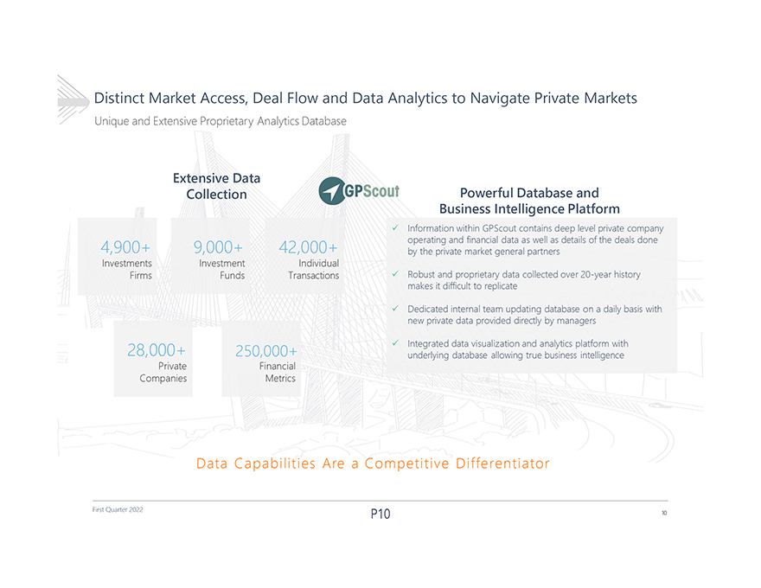
DistinctMarket Access,DealFlow andDataAnalyticstoNavigatePrivateMarkets UniqueandExtensiveProprietaryAnalyticsDatabase ExtensiveData PowerfulDatabaseand Collection BusinessIntelligencePlatform ï¼ InformationwithinGPScout containsdeeplevelprivatecompany 4,900+ 9,000+ 42,000+ operatingandfinancialdataas wellas details ofthedealsdone bytheprivatemarketgeneralpartners Investments Investment Individual Firms Funds Transactionsï¼ Robust and proprietary data collected over 20-year history makesitdifficultto replicateï¼ Dedicatedinternalteam updatingdatabaseonadaily basis with new private dataprovideddirectlybymanagers 28,000+ 250,000+ï¼ Integrated data visualization and analytics platform with Private Financial underlyingdatabaseallowingtruebusinessintelligence Companies Metrics DataCapabilitiesAreaCompetitiveDifferentiator First Quarter 2022 10

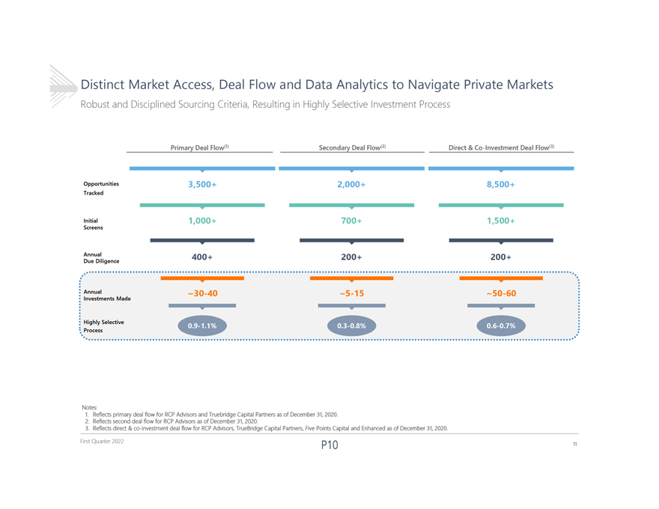
Distinct Market Access, Deal Flow and Data Analytics to Navigate Private Markets Robust and Disciplined Sourcing Criteria, Resulting in Highly Selective Investment Process Primary Deal Flow(1) Secondary Deal Flow(2) Direct & Co-Investment Deal Flow(3) Opportunities Tracked 3,500+ 2,000+ 8,500+ Initial Screens 1,000+ 700+ 1,500+ Annual Due Diligence 400+ 200+ 200+ Annual Investments Made ~30-40 ~5-15 ~50-60 Highly Selective Process Notes: 1. Reflects primary deal flow for RCP Advisors and Truebridge Capital Partners as of December 31, 2020. 2. Reflects second deal flow for RCP Advisors as of December 31, 2020. 3. Reflects direct & co-investment deal flow for RCP Advisors, TrueBridge Capital Partners, Five Points Capital and Enhanced as of December 31, 2020. First Quarter 2022 11

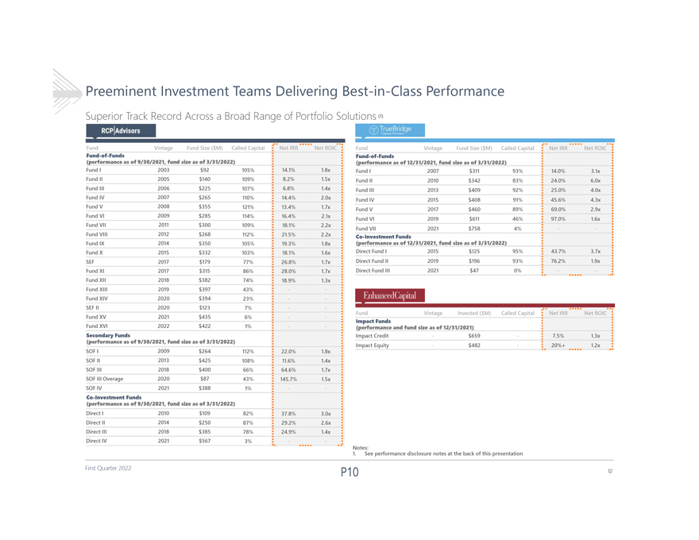
Preeminent Investment Teams Delivering Best-in-Class Performance Superior Track Record Across a Broad Range of Portfolio Solutions(1) Fund Vintage Fund Size ($M) Called Capital Net IRR Net ROIC Fund-of-Funds (performance as of 9/30/2021, fund size as of 3/31/2022) Fund I 2003 $92 105% 14.1% 1.8x Fund II 2005 $140 109% 8.2% 1.5x Fund III 2006 $225 107% 6.8% 1.4x Fund IV 2007 $265 110% 14.4% 2.0x Fund V 2008 $355 121% 13.4% 1.7x Fund VI 2009 $285 114% 16.4% 2.1x Fund VII 2011 $300 109% 18.1% 2.2x Fund VIII 2012 $268 112% 21.5% 2.2x Fund IX 2014 $350 105% 19.3% 1.8x Fund X 2015 $332 103% 18.1% 1.6x SEF 2017 $179 77% 26.8% 1.7x Fund XI 2017 $315 86% 28.0% 1.7x Fund XII 2018 $382 74% 18.9% 1.3x Fund XIII 2019 $397 43% - -Fund XIV 2020 $394 23% - -SEF II 2020 $123 7% - -Fund XV 2021 $435 6% - -Fund XVI 2022 $422 1% - - Secondary Funds (performance as of 9/30/2021, fund size as of 3/31/2022) SOF I 2009 $264 112% 22.0% 1.8x SOF II 2013 $425 108% 11.6% 1.4x SOF III 2018 $400 66% 64.6% 1.7x SOF III Overage 2020 $87 43% 145.7% 1.5x SOF IV 2021 $388 1% - - Co-Investment Funds (performance as of 9/30/2021, fund size as of 3/31/2022) Direct I 2010 $109 82% 37.8% 3.0x Direct II 2014 $250 87% 29.2% 2.6x Direct III 2018 $385 78% 24.9% 1.4x Direct IV 2021 $567 3% - - Fund Vintage Fund Size ($M) Called Capital Net IRR Net ROIC Fund-of-Funds (performance as of 12/31/2021, fund size as of 3/31/2022) Fund I 2007 $311 93% 14.0% 3.1x Fund II 2010 $342 83% 24.0% 6.0x Fund III 2013 $409 92% 25.0% 4.0x Fund IV 2015 $408 91% 45.6% 4.3x Fund V 2017 $460 89% 69.0% 2.9x Fund VI 2019 $611 46% 97.0% 1.6x Fund VII 2021 $758 4% - - Co-Investment Funds (performance as of 12/31/2021, fund size as of 3/31/2022) Direct Fund I 2015 $125 95% 43.7% 3.7x Direct Fund II 2019 $196 93% 76.2% 1.9x Direct Fund III 2021 $47 0% - - Fund Vintage Invested ($M) Called Capital Net IRR Net ROIC Impact Funds (performance and fund size as of 12/31/2021) Impact Credit - $659 - 7.5% 1.3x Impact Equity - $482 - 20%+ 1.2x 1Notes: . See performance disclosure notes at the back of this presentation First Quarter 2022 12

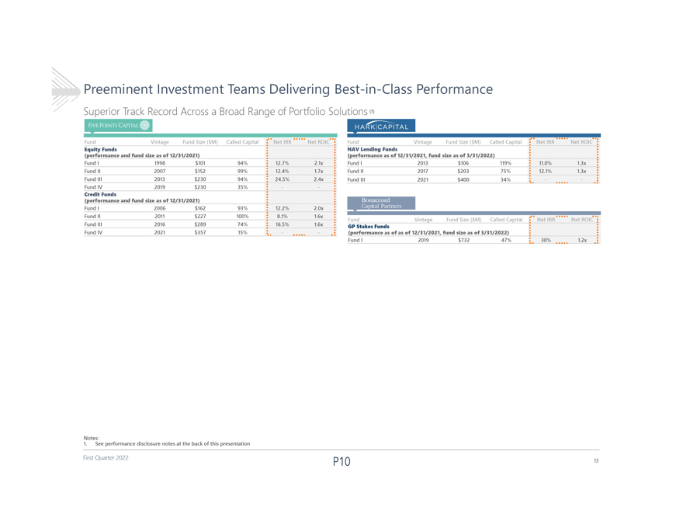
Preeminent Investment Teams Delivering Best-in-Class Performance Superior Track Record Across a Broad Range of Portfolio Solutions(1) Fund Vintage Fund Size ($M) Called Capital Net IRR Net ROIC Fund Vintage Fund Size ($M) Called Capital Net IRR Net ROIC Equity Funds NAV Lending Funds (performance and fund size as of 12/31/2021) (performance as of 12/31/2021, fund size as of 3/31/2022) Fund I 1998 $101 94% 12.7% 2.1x Fund I 2013 $106 119% 11.0% 1.3x Fund II 2007 $152 99% 12.4% 1.7x Fund II 2017 $203 75% 12.1% 1.3x Fund III 2013 $230 94% 24.5% 2.4x Fund III 2021 $400 34% Fund IV 2019 $230 35%  Credit Funds (performance and fund size as of 12/31/2021) Fund I 2006 $162 93% 12.2% 2.0x Fund II 2011 $227 100% 8.1% 1.6x Fund Vintage Fund Size ($M) Called Capital Net IRR Net ROIC Fund III 2016 $289 74% 16.5% 1.6x GP Stakes Funds Fund IV 2021 $357 15%  (performance as of as of 12/31/2021, fund size as of 3/31/2022) Fund I 2019 $732 47% 30% 1.2x 1. Notes: See performance disclosure notes at the back of this presentation First Quarter 2022 13

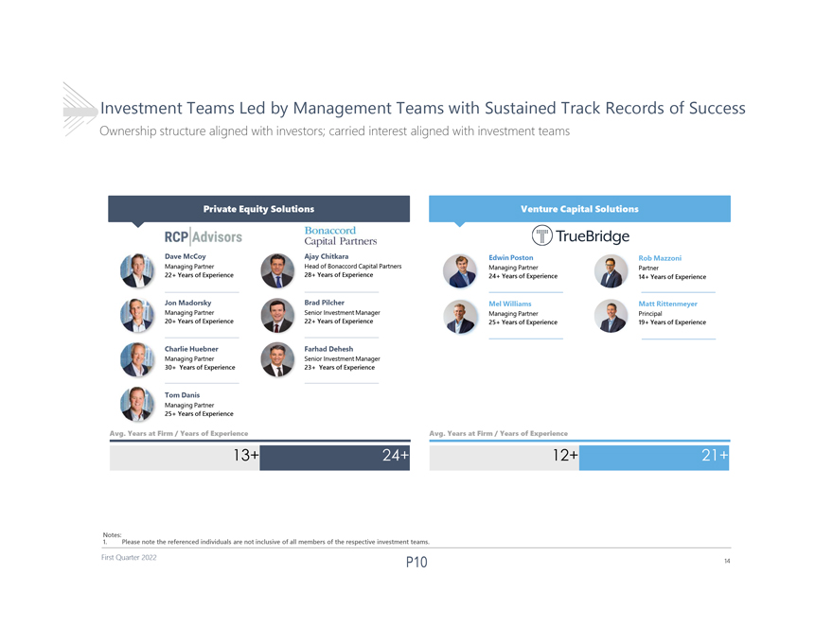
Investment Teams Led by Management Teams with Sustained Track Records of Success Ownership structure aligned with investors; carried interest aligned with investment teams DaveMcCoy Ajay Chitkara EdwinPoston RobMazzoni ManagingPartner Head of Bonaccord Capital Partners ManagingPartner Partner 22+YearsofExperience 28+YearsofExperience 24+YearsofExperience 14+YearsofExperience JonMadorsky Brad Pilcher MelWilliams MattRittenmeyer ManagingPartner Senior Investment Manager ManagingPartner Principal 20+YearsofExperience 22+YearsofExperience 25+YearsofExperience 19+YearsofExperience CharlieHuebner Farhad Dehesh ManagingPartner Senior Investment Manager 30+YearsofExperience 23+YearsofExperience TomDanis ManagingPartner 25+YearsofExperience Avg.YearsatFirm/ YearsofExperience Avg.YearsatFirm/ YearsofExperience 13+ 12+ 1. Notes: Please note the referenced individuals are not inclusive of all members of the respective investment teams. First Quarter 2022 14

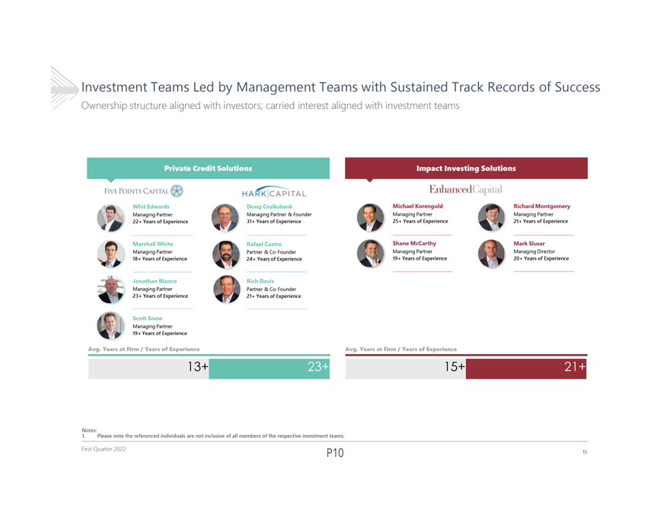
Investment Teams Led by Management Teams with Sustained Track Records of Success Ownership structure aligned with investors; carried interest aligned with investment teams WhitEdwards Doug Cruikshank MichaelKorengold RichardMontgomery ManagingPartner ManagingPartner& Founder ManagingPartner ManagingPartner 22+YearsofExperience 31+YearsofExperience 25+YearsofExperience 21+YearsofExperience MarshallWhite Rafael Castro ShaneMcCarthy MarkSlusar ManagingPartner Partner & Co-Founder ManagingPartner Managing Director 18+YearsofExperience 24+YearsofExperience 19+YearsofExperience 20+YearsofExperience JonathanBlanco Rich Davis ManagingPartner Partner & Co-Founder 23+YearsofExperience 21+YearsofExperience ScottSnow ManagingPartner 19+YearsofExperience Avg.YearsatFirm/ YearsofExperience Avg.YearsatFirm/ YearsofExperience 13+ 15+ 1. Notes: Please note the referenced individuals are not inclusive of all members of the respective investment teams. First Quarter 2022 15

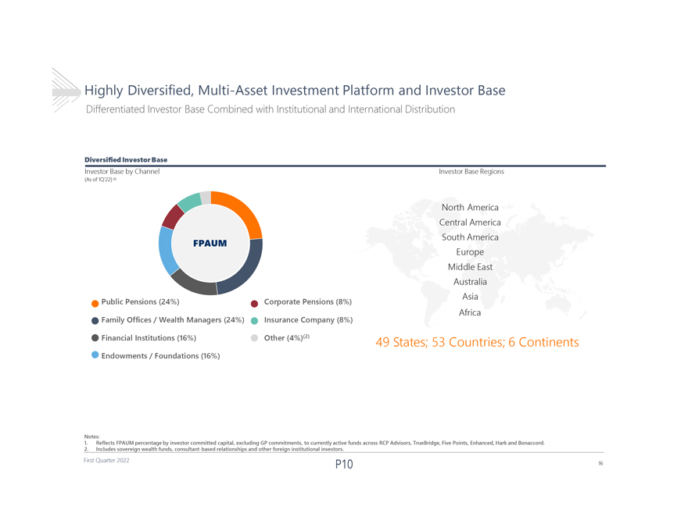
HighlyDiversified, Multi-AssetInvestmentPlatform and InvestorBase DifferentiatedInvestor BaseCombined withInstitutionaland InternationalDistribution DiversifiedInvestorBase InvestorBasebyChannel InvestorBaseRegions (Asof1Q22) (1) North America CentralAmerica South America FPAUM Europe MiddleEast Australia Asia Public Pensions (24%) Corporate Pensions (8%) Africa Family Offices / Wealth Managers (24%) Insurance Company (8%) Financial Institutions (16%) Other (4%)(2) 49States;53Countries;6Continents Endowments / Foundations (16%) Notes: 1. ReflectsFPAUM percentagebyinvestorcommittedcapital,excludingGPcommitments,tocurrentlyactivefundsacrossRCPAdvisors,TrueBridge,FivePoints, Enhanced, Hark and Bonaccord. 2. Includessovereignwealthfunds,consultant-basedrelationshipsandotherforeigninstitutionalinvestors. First Quarter 2022 16

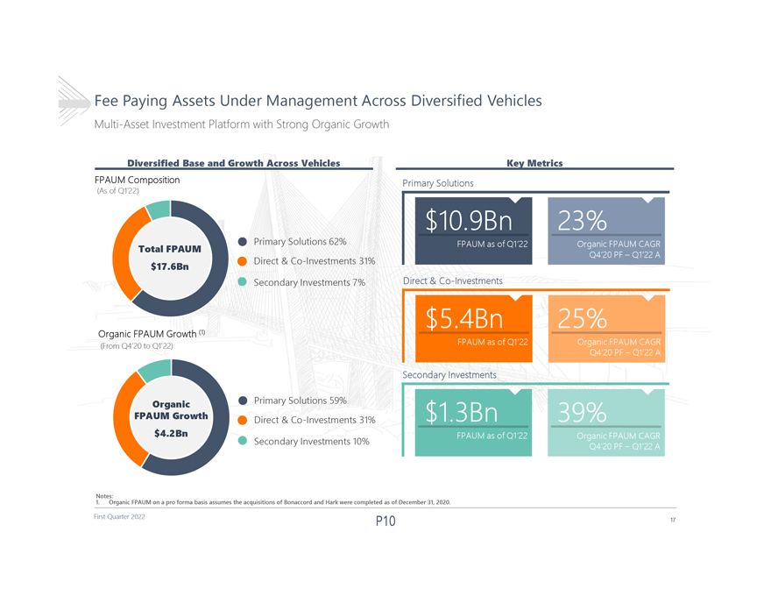
Fee Paying Assets Under Management Across Diversified Vehicles Multi-Asset Investment Platform with Strong Organic Growth Diversified Base and Growth Across Vehicles Key Metrics FPAUM Composition Primary Solutions (As of Q122) Primary Solutions62% Total FPAUM Direct & Co-Investments 31% $17.6Bn Secondary Investments 7% Direct & Co-Investments Organic FPAUM Growth (1) (From Q420 to Q122) Secondary Investments Organic Primary Solutions59% FPAUM Growth Direct & Co-Investments 31% $4.2Bn Secondary Investments 10% 1. Notes: Organic FPAUM on a pro forma basis assumes the acquisitions of Bonaccord and Hark were completed as of December 31, 2020. First Quarter 2022 17

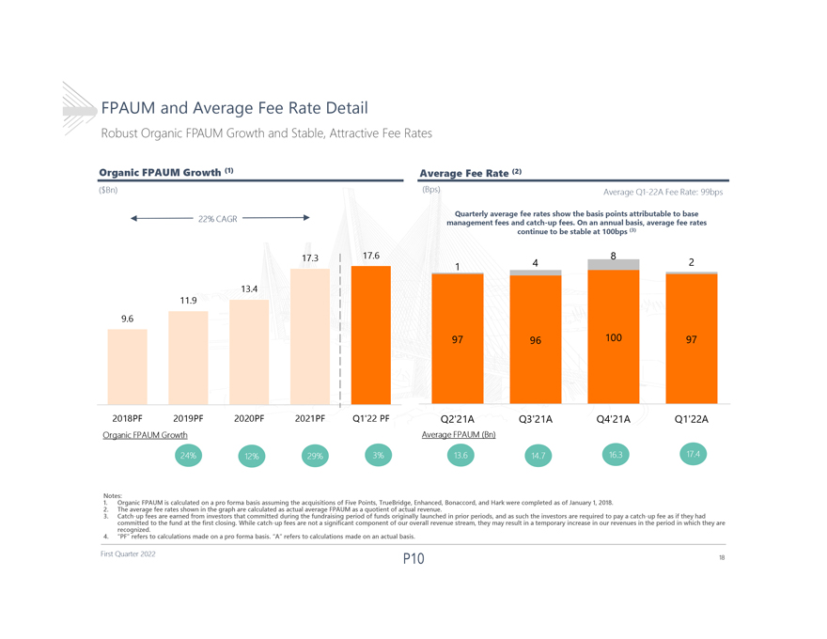
FPAUM and Average Fee Rate Detail Robust Organic FPAUM Growth and Stable, Attractive Fee Rates Organic FPAUM Growth (1) Average Fee Rate (2) ($Bn) (Bps) Average Q1-22A Fee Rate: 99bps Quarterly average fee rates show the basis points attributable to base 22% CAGR management fees and catch-up fees. On an annual basis, average fee rates continue to be stable at 100bps (3) 17.3 17.6 8 1 4 2 13.4 11.9 9.6 97 96 100 97 2018PF 2019PF 2020PF 2021PF Q122 PF Q221A Q321A Q421A Q122A Organic FPAUM Growth Average FPAUM (Bn) 1. Notes: Organic FPAUM is calculated on a pro forma basis assuming the acquisitions of Five Points, TrueBridge, Enhanced, Bonaccord, and Hark were completed as of January 1, 2018. 2. 3. Catch-up The average fees fee are rates earned shown from in investors the graph that are committed calculated as during actual the average fundraising FPAUM period as a quotient of funds of originally actual revenue. launched in prior periods, and as such the investors are required to pay a catch-up fee as if they had committed recognized. to the fund at the first closing. While catch-up fees are not a significant component of our overall revenue stream, they may result in a temporary increase in our revenues in the period in which they are 4. PF refers to calculations made on a pro forma basis. A refers to calculations made on an actual basis. First Quarter 2022 18

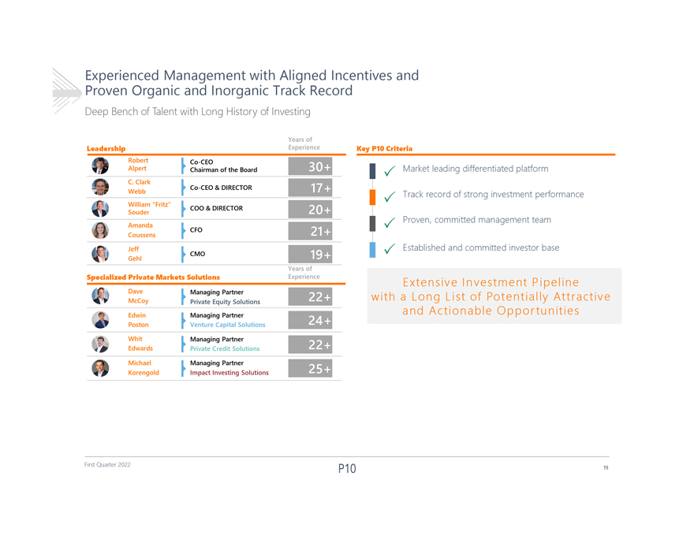
Proven Experienced Organic Management and Inorganic with Track Aligned Record Incentives and Deep Bench of Talent with Long History of Investing Years of Leadership Experience Key P10 Criteria Robert Co-CEO Alpert Chairman of the Board ï Market leading differentiated platform C. Clark Co-CEO & DIRECTOR Webbï Track record of strong investment performance William Fritz COO & DIRECTOR Souder Proven, committed management team Amandaï CFO Coussens Jeff Established and committed investor base CMO ï Gehl Years of Specialized Private Markets Solutions Experience Extensive Investment Pipeline Dave Managing Partner with a Long List of Potentially Attractive McCoy Private Equity Solutions Edwin Managing Partner and Actionable Opportunities Poston Venture Capital Solutions Whit Managing Partner Edwards Private Credit Solutions Michael Managing Partner Korengold Impact Investing Solutions First Quarter 2022 19

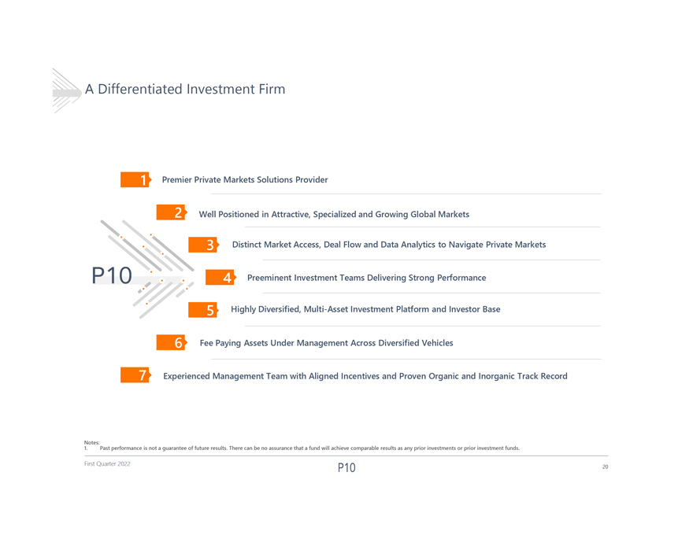
A Differentiated Investment Firm Premier Private Markets Solutions Provider Well Positioned in Attractive, Specialized and Growing Global Markets Distinct Market Access, Deal Flow and Data Analytics to Navigate Private Markets Preeminent Investment Teams Delivering Strong Performance Highly Diversified, Multi-Asset Investment Platform and Investor Base Fee Paying Assets Under Management Across Diversified Vehicles Experienced Management Team with Aligned Incentives and Proven Organic and Inorganic Track Record 1. Notes: Past performance is not a guarantee of future results. There can be no assurance that a fund will achieve comparable results as any prior investments or prior investment funds. First Quarter 2022 20

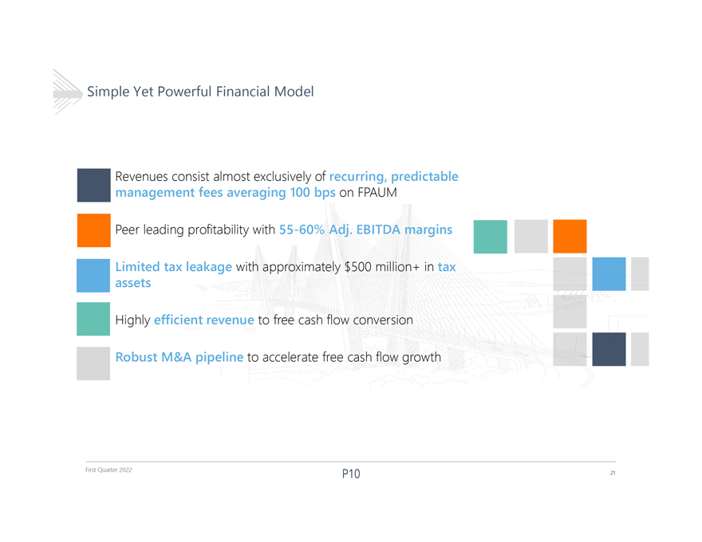
Simple Yet Powerful Financial Model Revenues consist almost exclusively of recurring, predictable management fees averaging 100 bps on FPAUM Peer leading profitability with 55-60% Adj. EBITDA margins Limited tax leakage with approximately $500 million+ in tax assets Highly efficient revenue to free cash flow conversion Robust M&A pipeline to accelerate free cash flow growth First Quarter 2022 21

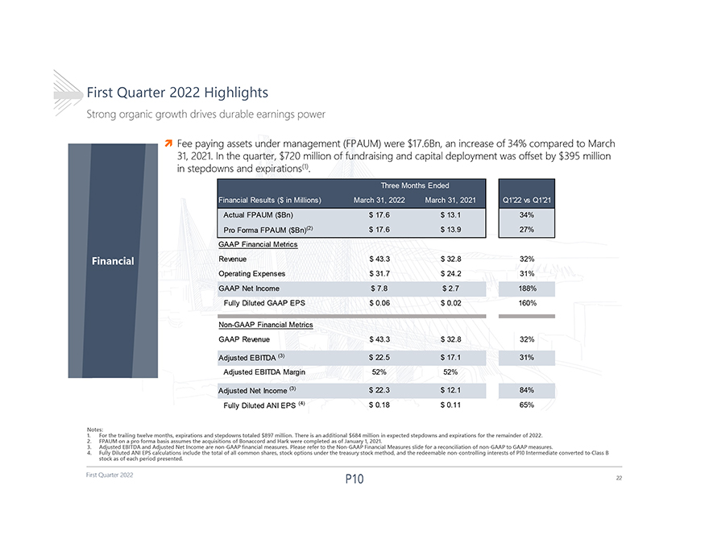
First Quarter 2022 First Quarter 2022 Highlights Strong organic growth drives durable earnings power Financial Notes: 1. For the trailing twelve months, expirations and stepdowns totaled $897 million. There is an additional $684 million in expected stepdowns and expirations for the remainder of 2022. 2. FPAUM on a pro forma basis assumes the acquisitions of Bonaccord and Hark were completed as of January 1, 2021. 3. Adjusted EBITDA and Adjusted Net Income are non-GAAP financial measures. Please refer to the Non-GAAP Financial Measures slide for a reconciliation of non-GAAP to GAAP measures. 4. Fully Diluted ANI EPS calculations include the total of all common shares, stock options under the treasury stock method, and the redeemable non-controlling interests of P10 Intermediate converted to Class B stock as of each period presented. Fee paying assets under management (FPAUM) were $17.6Bn, an increase of 34% compared to March 31, 2021. In the quarter, $720 million of fundraising and capital deployment was offset by $395 million in stepdowns and expirations(1). Th($ in Millions) March 31, 2022 March 31, 2021 Q122 vs Q121 Actual FPAUM ($Bn) $ 17.6 $ 13.1 34% Pro Forma FPAUM ($Bn)(2) $ 17.6 $ 13.9 27% GAAP Financial Metrics Revenue $ 43.3 $ 32.8 32% Operating Expenses $ 31.7 $ 24.2 31% GAAP Net Income $ 7.8 $ 2.7 188% Fully Diluted GAAP EPS $ 0.06 $ 0.02 160% Non-GAAP Financial Metrics GAAP Revenue $ 43.3 $ 32.8 32% Adjusted EBITDA (3) $ 22.5 $ 17.1 31% Adjusted EBITDA Margin 52% 52% Adjusted Net Income (3) $ 22.3 $ 12.1 84% Fully Diluted ANI EPS (4) $ 0.18 $ 0.11 65% 22

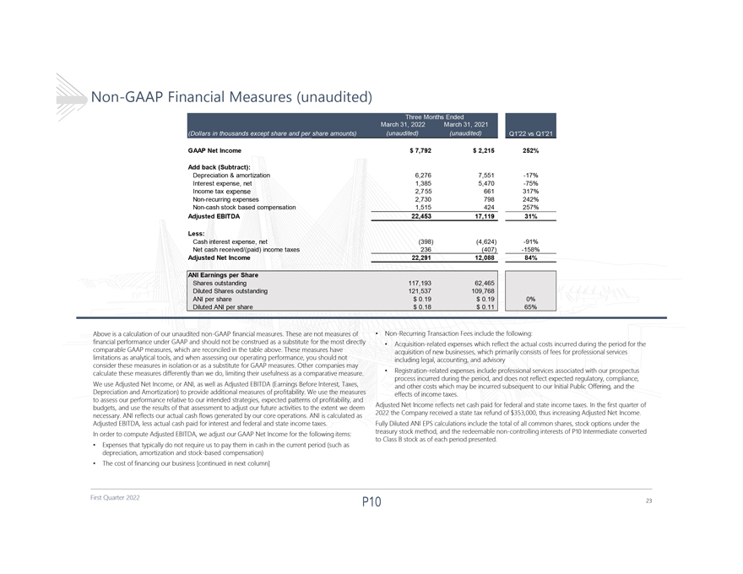
Non-GAAP Financial Measures (unaudited) GAAP Net Income $ 7,792 $ 2,215 252% Add back (Subtract): Depreciation & amortization 6,276 7,551 -17% Interest expense, net 1,385 5,470 -75% Income tax expense 2,755 661 317% Non-recurring expenses 2,730 798 242% Non-cash stock based compensation 1,515 424 257% Adjusted EBITDA 22,453 17,119 31% Less: Cash interest expense, net (398) (4,624) -91% Net cash received/(paid) income taxes 236 (407) -158% Adjusted Net Income 22,291 12,088 84% ANI Earnings per Share Shares outstanding 117,193 62,465 Diluted Shares outstanding 121,537 109,768 ANI per share $ 0.19 $ 0.19 0% Diluted ANI per share $ 0.18 $ 0.11 65% Above is a calculation of our unaudited non-GAAP financial measures. These are not measures of  Non-Recurring Transaction Fees include the following: financial performance under GAAP and should not be construed as a substitute for the most directly  Acquisition-related expenses which reflect the actual costs incurred during the period for the comparable GAAP measures, which are reconciled in the table above. These measures have acquisition of new businesses, which primarily consists of fees for professional services limitations as analytical tools, and when assessing our operating performance, you should not including legal, accounting, and advisory consider these measures in isolation or as a substitute for GAAP measures. Other companies may calculate these measures differently than we do, limiting their usefulness as a comparative measure.  Registration-related expenses include professional services associated with our prospectus process incurred during the period, and does not reflect expected regulatory, compliance, We use Adjusted Net Income, or ANI, as well as Adjusted EBITDA (Earnings Before Interest, Taxes, and other costs which may be incurred subsequent to our Initial Public Offering, and the Depreciation and Amortization) to provide additional measures of profitability. We use the measures effects of income taxes. to assess our performance relative to our intended strategies, expected patterns of profitability, and budgets, and use the results of that assessment to adjust our future activities to the extent we deem Adjusted Net Income reflects net cash paid for federal and state income taxes. In the first quarter of necessary. ANI reflects our actual cash flows generated by our core operations. ANI is calculated as 2022 the Company received a state tax refund of $353,000, thus increasing Adjusted Net Income. Adjusted EBITDA, less actual cash paid for interest and federal and state income taxes. Fully Diluted ANI EPS calculations include the total of all common shares, stock options under the In order to compute Adjusted EBITDA, we adjust our GAAP Net Income for the following items: treasury stock method, and the redeemable non-controlling interests of P10 Intermediate converted  to Class B stock as of each period presented. Expenses that typically do not require us to pay them in cash in the current period (such as depreciation, amortization and stock-based compensation)  The cost of financing our business [continued in next column] First Quarter 2022 23

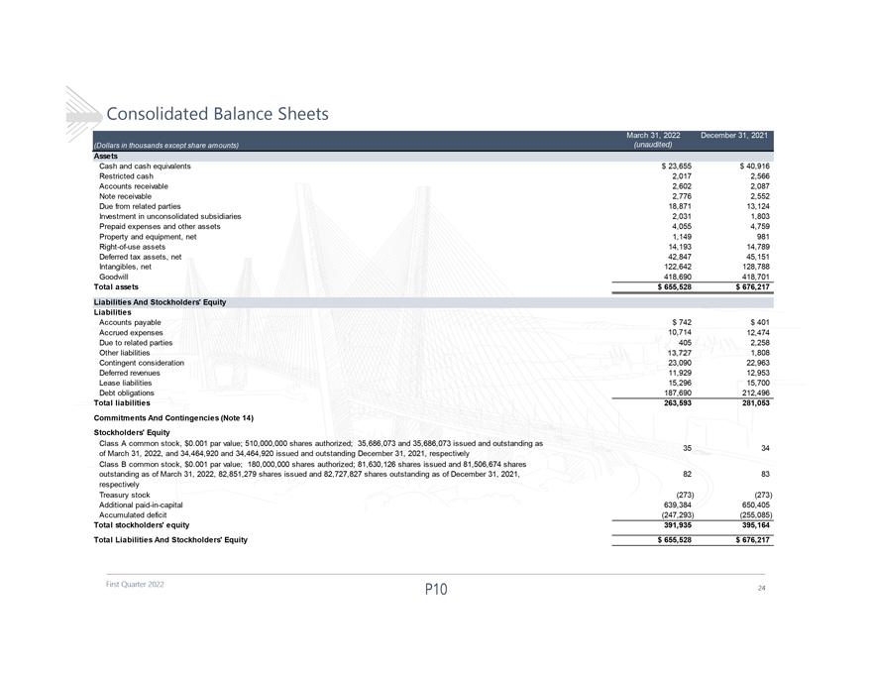
Consolidated Balance Sheets Assets Cash and cash equivalents $ 23,655 $ 40,916 Restricted cash 2,017 2,566 Accounts receivable 2,602 2,087 Note receivable 2,776 2,552 Due from related parties 18,871 13,124 Investment in unconsolidated subsidiaries 2,031 1,803 Prepaid expenses and other assets 4,055 4,759 Property and equipment, net 1,149 981 Right-of-use assets 14,193 14,789 Deferred tax assets, net 42,847 45,151 Intangibles, net 122,642 128,788 Goodwill 418,690 418,701 Total assets $ 655,528 $ 676,217 Liabilities And Stockholders Equity Liabilities Accounts payable $ 742 $ 401 Accrued expenses 10,714 12,474 Due to related parties 405 2,258 Other liabilities 13,727 1,808 Contingent consideration 23,090 22,963 Deferred revenues 11,929 12,953 Lease liabilities 15,296 15,700 Debt obligations 187,690 212,496 Total liabilities 263,593 281,053 Commitments And Contingencies (Note 14) Stockholders Equity Class A common stock, $0.001 par value; 510,000,000 shares authorized; 35,686,073 and 35,686,073 issued and outstanding as 35 34 of March 31, 2022, and 34,464,920 and 34,464,920 issued and outstanding December 31, 2021, respectively Class B common stock, $0.001 par value; 180,000,000 shares authorized; 81,630,126 shares issued and 81,506,674 shares outstanding as of March 31, 2022, 82,851,279 shares issued and 82,727,827 shares outstanding as of December 31, 2021, 82 83 respectively Treasury stock (273) (273) Additional paid-in-capital 639,384 650,405 Accumulated deficit (247,293) (255,085) Total stockholders equity 391,935 395,164 Total Liabilities And Stockholders Equity $ 655,528 $ 676,217 First Quarter 2022 24

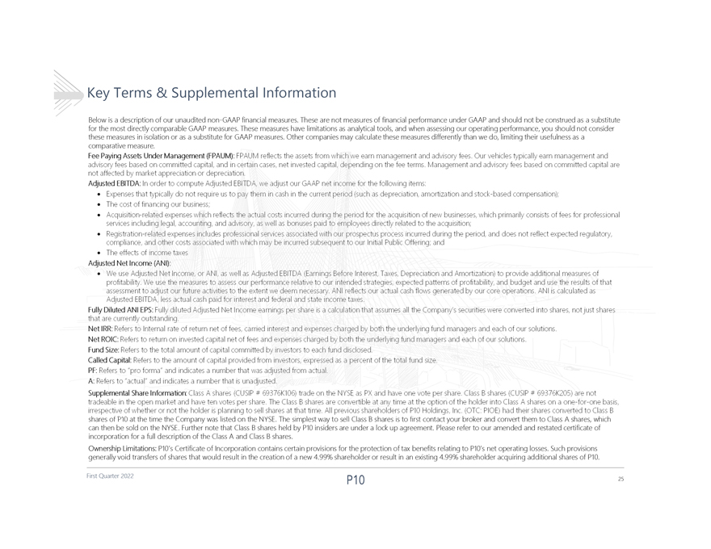
Key Terms & Supplemental Information Below is a description of our unaudited non-GAAP financial measures. These are not measures of financial performance under GAAP and should not be construed as a substitute for the most directly comparable GAAP measures. These measures have limitations as analytical tools, and when assessing our operating performance, you should not consider these measures in isolation or as a substitute for GAAP measures. Other companies may calculate these measures differently than we do, limiting their usefulness as a comparative measure. shares of P10 at the time the Company was listed on the NYSE. The simplest way to sell Class B shares is to first contact your broker and convert them to Class A shares, which can then be sold on the NYSE. Further note that Class B shares held by P10 insiders are under a lock up agreement. Please refer to our amended and restated certificate of incorporation for a full description of the Class A and Class B shares. Ownership Limitations: P10s Certificate of Incorporation contains certain provisions for the protection of tax benefits relating to P10s net operating losses. Such provisions generally void transfers of shares that would result in the creation of a new 4.99% shareholder or result in an existing 4.99% shareholder acquiring additional shares of P10. First Quarter 2022 25

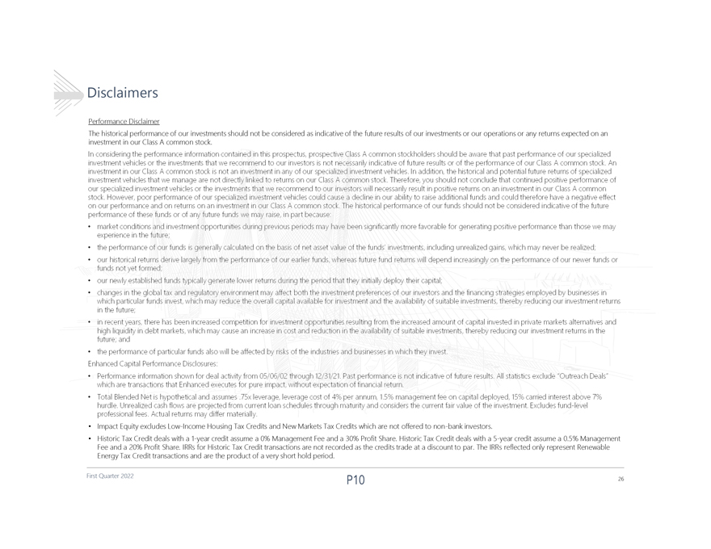
Disclaimers Performance Disclaimer The historical performance of our investments should not be considered as indicative of the future results of our investmentsorour operations or any returns expected on an investment in our Class A common stock.  Impact Equity excludes Low-Income Housing Tax Credits and New Markets Tax Credits which are not offered to non-bank investors.  Historic Tax Credit deals with a 1-year credit assume a 0% Management Fee and a 30% Profit Share. Historic Tax Credit deals witha 5-year credit assume a 0.5% Management Fee and a 20% Profit Share. IRRs for Historic Tax Credit transactions are not recorded as the credits trade at a discount to par. The IRRs reflected only represent Renewable Energy Tax Credit transactions and are the product of a very short hold period. First Quarter 2022 26

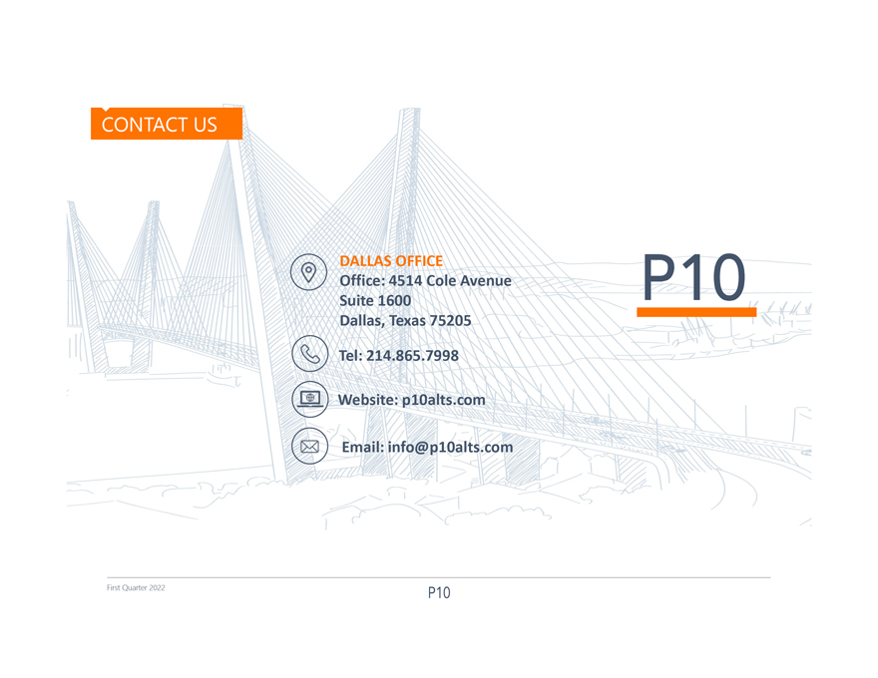
DALLAS OFFICE Office: 4514 Cole Avenue Suite 1600 Dallas, Texas 75205 Tel: 214.865.7998 Website: p10alts.com Email:info@p10alts.com First Quarter 2022

