UNITED STATES

SECURITIES AND EXCHANGE COMMISSION
WASHINGTON, D.C. 20549

FORM 8-K

CURRENT REPORT

Pursuant to Section 13 or 15(d) of

The Securities Exchange Act of 1934

Date of Report (Date of earliest event reported): August 13, 2007

ACTIVE POWER, INC.

(Exact Name of Registrant as Specified in Charter)

Delaware

000-30939

74-2961657

(State of Other Jurisdiction

of Incorporation)

(Commission File Number)

(IRS Employer
Identification No.)

2128 W. Braker Lane, BK12, Austin, Texas

78758

(Address of Principal Executive Offices)

(Zip Code)

(Registrant’s Telephone Number, Including Area Code) (512) 836-6464

Not Applicable

(Former Name or Former Address, if Changed Since Last Report)

Check the appropriate box below if the Form 8-K filing is intended to simultaneously satisfy the filing obligation of the registrant under any of the following provisions (see General Instruction A.2. below):

- Written communications pursuant to Rule 425 under the Securities Act (17 CFR 230.425)

- Soliciting material pursuant to Rule 14a-12 under the Exchange Act (17 CFR 240.14a-12)

- Pre-commencement communications pursuant to Rule 14d-2(b) under the Exchange Act (17 CFR 240.14d-2(b))

- Pre-commencement communications pursuant to Rule 13e-4(c) under the Exchange Act (17 CFR 240.13e-4(c))

Item 1.01. Entry into a Material Definitive Agreement.

On August 13, 2007, Active Power, Inc. (“Active Power”) entered into a Securities Purchase Agreement (the “Purchase Agreement”) with certain institutional investors (the

“Purchasers”) under which Active Power sold 10,000,000 shares (the “Shares”) of its common stock, par value $0.001 per share (the “Common Stock”), for $1.40 per share in a private placement (the “Placement”) exempt from the registration requirements of the Securities Act of 1933, as amended. Active Power received cash proceeds in the Placement of approximately $13.16 million, net of approximately $840,000 in commissions paid to Active Power’s exclusive placement agent, RBC Capital Markets. Active Power intends to use the proceeds of the Placement to grow its business in new markets and for working capital purposes. The Purchase Agreement is filed as Exhibit 10.1 to this Current Report on Form 8-K (the “Report”), and the terms of which are incorporated into this Item 1.01 by this reference.

In connection with the execution of the Purchase Agreement, Active Power also entered into a Registration Rights Agreement (the “Registration Rights Agreement”) dated August 14, 2007 with the Purchasers. Under the Registration Rights Agreement, Active Power is obligated to cause a registration statement on Form S-1 (the “Registration Statement”) relating to the resale by the Purchasers of the Shares to be filed with the Securities and Exchange Commission (the “SEC”) on or prior to the 30th calendar day following August 14, 2007, and will use its best efforts to cause the Registration Statement to become effective as soon as possible, but in no event later than (i) the 75th calendar day following August 14, 2007 if the Registration Statement is not reviewed by the SEC or (ii) the 120th calendar day following August 14, 2007, if the Registration Statement is reviewed by the SEC. The Registration Rights Agreement is filed as Exhibit 10.2 to this Report and the terms of which are incorporated into this Item 1.01 by this reference.

Item 3.02. Unregistered Sales of Equity Securities.

On August 14, 2007, Active Power completed the private placement of 10,000,000 shares of Common Stock at a price of $1.40 per share, for aggregate proceeds, after the payment of commissions of $840,000 to its placement agent, RBC Capital Markets, of $13,160,000.

The transaction was exempt from registration pursuant to Section 4(2) of the Securities Act of 1933, as amended (the “Securities Act”), and Regulation D promulgated thereunder, as a transaction not involving a public offering, and in reliance on similar exemptions under applicable state laws. Active Power believes that each of the Purchasers qualifies as an “accredited investor” (as defined by Rule 501(a) under the Securities Act).

Item 7.01 Regulation FD Disclosure.

On August 14, 2007, the Company issued a press release announcing the completion of the Placement, a copy of which is attached hereto as Exhibit 99.1.

From August 2, 2007 to August 9, 2007, the management of Active Power presented an overview of its business to certain potential investors in connection with the Placement. Each of

2

these investors agreed orally or in writing to maintain the confidentiality of this information. Attached as Exhibit 99.2 to this Report is a copy of the slide presentation used by Active Power in these meetings.

This information is being furnished pursuant to Item 7.01 of this Report and the exhibits being furnished as Exhibits 99.1 and 99.2 hereto shall not be deemed to be “filed” for the purposes of Section 18 of the Securities Exchange Act of 1934, as amended, or otherwise subject to the liabilities of that section and will not be incorporated by reference into any registration statement filed by the Company under the Securities Act of 1933, as amended, unless specifically identified as being incorporated therein by reference and regardless of any general incorporation language in such filing. This inclusion of such information in this Report will not be deemed an admission as to the materiality of any information in this Report that is being disclosed pursuant to Regulation FD.

Please refer to page 2 of Exhibit 99.2 for a discussion of certain forward-looking statements included therein and the risks and uncertainties related thereto. Active Power undertakes no duty to update the information contained in such presentation.

Item 9.01. Exhibits and Financial Statements.

- Exhibits

Exhibit |  | Description
Exhibit 10.1 |  | Securities Purchase Agreement dated August 13, 2007 by and among Active Power, Inc. and the Purchasers named therein.
Exhibit 10.2 |  | Registration Rights Agreement dated August 14, 2007 by and among Active Power, Inc. and the Shareholders named therein.
Exhibit 99.1 |  | Press Release dated August 14, 2007
Exhibit 99.2 |  | Presentation to Investors

In accordance with General Instruction B.2 of Form 8-K, the information contained in Item 7.01 of this Current Report, including the exhibits attached as Exhibit 99.1 and 99.2 hereto, shall not be deemed “filed” for purposes of Section 18 of the Securities Exchange Act of 1934, as amended, or otherwise subject to the liabilities of that section, nor shall such information be deemed incorporated by reference into any filing under the Securities Exchange Act of 1934, as amended, or the Securities Act of 1933, as amended, unless specifically identified as being incorporated therein by reference and regardless of any general incorporation language in such filing.

3

SIGNATURE

Pursuant to the requirements of the Securities Exchange Act of 1934, the Registrant has duly caused this report to be signed on its behalf by the undersigned hereunto duly authorized.

ACTIVE POWER, INC.

Dated: August 14, 2007 By: /s/ James A. Clishem

James A. Clishem

President and Chief Executive Officer

 |  | EXHIBIT INDEX
Exhibit No. |  | Description
Exhibit 10.1 |  | Securities Purchase Agreement dated August 13, 2007 by and among Active Power, Inc. and the Purchasers named therein.
Exhibit 10.2 |  | Registration Rights Agreement dated August 14, 2007 by and among Active Power, Inc. and the Shareholders named therein.
Exhibit 99.1 |  | Press Release dated August 14, 2007
Exhibit 99.2 |  | Presentation to Investors
Exhibit 10.1

SECURITIES PURCHASE AGREEMENT

This Securities Purchase Agreement (this “Agreement”) is dated as of August 13, 2007, between Active Power, Inc., a Delaware corporation (the “Company”), and each purchaser identified on the signature pages hereto (each, including its successors and assigns, a “Purchaser” and collectively the “Purchasers”).

WHEREAS, subject to the terms and conditions set forth in this Agreement and pursuant to Section 4(2) of the Securities Act (as defined below) and Rule 506 promulgated thereunder, the Company desires to issue and sell to each Purchaser, and each Purchaser, severally and not jointly, desires to purchase from the Company, securities of the Company as more fully described in this Agreement.

NOW, THEREFORE, IN CONSIDERATION of the mutual covenants contained in this Agreement, and for other good and valuable consideration the receipt and adequacy of which are hereby acknowledged, the Company and each Purchaser agree as follows:

ARTICLE I.

DEFINITIONS

1.1 Definitions. In addition to the terms defined elsewhere in this Agreement, for all purposes of this Agreement, the following terms have the meanings set forth in this

Section 1.1:

“Action” shall have the meaning ascribed to such term in Section 3.1(j).

“Affiliate” means any Person that, directly or indirectly through one or more intermediaries, controls or is controlled by or is under common control with a Person as such terms are used in and construed under Rule 405 under the Securities Act. With respect to a Purchaser, any investment fund or managed account that is managed on a discretionary basis by the same investment manager as such Purchaser will be deemed to be an Affiliate of such Purchaser.

“Board of Directors” means the board of directors of the Company.

“Business Day” means any day except any Saturday, any Sunday, any day which is a federal legal holiday in the United States or any day on which banking institutions in the State of New York are authorized or required by law or other governmental action to close.

“Closing” means the closing of the purchase and sale of the Shares pursuant to Section 2.1.

“Closing Date” means the Trading Day when all of the Transaction Documents have been executed and delivered by the applicable parties thereto, and all conditions precedent to (i) the Purchasers’ obligations to pay the Subscription Amount and (ii) the Company’s obligations to deliver the Shares have been satisfied or waived.

“Commission” means the Securities and Exchange Commission.

1

“Common Stock” means the common stock of the Company, par value $0.001 per share, together with the associated Rights, and any other class of securities into which such securities may hereafter be reclassified or changed into.

“Common Stock Equivalents” means any securities of the Company or the Subsidiaries which would entitle the holder thereof to acquire at any time Common Stock, including, without limitation, any debt, preferred stock, rights, options, warrants or other instrument that is at any time convertible into or exercisable or exchangeable for, or otherwise entitles the holder thereof to receive, Common Stock.

“Company Counsel” means Andrews Kurth LLP, with offices located at 111 Congress Avenue, Suite 1700, Austin, TX 78701.

“Disclosure Schedules” means the Disclosure Schedules of the Company delivered concurrently herewith.

“Effective Date” means the date that the initial Registration Statement filed by the Company pursuant to the Registration Rights Agreement is first declared effective by the Commission.

“Evaluation Date” shall have the meaning ascribed to such term in Section 3.1(r).

“Exchange Act” means the Securities Exchange Act of 1934, as amended, and the rules and regulations promulgated thereunder.

“Exempt Issuance” means the issuance of (a) shares of Common Stock or options to employees, officers, directors of the Company or others providing services to the Company pursuant to the Company’s 2000 Stock Incentive Plan, as amended (the “Stock Incentive Plan”), or pursuant to any stock or option plan or agreement duly adopted for such purpose, by a majority of the non-employee members of the Board of Directors or a majority of the members of a committee of non-employee directors established for such purpose, (b) securities upon the exercise or exchange of or conversion of any securities exercisable or exchangeable for or convertible into shares of Common Stock issued and outstanding on the date of this Agreement, provided that such securities have not been amended since the date of this Agreement to increase the number of such securities or to decrease the exercise, exchange or conversion price of such securities, and (c) securities issued pursuant to acquisitions or strategic transactions approved by a majority of the disinterested directors of the Company, provided that any such issuance shall only be to a Person which is, itself or through its subsidiaries, and in good faith judgment of the Board of Directors, an operating company in a business synergistic with the business of the Company and in which the Company receives benefits in addition to the investment of funds, but shall not include a transaction in which the Company is issuing securities primarily for the purpose of raising capital or to an entity whose primary business is investing in securities.

“FWS” means Feldman Weinstein & Smith LLP with offices located at 420 Lexington Avenue, Suite 2620, New York, New York 10170-0002.

2

“GAAP” shall have the meaning ascribed to such term in Section 3.1(h).

“Indebtedness” shall have the meaning ascribed to such term in Section 3.1(aa).

“Intellectual Property Rights” shall have the meaning ascribed to such term in Section 3.1(o).

“Legend Removal Date” shall have the meaning ascribed to such term in Section 4.1(c).

“Liens” means a lien, charge, security interest, encumbrance, right of first refusal, preemptive right or other restriction.

“Material Adverse Effect” shall have the meaning assigned to such term in Section 3.1(b).

“Material Permits” shall have the meaning ascribed to such term in Section 3.1(m).

“Per Share Purchase Price” equals $1.40, subject to adjustment for reverse and forward stock splits, stock dividends, stock combinations and other similar transactions of the Common Stock that occur after the date of this Agreement.

“Permitted Lien” means (i) any Lien for taxes not yet due or delinquent or being contested in good faith by appropriate proceedings for which adequate reserves have been established in accordance with GAAP; (ii) any statutory Lien arising in the ordinary course of business by operation of law with respect to a liability that is not yet due or delinquent; (iii) any minor imperfection of title or similar Lien which individually or in the aggregate with other such Liens does not materially impair the value of the property subject to such Lien or the use of such property in the conduct of the Company’s business; and (iv) a security interest in all the Company’s properties’ assets given in favor of Silicon Valley Bank.

“Person” means an individual or corporation, partnership, trust, incorporated or unincorporated association, joint venture, limited liability company, joint stock company, government (or an agency or subdivision thereof) or other entity of any kind.

“Proceeding” means an action, claim, suit, investigation or proceeding (including, without limitation, an informal investigation or partial proceeding, such as a deposition), whether commenced or threatened.

“Purchaser Party” shall have the meaning ascribed to such term in Section 4.8.

“Registration Rights Agreement” means the Registration Rights Agreement, dated the date hereof, among the Company and the Purchasers, in the form of Exhibit A attached hereto.

3

“Registration Statement” means a registration statement meeting the requirements set forth in the Registration Rights Agreement and covering the resale by the Purchasers of the Shares.

“Required Approvals” shall have the meaning ascribed to such term in Section 3.1(e).

“Rights” shall mean the Company’s preferred share purchase rights pursuant to that certain Rights Agreement dated December 13, 2001, as amended or restated from time to time.

“Rule 144” means Rule 144 promulgated by the Commission pursuant to the Securities Act, as such Rule may be amended from time to time, or any similar rule or regulation hereafter adopted by the Commission having substantially the same effect as such Rule.

“SEC Reports” shall have the meaning ascribed to such term in Section 3.1(h).

“Securities Act” means the Securities Act of 1933, as amended, and the rules and regulations promulgated thereunder.

“Shares” means the shares of Common Stock issued or issuable to each Purchaser pursuant to this Agreement.

“Short Sales” means all “short sales” as defined in Rule 200 of Regulation SHO under the Exchange Act (but shall not be deemed to include the location and/or reservation of borrowable shares of Common Stock).

“Subscription Amount” means, as to each Purchaser, the aggregate amount to be paid for Shares purchased hereunder as specified below such Purchaser’s name on the signature page of this Agreement and next to the heading “Subscription Amount,” in United States dollars and in immediately available funds.

“Subsidiary” means any subsidiary of the Company as set forth on Schedule 3.1(a), and shall, where applicable, include any subsidiary of the Company formed or acquired after the date hereof.

“Trading Day” means a day on which the New York Stock Exchange is open for trading.

“Trading Market” means the following markets or exchanges on which the Common Stock is listed or quoted for trading on the date in question: the American Stock Exchange, the Nasdaq Capital Market, the Nasdaq Global Market, the Nasdaq Global Select Market, or the New York Stock Exchange.

“Transaction Documents” means this Agreement, the Registration Rights Agreement and any other documents or agreements executed in connection with the transactions contemplated hereunder.

4

“Transfer Agent” means American Stock Transfer & Trust Company, the current transfer agent of the Company, with a mailing address of 6201 15th Avenue, 3rd Floor, Brooklyn, NY 11219 and a facsimile number of 718-921-8327, and any successor transfer agent of the Company.

ARTICLE II.

PURCHASE AND SALE

2.1 Closing. On the Closing Date, upon the terms and subject to the conditions set forth herein, substantially concurrent with the execution and delivery of this Agreement by the parties hereto, the Company agrees to sell, and the Purchasers, severally and not jointly, agree to purchase, up to an aggregate number of 10,000,000 of Shares (equal to $14,000,000.00 divided by the Per Share Purchase Price), in the individual amounts specified on each Purchaser’s signature page. Each Purchaser shall deliver to the Company, via wire transfer or a certified check, immediately available funds equal to its Subscription Amount and the Company shall deliver to each Purchaser its respective Shares, and the Company and each Purchaser shall deliver the other items set forth in Section 2.2 deliverable at the Closing. Upon satisfaction of the covenants and conditions set forth in Sections 2.2 and 2.3, the Closing shall occur at the offices of FWS or such other location as the parties shall mutually agree.

2.2 Deliveries.

- On or prior to the Closing Date, the Company shall deliver or cause to be delivered to each Purchaser the following:

  - this Agreement duly executed by the Company;

  - a legal opinion of Company Counsel, substantially in the form of Exhibit B attached hereto;

  - a copy of the irrevocable instructions to the Transfer Agent instructing the Transfer Agent to deliver, on an expedited basis, a certificate evidencing a number of Shares equal to such Purchaser’s Subscription Amount divided by the Per Share Purchase Price, registered in the name of such Purchaser;

  - the Registration Rights Agreement duly executed by the Company;

  - copies of good standing certificates for the Company and each Subsidiary as of a recent date and certificates of qualification as a foreign corporation for the Company and each Subsidiary as of a recent date; and

  - a certificate from the Company’s transfer agent as of a recent date certifying the number of shares of Common Stock outstanding.

- On or prior to the Closing Date, each Purchaser shall deliver or cause to be delivered to the Company the following:

  - this Agreement duly executed by such Purchaser;

5

- such Purchaser’s Subscription Amount by wire transfer to the account as specified in writing by the Company; and

- the Registration Rights Agreement duly executed by such Purchaser.

2.3 Closing Conditions.

- The obligations of the Company hereunder in connection with the Closing are subject to the following conditions being met:

  - the accuracy when made and on the Closing Date of the representations and warranties of the Purchasers contained herein;

  - all obligations, covenants and agreements of each Purchaser required to be performed at or prior to the Closing Date shall have been performed; and

  - the delivery by each Purchaser of the items set forth in Section 2.2(b) of this Agreement.

- The respective obligations of the Purchasers hereunder in connection with the Closing are subject to the following conditions being met:

  - the accuracy when made and on the Closing Date of the representations and warranties of the Company contained herein;

  - all obligations, covenants and agreements of the Company required to be performed at or prior to the Closing Date shall have been performed;

  - the delivery by the Company of the items set forth in Section 2.2(a) of this Agreement;

  - there shall have been no Material Adverse Effect with respect to the Company since the date hereof; and

  - from the date hereof to the Closing Date, trading in the Common Stock shall not have been suspended by the Commission or the Company’s principal Trading Market (except for any suspension of trading of limited duration agreed to by the Company, which suspension shall be terminated prior to the Closing), and, at any time prior to the Closing Date, trading in securities generally as reported by Bloomberg L.P. shall not have been suspended or limited, or minimum prices shall not have been established on securities whose trades are reported by such service, or on any Trading Market, nor shall a banking moratorium have been declared either by the United States or New York State authorities nor shall there have occurred any material outbreak or escalation of hostilities or other national or international calamity of such magnitude in its effect on, or any material adverse change in, any financial market which, in each case, in the reasonable judgment of each Purchaser, makes it impracticable or inadvisable to purchase the Shares at the Closing.

6

ARTICLE III.

REPRESENTATIONS AND WARRANTIES

3.1 Representations and Warranties of the Company. Except as set forth in the Disclosure Schedules, which Disclosure Schedules shall be deemed a part hereof and shall qualify any representation or otherwise made herein to the extent of the disclosure contained in the corresponding section of the Disclosure Schedules, the Company hereby makes the following representations and warranties to each Purchaser:

- Subsidiaries. All of the direct and indirect subsidiaries of the Company are set forth on Schedule 3.1(a) of the Disclosure Schedules. The Company owns, directly or indirectly, all of the capital stock or other equity interests of each Subsidiary free and clear of any Liens other than Permitted Liens, and all of the issued and outstanding shares of capital stock of each Subsidiary are validly issued and are fully paid, non-assessable and free of preemptive and similar rights to subscribe for or purchase securities. If the Company has no subsidiaries, then all other references to the Subsidiaries or any of them in the Transaction Documents shall be disregarded.

- Organization and Qualification. The Company and each of the Subsidiaries is an entity duly incorporated or otherwise organized, validly existing and in good standing under the laws of the jurisdiction of its incorporation or organization (as applicable), with the requisite power and authority to own and use its properties and assets and to carry on its business as currently conducted. Neither the Company nor any Subsidiary is in violation or default of any of the provisions of its respective certificate or articles of incorporation, bylaws or other organizational or charter documents. Each of the Company and the Subsidiaries is duly qualified to conduct business and is in good standing as a foreign corporation or other entity in each jurisdiction in which the nature of the business conducted or property owned by it makes such qualification necessary, except where the failure to be so qualified or in good standing, as the case may be, could not have or reasonably be expected to result in (i) a material adverse effect on the legality, validity or enforceability of any Transaction Document, (ii) a material adverse effect on the results of operations, assets, business, or condition (financial or otherwise) of the Company and the Subsidiaries, taken as a whole, or (iii) a material adverse effect on the Company’s ability to perform in any material respect on a timely basis its obligations under any Transaction Document (any of (i), (ii) or (iii), a “Material Adverse Effect”) and no Proceeding has been instituted in any such jurisdiction revoking, limiting or curtailing or seeking to revoke, limit or curtail such power and authority or qualification.

- Authorization; Enforcement. The Company has the requisite corporate power and authority to enter into and to consummate the transactions contemplated by each of the Transaction Documents and otherwise to carry out its obligations hereunder and thereunder. The execution and delivery of each of the Transaction Documents by the Company and the consummation by it of the transactions contemplated hereby and

7

thereby have been duly authorized by all necessary action on the part of the Company and no further action is required by the Company, the Board of Directors or the Company’s stockholders in connection therewith other than in connection with the Required Approvals. Each Transaction Document has been (or upon delivery will have been) duly executed by the Company and, when delivered in accordance with the terms hereof and thereof, will constitute the valid and binding obligation of the Company enforceable against the Company in accordance with its terms, except (i) as limited by general equitable principles and applicable bankruptcy, insolvency, reorganization, moratorium and other laws of general application affecting enforcement of creditors’ rights generally, (ii) as limited by laws relating to the availability of specific performance, injunctive relief or other equitable remedies and (iii) insofar as indemnification and contribution provisions may be limited by applicable law.

  - No Conflicts. The execution, delivery and performance of the Transaction Documents by the Company, the issuance and sale of the Shares and the consummation by the Company of the other transactions contemplated hereby and thereby do not and will not (i) conflict with or violate any provision of the Company’s or any Subsidiary’s certificate or articles of incorporation, bylaws or other organizational or charter documents, or (ii) conflict with, or constitute a default (or an event that with notice or lapse of time or both would become a default) under, result in the creation of any Lien upon any of the properties or assets of the Company or any Subsidiary, or give to others any rights of termination, amendment, acceleration or cancellation (with or without notice, lapse of time or both) of, any agreement, credit facility, debt or other instrument (evidencing a Company or Subsidiary debt or otherwise) or other understanding to which the Company or any Subsidiary is a party or by which any property or asset of the Company or any Subsidiary is bound or affected, or (iii) subject to the Required Approvals, conflict with or result in a violation of any law, rule, regulation, order, judgment, injunction, decree or other restriction of any court or governmental authority to which the Company or a Subsidiary is subject (including federal and state securities laws and regulations), or by which any property or asset of the Company or a Subsidiary is bound or affected; except in the case of each of clauses (ii) and (iii), such as could not have or reasonably be expected to result in a Material Adverse Effect.

  - Filings, Consents and Approvals. The Company is not required to obtain any consent, waiver, authorization or order of, give any notice to, or make any filing or registration with, any court or other federal, state, local or other governmental authority or other Person in connection with the execution, delivery and performance by the Company of the Transaction Documents, other than (i) filings required pursuant to Section 4.4 of this Agreement, (ii) the filing with the Commission of the Registration Statement,
- application(s) to each applicable Trading Market for the listing of the Shares for trading thereon in the time and manner required thereby, and (iv) the filing of Form D with the Commission and such filings as are required to be made under applicable state securities laws (collectively, the “Required Approvals”).

  - Issuance of the Shares. The Shares are duly authorized and, when issued and paid for in accordance with the applicable Transaction Documents, will be duly and validly issued, fully paid and nonassessable, free and clear of all Liens imposed by the Company other than restrictions on transfer provided for in the Transaction Documents.

8

- Capitalization. The capitalization of the Company is as set forth on Schedule 3.1(g) of the Disclosure Schedules, which Schedule 3.1(g) shall also include the number of shares of Common Stock owned beneficially, and of record, by Affiliates of the Company as of the date hereof. The Company has not issued any capital stock since its most recently filed periodic report under the Exchange Act, other than pursuant to the exercise of employee stock options or issuance of restricted stock under the Company’s Stock Incentive Plan and pursuant to the conversion or exercise of Common Stock Equivalents outstanding as of the date of the most recently filed periodic report under the Exchange Act. No Person has any right of first refusal, preemptive right, right of participation, or any similar right to participate in the transactions contemplated by the Transaction Documents. Except as a result of the purchase and sale of the Shares, there are no outstanding options, warrants, scrip rights to subscribe to, calls or commitments of any character whatsoever relating to, or securities, rights or obligations convertible into or exercisable or exchangeable for, or giving any Person any right to subscribe for or acquire, any shares of Common Stock, or contracts, commitments, understandings or arrangements by which the Company or any Subsidiary is or may become bound to issue additional shares of Common Stock or Common Stock Equivalents. The issuance and sale of the Shares will not obligate the Company to issue shares of Common Stock or other securities to any Person (other than the Purchasers) and will not result in a right of any holder of Company securities to adjust the exercise, conversion, exchange or reset price under any of such securities. All of the outstanding shares of capital stock of the Company are validly issued, fully paid and nonassessable, have been issued in compliance with all federal and state securities laws, and none of such outstanding shares was issued in violation of any preemptive rights or similar rights to subscribe for or purchase securities. No further approval or authorization of any stockholder, the Board of Directors or others is required for the issuance and sale of the Shares. Other than that certain Second Amended and Restated Investors’ Right dated November 23, 1999 (filed as Exhibit 10.4 to the Company’s Registration Statement on Form S-1 with respect to its initial public offering), there are no stockholders agreements, voting agreements or other similar agreements with respect to the Company’s capital stock to which the Company is a party or, to the knowledge of the Company, between or among any of the Company’s stockholders.

- SEC Reports; Financial Statements. Other than the Company’s Annual Report on Form 10-K for the fiscal year ended December 31, 2006 (the “2006 10-K”), which was not timely filed, the Company has filed all reports, schedules, forms, statements and other documents required to be filed by the Company under the Securities Act and the Exchange Act, including pursuant to Section 13(a) or 15(d) thereof, for the two years preceding the date hereof (or such shorter period as the Company was required by law or regulation to file such material) (the foregoing materials, including the exhibits thereto and documents incorporated by reference therein, being collectively referred to herein as the “SEC Reports”) on a timely basis or has received a valid extension of such time of filing and has filed any such SEC Reports prior to the expiration of any such extension. Except to the extent corrected by subsequent SEC Reports or amendments to

9

a prior SEC Report, including the restatement of certain prior year financial information as set forth in the 2006 10-K, as of their respective dates, the SEC Reports complied in all material respects with the requirements of the Securities Act and the Exchange Act, as applicable, and none of the SEC Reports, when filed, contained any untrue statement of a material fact or omitted to state a material fact required to be stated therein or necessary in order to make the statements therein, in the light of the circumstances under which they were made, not misleading. As corrected and restated in the 2006 10-K, the financial statements of the Company included in the SEC Reports comply in all material respects with applicable accounting requirements and the rules and regulations of the Commission with respect thereto as in effect at the time of filing. As corrected and restated by the 2006 10-K, such financial statements have been prepared in accordance with United States generally accepted accounting principles applied on a consistent basis during the periods involved (“GAAP”), except as may be otherwise specified in such financial statements or the notes thereto and except that unaudited financial statements may not contain all footnotes required by GAAP, and fairly present in all material respects the financial position of the Company and its consolidated subsidiaries as of and for the dates thereof and the results of operations and cash flows for the periods then ended, subject, in the case of unaudited statements, to normal, immaterial, year-end audit adjustments.

- Material Changes; Undisclosed Events, Liabilities or Developments. Since the date of the latest audited financial statements included within the SEC Reports, except as specifically disclosed except as disclosed on Schedule 3.1(i) hereto, (i) there has been no event, occurrence or development that has had or that could reasonably be expected to result in a Material Adverse Effect, (ii) the Company has not incurred any liabilities (contingent or otherwise) other than (A) trade payables and accrued expenses incurred in the ordinary course of business consistent with past practice and (B) liabilities not required to be reflected in the Company’s financial statements pursuant to GAAP or disclosed in filings made with the Commission, (iii) the Company has not altered its method of accounting, (iv) the Company has not declared or made any dividend or distribution of cash or other property to its stockholders or purchased, redeemed or made any agreements to purchase or redeem any shares of its capital stock and (v) the Company has not issued any equity securities to any officer, director or Affiliate, except pursuant to existing Company stock option plans. The Company does not have pending before the Commission any request for confidential treatment of information. Except for the issuance of the Shares contemplated by this Agreement or as set forth on Schedule 3.1(i), no event, liability or development has occurred or exists with respect to the Company or its Subsidiaries or their respective business, properties, operations or financial condition, that would be required to be disclosed by the Company under applicable securities laws at the time this representation is made or deemed made that has not been publicly disclosed at least 1 Trading Day prior to the date that this representation is made.

- Litigation. There is no action, suit, inquiry, notice of violation, proceeding or investigation pending or, to the knowledge of the Company, threatened against or affecting the Company, any Subsidiary or any of their respective properties before or by any court, arbitrator, governmental or administrative agency or regulatory authority

10

(federal, state, county, local or foreign) (collectively, an “Action”) not already disclosed in the SEC Reports which (i) adversely affects or challenges the legality, validity or enforceability of any of the Transaction Documents or the Shares or (ii) could, if there were an unfavorable decision, have or reasonably be expected to result in a Material Adverse Effect. Neither the Company nor any Subsidiary, nor any director or officer thereof, is or has been the subject of any Action involving a claim of violation of or liability under federal or state securities laws or a claim of breach of fiduciary duty. Except as disclosed in the SEC Reports, there has not been, and to the knowledge of the Company, there is not pending or contemplated, any investigation by the Commission involving the Company or any current or former director or officer of the Company. The Commission has not issued any stop order or other order suspending the effectiveness of any registration statement filed by the Company or any Subsidiary under the Exchange Act or the Securities Act.

- Labor Relations. No material labor dispute exists or, to the knowledge of the Company, is imminent with respect to any of the employees of the Company which could reasonably be expected to result in a Material Adverse Effect. No executive officer, to the knowledge of the Company, is, or is now expected to be, in violation of any material term of any employment contract, confidentiality, disclosure or proprietary information agreement or non-competition agreement, or any other contract or agreement or any restrictive covenant in favor of any third party, and the continued employment of each such executive officer does not subject the Company or any of its Subsidiaries to any liability with respect to any of the foregoing matters. The Company and its Subsidiaries are in compliance with all U.S. federal, state, local and foreign laws and regulations relating to employment and employment practices, terms and conditions of employment and wages and hours, except where the failure to be in compliance could not, individually or in the aggregate, reasonably be expected to have a Material Adverse Effect.

- Compliance. Neither the Company nor any Subsidiary (i) is in default under or in violation of (and no event has occurred that has not been waived that, with notice or lapse of time or both, would result in a default by the Company or any Subsidiary under), nor has the Company or any Subsidiary received notice of a claim that it is in default under or that it is in violation of, any indenture, loan or credit agreement or any other agreement or instrument to which it is a party or by which it or any of its properties is bound (whether or not such default or violation has been waived), (ii) is in violation of any order of any court, arbitrator or governmental body, or (iii) is or has been in violation of any statute, rule or regulation of any governmental authority, including without limitation all foreign, federal, state and local laws applicable to its business and all such laws that affect the environment, except in each case as could not have or reasonably be expected to result in a Material Adverse Effect.

- Regulatory Permits. The Company and the Subsidiaries possess all certificates, authorizations and permits issued by the appropriate federal, state, local or foreign regulatory authorities necessary to conduct their respective businesses as described in the SEC Reports, except where the failure to possess such permits could not reasonably be expected to result in a Material Adverse Effect (“Material Permits”), and neither the Company nor any Subsidiary has received any notice of proceedings relating to the revocation or modification of any Material Permit.

11

- Title to Assets. The Company and the Subsidiaries have good and marketable title in fee simple to all real property owned by them and good and marketable title in all personal property owned by them that is material to the business of the Company and the Subsidiaries, in each case free and clear of all Liens, except for Permitted Liens. Any real property and facilities held under lease by the Company and the Subsidiaries are held by them under valid, subsisting and enforceable leases with which the Company and the Subsidiaries are in compliance.

- Patents and Trademarks. The Company and the Subsidiaries have, or have rights to use, all patents, patent applications, trademarks, trademark applications, service marks, trade names, trade secrets, inventions, copyrights, licenses and other intellectual property rights and similar rights necessary or material for use in connection with their respective businesses as described in the SEC Reports and which the failure to so have could have a Material Adverse Effect (collectively, the “Intellectual Property Rights”).
Neither the Company nor any Subsidiary has received a notice (written or otherwise) that any of the Intellectual Property Rights used by the Company or any Subsidiary violates or infringes upon the rights of any Person. To the knowledge of the Company, all such Intellectual Property Rights are enforceable and there is no existing infringement by another Person of any of the Intellectual Property Rights. The Company and its Subsidiaries have taken reasonable security measures to protect the secrecy, confidentiality and value of all of their intellectual properties, except where failure to do so could not, individually or in the aggregate, reasonably be expected to have a Material Adverse Effect.

- Insurance. The Company and the Subsidiaries are insured by insurers of recognized financial responsibility against such losses and risks and in such amounts as are prudent and customary in the businesses in which the Company and the Subsidiaries are engaged, including, but not limited to, directors and officers insurance coverage. Neither the Company nor any Subsidiary has any reason to believe that it will not be able to renew its existing insurance coverage as and when such coverage expires or to obtain similar coverage from similar insurers as may be necessary to continue its business without a significant increase in cost.

- Transactions With Affiliates and Employees. Except as set forth in the SEC Reports, none of the officers or directors of the Company and, to the knowledge of the Company, none of the employees of the Company is presently a party to any transaction with the Company or any Subsidiary (other than for services as employees, officers and directors), including any contract, agreement or other arrangement providing for the furnishing of services to or by, providing for rental of real or personal property to or from, or otherwise requiring payments to or from any officer, director or such employee or, to the knowledge of the Company, any entity in which any officer, director, or any such employee has a substantial interest or is an officer, director, trustee or partner, in each case in excess of $120,000 other than for (i) payment of salary or consulting fees for services rendered, (ii) reimbursement for expenses incurred on behalf

12

of the Company and (iii) other employee benefits, including stock option agreements under any stock option plan of the Company or the issuance of Common Stock under the Company’s employee stock purchase plan.

- Sarbanes-Oxley; Internal Accounting Controls. The Company is in material compliance with all provisions of the Sarbanes-Oxley Act of 2002 which are applicable to it as of the Closing Date. The Company and the Subsidiaries maintain a system of internal accounting controls sufficient to provide reasonable assurance that (i) transactions are executed in accordance with management’s general or specific authorizations, (ii) transactions are recorded as necessary to permit preparation of financial statements in conformity with GAAP and to maintain asset accountability, (iii) access to assets is permitted only in accordance with management’s general or specific authorization, and (iv) the recorded accountability for assets is compared with the existing assets at reasonable intervals and appropriate action is taken with respect to any differences. The Company has established disclosure controls and procedures (as defined in Exchange Act Rules 13a-15(e) and 15d-15(e)) for the Company and designed such disclosure controls and procedures to ensure that information required to be disclosed by the Company in the reports it files or submits under the Exchange Act is recorded, processed, summarized and reported, within the time periods specified in the Commission’s rules and forms. The Company’s certifying officers have evaluated the effectiveness of the Company’s disclosure controls and procedures as of the end of the period covered by the Company’s most recently filed periodic report under the Exchange Act (such date, the “Evaluation Date”). The Company presented in its most recently filed periodic report under the Exchange Act the conclusions of the certifying officers about the effectiveness of the disclosure controls and procedures based on their evaluations as of the Evaluation Date. Since the Evaluation Date, there have been no changes in the Company’s internal control over financial reporting (as such term is defined in the Exchange Act) that has materially affected, or is reasonably likely to materially affect, the Company’s internal control over financial reporting.

- Certain Fees. Except for fees payable to RBC Capital Markets, no brokerage or finder’s fees or commissions are or will be payable by the Company to any broker, financial advisor or consultant, finder, placement agent, investment banker, bank or other Person with respect to the transactions contemplated by the Transaction Documents. The Purchasers shall have no obligation with respect to any fees or with respect to any claims made by or on behalf of other Persons for fees of a type contemplated in this Section that may be due in connection with the transactions contemplated by the Transaction Documents.

- Private Placement. Assuming the accuracy of the Purchasers representations and warranties set forth in Section 3.2, no registration under the Securities Act is required for the offer and sale of the Shares by the Company to the Purchasers as contemplated hereby. The issuance and sale of the Shares hereunder does not contravene the rules and regulations of the Trading Market.

- Investment Company. The Company is not, and is not an Affiliate of, and immediately after receipt of payment for the Shares, will not be or be an Affiliate of, an

13

“investment company” within the meaning of the Investment Company Act of 1940, as amended. The Company shall conduct its business in a manner so that it will not become subject to the Investment Company Act of 1940, as amended.

- Registration Rights. Other than each of the Purchasers, no Person has any right to cause the Company to effect the registration under the Securities Act of any securities of the Company.

- Listing and Maintenance Requirements. The Common Stock is registered pursuant to Section 12(b) or 12(g) of the Exchange Act, and the Company has taken no action designed to, or which to its knowledge is likely to have the effect of, terminating the registration of the Common Stock under the Exchange Act nor has the Company received any notification that the Commission is contemplating terminating such registration. The Company has not, in the 12 months preceding the date hereof, received notice from any Trading Market on which the Common Stock is or has been listed or quoted to the effect that the Company is not in compliance with the listing or maintenance requirements of such Trading Market. The Company is, and has no reason to believe that it will not in the foreseeable future continue to be, in compliance with all such listing and maintenance requirements.

- Application of Takeover Protections. The Company and the Board of Directors have taken all necessary action, if any, in order to render inapplicable any control share acquisition, business combination, poison pill (including any distribution under a rights agreement) or other similar anti-takeover provision under the Company’s certificate of incorporation (or similar charter documents) or the laws of its state of incorporation that is or could become applicable to the Purchasers as a result of the Purchasers and the Company fulfilling their obligations or exercising their rights under the Transaction Documents, including without limitation as a result of the Company’s issuance of the Shares and the Purchasers’ ownership of the Shares.

- Disclosure. Except with respect to the material terms and conditions of the transactions contemplated by the Transaction Documents, the Company confirms that neither it nor any other Person acting on its behalf has provided any of the Purchasers or their agents or counsel with any information that it believes constitutes or might constitute material, non-public information. The Company understands and confirms that the Purchasers will rely on the foregoing representation in effecting transactions in securities of the Company. All disclosure furnished by or on behalf of the Company to the Purchasers regarding the Company, its business and the transactions contemplated hereby, including the Disclosure Schedules to this Agreement, is true and correct in all material respects and does not contain any untrue statement of a material fact or omit to state any material fact necessary in order to make the statements made therein, in light of the circumstances under which they were made, not misleading. The press releases disseminated by the Company during the twelve months preceding the date of this Agreement taken as a whole do not contain any untrue statement of a material fact or omit to state a material fact required to be stated therein or necessary in order to make the statements therein, in light of the circumstances under which they were made and when made, not misleading. The Company acknowledges and agrees that no Purchaser makes or has made any representations or warranties with respect to the transactions contemplated hereby other than those specifically set forth in Section 3.2 hereof.

14

- No Integrated Offering. Assuming the accuracy of the Purchasers’ representations and warranties set forth in Section 3.2, neither the Company, nor any of its Affiliates, nor any Person acting on its or their behalf has, directly or indirectly, made any offers or sales of any security or solicited any offers to buy any security, under circumstances that would cause this offering of the Shares to be integrated with prior offerings by the Company for purposes of (i) the Securities Act which would require the registration of any such securities under the Securities Act, or (ii) any applicable shareholder approval provisions of any Trading Market on which any of the securities of the Company are listed or designated.

- Solvency. Based on the consolidated financial condition of the Company as of the Closing Date, after giving effect to the receipt by the Company of the proceeds from the sale of the Shares hereunder, (i) the fair saleable value of the Company’s assets exceeds the amount that will be required to be paid on or in respect of the Company’s existing debts and other liabilities (including known contingent liabilities) as they mature, (ii) the Company’s assets do not constitute unreasonably small capital to carry on its business for at least the next 12 months, as now conducted and as proposed to be conducted, including its capital needs taking into account the particular capital requirements of the business conducted by the Company, and projected capital requirements and capital availability thereof, and (iii) the current cash flow of the Company, together with the proceeds the Company would receive, were it to liquidate all of its assets, after taking into account all anticipated uses of the cash, would be sufficient to pay all amounts on or in respect of its liabilities when such amounts are required to be paid. The Company does not intend to incur debts beyond its ability to pay such debts as they mature (taking into account the timing and amounts of cash to be payable on or in respect of its debt). The Company has no knowledge of any facts or circumstances which lead it to believe that it will file for reorganization or liquidation under the bankruptcy or reorganization laws of any jurisdiction within one year from the Closing Date. Schedule 3.1(aa) of the Disclosure Schedules sets forth as of the date thereof all outstanding secured and unsecured Indebtedness of the Company or any Subsidiary, or for which the Company or any Subsidiary has commitments. For the purposes of this Agreement, “Indebtedness” means (a) any liabilities for borrowed money or amounts owed in excess of $50,000 (other than trade accounts payable incurred in the ordinary course of business), (b) all guaranties, endorsements and other contingent obligations in respect of indebtedness of others, whether or not the same are or should be reflected in the Company’s balance sheet (or the notes thereto), except guaranties by endorsement of negotiable instruments for deposit or collection or similar transactions in the ordinary course of business; and (c) the present value of any lease payments in excess of $50,000 due under leases required to be capitalized in accordance with GAAP. Neither the Company nor any Subsidiary is in default with respect to any Indebtedness.

- Tax Status. Except for matters that would not, individually or in the aggregate, have or reasonably be expected to result in a Material Adverse Effect, the Company and each Subsidiary has filed all necessary federal, state and foreign income

15

and franchise tax returns and has paid or accrued all taxes shown as due thereon, and the Company has no knowledge of a tax deficiency which has been asserted or threatened against the Company or any Subsidiary.

- No General Solicitation. Neither the Company nor any person acting on behalf of the Company has offered or sold any of the Shares by any form of general solicitation or general advertising. The Company has offered the Shares for sale only to the Purchasers and certain other “accredited investors” within the meaning of Rule 501 under the Securities Act.

- Foreign Corrupt Practices. Neither the Company, nor to the knowledge of the Company, any agent or other person acting on behalf of the Company, has (i) directly or indirectly, used any funds for unlawful contributions, gifts, entertainment or other unlawful expenses related to foreign or domestic political activity, (ii) made any unlawful payment to foreign or domestic government officials or employees or to any foreign or domestic political parties or campaigns from corporate funds, (iii) failed to disclose fully any contribution made by the Company (or made by any person acting on its behalf of which the Company is aware) which is in violation of law, or (iv) violated in any material respect any provision of the Foreign Corrupt Practices Act of 1977, as amended.

- Accountants. The Company’s accounting firm is set forth on Schedule 3.1(ee) of the Disclosure Schedule. To the knowledge and belief of the Company, such accounting firm (i) is a registered public accounting firm as required by the Exchange Act and (ii) shall express its opinion with respect to the financial statements to be included in the Company’s Annual Report on Form 10-K for the year ending December 31, 2007.

- No Disagreements with Accountants and Lawyers. There are no disagreements of any kind presently existing, or reasonably anticipated by the Company to arise, between the Company and the independent auditing firms and outside counsel formerly or presently employed by the Company which could affect the Company’s ability to perform any of its obligations under any of the Transaction Documents, and the Company is current with respect to any fees owed to its independent auditing firm and outside counsel.

- Acknowledgment Regarding Purchasers’ Purchase of Shares. The Company acknowledges and agrees that each of the Purchasers is acting solely in the capacity of an arm’s length purchaser with respect to the Transaction Documents and the transactions contemplated thereby. The Company further acknowledges that no Purchaser is acting as a financial advisor or fiduciary of the Company (or in any similar capacity) with respect to the Transaction Documents and the transactions contemplated thereby and any advice given by any Purchaser or any of their respective representatives or agents in connection with the Transaction Documents and the transactions contemplated thereby is merely incidental to the Purchasers’ purchase of the Shares. The Company further represents to each Purchaser that the Company’s decision to enter into this Agreement and the other Transaction Documents has been based solely on the independent evaluation of the transactions contemplated hereby by the Company and its representatives.

16

  - Acknowledgement Regarding Purchaser’s Trading Activity. Anything in this Agreement or elsewhere herein to the contrary notwithstanding (except for Sections 3.2(f) and 4.12 hereof), it is understood and acknowledged by the Company (i) that none of the Purchasers have been asked by the Company to agree, nor has any Purchaser agreed, to desist from purchasing or selling, long and/or short, securities of the Company, or “derivative” securities based on securities issued by the Company or to hold the Shares for any specified term; (ii) that past or future open market or other transactions by any Purchaser, specifically including, without limitation, Short Sales or “derivative” transactions, before or after the closing of this or future private placement transactions, may negatively impact the market price of the Company’s publicly-traded securities; (iii) that any Purchaser, and counter-parties in “derivative” transactions to which any such Purchaser is a party, directly or indirectly, presently may have a “short” position in the Common Stock; and

- that each Purchaser shall not be deemed to have any affiliation with or control over any arm’s length counter-party in any “derivative” transaction. The Company further understands and acknowledges that (a) one or more Purchasers may engage in hedging activities at various times during the period that the Shares are outstanding, and (b) such hedging activities (if any) could reduce the value of the existing stockholders’ equity interests in the Company at and after the time that the hedging activities are being conducted. The Company acknowledges that such aforementioned hedging activities do not constitute a breach of any of the Transaction Documents.

  - Regulation M Compliance. The Company has not, and to its knowledge no one acting on its behalf has, (i) taken, directly or indirectly, any action designed to cause or to result in the stabilization or manipulation of the price of any security of the Company to facilitate the sale or resale of any of the Shares, (ii) sold, bid for, purchased, or, paid any compensation for soliciting purchases of, any of the Shares, or (iii) paid or agreed to pay to any Person any compensation for soliciting another to purchase any other securities of the Company, other than, in the case of clauses (ii) and (iii), compensation paid to the Company’s placement agent in connection with the placement of the Shares.

  - U.S. Real Property Holding Corporation. The Company is not, nor has ever been, a U.S. real property holding corporation within the meaning of Section 897 of the Internal Revenue Code of 1986, as amended, and the Company shall so certify upon Purchaser’s request.

  - Off Balance Sheet Arrangements. There is no transaction, arrangement, or other relationship between the Company and an unconsolidated or other off balance sheet entity that is required to be disclosed by the Company in its Exchange Act filings and is not so disclosed or that otherwise would be reasonably likely to have a Material Adverse Effect.

  - Investment Company Status. The Company is not, and upon consummation of the sale of the Securities will not be, an “investment company,” a company controlled by an “investment company” or an “affiliated person” of, or “promoter” or “principal underwriter” for, an “investment company” as such terms are defined in the Investment Company Act of 1940, as amended.

17

3.2 Representations and Warranties of the Purchasers. Each Purchaser, for itself and for no other Purchaser, hereby represents and warrants as of the date hereof and as of the

Closing Date to the Company as follows:

- Organization; Authority. Such Purchaser is an entity duly organized, validly existing and in good standing under the laws of the jurisdiction of its organization with full right, corporate or partnership power and authority to enter into and to consummate the transactions contemplated by the Transaction Documents and otherwise to carry out its obligations hereunder and thereunder. The execution and delivery of the Transaction Documents and performance by such Purchaser of the transactions contemplated by the Transaction Documents have been duly authorized by all necessary corporate or similar action on the part of such Purchaser. Each Transaction Document to which it is a party has been duly executed by such Purchaser, and when delivered by such Purchaser in accordance with the terms hereof, will constitute the valid and legally binding obligation of such Purchaser, enforceable against it in accordance with its terms, except (i) as limited by general equitable principles and applicable bankruptcy, insolvency, reorganization, moratorium and other laws of general application affecting enforcement of creditors’ rights generally, (ii) as limited by laws relating to the availability of specific performance, injunctive relief or other equitable remedies and (iii) insofar as indemnification and contribution provisions may be limited by applicable law.

- Own Account. Such Purchaser understands that the Shares are “restricted securities” and have not been registered under the Securities Act or any applicable state securities law and is acquiring the Shares as principal for its own account and not with a view to or for distributing or reselling such Shares or any part thereof in violation of the Securities Act or any applicable state securities law, has no present intention of distributing any of such Shares in violation of the Securities Act or any applicable state securities law and has no direct or indirect arrangement or understandings with any other persons to distribute or regarding the distribution of such Shares (this representation and warranty not limiting such Purchaser’s right to sell the Shares pursuant to the Registration Statement or otherwise in compliance with applicable federal and state securities laws) in violation of the Securities Act or any applicable state securities law. Such Purchaser is acquiring the Shares hereunder in the ordinary course of its business.

- Purchaser Status. At the time such Purchaser was offered the Shares, it was, and at the date hereof it is either: (i) an “accredited investor” as defined in Rule 501(a)(1), (a)(2), (a)(3), (a)(7) or (a)(8) under the Securities Act or (ii) a “qualified institutional buyer” as defined in Rule 144A(a) under the Securities Act. Such Purchaser is not required to be registered as a broker-dealer under Section 15 of the Exchange Act.

- Experience of Such Purchaser. Such Purchaser, either alone or together with its representatives, has such knowledge, sophistication and experience in business and financial matters so as to be capable of evaluating the merits and risks of the prospective investment in the Shares, and has so evaluated the merits and risks of such investment. Such Purchaser is able to bear the economic risk of an investment in the Shares and, at the present time, is able to afford a complete loss of such investment.

18

- General Solicitation. Such Purchaser is not purchasing the Shares as a result of any advertisement, article, notice or other communication regarding the Shares published in any newspaper, magazine or similar media or broadcast over television or radio or presented at any seminar or any other general solicitation or general advertisement.

- Short Sales and Confidentiality Prior To The Date Hereof. Other than consummating the transactions contemplated hereunder, such Purchaser has not, nor has any Person acting on behalf of or pursuant to any understanding with such Purchaser, directly or indirectly executed any purchases or sales, including Short Sales, of the securities of the Company during the period commencing from the time that such Purchaser was first contacted by the Company or any other Person representing the Company concerning the terms of the transactions contemplated hereunder until the date hereof (“Discussion Time”). Notwithstanding the foregoing, in the case of a Purchaser that is a multi-managed investment vehicle whereby separate portfolio managers manage separate portions of such Purchaser’s assets and the portfolio managers have no direct knowledge of the investment decisions made by the portfolio managers managing other portions of such Purchaser’s assets, the representation set forth above shall only apply with respect to the portion of assets managed by the portfolio manager that made the investment decision to purchase the Shares covered by this Agreement. Other than to other Persons party to this Agreement, such Purchaser has maintained the confidentiality of all disclosures made to it in connection with this transaction (including the existence and terms of this transaction).

ARTICLE IV.

OTHER AGREEMENTS OF THE PARTIES

4.1 Transfer Restrictions. The Shares may only be disposed of in compliance with state and federal securities laws. In connection with any transfer of Shares other than pursuant to an effective registration statement or Rule 144, to the Company or to an Affiliate of a Purchaser or in connection with a pledge as contemplated in Section 4.1(b), the Company may require the transferor thereof to provide to the Company an opinion of counsel selected by the transferor and reasonably acceptable to the Company, the form and substance of which opinion shall be reasonably satisfactory to the Company, to the effect that such transfer does not require registration of such transferred Shares under the Securities Act. As a condition of transfer, any such transferee shall agree in writing to be bound by the terms of this Agreement and shall have the rights of a Purchaser under this Agreement and the Registration Rights Agreement.

(a) The Purchasers agree to the imprinting, so long as is required by this Section 4.1, of a legend on any of the Shares in the following form:

THIS SECURITY HAS NOT BEEN REGISTERED WITH THE SECURITIES AND EXCHANGE COMMISSION OR THE SECURITIES COMMISSION OF ANY STATE IN RELIANCE UPON AN EXEMPTION FROM REGISTRATION UNDER THE SECURITIES ACT OF 1933, AS AMENDED (THE “SECURITIES ACT”), AND, ACCORDINGLY, MAY NOT BE OFFERED OR SOLD EXCEPT PURSUANT TO AN EFFECTIVE

19

REGISTRATION STATEMENT UNDER THE SECURITIES ACT OR PURSUANT TO AN AVAILABLE EXEMPTION FROM, OR IN A TRANSACTION NOT SUBJECT TO, THE REGISTRATION REQUIREMENTS OF THE SECURITIES ACT AND IN ACCORDANCE WITH APPLICABLE STATE SECURITIES LAWS AS EVIDENCED BY A LEGAL OPINION OF COUNSEL TO THE TRANSFEROR TO SUCH EFFECT, THE SUBSTANCE OF WHICH SHALL BE REASONABLY ACCEPTABLE TO THE COMPANY. THIS SECURITY MAY BE PLEDGED IN CONNECTION WITH A BONA FIDE MARGIN ACCOUNT WITH A REGISTERED BROKER-DEALER OR OTHER LOAN WITH A FINANCIAL INSTITUTION THAT IS AN “ACCREDITED INVESTOR” AS DEFINED IN RULE 501(a) UNDER THE SECURITIES ACT OR OTHER LOAN SECURED BY SUCH SECURITIES.

The Company acknowledges and agrees that a Purchaser may from time to time pledge pursuant to a bona fide margin agreement with a registered broker-dealer or grant a security interest in some or all of the Shares to a financial institution that is an “accredited investor” as defined in Rule 501(a) under the Securities Act and who agrees to be bound by the provisions of this Agreement and the Registration Rights Agreement and, if required under the terms of such arrangement, such Purchaser may transfer pledged or secured Shares to the pledgees or secured parties. Such a pledge or transfer would not be subject to approval of the Company and no legal opinion of legal counsel of the pledgee, secured party or pledgor shall be required in connection therewith. Further, no notice shall be required of such pledge. At the appropriate Purchaser’s expense, the Company will execute and deliver such reasonable documentation as a pledgee or secured party of Shares may reasonably request in connection with a pledge or transfer of the Shares, including, if the Shares are subject to registration pursuant to the Registration Rights Agreement, the preparation and filing of any required prospectus supplement under Rule 424(b)(3) under the Securities Act or other applicable provision of the Securities Act to appropriately amend the list of Selling Stockholders thereunder.

- Certificates evidencing the Shares shall not contain any legend (including the legend set forth in Section 4.1(b)), (i) while a registration statement (including the Registration Statement) covering the resale of such security is effective under the Securities Act, or (ii) following any sale of such Shares pursuant to Rule 144, or (iii) if such Shares are eligible for sale under Rule 144(k), or (iv) if such legend is not required under applicable requirements of the Securities Act (including judicial interpretations and pronouncements issued by the staff of the Commission). The Company shall cause its counsel to issue a legal opinion to the Transfer Agent promptly after the Effective Date if required by the Transfer Agent to effect the removal of the legend hereunder. The Company agrees that following the Effective Date or at such time as such legend is no longer required under this Section 4.1(c), it will, no later than three Trading Days following the delivery by a Purchaser to the Company or the Transfer Agent of a certificate representing Shares, issued with a restrictive legend (such third Trading Day, the “Legend Removal Date”), deliver or cause to be delivered to such Purchaser a certificate representing such Shares that is free from all restrictive and other legends. The Company may not make any notation on its records or give instructions to the Transfer

20

Agent that enlarge the restrictions on transfer set forth in this Section. Certificates for Shares subject to legend removal hereunder shall be transmitted by the Transfer Agent to the Purchaser by crediting the account of the Purchaser’s prime broker with the Depository Trust Company System as directed by such Purchaser.

- In addition to such Purchaser’s other available remedies, the Company shall pay to a Purchaser, in cash, as partial liquidated damages and not as a penalty, for each $1,000 of Shares (based on the volume weighted average price of the Common Stock on the date such Shares are submitted to the Transfer Agent) delivered for removal of the restrictive legend and subject to Section 4.1(c), $10 per Trading Day (increasing to $20 per Trading Day five (5) Trading Days after such damages have begun to accrue) for each Trading Day after the Legend Removal Date until such certificate is delivered without a legend. Nothing herein shall limit such Purchaser’s right to pursue actual damages for the Company’s failure to deliver certificates representing any Shares as required by the Transaction Documents, and such Purchaser shall have the right to pursue all remedies available to it at law or in equity including, without limitation, a decree of specific performance and/or injunctive relief.

- Each Purchaser, severally and not jointly with the other Purchasers, agrees that such Purchaser will sell any Shares pursuant to either the registration requirements of the Securities Act, including any applicable prospectus delivery requirements, or an exemption therefrom, and that if Shares are sold pursuant to a Registration Statement, they will be sold in compliance with the plan of distribution set forth therein, and acknowledges that the removal of the restrictive legend from certificates representing Shares as set forth in this Section 4.1 is predicated upon the Company’s reliance upon this understanding.

4.2 Furnishing of Information. Until the earliest of the time that no Purchaser owns Shares, the Company covenants to timely file (or obtain extensions in respect thereof and file within the applicable grace period) all reports required to be filed by the Company after the date hereof pursuant to the Exchange Act even if the Company is not then subject to the reporting requirements of the Exchange Act. As long as any Purchaser owns Shares, if the Company is not required to file reports pursuant to the Exchange Act, it will prepare and furnish to the Purchasers and make publicly available in accordance with Rule 144(c) such information as is required for the Purchasers to sell the Shares under Rule 144. The Company further covenants that it will take such further action as any holder of Shares may reasonably request, to the extent required from time to time to enable such Person to sell such Shares without registration under the Securities Act within the requirements of the exemption provided by Rule 144.

4.3 Integration. The Company shall not sell, offer for sale or solicit offers to buy or otherwise negotiate in respect of any security (as defined in Section 2 of the Securities Act) that would be integrated with the offer or sale of the Shares in a manner that would require the registration under the Securities Act of the sale of the Shares to the Purchasers or that would be integrated with the offer or sale of the Shares to the Purchasers for purposes of the rules and regulations of any Trading Market such that it would require shareholder approval prior to the closing of such other transaction unless shareholder approval is obtained before the closing of such subsequent transaction.

21

4.4 Securities Laws Disclosure; Publicity. The Company shall, by 8:30 a.m. (New York City time) on the Trading Day immediately following the date hereof, issue a press release disclosing the material terms of the transactions contemplated hereby, and by the fourth Trading Day following the date hereof, file a Current Report on Form 8-K, filing the Transaction Documents as exhibits thereto. The Company and each Purchaser shall consult with each other in issuing any other press releases with respect to the transactions contemplated hereby, and neither the Company nor any Purchaser shall issue any such press release or otherwise make any such public statement without the prior consent of the Company, with respect to any press release of any Purchaser, or without the prior consent of each Purchaser, with respect to any press release of the Company, which consent shall not unreasonably be withheld or delayed, except if such disclosure is required by law, in which case the disclosing party shall promptly provide the other party with prior notice of such public statement or communication. Notwithstanding the foregoing, the Company shall not publicly disclose the name of any Purchaser, or include the name of any Purchaser in any filing with the Commission or any regulatory agency or Trading Market, without the prior written consent of such Purchaser, except (i) as required by federal securities law in connection with (A) any registration statement contemplated by the Registration Rights Agreement and (B) the filing of final Transaction Documents (including signature pages thereto) with the Commission and (ii) to the extent such disclosure is required by law or Trading Market regulations, in which case the Company shall provide the Purchasers with prior notice of such disclosure permitted under this clause (ii).

4.5 Shareholder Rights Plan. No claim will be made or enforced by the Company or, with the consent of the Company, any other Person, that any Purchaser is an “Acquiring Person” under the Rights or any other control share acquisition, business combination, poison pill (including any distribution under a rights agreement) or similar anti-takeover plan or arrangement in effect or hereafter adopted by the Company, or that any Purchaser could be deemed to trigger the provisions of any such plan or arrangement, by virtue of receiving Shares under the Transaction Documents or under any other agreement between the Company and the Purchasers.

4.6 Non-Public Information. Except with respect to the material terms and conditions of the transactions contemplated by the Transaction Documents, the Company covenants and agrees that neither it nor any other Person acting on its behalf will provide any Purchaser or its agents or counsel with any information that the Company believes constitutes material non-public information, unless prior thereto such Purchaser shall have executed a written agreement regarding the confidentiality and use of such information. The Company understands and confirms that each Purchaser shall be relying on the foregoing covenant in effecting transactions in securities of the Company.

4.7 Use of Proceeds. Except as set forth on Schedule 4.7 of the Disclosure Schedules, the Company shall use the net proceeds from the sale of the Shares hereunder for working capital purposes and shall not use such proceeds for (a) the satisfaction of any portion of the Company’s debt (other than payment of trade payables in the ordinary course of the Company’s business and prior practices), (b) the redemption of any Common Stock or Common Stock Equivalents or (c) the settlement of any outstanding litigation.

22

4.8 Indemnification of Purchasers. Subject to the provisions of this Section 4.8, the Company will indemnify and hold each Purchaser and its directors, officers, shareholders, members, partners, employees and agents (and any other Persons with a functionally equivalent role of a Person holding such titles notwithstanding a lack of such title or any other title), each Person who controls such Purchaser (within the meaning of Section 15 of the Securities Act and Section 20 of the Exchange Act), and the directors, officers, shareholders, agents, members, partners or employees (and any other Persons with a functionally equivalent role of a Person holding such titles notwithstanding a lack of such title or any other title) of such controlling persons (each, a “Purchaser Party”) harmless from any and all losses, liabilities, obligations, claims, contingencies, damages, costs and expenses, including all judgments, amounts paid in settlements, court costs and reasonable attorneys’ fees and costs of reasonable investigation that any such Purchaser Party may suffer or incur as a result of or relating to

- any breach of any of the representations, warranties, covenants or agreements made by the Company in this Agreement or in the other Transaction Documents or (b) any action instituted against a Purchaser in any capacity, or any of them or their respective Affiliates, by any stockholder of the Company who is not an Affiliate of such Purchaser, with respect to any of the transactions contemplated by the Transaction Documents (unless such action is based upon a breach of such Purchaser’s representations, warranties or covenants under the Transaction Documents or any agreements or understandings such Purchaser may have with any such stockholder or any violations by the Purchaser of state or federal securities laws or any conduct by such Purchaser which constitutes fraud, gross negligence, willful misconduct or malfeasance). If any action shall be brought against any Purchaser Party in respect of which indemnity may be sought pursuant to this Agreement, such Purchaser Party shall promptly notify the Company in writing, and the Company shall have the right to assume the defense thereof with counsel of its own choosing reasonably acceptable to the Purchaser Party. Any Purchaser Party shall have the right to employ separate counsel in any such action and participate in the defense thereof, but the fees and expenses of such counsel shall be at the expense of such Purchaser Party except to the extent that (i) the employment thereof has been specifically authorized by the Company in writing, (ii) the Company has failed after a reasonable period of time to assume such defense and to employ counsel or (iii) in such action there is, in the reasonable opinion of such separate counsel, a material conflict on any material issue between the position of the Company and the position of such Purchaser Party, in which case the Company shall be responsible for the reasonable fees and expenses of no more than one such separate counsel. The Company will not be liable to any Purchaser Party under this Agreement (i) for any settlement by a Purchaser Party effected without the Company’s prior written consent, which shall not be unreasonably withheld or delayed; or (ii) to the extent, but only to the extent that a loss, claim, damage or liability is attributable to any Purchaser Party’s breach of any of the representations, warranties, covenants or agreements made by such Purchaser Party in this Agreement or in the other Transaction Documents.

4.9 Listing of Common Stock. The Company hereby agrees to use best efforts to maintain the listing of the Common Stock on a Trading Market, and as soon as reasonably practicable following the Closing (but not later than the earlier of the Effective Date and the first anniversary of the Closing Date) to list all of the Shares on such Trading Market. The Company further agrees, if the Company applies to have the Common Stock traded on any other Trading Market, it will include in such application all of the Shares, and will take such other action as is necessary to cause all of the Shares to be listed on such other Trading Market as promptly as

23

possible. The Company will take all action reasonably necessary to continue the listing and trading of its Common Stock on a Trading Market and will comply in all respects with the Company’s reporting, filing and other obligations under the bylaws or rules of the Trading Market.

4.10 Equal Treatment of Purchasers. No consideration shall be offered or paid to any Person to amend or consent to a waiver or modification of any provision of any of the Transaction Documents unless the same consideration is also offered to all of the parties to the Transaction Documents. For clarification purposes, this provision constitutes a separate right granted to each Purchaser by the Company and negotiated separately by each Purchaser, and is intended for the Company to treat the Purchasers as a class and shall not in any way be construed as the Purchasers acting in concert or as a group with respect to the purchase, disposition or voting of Shares or otherwise.

4.11 Subsequent Equity Sales.

- From the date hereof until 90 days after the Effective Date, neither the Company nor any Subsidiary shall issue shares of Common Stock or Common Stock Equivalents; provided, however, the 90 day period set forth in this Section 4.11 shall be extended for the number of Trading Days during such period in which (i) trading in the Common Stock is suspended by any Trading Market, or (ii) following the Effective Date, the Registration Statement is not effective or the prospectus included in the Registration Statement may not be used by the Purchasers for the resale of the Shares.

- From the date hereof until the earlier of (i) two (2) years after the Effective Date or (ii) such time as the Purchaser’s collectively hold less than 10% of the Securities issued pursuant to this Agreement, the Company shall be prohibited from effecting or entering into an agreement to effect any Subsequent Financing involving a Variable Rate Transaction. “Variable Rate Transaction” means a transaction in which the Company issues or sells (i) any debt or equity securities that are convertible into, exchangeable or exercisable for, or include the right to receive additional shares of Common Stock either (A) at a conversion, exercise or exchange rate or other price that is based upon and/or varies with the trading prices of or quotations for the shares of Common Stock at any time after the initial issuance of such debt or equity securities, or (B) with a conversion, exercise or exchange price that is subject to being reset at some future date after the initial issuance of such debt or equity security or upon the occurrence of specified or contingent events directly or indirectly related to the business of the Company or the market for the Common Stock or (ii) enters into any agreement, including, but not limited to, an equity line of credit, whereby the Company may sell securities at a future determined price. Any Purchaser shall be entitled to obtain injunctive relief against the Company to preclude any such issuance, which remedy shall be in addition to any right to collect damages.

- Notwithstanding the foregoing, this Section 4.11 shall not apply in respect of an Exempt Issuance, except that no Variable Rate Transaction shall be an Exempt Issuance.

24

4.12 Short Sales and Confidentiality After The Date Hereof. Each Purchaser, severally and not jointly with the other Purchasers, covenants that neither it nor any Affiliate acting on its behalf or pursuant to any understanding with it have executed or will execute any Short Sales during the period commencing at the Discussion Time and ending at the time that the transactions contemplated by this Agreement are first publicly announced as described in Section 4.4. Each Purchaser, severally and not jointly with the other Purchasers, covenants that until such time as the transactions contemplated by this Agreement are publicly disclosed by the Company as described in Section 4.4, such Purchaser has maintained and will maintain the confidentiality of the existence and terms of this transaction and the information included in the Disclosure Schedules. Each Purchaser severally and not jointly with any other Purchaser, understands and acknowledges, and agrees, to act in a manner that will not violate the positions of the Commission as set forth in Item 65, Section A, of the Manual of Publicly Available Telephone Interpretations, dated July 1997, compiled by the Office of Chief Counsel, Division of Corporation Finance. Notwithstanding the foregoing, no Purchaser makes any representation, warranty or covenant hereby that it will not engage in Short Sales in the securities of the Company after the time that the transactions contemplated by this Agreement are first publicly announced as described in Section 4.4. Notwithstanding the foregoing, in the case of a Purchaser that is a multi-managed investment vehicle whereby separate portfolio managers manage separate portions of such Purchaser’s assets and the portfolio managers have no direct knowledge of the investment decisions made by the portfolio managers managing other portions of such Purchaser’s assets, the covenant set forth above shall only apply with respect to the portion of assets managed by the portfolio manager that made the investment decision to purchase the Shares covered by this Agreement.

4.13 Delivery of Shares After Closing. The Company shall deliver, or cause to be delivered, the respective Shares purchased by each Purchaser to such Purchaser within 3 Trading Days of the Closing Date.

4.14 Form D; Blue Sky Filings. The Company agrees to timely file a Form D with respect to the Shares as required under Regulation D and to provide a copy thereof, promptly upon request of any Purchaser. The Company shall take such action as the Company shall reasonably determine is necessary in order to obtain an exemption for, or to qualify the Shares for, sale to the Purchasers at the Closing under applicable securities or “Blue Sky” laws of the states of the United States, and shall provide evidence of such actions promptly upon request of any Purchaser.

4.15 Capital Changes. Until the one year anniversary of the Effective Date, the Company shall not undertake a reverse or forward stock split or reclassification of the Common Stock without the prior written consent of the Purchasers holding a majority in interest of the Shares.

4.16 Participation in Future Financing. From the date hereof until the date that is the 12 month anniversary of the Effective Date, upon any issuance by the Company or any of its Subsidiaries of Common Stock or Common Stock Equivalents for cash consideration (a “Subsequent Financing”), each Purchaser shall have the right to participate in the Subsequent Financing up to an amount equal to 30% of the Subsequent Financing (the “Participation Maximum”) on the same terms, conditions and price provided for in the Subsequent Financing.

25

- At least 5 Trading Days prior to the closing of the Subsequent Financing, the Company shall deliver to each Purchaser a written notice of its intention to effect a Subsequent Financing (“Pre-Notice”), which Pre-Notice shall ask such Purchaser if it wants to review the details of such financing (such additional notice, a “Subsequent Financing Notice”). Upon the request of a Purchaser, and only upon a request by such Purchaser, for a Subsequent Financing Notice, the Company shall promptly, but no later than 1 Trading Day after such request, deliver a Subsequent Financing Notice to such Purchaser. The Subsequent Financing Notice shall describe in reasonable detail the proposed terms of such Subsequent Financing, the amount of proceeds intended to be raised thereunder and the Person or Persons through or with whom such Subsequent Financing is proposed to be effected and shall include a term sheet or similar document relating thereto as an attachment.

- Any Purchaser desiring to participate in such Subsequent Financing must provide written notice to the Company by not later than 5:30 p.m. (New York City time) on the 5th Trading Day after all of the Purchasers have received the Pre-Notice that the Purchaser is willing to participate in the Subsequent Financing, the amount of the Purchaser’s participation, and that the Purchaser has such funds ready, willing, and available for investment on the terms set forth in the Subsequent Financing Notice. If the Company receives no notice from a Purchaser as of such 5th Trading Day, such Purchaser shall be deemed to have notified the Company that it does not elect to participate.

- If by 5:30 p.m. (New York City time) on the 5th Trading Day after all of the Purchasers have received the Pre-Notice, notifications by the Purchasers of their willingness to participate in the Subsequent Financing (or to cause their designees to participate) is, in the aggregate, less than the total amount of the Subsequent Financing, then the Company may effect the remaining portion of such Subsequent Financing on the terms and with the Persons set forth in the Subsequent Financing Notice.

- If by 5:30 p.m. (New York City time) on the 5th Trading Day after all of the Purchasers have received the Pre-Notice, the Company receives responses to a Subsequent Financing Notice from Purchasers seeking to purchase more than the aggregate amount of the Participation Maximum, each such Purchaser shall have the right to purchase its Pro Rata Portion (as defined below) of the Participation Maximum. “Pro Rata Portion” means the ratio of (x) the Subscription Amount of Securities purchased on the Closing Date by a Purchaser participating under this Section 4.12 and (y) the sum of the aggregate Subscription Amounts of Securities purchased on the Closing Date by all Purchasers participating under this Section 4.16.

- The Company must provide the Purchasers with a second Subsequent Financing Notice, and the Purchasers will again have the right of participation set forth above in this Section 4.16, if the Subsequent Financing subject to the initial Subsequent Financing Notice is not consummated for any reason on the terms set forth in such Subsequent Financing Notice within 60 Trading Days after the date of the initial Subsequent Financing Notice.

26

(f) Notwithstanding the foregoing, this Section 4.16 shall not apply in respect of (i) an Exempt Issuance or (ii) an underwritten public offering of Common Stock.

ARTICLE V.

MISCELLANEOUS

5.1 Termination. This Agreement may be terminated by any Purchaser, as to such Purchaser’s obligations hereunder only and without any effect whatsoever on the obligations between the Company and the other Purchasers, by written notice to the other parties, if the Closing has not been consummated on or before August 14, 2007; provided, however, that no such termination will affect the right of any party to sue for any breach by the other party (or parties).

5.2 Fees and Expenses. Except as expressly set forth in the Transaction Documents to the contrary, each party shall pay the fees and expenses of its advisers, counsel, accountants and other experts, if any, and all other expenses incurred by such party incident to the negotiation, preparation, execution, delivery and performance of this Agreement; provided, that the Company shall reimburse Steelhead Investments Ltd. (or its designee(s)) for up to $5,000 for its reasonable legal fees and disbursements incurred in connection with the transactions contemplated by this Agreement. The Company shall pay all Transfer Agent fees, stamp taxes and other taxes and duties levied in connection with the delivery of any Shares to the Purchasers.

5.3 Entire Agreement. The Transaction Documents, together with the exhibits and schedules thereto, contain the entire understanding of the parties with respect to the subject matter hereof and supersede all prior agreements and understandings, oral or written, with respect to such matters, which the parties acknowledge have been merged into such documents, exhibits and schedules.

5.4 Notices. Any and all notices or other communications or deliveries required or permitted to be provided hereunder shall be in writing and shall be deemed given and effective on the earliest of (a) the date of transmission, if such notice or communication is delivered via facsimile at the facsimile number set forth on the signature pages attached hereto prior to 5:30 p.m. (New York City time) on a Trading Day, (b) the next Trading Day after the date of transmission, if such notice or communication is delivered via facsimile at the facsimile
number set forth on the signature pages attached hereto on a day that is not a Trading Day or later than 5:30 p.m. (New York City time) on any Trading Day, (c) the 2nd Trading Day following the date of mailing, if sent by U.S. nationally recognized overnight courier service, or (d) upon actual receipt by the party to whom such notice is required to be given. The address for such notices and communications shall be as set forth on the signature pages attached hereto.

5.5 Amendments; Waivers. No provision of this Agreement may be waived or amended except in a written instrument signed, in the case of an amendment, by the Company and the Purchasers of at least 67% of the Shares still held by the Purchasers or, in the case of a waiver, by the party against whom enforcement of any such waived provision is sought. No waiver of any default with respect to any provision, condition or requirement of this Agreement

27

shall be deemed to be a continuing waiver in the future or a waiver of any subsequent default or a waiver of any other provision, condition or requirement hereof, nor shall any delay or omission of any party to exercise any right hereunder in any manner impair the exercise of any such right.

5.6 Headings. The headings herein are for convenience only, do not constitute a part of this Agreement and shall not be deemed to limit or affect any of the provisions hereof. The language used in this Agreement will be deemed to be the language chosen by the parties to express their mutual intent, and no rules of strict construction will be applied against any party.

5.7 Successors and Assigns. This Agreement shall be binding upon and inure to the benefit of the parties and their successors and permitted assigns. The Company may not assign this Agreement or any rights or obligations hereunder without the prior written consent of each Purchaser (other than by merger or otherwise by operation of law). Any Purchaser may assign any or all of its rights under this Agreement to any Person to whom such Purchaser assigns or transfers any Shares, provided such transferee agrees in writing to be bound, with respect to the transferred Shares, by the provisions of the Transaction Documents that apply to the “Purchasers.”

5.8 No Third-Party Beneficiaries. This Agreement is intended for the benefit of the parties hereto and their respective successors and permitted assigns and is not for the benefit of, nor may any provision hereof be enforced by, any other Person, except as otherwise set forth in Section 4.8.

5.9 Governing Law. All questions concerning the construction, validity, enforcement and interpretation of the Transaction Documents shall be governed by and construed and enforced in accordance with the internal laws of the State of New York, without regard to the principles of conflicts of law thereof. Each party agrees that all legal proceedings concerning the interpretations, enforcement and defense of the transactions contemplated by this Agreement and any other Transaction Documents (whether brought against a party hereto or its respective affiliates, directors, officers, shareholders, employees or agents) shall be commenced exclusively in the state and federal courts sitting in the City of New York. Each party hereby irrevocably submits to the exclusive jurisdiction of the state and federal courts sitting in the City of New York, borough of Manhattan for the adjudication of any dispute hereunder or in connection herewith or with any transaction contemplated hereby or discussed herein (including with respect to the enforcement of any of the Transaction Documents), and hereby irrevocably waives, and agrees not to assert in any suit, action or proceeding, any claim that it is not personally subject to the jurisdiction of any such court, that such suit, action or proceeding is improper or is an inconvenient venue for such proceeding. Each party hereby irrevocably waives personal service of process and consents to process being served in any such suit, action or proceeding by mailing a copy thereof via registered or certified mail or overnight delivery (with evidence of delivery) to such party at the address in effect for notices to it under this Agreement and agrees that such service shall constitute good and sufficient service of process and notice thereof. Nothing contained herein shall be deemed to limit in any way any right to serve process in any other manner permitted by law. If either party shall commence an action or proceeding to enforce any provisions of the Transaction Documents, then the prevailing party in such action or proceeding shall be reimbursed by the other party for its reasonable attorneys’ fees and other costs and expenses incurred with the investigation, preparation and prosecution of such action or proceeding.

28

5.10 Survival. The representations and warranties contained herein shall survive the Closing and the delivery of the Shares.

5.11 Execution. This Agreement may be executed in two or more counterparts, all of which when taken together shall be considered one and the same agreement and shall become effective when counterparts have been signed by each party and delivered to the other party, it being understood that both parties need not sign the same counterpart. In the event that any signature is delivered by facsimile transmission or by e-mail delivery of a “.pdf” or “.tif” format data file, such signature shall create a valid and binding obligation of the party executing (or on whose behalf such signature is executed) with the same force and effect as if such facsimile or “.pdf” or “.tif” signature page were an original thereof.

5.12 Severability. If any term, provision, covenant or restriction of this Agreement is held by a court of competent jurisdiction to be invalid, illegal, void or unenforceable, the remainder of the terms, provisions, covenants and restrictions set forth herein shall remain in full force and effect and shall in no way be affected, impaired or invalidated, and the parties hereto shall use their commercially reasonable efforts to find and employ an alternative means to achieve the same or substantially the same result as that contemplated by such term, provision, covenant or restriction. It is hereby stipulated and declared to be the intention of the parties that they would have executed the remaining terms, provisions, covenants and restrictions without including any of such that may be hereafter declared invalid, illegal, void or unenforceable.

5.13 Rescission and Withdrawal Right. Notwithstanding anything to the contrary contained in (and without limiting any similar provisions of) any of the other Transaction Documents, whenever any Purchaser exercises a right, election, demand or option under a Transaction Document and the Company does not timely perform its related obligations within the periods therein provided, then such Purchaser may rescind or withdraw, in its sole discretion from time to time upon written notice to the Company, any relevant notice, demand or election in whole or in part without prejudice to its future actions and rights.

5.14 Replacement of Shares. If any certificate or instrument evidencing any Shares is mutilated, lost, stolen or destroyed, the Company shall issue or cause to be issued in exchange and substitution for and upon cancellation thereof (in the case of mutilation), or in lieu of and substitution therefor, a new certificate or instrument, but only upon receipt of evidence reasonably satisfactory to the Company of such loss, theft or destruction. The applicant for a new certificate or instrument under such circumstances shall also pay any reasonable third-party costs (including customary indemnity) associated with the issuance of such replacement Shares.

5.15 Remedies. In addition to being entitled to exercise all rights provided herein or granted by law, including recovery of damages, each of the Purchasers and the Company will be entitled to specific performance under the Transaction Documents. The parties agree that monetary damages may not be adequate compensation for any loss incurred by reason of any breach of obligations contained in the Transaction Documents and hereby agrees to waive and not to assert in any action for specific performance of any such obligation the defense that a remedy at law would be adequate.

29

5.16 Payment Set Aside. To the extent that the Company makes a payment or payments to any Purchaser pursuant to any Transaction Document or a Purchaser enforces or exercises its rights thereunder, and such payment or payments or the proceeds of such enforcement or exercise or any part thereof are subsequently invalidated, declared to be fraudulent or preferential, set aside, recovered from, disgorged by or are required to be refunded, repaid or otherwise restored to the Company, a trustee, receiver or any other person under any law (including, without limitation, any bankruptcy law, state or federal law, common law or equitable cause of action), then to the extent of any such restoration the obligation or part thereof originally intended to be satisfied shall be revived and continued in full force and effect as if such payment had not been made or such enforcement or setoff had not occurred.

5.17 Independent Nature of Purchasers’ Obligations and Rights. The obligations of each Purchaser under any Transaction Document are several and not joint with the obligations of any other Purchaser, and no Purchaser shall be responsible in any way for the performance or non-performance of the obligations of any other Purchaser under any Transaction Document. Nothing contained herein or in any other Transaction Document, and no action taken by any Purchaser pursuant thereto, shall be deemed to constitute the Purchasers as a partnership, an association, a joint venture or any other kind of entity, or create a presumption that the Purchasers are in any way acting in concert or as a group with respect to such obligations or the transactions contemplated by the Transaction Documents. Each Purchaser shall be entitled to independently protect and enforce its rights, including without limitation, the rights arising out of this Agreement or out of the other Transaction Documents, and it shall not be necessary for any other Purchaser to be joined as an additional party in any proceeding for such purpose. Each Purchaser has been represented by its own separate legal counsel in their review and negotiation of the Transaction Documents. For reasons of administrative convenience only, Purchasers and their respective counsel have chosen to communicate with the Company through FWS. FWS does not represent all of the Purchasers but only RBC Capital Markets, who has acted as placement agent to the transaction. The Company has elected to provide all Purchasers with the same terms and Transaction Documents for the convenience of the Company and not because it was required or requested to do so by the Purchasers.

5.18 Liquidated Damages. The Company’s obligations to pay any partial liquidated damages or other amounts owing under the Transaction Documents is a continuing obligation of the Company and shall not terminate until all unpaid partial liquidated damages and other amounts have been paid notwithstanding the fact that the instrument or security pursuant to which such partial liquidated damages or other amounts are due and payable shall have been canceled.

5.19 Saturdays, Sundays, Holidays. If the last or appointed day for the taking of any action or the expiration of any right required or granted herein shall not be a Business Day, then such action may be taken or such right may be exercised on the next succeeding Business Day.

5.20 Construction. The parties agree that each of them and/or their respective counsel has reviewed and had an opportunity to revise the Transaction Documents and, therefore, the

30

normal rule of construction to the effect that any ambiguities are to be resolved against the drafting party shall not be employed in the interpretation of the Transaction Documents or any amendments hereto.

5.21 Waiver of Jury Trial. In any action, suit or proceeding in any jurisdiction brought by any party against any other party, the parties each knowingly and intentionally, to the greatest extent permitted by applicable law, hereby absolutely, unconditionally, irrevocably and expressly waives forever trial by jury.

(Signature Pages Follow)

31

IN WITNESS WHEREOF, the parties hereto have caused this Securities Purchase Agreement to be duly executed by their respective authorized signatories as of the date first indicated above.

ACTIVE POWER, INC. |  |  | Address for Notice:
By: | /s/ Jim Clishem |  | Active Power, Inc.
Name: | Jim Clishem |  | 2128 W. Braker Lane, BK 12
Title: | President and CEO |  | Austin, Texas 78758
 |  |  | Attn: Chief Financial Officer

With a copy to (which shall not constitute notice):

Andrews Kurth LLP

111 Congress Avenue, Suite 1700

Austin, Texas 78701

Attn: J. Matthew Lyons

[REMAINDER OF PAGE INTENTIONALLY LEFT BLANK

SIGNATURE PAGES FOR PURCHASERS FOLLOW]

[Signature Page to Active Power 2007 PIPE Securities Purchase Agreement]

[PURCHASER SIGNATURE PAGES TO ACPW SECURITIES PURCHASE AGREEMENT]

IN WITNESS WHEREOF, the undersigned have caused this Securities Purchase Agreement to be duly executed by their respective authorized signatories as of the date first indicated above.

Name of Purchaser: SF Capital Partners Ltd.

Signature of Authorized Signatory of Purchaser: /s/ Brian H. Davidson

Name of Authorized Signatory: Brian H. Davidson

Title of Authorized Signatory: Managing Director

Email Address of Purchaser: Bdavidson@sf.capital.com

Fax Number of Purchaser: 414-294-7700

Telephone Number of Purchaser: 414-294-7000

Address for Notice of Purchaser:

c/o Stark Offshore Management LLC

3600 South Lake Drive

St. Francis, WI 53235

Address for Delivery of Shares for Purchaser (if not same as address for notice):

M&I Wealth Management Investment Coordination Department

Attention: Jamie Race

11270 W. Park Place, Suite 400

Milwaukee, WI 53224

Subscription Amount: $1,540,000.00

Shares: 1,100,000

EIN Number: [PROVIDE THIS UNDER SEPARATE COVER]

[SIGNATURE PAGES CONTINUE]

[PURCHASER SIGNATURE PAGES TO ACPW SECURITIES PURCHASE AGREEMENT]

IN WITNESS WHEREOF, the undersigned have caused this Securities Purchase Agreement to be duly executed by their respective authorized signatories as of the date first indicated above.

Name of Purchaser: Southport Energy Alternatives Fund, L.P.

Signature of Authorized Signatory of Purchaser: /s/ Anthony Grammalva

Name of Authorized Signatory: Anthony Grammalva

Title of Authorized Signatory: CEO Sound Energy Partners, Inc. Its Investment Manager

Email Address of Purchaser: SNegulic@secm.com

Fax Number of Purchaser: 203-254-4509

Telephone Number of Purchaser: 203-254-4500

Address for Notice of Purchaser:

c/o Sound Energy Partners, Inc.

354 Pequot Ave.

Southport, CT 06590

Address for Delivery of Shares for Purchaser (if not same as address for notice):

Morgan Stanley

c/o Swaine Napier

2000 Westchester Ave.

Purchase, NY 10577

Subscription Amount: $837,060

Shares: 597,900

EIN Number: [PROVIDE THIS UNDER SEPARATE COVER]

[SIGNATURE PAGES CONTINUE]

[PURCHASER SIGNATURE PAGES TO ACPW SECURITIES PURCHASE AGREEMENT]

IN WITNESS WHEREOF, the undersigned have caused this Securities Purchase Agreement to be duly executed by their respective authorized signatories as of the date first indicated above.

Name of Purchaser: Southport Energy Alternatives SPV Offshore Fund, Inc.

Signature of Authorized Signatory of Purchaser: /s/ Anthony Giammalva

Name of Authorized Signatory: Anthony Giammalva

Title of Authorized Signatory: CEO – Sound Energy Partners, Inc. – It’s Investment Advisor

Email Address of Purchaser: SNegulic@secm.com

Fax Number of Purchaser: 203-254-4509

Telephone Number of Purchaser: 203-254-4500

Address for Notice of Purchaser:

c/o Sound Energy Partners, Inc.

354 Pequot Avenue

Southport, CT 06890

Address for Delivery of Shares for Purchaser (if not same as address for notice):

Morgan Stanley

c/o Swaine Napier

2000 Westchester Avenue

Purchase, NY 10577

Subscription Amount: $633,220

Shares: 452,300

EIN Number: [PROVIDE THIS UNDER SEPARATE COVER]

[SIGNATURE PAGES CONTINUE]

[PURCHASER SIGNATURE PAGES TO ACPW SECURITIES PURCHASE AGREEMENT]

IN WITNESS WHEREOF, the undersigned have caused this Securities Purchase Agreement to be duly executed by their respective authorized signatories as of the date first indicated above.

Name of Purchaser: Southport Energy Alternatives SPV Fund, LP

Signature of Authorized Signatory of Purchaser: /s/ Anthony Giammalva

Name of Authorized Signatory: Anthony Giammalva

Title of Authorized Signatory: CEO Sound Energy Partners, Inc. Its Investment Manager

Email Address of Purchaser: SNegulic@secm.com

Fax Number of Purchaser: 203-254-4509

Telephone Number of Purchaser: 203-254-4500

Address for Notice of Purchaser:

c/o Sound Energy Partners, Inc.

354 Pequot Avenue

Southport, CT 06890

Address for Delivery of Shares for Purchaser (if not same as address for notice):

Morgan Stanley

c/o Swaine Napier

2000 Westchester Avenue

Purchase, NY 10577

Subscription Amount: $979,720

Shares: 699,800

EIN Number: [PROVIDE THIS UNDER SEPARATE COVER]

[SIGNATURE PAGES CONTINUE]

[PURCHASER SIGNATURE PAGES TO ACPW SECURITIES PURCHASE AGREEMENT]

IN WITNESS WHEREOF, the undersigned have caused this Securities Purchase Agreement to be duly executed by their respective authorized signatories as of the date first indicated above.

Name of Purchaser: UBS O’Connor LLC F/B/O: O’Connor Pipes Corporate Strategies Master Limited

Signature of Authorized Signatory of Purchaser: /s/ Andy Martin

Name of Authorized Signatory: Andy Martin

Title of Authorized Signatory: Executive Director

Email Address of Purchaser: DL-ubsoc-corpact@ubs.com

Fax Number of Purchaser: 312-525-6271

Telephone Number of Purchaser: 312-525-5839

Address for Notice of Purchaser:

c/o UBS O’ Connor LLOC

Attn: Rob Murray

One North Wacker Drive, 32nd Floor

Chicago, IL 60606

Address for Delivery of Shares for Purchaser (if not same as address for notice):

Same as above

Subscription Amount: $770,000

Shares: 550,000

EIN Number: [PROVIDE THIS UNDER SEPARATE COVER]

[SIGNATURE PAGES CONTINUE]

[PURCHASER SIGNATURE PAGES TO ACPW SECURITIES PURCHASE AGREEMENT]

IN WITNESS WHEREOF, the undersigned have caused this Securities Purchase Agreement to be duly executed by their respective authorized signatories as of the date first indicated above.

Name of Purchaser: RHO Management Trust IV

Signature of Authorized Signatory of Purchaser: /s/ Jeffrey I. Martin

Name of Authorized Signatory: Jeffrey I. Martin

Title of Authorized Signatory: Attorney-in-fact

Email Address of Purchaser: JMARTIN@Rho.com

Fax Number of Purchaser: 212-751-3613

Telephone Number of Purchaser: 212-751-6677

Address for Notice of Purchaser: 152 West 57th Street, 23rd Floor

New York, NY 10019

Address for Delivery of Shares for Purchaser (if not same as address for notice):

Same as above

Subscription Amount: $840,000

Shares: 600,000

EIN Number: [PROVIDE THIS UNDER SEPARATE COVER]

[SIGNATURE PAGES CONTINUE]

[PURCHASER SIGNATURE PAGES TO ACPW SECURITIES PURCHASE AGREEMENT]

IN WITNESS WHEREOF, the undersigned have caused this Securities Purchase Agreement to be duly executed by their respective authorized signatories as of the date first indicated above.

Name of Purchaser: Steelhead Investments Ltd.

Signature of Authorized Signatory of Purchaser: /s/ J. Baker Gentry, Jr.

Name of Authorized Signatory: J. Baker Gentry, Jr.

Title of Authorized Signatory: Authorized Signatory

Email Address of Purchaser: legal@hbk.com

Fax Number of Purchaser: 214-758-1207

Telephone Number of Purchaser: 214-758-6107

Address for Notice of Purchaser: c/o HBK Services LLC

300 Crescent Court, Suite 700

Dallas, TX 75201

Address for Delivery of Shares for Purchaser (if not same as address for notice):

Same as above.

Subscription Amount: $6,720,000

Shares: 4,800,000

EIN Number: [PROVIDE THIS UNDER SEPARATE COVER]

[SIGNATURE PAGES CONTINUE]

[PURCHASER SIGNATURE PAGES TO ACPW SECURITIES PURCHASE AGREEMENT]

IN WITNESS WHEREOF, the undersigned have caused this Securities Purchase Agreement to be duly executed by their respective authorized signatories as of the date first indicated above.

Name of Purchaser: Paperworld Environmental Opportunities Fund (Register Holder: Paperworld Environmental Opportunities)

Signature of Authorized Signatory of Purchaser: /s/ Bruce Jenkyn-Jones

Name of Authorized Signatory: Bruce Jenkyn-Jones

Title of Authorized Signatory: Director of Investments

Email Address of Purchaser: b.jenkyn-jones@impax.co.uk.

Fax Number of Purchaser: +44(0)2074371245

Telephone Number of Purchaser: +44(0)2074322612

Address for Notice of Purchaser: c/o Impax Asset Management LTD (Attn: Debbie Vanderkolk Broughton House, 6-8 Sackville Street

London W1S 3DG, UK

Address for Delivery of Shares for Purchaser (if not same as address for notice):

BNP Paribas Securities Services Luxembourg

33, Rue de GASPERICH

Howald-Hesperange

L-2085 Luxembourg

Subscription Amount: $630,000.00

Shares: 450,000

EIN Number: [PROVIDE THIS UNDER SEPARATE COVER]

[SIGNATURE PAGES CONTINUE]

[PURCHASER SIGNATURE PAGES TO ACPW SECURITIES PURCHASE AGREEMENT]

IN WITNESS WHEREOF, the undersigned have caused this Securities Purchase Agreement to be duly executed by their respective authorized signatories as of the date first indicated above.

Name of Purchaser: Impax Environmental Markets (Ireland) Fund (Registered Holder: RBC Dexia Investor Services Bank)

Signature of Authorized Signatory of Purchaser: /s/ Bruce Jenkyn-Jones

Name of Authorized Signatory: Bruce Jenkyn-Jones

Title of Authorized Signatory: Director of Investments

Email Address of Purchaser: b.jenkyn-jones@impax.co.uk.

Fax Number of Purchaser: +44(0)2074371245

Telephone Number of Purchaser: +44(0)2074322612

Address for Notice of Purchaser: c/o Impax Asset Management LTD (Attn: Debbie Vanderkolk)

Broughton House, 6-8 Sackville Street

London W1S 3DG, UK

Address for Delivery of Shares for Purchaser (if not same as address for notice):

Brown Brothers Harriman

140 Broadway, Ground Floor

New York, NY 10006

Attn: Trade Processing Dept.

Ralph Firneno, For Deposit To Account 8050056

Subscription Amount: $560,000.00

Shares: 400,000

EIN Number: [PROVIDE THIS UNDER SEPARATE COVER]

[SIGNATURE PAGES CONTINUE]

[PURCHASER SIGNATURE PAGES TO ACPW SECURITIES PURCHASE AGREEMENT]

IN WITNESS WHEREOF, the undersigned have caused this Securities Purchase Agreement to be duly executed by their respective authorized signatories as of the date first indicated above.

Name of Purchaser: Impax Environmental Markets PLC (Registered Holder: Nortrust Nominees

Limited Account: IEM01)

Signature of Authorized Signatory of Purchaser: /s/ Bruce Jenkyn-Jones

Name of Authorized Signatory: Bruce Jenkyn-Jones

Title of Authorized Signatory: Director of Investments

Email Address of Purchaser: b.jenkyn-jones@impax.co.uk.

Fax Number of Purchaser: +44(0)2074371245

Telephone Number of Purchaser: +44(0)2074322612

Address for Notice of Purchaser: c/o Cavendish Administration

145-157 St Johns Street

London EC1V 4RU, UK

Address for Delivery of Shares for Purchaser (if not same as address for notice):

Same as above.

Subscription Amount: $490,000.00

Shares: 350,000

EIN Number: [PROVIDE THIS UNDER SEPARATE COVER]

[SIGNATURE PAGES CONTINUE]

Exhibit 10.2

REGISTRATION RIGHTS AGREEMENT

This Registration Rights Agreement (this “Agreement”) is made and entered into as of August 14, 2007, among Active Power, Inc., a Delaware corporation (the “Company”) and the purchasers signatory hereto (each such purchaser, a “Purchaser” and, collectively, the “Purchasers”).

This Agreement is made pursuant to the Securities Purchase Agreement, dated as of the date hereof, between the Company and each Purchaser (the “Purchase Agreement”).

The Company and the Purchasers hereby agree as follows:

- Definitions

Capitalized terms used and not otherwise defined herein that are defined in the Purchase Agreement shall have the meanings given such terms in the Purchase Agreement. As used in this Agreement, the following terms shall have the following meanings:

“Advice” shall have the meaning set forth in Section 6(d).

“Effectiveness Date” means, with respect to the Initial Registration Statement required to be filed hereunder, the 75th calendar day following the date hereof (or, in the event of a “full review” by the Commission, the 120th calendar day following the date hereof) and with respect to any additional Registration Statements which may be required pursuant
to Section 3(c), the 90th calendar day following the date on which an additional Registration Statement is required to be filed hereunder; provided, however, that in the event the Company is notified by the Commission that one or more of the above Registration Statements will not be reviewed or is no longer subject to further review and comments, the Effectiveness Date as to such Registration Statement shall be the fifth Trading Day following the date on which the Company is so notified if such date precedes the dates otherwise required above.

“Effectiveness Period” shall have the meaning set forth in Section 2(a).

“Event” shall have the meaning set forth in Section 2(b).

“Event Date” shall have the meaning set forth in Section 2(b).

“Filing Date” means, with respect to the Initial Registration Statement required hereunder, the 30th calendar day following the date hereof and, with respect to any additional Registration Statements which may be required pursuant to Section 3(c), the earliest practical date on which the Company is permitted by SEC Guidance to file such additional Registration Statement related to the Registrable Securities.

“Holder” or “Holders” means the holder or holders, as the case may be, from time to time of Registrable Securities.

1

“Indemnified Party” shall have the meaning set forth in Section 5(c).

“Indemnifying Party” shall have the meaning set forth in Section 5(c).

“Initial Registration Statement” means the initial Registration Statement filed pursuant to this Agreement.

“Initial Shares” means a number of Registrable Securities equal to the lesser of (i) the total number of Registrable Securities and (ii) one-third of the number of issued and outstanding shares of Common Stock that are held by non-affiliates of the Company on the day immediately prior to the filing date of the Initial Registration Statement.

“Losses” shall have the meaning set forth in Section 5(a).

“Plan of Distribution” shall have the meaning set forth in Section 2(a).

“Prospectus” means the prospectus included in a Registration Statement (including, without limitation, a prospectus that includes any information previously omitted from a prospectus filed as part of an effective registration statement in reliance upon Rule 430A promulgated by the Commission pursuant to the Securities Act), as amended or supplemented by any prospectus supplement, with respect to the terms of the offering of any portion of the Registrable Securities covered by a Registration Statement, and all other amendments and supplements to the Prospectus, including post-effective amendments, and all material incorporated by reference or deemed to be incorporated by reference in such Prospectus.

“Registrable Securities” means (i) all of the Shares and (ii) any securities issued or issuable upon any stock split, dividend or other distribution, recapitalization or similar event with respect to the foregoing.

“Registration Statement” means the registration statement required to be filed hereunder and any additional registration statements contemplated by Section 3(c), including (in each case) the Prospectus, amendments and supplements to such registration statement or Prospectus, including pre- and post-effective amendments, all exhibits thereto, and all material incorporated by reference or deemed to be incorporated by reference in such registration statement.

“Rule 415” means Rule 415 promulgated by the Commission pursuant to the Securities Act, as such Rule may be amended or interpreted from time to time, or any similar rule or regulation hereafter adopted by the Commission having substantially the same purpose and effect as such Rule.

“Rule 424” means Rule 424 promulgated by the Commission pursuant to the Securities Act, as such Rule may be amended or interpreted from time to time, or any similar rule or regulation hereafter adopted by the Commission having substantially the same purpose and effect as such Rule.

2

“Selling Shareholder Questionnaire” shall have the meaning set forth in Section 3(a).

“SEC Guidance” means (i) any publicly-available written or oral guidance, comments, requirements or requests of the Commission staff and (ii) the Securities Act.

- Shelf Registration

  - On or prior to each Filing Date, the Company shall prepare and file with the Commission a Registration Statement covering the resale of all or such maximum portion of the Registrable Securities as permitted by SEC Guidance (provided that the Company shall use diligent efforts to advocate with the Commission for the registration of all of the Registrable Securities in accordance with the SEC Guidance, including without limitation, the Manual of Publicly Available Telephone Interpretations D.29) that are not then registered on an effective Registration Statement for an offering to be made on a continuous basis pursuant to Rule 415. The Registration Statement shall be on Form S-3 (except if the Company is not then eligible to register for resale the Registrable Securities on Form S-3, in which case such registration shall be on another appropriate form in accordance herewith) and shall contain (unless otherwise directed by at least a majority in interest of the Holders) substantially the “Plan of Distribution” attached hereto as Annex A. Subject to the terms of this Agreement, the Company shall use its best efforts to cause a Registration Statement to be declared effective under the Securities Act as promptly as possible after the filing thereof, but in any event prior to the applicable Effectiveness Date, and shall use its best efforts to keep such Registration Statement continuously effective under the Securities Act until all Registrable Securities covered by such Registration Statement have been sold, or may be sold without volume restrictions pursuant to Rule 144(k), as determined by the counsel to the Company pursuant to a written opinion letter to such effect, addressed and acceptable to the Transfer Agent and the affected Holders (the “Effectiveness Period”). The Company shall telephonically request effectiveness of a Registration Statement as of 5:00 p.m. New York City time on a Trading Day. The Company shall immediately notify the Holders via facsimile or by e-mail of the effectiveness of a Registration Statement on the same Trading Day that the Company telephonically confirms effectiveness with the Commission, which shall be the date requested for effectiveness of such Registration Statement. The Company shall, by 9:30 a.m. New York City time on the Trading Day after the effective date of such Registration Statement, file a final Prospectus with the Commission as required by Rule 424. Failure to so notify the Holder within 1 Trading Day after such notification of effectiveness or failure to file a final Prospectus as foresaid shall be deemed an Event under Section 2(b). Notwithstanding any other provision of this Agreement and subject to the payment of liquidated damages pursuant to Section 2(b), if any SEC Guidance sets forth a limitation on the number of Registrable Securities permitted to be registered on a particular Registration Statement (and notwithstanding that the Company used diligent efforts to advocate with the Commission for the

3

registration of all or a greater portion of Registrable Securities), the number of Registrable Securities to be registered on such Registration Statement will be reduced on a pro rata basis based on the total number of unregistered Shares held by such Holders; provided, however, that, prior to any reduction in the number of Registrable Securities included in a Registration Statement as set forth in this sentence, the number of shares of Common Stock set forth on Schedule 6(b) hereto which shall have been included on such Registration Statement shall be reduced by up to 100%.

  - If: (i) the Initial Registration Statement is not filed on or prior to its Filing Date (if the Company files the Initial Registration Statement without affording the Holders the opportunity to review and comment on the same as required by Section 3(a) herein, the Company shall be deemed to have not satisfied this clause (i)), or (ii) the Company fails to file with the Commission a request for acceleration of a Registration Statement in accordance with Rule 461 promulgated by the Commission pursuant to the Securities Act, within five Trading Days of the date that the Company is notified (orally or in writing, whichever is earlier) by the Commission that such Registration Statement will not be “reviewed” or will not be subject to further review, or (iii) prior to the effective date of a Registration Statement, the Company fails to file a pre-effective amendment and otherwise respond in writing to comments made by the Commission in respect of such Registration Statement within 10 Trading Days after the receipt of comments by or notice from the Commission that such amendment is required in order for such Registration Statement to be declared effective, or (iv) as to, in the aggregate among all Holders on a pro-rata basis based on their purchase of the Securities pursuant to the Purchase Agreement, a Registration Statement registering for resale all of the Initial Shares is not declared effective by the Commission by the Effectiveness Date of the Initial Registration Statement, or (v) all of the Registrable Securities are not registered for resale pursuant to one or more effective Registration Statements on or before September 30, 2008, or (vi) after the effective date of a Registration Statement, such Registration Statement ceases for any reason to remain continuously effective as to all Registrable Securities included in such Registration Statement, or the Holders are otherwise not permitted to utilize the Prospectus therein to resell such Registrable Securities, for more than 10 consecutive Trading Days or more than an aggregate of 20 Trading Days (which need not be consecutive Trading Days) during any 12-month period (any such failure or breach being referred to as an “Event”, and for purposes of clause (i), (iv) and (v) the date on which such Event occurs, and for purpose of clause (ii) the date on which such five Trading Day period is exceeded, and for purpose of clause (iii) the date which such 10 Trading Day period is exceeded, and for purpose of clause (vi) the date on which such 10 or 20 Trading Day period, as applicable, is exceeded being referred to as “Event Date”), then, in addition to any other rights the Holders may have hereunder or under applicable law, on each such Event Date and on each monthly anniversary of each such Event Date (if the applicable Event shall not have been cured by such date) until the applicable Event is cured, the Company shall pay to each Holder an amount in cash, as partial liquidated damages and not as a penalty, equal to 1% of the aggregate purchase price paid by such Holder pursuant to the Purchase Agreement for any unregistered Registrable Securities then held by such Holder. The parties agree that

- the Company shall not be liable for liquidated damages under this Agreement with

4

respect to any Warrants or Warrant Shares and (2) the maximum aggregate liquidated damages payable to a Holder under this Agreement shall be 12% of the aggregate Subscription Amount paid by such Holder pursuant to the Purchase Agreement. If the Company fails to pay any partial liquidated damages pursuant to this Section in full within seven business days after the date payable, the Company will pay interest thereon at a rate of 18% per annum (or such lesser maximum amount that is permitted to be paid by applicable law) to the Holder, accruing daily from the date such partial liquidated damages are due until such amounts, plus all such interest thereon, are paid in full. The partial liquidated damages pursuant to the terms hereof shall apply on a daily pro rata basis for any portion of a month prior to the cure of an Event.

- Registration Procedures.

In connection with the Company’s registration obligations hereunder, the Company shall:

- Not less than 5 Trading Days prior to the initial filing of each Registration Statement and not less than one Trading Day prior to the filing of any related Prospectus or any pre- or post-amendment or supplement thereto or to such Registration Statement (including, upon request of any Holder, any document that would be incorporated or deemed to be incorporated therein by reference, provided that if such request is not made prior to such 5 or 2 Trading Day period, as applicable, then the Company’s obligation shall only be to provide such document promptly within a reasonable period of time following such request), the Company shall (i) furnish to each Holder copies of all such documents proposed to be filed, which documents (other than those incorporated or deemed to be incorporated by reference) will be subject to the review of such Holders and (ii) cause its officers and directors, counsel and independent certified public accountants to respond to such inquiries as shall be necessary, in the reasonable opinion of respective counsel to each Holder, to conduct a reasonable investigation within the meaning of the Securities Act. The Company shall not file a Registration Statement or any such Prospectus or any amendments or supplements thereto to which the Holders of a majority of the Registrable Securities shall reasonably object in good faith, provided that the Company is notified of such objection in writing no later than 5 Trading Days after the Holders have been so furnished copies of an initial Registration Statement or 1 Trading Day after the Holders have been so furnished copies of any related Prospectus or pre- or post-effective amendments or supplements thereto or to such Registration Statement. Each Holder agrees to furnish to the Company a completed questionnaire in the form attached to this Agreement as Annex B (a “Selling Shareholder Questionnaire”) not less than two Trading Days prior to the Filing Date or by the end of the fourth Trading Day following the date on which such Holder receives draft materials in accordance with this Section.

- (i) Prepare and file with the Commission such amendments, including post-effective amendments, to a Registration Statement and the Prospectus used in connection therewith as may be necessary to keep a Registration Statement continuously effective as to the applicable Registrable Securities for the Effectiveness Period and

5

prepare and file with the Commission such additional Registration Statements in order to register for resale under the Securities Act all of the Registrable Securities; (ii) cause the related Prospectus to be amended or supplemented by any required Prospectus supplement (subject to the terms of this Agreement), and, as so supplemented or amended, to be filed pursuant to Rule 424; (iii) respond as promptly as reasonably possible to any comments received from the Commission with respect to a Registration Statement or any amendment thereto and provide as promptly as reasonably possible to any Holder upon request true and complete copies of all correspondence from and to the Commission relating to a Registration Statement (provided that the Company may excise any information contained therein which would constitute material non-public information as to any Holder which has not executed a confidentiality agreement with the Company); and (iv) comply in all material respects with the provisions of the Securities Act and the Exchange Act with respect to the disposition of all Registrable Securities covered by a Registration Statement during the applicable period in accordance (subject to the terms of this Agreement) with the intended methods of disposition by the Holders thereof set forth in such Registration Statement as so amended or in such Prospectus as so supplemented.

- If during the Effectiveness Period, the number of Registrable Securities at any time exceeds 100% of the number of shares of Common Stock then registered in a Registration Statement, then the Company shall file as soon as reasonably practicable, but in any case prior to the applicable Filing Date, an additional Registration Statement covering the resale by the Holders of not less than the number of such Registrable Securities.

- Notify the Holders of Registrable Securities to be sold (which notice shall, pursuant to clauses (iii) through (vi) hereof, be accompanied by an instruction to suspend the use of the Prospectus until the requisite changes have been made) as promptly as reasonably possible (and, in the case of (i)(A) below, not less than one Trading Day prior to such filing) and (if requested by any such Person) confirm such notice in writing no later than one Trading Day following the day (i)(A) when a Prospectus or any Prospectus supplement or post-effective amendment to a Registration Statement is proposed to be filed; (B) when the Commission notifies the Company whether there will be a “review” of such Registration Statement and, upon request of any Holder whenever the Commission comments in writing on such Registration Statement; and (C) with respect to a Registration Statement or any post-effective amendment, when the same has become effective; (ii) of any request by the Commission or any other federal or state governmental authority for amendments or supplements to a Registration Statement or Prospectus or for additional information; (iii) of the issuance by the Commission or any other federal or state governmental authority of any stop order suspending the effectiveness of a Registration Statement covering any or all of the Registrable Securities or the initiation of any Proceedings for that purpose; (iv) of the receipt by the Company of any notification with respect to the suspension of the qualification or exemption from qualification of any of the Registrable Securities for sale in any jurisdiction, or the initiation or threatening of any Proceeding for such purpose; (v) of the occurrence of any event or passage of time that makes the financial statements included in a Registration

6

Statement ineligible for inclusion therein or any statement made in a Registration Statement or Prospectus or any document incorporated or deemed to be incorporated therein by reference untrue in any material respect or that requires any revisions to a Registration Statement, Prospectus or other documents so that, in the case of a Registration Statement or the Prospectus, as the case may be, it will not contain any untrue statement of a material fact or omit to state any material fact required to be stated therein or necessary to make the statements therein, in light of the circumstances under which they were made, not misleading; and (vi) of the occurrence or existence of any pending corporate development with respect to the Company that the Company believes may be material and that, in the determination of the Company, makes it not in the best interest of the Company to allow continued availability of a Registration Statement or Prospectus, provided that any and all of such information shall remain confidential to each Holder until such information otherwise becomes public, unless disclosure by a Holder is required by law; provided, further, that notwithstanding each Holder’s agreement to keep such information confidential, each such Holder makes no acknowledgement that any such information is material, non-public information.

- Use its reasonable best efforts to avoid the issuance of, or, if issued, obtain the withdrawal of (i) any order stopping or suspending the effectiveness of a Registration Statement, or (ii) any suspension of the qualification (or exemption from qualification) of any of the Registrable Securities for sale in any jurisdiction, at the earliest practicable moment.

- Furnish to each Holder, without charge, at least one conformed copy of each such Registration Statement and each amendment thereto, including financial statements and schedules, all documents incorporated or deemed to be incorporated therein by reference to the extent requested by such Person, and all exhibits to the extent requested by such Person (including those previously furnished or incorporated by reference) promptly after the filing of such documents with the Commission; provided, that any such item which is available on the EDGAR system need not be furnished in physical form.

- Subject to the terms of this Agreement, the Company hereby consents to the use of such Prospectus and each amendment or supplement thereto by each of the selling Holders in connection with the offering and sale of the Registrable Securities covered by such Prospectus and any amendment or supplement thereto, except after the giving of any notice pursuant to Section 3(d).

- The Company shall cooperate with any registered broker-dealer which is effecting resales of Registrable Securities in effecting any filing with the National Association of Securities Dealers, Inc. (“NASD”) Corporate Financing Department pursuant to NASD Rule 2710 and pay the filing fee required in connection with such filing.

- Prior to any resale of Registrable Securities by a Holder, use its commercially reasonable efforts to register or qualify or cooperate with the selling

7

Holders in connection with the registration or qualification (or exemption from the Registration or qualification) of such Registrable Securities for the resale by the Holder under the securities or Blue Sky laws of such jurisdictions within the United States as any Holder reasonably requests in writing, to keep each registration or qualification (or exemption therefrom) effective during the Effectiveness Period and to do any and all other acts or things reasonably necessary to enable the disposition in such jurisdictions of the Registrable Securities covered by each Registration Statement; provided, that the Company shall not be required to qualify generally to do business in any jurisdiction where it is not then so qualified, subject the Company to any material tax in any such jurisdiction where it is not then so subject or file a general consent to service of process in any such jurisdiction.

- If requested by a Holder, cooperate with such Holders to facilitate the timely preparation and delivery of certificates representing Registrable Securities to be delivered to a transferee pursuant to a Registration Statement, which certificates shall be free, to the extent permitted by the Purchase Agreement, of all restrictive legends, and to enable such Registrable Securities to be in such denominations and registered in such names as any such Holder may request.

- Upon the occurrence of any event contemplated by Section 3(d), as promptly as reasonably possible under the circumstances taking into account the Company’s good faith assessment of any adverse consequences to the Company and its stockholders of the premature disclosure of such event, prepare a supplement or amendment, including a post-effective amendment, to a Registration Statement or a supplement to the related Prospectus or any document incorporated or deemed to be incorporated therein by reference, and file any other required document so that, as thereafter delivered, neither a Registration Statement nor such Prospectus will contain an untrue statement of a material fact or omit to state a material fact required to be stated therein or necessary to make the statements therein, in light of the circumstances under which they were made, not misleading. If the Company notifies the Holders in accordance with clauses (iii) through (vi) of Section 3(d) above to suspend the use of any Prospectus until the requisite changes to such Prospectus have been made, then the Holders shall suspend use of such Prospectus. The Company will use its best efforts to ensure that the use of the Prospectus may be resumed as promptly as is practicable. The Company shall be entitled to exercise its right under this Section 3(k) to suspend the availability of a Registration Statement and Prospectus, subject to the payment of partial liquidated damages otherwise required pursuant to Section 2(b), for a period not to exceed 60 calendar days (which need not be consecutive days) in any 12 month period.

- Comply with all applicable rules and regulations of the Commission.

- The Company may require each selling Holder to furnish to the Company a certified statement as to the number of shares of Common Stock beneficially owned by such Holder and, if required by the Commission, the natural persons thereof that have voting and dispositive control over the shares. During any periods that the Company is unable to meet its obligations hereunder with respect to the registration of the Registrable

8

Securities solely because any Holder fails to furnish such information within three Trading Days of the Company’s request, any liquidated damages that are accruing at such time as to such Holder only shall be tolled and any Event that may otherwise occur solely because of such delay shall be suspended as to such Holder only, until such information is delivered to the Company.

- If the Commission requires any Holder to be identified in a Registration Statement as an underwriter, then the Company shall make available for inspection by (i) any Holder, (ii) legal counsel for such Holder and (iii) one firm of accountants or other agents retained by the Holders (collectively, the “Inspectors”), all pertinent financial and other records, and pertinent corporate documents and properties of the Company (collectively, the “Records”), as shall be reasonably deemed necessary by each Inspector, and cause the Company’s officers, directors and employees to supply all information which any Inspector may reasonably request; provided, however, that each Inspector shall agree to hold in strict confidence and shall not make any disclosure (except to a Holder) or use of any Record or other information which the Company determines in good faith to be confidential, and of which determination the Inspectors are so notified, unless (a) the disclosure of such Records is necessary to avoid or correct a misstatement or omission in any Registration Statement or is otherwise required under the Securities Act, (b) the release of such Records is ordered pursuant to a final, non-appealable subpoena or order from a court or government body of competent jurisdiction, or (c) the information in such Records has been made generally available to the public other than by disclosure in violation of this or any other Transaction Document. Each Holder agrees that it shall, upon learning that disclosure of such Records is sought in or by a court or governmental body of competent jurisdiction or through other means, give prompt notice to the Company and allow the Company, at its expense, to undertake appropriate action to prevent disclosure of, or to obtain a protective order for, the Records deemed confidential. Nothing herein (or in any other confidentiality agreement between the Company and any Holder) shall be deemed to limit the Holders’ ability to sell Registrable Securities in a manner which is otherwise consistent with applicable laws and regulations.

At the reasonable request of any Holder required to be identified as an underwriter by the Commission, the Company shall furnish to such Holder, on the date of the effectiveness of the Registration Statement and thereafter from time to time on such dates as a Holder may reasonably request (i) a letter, dated such date, from the Company’s independent certified public accountants in form and substance as is customarily given by independent certified public accountants to underwriters in an underwritten public offering, addressed to the Holders, and (ii) an opinion, dated as of such date, of counsel representing the Company for purposes of such Registration Statement, in form, scope and substance as is customarily given in an underwritten public offering, addressed to the Holders.

- Registration Expenses. All fees and expenses incident to the performance of or compliance with this Agreement by the Company shall be borne by the Company whether or not any Registrable Securities are sold pursuant to a Registration Statement. The fees and expenses

9

referred to in the foregoing sentence shall include, without limitation, (i) all registration and filing fees (including, without limitation, fees and expenses of the Company’s counsel and auditors) (A) with respect to filings made with the Commission, (B) with respect to filings required to be made with any Trading Market on which the Common Stock is then listed for trading, (C) in compliance with applicable state securities or Blue Sky laws reasonably agreed to by the Company in writing (including, without limitation, fees and disbursements of counsel for the Company in connection with Blue Sky qualifications or exemptions of the Registrable Securities) and determination of the eligibility of the Registrable Securities for investment under the laws of such jurisdictions as requested by the Holders, and (D) if not previously paid by the Company in connection with an Issuer Filing, with respect to any filing that may be required to be made by any broker through which a Holder intends to make sales of Registrable Securities with the NASD pursuant to NASD Rule 2710, so long as the broker is receiving no more than a customary brokerage commission in connection with such sale, (ii) printing expenses (including, without limitation, expenses of printing certificates for Registrable Securities), (iii) messenger, telephone and delivery expenses, (iv) fees and disbursements of counsel for the Company, (v) Securities Act liability insurance, if the Company so desires such insurance, and (vi) fees and expenses of all other Persons retained by the Company in connection with the consummation of the transactions contemplated by this Agreement. In addition, the Company shall be responsible for all of its internal expenses incurred in connection with the consummation of the transactions contemplated by this Agreement (including, without limitation, all salaries and expenses of its officers and employees performing legal or accounting duties), the expense of any annual audit and the fees and expenses incurred in connection with the listing of the Registrable Securities on any securities exchange as required hereunder. In no event shall the Company be responsible for any broker or similar commissions of any Holder or, except to the extent provided for in the Transaction Documents, any legal fees or other costs of the Holders.

- Indemnification.

  - Indemnification by the Company. The Company shall, notwithstanding any termination of this Agreement, indemnify and hold harmless each Holder, the officers, directors, members, partners, agents, brokers (including brokers who offer and sell Registrable Securities as principal as a result of a pledge or any failure to perform under a margin call of Common Stock), investment advisors and employees (and any other Persons with a functionally equivalent role of a Person holding such titles, notwithstanding a lack of such title or any other title) of each of them, each Person who controls any such Holder (within the meaning of Section 15 of the Securities Act or Section 20 of the Exchange Act) and the officers, directors, members, shareholders, partners, agents and employees (and any other Persons with a functionally equivalent role of a Person holding such titles, notwithstanding a lack of such title or any other title) of each such controlling Person, to the fullest extent permitted by applicable law, from and against any and all losses, claims, damages, liabilities, costs (including, without limitation, reasonable attorneys’ fees) and expenses (collectively, “Losses”), as incurred, arising out of or relating to

(1) any untrue or alleged untrue statement of a material fact contained in a Registration Statement, any Prospectus or in any amendment or supplement thereto or in any preliminary prospectus, or arising out of or relating to any omission or alleged omission of a material fact required to be stated therein or necessary

10

to make the statements therein (in the case of any Prospectus or supplement thereto, in light of the circumstances under which they were made) not misleading or (2) any violation or alleged violation by the Company of the Securities Act, the Exchange Act or any state securities law, or any rule or regulation thereunder, in connection with the performance of its obligations under this Agreement, except to the extent, but only to the extent, that (i) such untrue statements or omissions are based solely upon information regarding such Holder furnished in writing to the Company by such Holder expressly for use therein, or to the extent that such information relates to such Holder or such Holder’s proposed method of distribution of Registrable Securities and was reviewed and expressly approved in writing by such Holder expressly for use in a Registration Statement, such Prospectus or in any amendment or supplement thereto (it being understood that the Holder has approved Annex A hereto for this purpose) or (ii) in the case of an occurrence of an event of the type specified in Section 3(d)(iii)-(vi), the use by such Holder of an outdated or defective Prospectus after the Company has notified such Holder in writing that the Prospectus is outdated or defective and prior to the receipt by such Holder of the Advice contemplated in Section 6(d). The Company shall notify the Holders promptly of the institution, threat or assertion of any Proceeding arising from or in connection with the transactions contemplated by this Agreement of which the Company is aware.

- Indemnification by Holders. Each Holder shall, severally and not jointly, indemnify and hold harmless the Company, its directors, officers, agents and employees, each Person who controls the Company (within the meaning of Section 15 of the Securities Act and Section 20 of the Exchange Act), and the directors, officers, agents or employees of such controlling Persons, to the fullest extent permitted by applicable law, from and against all Losses, as incurred, to the extent arising out of or based solely upon: (x) such Holder’s failure to comply with the prospectus delivery requirements of the Securities Act or (y) any untrue or alleged untrue statement of a material fact contained in any Registration Statement, any Prospectus, or in any amendment or supplement thereto or in any preliminary prospectus, or arising out of or relating to any omission or alleged omission of a material fact required to be stated therein or necessary to make the statements therein not misleading (i) to the extent, but only to the extent, that such untrue statement or omission is contained in any information so furnished in writing by such Holder to the Company specifically for inclusion in such Registration Statement or such Prospectus or (ii) to the extent that such information relates to such Holder’s proposed method of distribution of Registrable Securities and was reviewed and expressly approved in writing by such Holder expressly for use in a Registration Statement (it being understood that the Holder has approved Annex A hereto for this purpose), such Prospectus or in any amendment or supplement thereto or (ii) in the case of an occurrence of an event of the type specified in Section 3(d)(iii)-(vi), the use by such Holder of an outdated or defective Prospectus after the Company has notified such Holder in writing that the Prospectus is outdated or defective and prior to the receipt by such Holder of the Advice contemplated in Section 6(d). In no event shall the liability of any selling Holder hereunder be greater in amount than the dollar amount of the net proceeds received by such Holder upon the sale of the Registrable Securities giving rise to such indemnification obligation.

11

- Conduct of Indemnification Proceedings. If any Proceeding shall be brought or asserted against any Person entitled to indemnity hereunder (an “Indemnified Party”), such Indemnified Party shall promptly notify the Person from whom indemnity is sought (the “Indemnifying Party”) in writing, and the Indemnifying Party shall have the right to assume the defense thereof, including the employment of counsel reasonably satisfactory to the Indemnified Party and the payment of all fees and expenses incurred in connection with defense thereof; provided, that the failure of any Indemnified Party to give such notice shall not relieve the Indemnifying Party of its obligations or liabilities pursuant to this Agreement, except (and only) to the extent that it shall be finally determined by a court of competent jurisdiction (which determination is not subject to appeal or further review) that such failure shall have prejudiced the Indemnifying Party.

An Indemnified Party shall have the right to employ separate counsel in any such Proceeding and to participate in the defense thereof, but the fees and expenses of such counsel shall be at the expense of such Indemnified Party or Parties unless: (1) the Indemnifying Party has agreed in writing to pay such fees and expenses; (2) the Indemnifying Party shall have failed promptly to assume the defense of such Proceeding and to employ counsel reasonably satisfactory to such Indemnified Party in any such Proceeding; or
- the named parties to any such Proceeding (including any impleaded parties) include both such Indemnified Party and the Indemnifying Party, and counsel to the Indemnified Party shall reasonably believe that a material conflict of interest is likely to exist if the same counsel were to represent such Indemnified Party and the Indemnifying Party (in which case, if such Indemnified Party notifies the Indemnifying Party in writing that it elects to employ separate counsel at the expense of the Indemnifying Party, the Indemnifying Party shall not have the right to assume the defense thereof and the reasonable fees and expenses of no more than one separate counsel shall be at the expense of the Indemnifying Party). The Indemnifying Party shall not be liable for any settlement of any such Proceeding effected without its written consent, which consent shall not be unreasonably withheld or delayed. No Indemnifying Party shall, without the prior written consent of the Indemnified Party, effect any settlement of any pending Proceeding in respect of which any Indemnified Party is a party, unless such settlement includes an unconditional release of such Indemnified Party from all liability on claims that are the subject matter of such Proceeding.

Subject to the terms of this Agreement, all reasonable fees and expenses of the Indemnified Party (including reasonable fees and expenses to the extent incurred in connection with investigating or preparing to defend such Proceeding in a manner not inconsistent with this Section) shall be paid to the Indemnified Party, as incurred, within ten Trading Days of written notice thereof to the Indemnifying Party; provided, that the Indemnified Party shall promptly reimburse the Indemnifying Party for that portion of such fees and expenses applicable to such actions for which such Indemnified Party is judicially determined to be not entitled to indemnification hereunder.

- Contribution. If the indemnification under Section 5(a) or 5(b) is unavailable to an Indemnified Party or insufficient to hold an Indemnified Party harmless

12

for any Losses, then each Indemnifying Party shall contribute to the amount paid or payable by such Indemnified Party, in such proportion as is appropriate to reflect the relative fault of the Indemnifying Party and Indemnified Party in connection with the actions, statements or omissions that resulted in such Losses as well as any other relevant equitable considerations. The relative fault of such Indemnifying Party and Indemnified Party shall be determined by reference to, among other things, whether any action in question, including any untrue or alleged untrue statement of a material fact or omission or alleged omission of a material fact, has been taken or made by, or relates to information supplied by, such Indemnifying Party or Indemnified Party, and the parties’ relative intent, knowledge, access to information and opportunity to correct or prevent such action, statement or omission. The amount paid or payable by a party as a result of any Losses shall be deemed to include, subject to the limitations set forth in this Agreement, any reasonable attorneys’ or other reasonable fees or expenses incurred by such party in connection with any Proceeding to the extent such party would have been indemnified for such fees or expenses if the indemnification provided for in this Section was available to such party in accordance with its terms.

The parties hereto agree that it would not be just and equitable if contribution pursuant to this Section 5(d) were determined by pro rata allocation or by any other method of allocation that does not take into account the equitable considerations referred to in the immediately preceding paragraph. Notwithstanding the provisions of this Section 5(d), no Holder shall be required to contribute, in the aggregate, any amount in excess of the amount by which the net proceeds actually received by such Holder from the sale of the Registrable Securities subject to the Proceeding exceeds the amount of any damages that such Holder has otherwise been required to pay by reason of such untrue or alleged untrue statement or omission or alleged omission, except in the case of fraud by such Holder.

The indemnity and contribution agreements contained in this Section are in addition to any liability that the Indemnifying Parties may have to the Indemnified Parties.

- Miscellaneous.

- Remedies. In the event of a breach by the Company or by a Holder of any of their respective obligations under this Agreement, each Holder or the Company, as the case may be, in addition to being entitled to exercise all rights granted by law and under this Agreement, including recovery of damages, shall be entitled to specific performance of its rights under this Agreement. The Company and each Holder agree that monetary damages would not provide adequate compensation for any losses incurred by reason of a breach by it of any of the provisions of this Agreement and hereby further agrees that, in the event of any action for specific performance in respect of such breach, it shall not assert or shall waive the defense that a remedy at law would be adequate.

- No Piggyback on Registrations; Prohibition on Filing Other Registration Statements. Except for Joseph F. Pinkerton, III, who has waived such rights with respect to any Registration Statement to be filed with respect to the Registrable Shares covered by this

13

Agreement, neither the Company nor any of its security holders (other than the Holders in such capacity pursuant hereto) may include securities of the Company in any Registration Statements other than the Registrable Securities. The Company shall not file any other registration statements (other than on Form S-8 or Form S-4) until all Registrable Securities are registered pursuant to a Registration Statement that is declared effective by the Commission, provided that this Section 6(b) shall not prohibit the Company from filing amendments to registration statements filed prior to the date of this Agreement.

- Compliance. Each Holder covenants and agrees that it will comply with the prospectus delivery requirements of the Securities Act as applicable to it in connection with sales of Registrable Securities pursuant to a Registration Statement.

- Discontinued Disposition. By its acquisition of Registrable Securities, each Holder agrees that, upon receipt of a notice from the Company of the occurrence of any event of the kind described in Section 3(d)(iii) through (vi), such Holder will forthwith discontinue disposition of such Registrable Securities under a Registration Statement until it is advised in writing (the “Advice”) by the Company that the use of the applicable Prospectus (as it may have been supplemented or amended) may be resumed. The Company will use its best efforts to ensure that the use of the Prospectus may be resumed as promptly as it practicable. The Company agrees and acknowledges that any periods during which the Holder is required to discontinue the disposition of the Registrable Securities hereunder shall be subject to the provisions of Section 2(b).

- Piggy-Back Registrations. If, at any time during the Effectiveness Period, there is not an effective Registration Statement covering all of the Registrable Securities and the Company shall determine to prepare and file with the Commission a registration statement relating to an offering for its own account or the account of others under the Securities Act of any of its equity securities, other than on Form S-4 or Form S-8 (each as promulgated under the Securities Act) or their then equivalents relating to equity securities to be issued solely in connection with any acquisition of any entity or business or equity securities issuable in connection with the Company’s stock option or other employee benefit plans, then the Company shall deliver to each Holder a written notice of such determination and, if within fifteen days after the date of the delivery of such notice, any such Holder shall so request in writing, the Company shall include in such registration statement all or any part of such Registrable Securities such Holder requests to be registered; provided, however, that the Company shall not be required to register any Registrable Securities pursuant to this Section 6(e) that are eligible for resale pursuant to Rule 144(k) promulgated by the Commission pursuant to the Securities Act or that are the subject of a then effective Registration Statement.

- Amendments and Waivers. The provisions of this Agreement, including the provisions of this sentence, may not be amended, modified or supplemented, and waivers or consents to departures from the provisions hereof may not be given, unless the same shall be in writing and signed by the Company and the Holders of a majority of the then outstanding Registrable Securities (including, for this purpose any Registrable Securities issuable upon exercise or conversion of any Security). If a Registration Statement does not register all of the Registrable Securities pursuant to a waiver or amendment done in compliance with the previous

14

sentence, then the number of Registrable Securities to be registered for each Holder shall be reduced pro rata among all Holders and each Holder shall have the right to designate which of its Registrable Securities shall be omitted from such Registration Statement. Notwithstanding the foregoing, a waiver or consent to depart from the provisions hereof with respect to a matter that relates exclusively to the rights of a Holder or some Holders and that does not directly or indirectly affect the rights of other Holders may be given by such Holder or Holders of all of the Registrable Securities to which such waiver or consent relates; provided, however, that the provisions of this sentence may not be amended, modified, or supplemented except in accordance with the provisions of the first sentence of this Section 6(f).

- Notices. Any and all notices or other communications or deliveries required or permitted to be provided hereunder shall be delivered as set forth in the Purchase Agreement.

- Successors and Assigns. This Agreement shall inure to the benefit of and be binding upon the successors and permitted assigns of each of the parties and shall inure to the benefit of each Holder. The Company may not assign (except by merger) its rights or obligations hereunder without the prior written consent of all of the Holders of the then outstanding Registrable Securities. Each Holder may assign their respective rights hereunder in the manner and to the Persons as permitted under the Purchase Agreement.

- No Inconsistent Agreements. Neither the Company nor any of its Subsidiaries has entered, as of the date hereof, nor shall the Company or any of its Subsidiaries, on or after the date of this Agreement, enter into any agreement with respect to its securities, that would have the effect of impairing the rights granted to the Holders in this Agreement or otherwise conflicts with the provisions hereof. Except as set forth on Schedule 6(i), neither the Company nor any of its Subsidiaries has previously entered into any agreement granting any registration rights with respect to any of its securities to any Person that have not been satisfied in full.

- Execution and Counterparts. This Agreement may be executed in two or more counterparts, all of which when taken together shall be considered one and the same agreement and shall become effective when counterparts have been signed by each party and delivered to the other party, it being understood that both parties need not sign the same counterpart. In the event that any signature is delivered by facsimile transmission or by e-mail delivery of a “.pdf” or “.tif” format data file, such signature shall create a valid and binding obligation of the party executing (or on whose behalf such signature is executed) with the same force and effect as if such facsimile or “.pdf” or “.tif” signature page were an original thereof.

- Governing Law. All questions concerning the construction, validity, enforcement and interpretation of this Agreement shall be determined in accordance with the provisions of the Purchase Agreement.

- Cumulative Remedies. The remedies provided herein are cumulative and not exclusive of any other remedies provided by law.

- Severability. If any term, provision, covenant or restriction of this Agreement is held by a court of competent jurisdiction to be invalid, illegal, void or unenforceable, the

15

remainder of the terms, provisions, covenants and restrictions set forth herein shall remain in full force and effect and shall in no way be affected, impaired or invalidated, and the parties hereto shall use their commercially reasonable efforts to find and employ an alternative means to achieve the same or substantially the same result as that contemplated by such term, provision, covenant or restriction. It is hereby stipulated and declared to be the intention of the parties that they would have executed the remaining terms, provisions, covenants and restrictions without including any of such that may be hereafter declared invalid, illegal, void or unenforceable.

(n) Headings. The headings in this Agreement are for convenience only, do not constitute a part of the Agreement and shall not be deemed to limit or affect any of the provisions

hereof.

- Independent Nature of Holders’ Obligations and Rights. The obligations of each Holder hereunder are several and not joint with the obligations of any other Holder hereunder, and no Holder shall be responsible in any way for the performance of the obligations of any other Holder hereunder. Nothing contained herein or in any other agreement or document delivered at any closing, and no action taken by any Holder pursuant hereto or thereto, shall be deemed to constitute the Holders as a partnership, an association, a joint venture or any other kind of entity, or create a presumption that the Holders are in any way acting in concert with respect to such obligations or the transactions contemplated by this Agreement. Each Holder shall be entitled to protect and enforce its rights, including without limitation the rights arising out of this Agreement, and it shall not be necessary for any other Holder to be joined as an additional party in any proceeding for such purpose.

********************

16

IN WITNESS WHEREOF, the parties have executed this Registration Rights Agreement as of the date first written above.

ACTIVE POWER, INC.

By: /s/ Jim Clishem

Name: Jim Clishem

Title: President and CEO

[SIGNATURE PAGES OF HOLDERS FOLLOW]

[Signature Page to Active Power 2007 PIPE Registration Rights Agreement]

[SIGNATURE PAGE OF HOLDERS TO ACPW RRA]

Name of Holder: SF Capital Partners Ltd.

Signature of Authorized Signatory of Purchaser: /s/ Brian H. Davidson

Name of Authorized Signatory: Brian H. Davidson

Title of Authorized Signatory: Managing Director

[SIGNATURE PAGES CONTINUE]

[SIGNATURE PAGE OF HOLDERS TO ACPW RRA]

Name of Holder: Southport Energy Alternatives Fund, L.P.

Signature of Authorized Signatory of Purchaser: /s/ Anthony Grammalva

Name of Authorized Signatory: Anthony Grammalva

Title of Authorized Signatory: CEO Sound Energy Partners, Inc. Its Investment Manager

[SIGNATURE PAGES CONTINUE]

[SIGNATURE PAGE OF HOLDERS TO ACPW RRA]

Name of Holder: Southport Energy Alternatives SPV Offshore Fund, Inc.

Signature of Authorized Signatory of Purchaser: /s/ Anthony Giammalva

Name of Authorized Signatory: Anthony Giammalva

Title of Authorized Signatory: CEO – Sound Energy Partners, Inc. – It’s Investment Advisor

[SIGNATURE PAGES CONTINUE]

[SIGNATURE PAGE OF HOLDERS TO ACPW RRA]

Name of Holder: Southport Energy Alternatives SPV Fund, LP

Signature of Authorized Signatory of Purchaser: /s/ Anthony Giammalva

Name of Authorized Signatory: Anthony Giammalva

Title of Authorized Signatory: CEO Sound Energy Partners, Inc. Its Investment Manager

[SIGNATURE PAGES CONTINUE]

[SIGNATURE PAGE OF HOLDERS TO ACPW RRA]

Name of Holder: UBS O’Connor LLC F/B/O: O’Connor Pipes Corporate Strategies Master Limited

Signature of Authorized Signatory of Purchaser: /s/ Andy Martin

Name of Authorized Signatory: Andy Martin

Title of Authorized Signatory: Executive Director

[SIGNATURE PAGES CONTINUE]

[SIGNATURE PAGE OF HOLDERS TO ACPW RRA]

Name of Holder: RHO Management Trust IV

Signature of Authorized Signatory of Purchaser: /s/ Jeffrey I. Martin

Name of Authorized Signatory: Jeffrey I. Martin

Title of Authorized Signatory: Attorney-in-fact

[SIGNATURE PAGES CONTINUE]

[SIGNATURE PAGE OF HOLDERS TO ACPW RRA]

Name of Holder: Steelhead Investments Ltd.

Signature of Authorized Signatory of Purchaser: /s/ J. Baker Gentry, Jr.

Name of Authorized Signatory: J. Baker Gentry, Jr.

Title of Authorized Signatory: Authorized Signatory

[SIGNATURE PAGES CONTINUE]

[SIGNATURE PAGE OF HOLDERS TO ACPW RRA]

Name of Holder: Paperworld Environmental Opportunities Fund (Register Holder: Paperworld Environmental Opportunities)

Signature of Authorized Signatory of Purchaser: /s/ Bruce Jenkyn-Jones

Name of Authorized Signatory: Bruce Jenkyn-Jones

Title of Authorized Signatory: Director of Investments

[SIGNATURE PAGES CONTINUE]

[SIGNATURE PAGE OF HOLDERS TO ACPW RRA]

Name of Holder: Impax Environmental Markets (Ireland) Fund (Registered Holder: RBC Dexia Investor Services Bank)

Signature of Authorized Signatory of Purchaser: /s/ Bruce Jenkyn-Jones

Name of Authorized Signatory: Bruce Jenkyn-Jones

Title of Authorized Signatory: Director of Investments

[SIGNATURE PAGES CONTINUE]

[SIGNATURE PAGE OF HOLDERS TO ACPW RRA]

Name of Holder: Impax Environmental Markets PLC (Registered Holder: Nortrust Nominees Limited Account: IEM01)

Signature of Authorized Signatory of Purchaser: /s/ Bruce Jenkyn-Jones

Name of Authorized Signatory: Bruce Jenkyn-Jones

Title of Authorized Signatory: Director of Investments

[SIGNATURE PAGES CONTINUE]

Annex A

Plan of Distribution

Each Selling Stockholder (the “Selling Stockholders”) of the common stock and any of their pledgees, assignees and successors-in-interest may, from time to time, sell any or all of their shares of common stock on the Nasdaq Global Market or any other stock exchange, market or trading facility on which the shares are traded or in private transactions. These sales may be at fixed or negotiated prices. A Selling Stockholder may use any one or more of the following methods when selling shares:

- ordinary brokerage transactions and transactions in which the broker-dealer solicits purchasers;

- block trades in which the broker-dealer will attempt to sell the shares as agent but may position and resell a portion of the block as principal to facilitate the transaction;

- purchases by a broker-dealer as principal and resale by the broker-dealer for its account;

- an exchange distribution in accordance with the rules of the applicable exchange;

- privately negotiated transactions;

- settlement of short sales entered into after the effective date of the registration statement of which this prospectus is a part;

- broker-dealers may agree with the Selling Stockholders to sell a specified number of such shares at a stipulated price per share;

- through the writing or settlement of options or other hedging transactions, whether through an options exchange or otherwise;

- a combination of any such methods of sale; or

- any other method permitted pursuant to applicable law.

The Selling Stockholders may also sell shares under Rule 144 under the Securities Act of 1933, as amended (the “Securities Act”), if available, rather than under this prospectus.

Broker-dealers engaged by the Selling Stockholders may arrange for other brokers-dealers to participate in sales. Broker-dealers may receive commissions or discounts from the Selling Stockholders (or, if any broker-dealer acts as agent for the purchaser of shares, from the purchaser) in amounts to be negotiated, but, except as set forth in a supplement to this Prospectus, in the case of an agency transaction not in excess of a customary brokerage commission in compliance with NASDR Rule 2440; and in the case of a principal transaction a markup or markdown in compliance with NASDR IM-2440.

A-1

In connection with the sale of the common stock or interests therein, the Selling Stockholders may enter into hedging transactions with broker-dealers or other financial institutions, which may in turn engage in short sales of the common stock in the course of hedging the positions they assume. The Selling Stockholders may also sell shares of the common stock short and deliver these securities to close out their short positions, or loan or pledge the common stock to broker-dealers that in turn may sell these securities. The Selling Stockholders may also enter into option or other transactions with broker-dealers or other financial institutions or the creation of one or more derivative securities which require the delivery to such broker-dealer or other financial institution of shares offered by this prospectus, which shares such broker-dealer or other financial institution may resell pursuant to this prospectus (as supplemented or amended to reflect such transaction).

The Selling Stockholders and any broker-dealers or agents that are involved in selling the shares may be deemed to be “underwriters” within the meaning of the Securities Act in connection with such sales. In such event, any commissions received by such broker-dealers or agents and any profit on the resale of the shares purchased by them may be deemed to be underwriting commissions or discounts under the Securities Act. Each Selling Stockholder has informed the Company that it does not have any written or oral agreement or understanding, directly or indirectly, with any person to distribute the Common Stock. In no event shall any broker-dealer receive fees, commissions and markups which, in the aggregate, would exceed eight percent (8%).

The Company is required to pay certain fees and expenses incurred by the Company incident to the registration of the shares. The Company has agreed to indemnify the Selling Stockholders against certain losses, claims, damages and liabilities, including liabilities under the Securities Act.

Because Selling Stockholders may be deemed to be “underwriters” within the meaning of the Securities Act, they will be subject to the prospectus delivery requirements of the Securities Act including Rule 172 thereunder. In addition, any securities covered by this prospectus which qualify for sale pursuant to Rule 144 under the Securities Act may be sold under Rule 144 rather than under this prospectus. Each Selling Stockholder has advised us that they have not entered into any written or oral agreements, understandings or arrangements with any underwriter or broker dealer regarding the sale of the resale shares. There is no underwriter or coordinating broker acting in connection with the proposed sale of the resale shares by the Selling Stockholders.

We agreed to keep this prospectus effective until the earlier of (i) the date on which the shares may be resold by the Selling Stockholders without registration and without regard to any volume limitations by reason of Rule 144(k) under the Securities Act or any other rule of similar effect or (ii) all of the shares have been sold pursuant to this prospectus or Rule 144 under the Securities Act or any other rule of similar effect. The resale shares will be sold only through registered or licensed brokers or dealers if required under applicable state securities laws. In addition, in certain states, the resale shares may not be sold unless they have been registered or qualified for sale in the applicable state or an exemption from the registration or qualification requirement is available and is complied with.

A-2

Under applicable rules and regulations under the Exchange Act, any person engaged in the distribution of the resale shares may not simultaneously engage in market making activities with respect to the common stock for the applicable restricted period, as defined in Regulation M, prior to the commencement of the distribution. In addition, the Selling Stockholders will be subject to applicable provisions of the Exchange Act and the rules and regulations thereunder, including Regulation M, which may limit the timing of purchases and sales of shares of the common stock by the Selling Stockholders or any other person. We will make copies of this prospectus available to the Selling Stockholders and have informed them of the need to deliver a copy of this prospectus to each purchaser at or prior to the time of the sale (including by compliance with Rule 172 under the Securities Act).

A-3

Annex B

ACTIVE POWER, INC.

Selling Securityholder Notice and Questionnaire

The undersigned beneficial owner of common stock (the “Registrable Securities”) of Active Power, Inc., a Delaware corporation (the “Company”), understands that the Company

has filed or intends to file with the Securities and Exchange Commission (the “Commission”) a registration statement (the “Registration Statement”) for the registration and resale under

Rule 415 of the Securities Act of 1933, as amended (the “Securities Act”), of the Registrable Securities, in accordance with the terms of the Registration Rights Agreement (the

“Registration Rights Agreement”) to which this document is annexed. A copy of the Registration Rights Agreement is available from the Company upon request at the address set forth

below. All capitalized terms not otherwise defined herein shall have the meanings ascribed thereto in the Registration Rights Agreement.

Certain legal consequences arise from being named as a selling securityholder in the Registration Statement and the related prospectus. Accordingly, holders and beneficial owners of Registrable Securities are advised to consult their own securities law counsel regarding the consequences of being named or not being named as a selling securityholder in the Registration Statement and the related prospectus.

NOTICE

The undersigned beneficial owner (the “Selling Securityholder”) of Registrable Securities hereby elects to include the Registrable Securities owned by it in the Registration Statement.

B-1

The undersigned hereby provides the following information to the Company and represents and warrants that such information is accurate:

QUESTIONNAIRE

- Name.

  - Full Legal Name of Selling Securityholder

  - Full Legal Name of Registered Holder (if not the same as (a) above) through which Registrable Securities are held:

  - Full Legal Name of Natural Control Person (which means a natural person who directly or indirectly alone or with others has power to vote or dispose of the securities covered by this Questionnaire):

- Address for Notices to Selling Securityholder:

Telephone:

Fax:

Contact Person:

- Broker-Dealer Status:

  - Are you a broker-dealer?

Yes ☐ No ☐

- If “yes” to Section 3(a), did you receive your Registrable Securities as compensation for investment banking services to the Company? Yes ☐ No ☐

Note: If “no” to Section 3(b), the Commission’s staff has indicated that you should be identified as an underwriter in the Registration Statement.

B-2

(c) Are you an affiliate of a broker-dealer?

Yes ☐ No ☐

- If you are an affiliate of a broker-dealer, do you certify that you purchased the Registrable Securities in the ordinary course of business, and at the time of the purchase of the Registrable Securities to be resold, you had no agreements or understandings, directly or indirectly, with any person to distribute the Registrable Securities?

Yes ☐ No ☐

Note: If “no” to Section 3(d), the Commission’s staff has indicated that you should be identified as an underwriter in the Registration Statement.

- Beneficial Ownership of Securities of the Company Owned by the Selling Securityholder.

Except as set forth below in this Item 4, the undersigned is not the beneficial or registered owner of any securities of the Company other than the securities issuable pursuant to the Purchase Agreement.

- Type and Amount of other securities beneficially owned by the Selling Securityholder:

B-3

- Relationships with the Company:

Except as set forth below, neither the undersigned nor any of its affiliates, officers, directors or principal equity holders (owners of 5% of more of the equity securities of the undersigned) has held any position or office or has had any other material relationship with the Company (or its predecessors or affiliates) during the past three years.

State any exceptions here:

The undersigned agrees to promptly notify the Company of any inaccuracies or changes in the information provided herein that may occur subsequent to the date hereof at any time while the Registration Statement remains effective.

By signing below, the undersigned consents to the disclosure of the information contained herein in its answers to Items 1 through 5 and the inclusion of such information in the Registration Statement and the related prospectus and any amendments or supplements thereto. The undersigned understands that such information will be relied upon by the Company in connection with the preparation or amendment of the Registration Statement and the related prospectus.

IN WITNESS WHEREOF the undersigned, by authority duly given, has caused this Notice and Questionnaire to be executed and delivered either in person or by its duly authorized agent.

Date: Beneficial Owner:

By:

Name:

Title:

PLEASE FAX A COPY OF THE COMPLETED AND EXECUTED NOTICE AND QUESTIONNAIRE, AND RETURN THE ORIGINAL BY OVERNIGHT MAIL, TO:

B-4

Exhibit 99.1


FOR IMMEDIATE RELEASE

Active Power Closes $14 Million Private Placement of Common Stock

Net Proceeds from Placement to Support Continued Growth and

Successful Go to Market Strategy

AUSTIN, Texas (Aug. 14, 2007) – Active Power, Inc. (NASDAQ: ACPW), inventor and manufacturer of the most energy-efficient critical power systems in the world, announced today it completed a private placement of approximately $14 million of common stock to institutional investors. The transaction involved the sale of 10,000,000 shares of common stock at a purchase price of approximately $1.40 per share. Active Power intends to use the net proceeds from the placement to grow the business in new and expanding markets and for working capital purposes. RBC Capital Markets acted as the exclusive placement agent for the offering.

“This transaction is another proof point of the confidence that existing and new shareholders have in the current Active Power go to market strategy initiated just over a year ago,” said Jim Clishem, president and CEO of Active Power. “Our strategies to natively expand into new global markets, expand our multi-channel sales distribution, increase our focus on service, and deliver complete backup power solutions are demonstrating measurable results. In addition, these new funds allow us to strengthen our balance sheet and build on our success in providing customers with energy efficient, reliable and economically green backup power solutions across the globe. Customers recognize the need and importance of deploying environmentally friendly and energy efficient backup power products to their businesses. We’re beginning to see more and more mission-critical enterprises seek us out by name which truly reinforces our commitment to this expanding market. ”

“The proceeds from this transaction along with the previously announced $5 million line of credit facility we intend to enter into in the third quarter significantly enhances our liquidity position and the financial flexibility to further execute our business strategies,” said John Penver, CFO of Active Power.

Neither the offer nor sale of the shares of common stock sold to the investors has been registered under the Securities Act of 1933. Accordingly, these securities may not be offered or sold in the United States, except pursuant to an effective registration

statement or an applicable exemption from the registration requirements of the Securities Act. Active Power has agreed to file a registration statement covering resale of the shares of common stock sold to the investors. This press release shall not constitute an offer to sell or the solicitation of an offer to buy the common stock.

# # #

About Active Power

Active Power (NASDAQ: ACPW) provides efficient, reliable and green critical power solutions and uninterruptible power supply (UPS) systems to enable business continuity in the event of power disturbances. Founded in 1992, Active Power’s flywheel-based UPS systems protect critical operations in data centers, healthcare facilities, manufacturing plants, broadcast stations and governmental agencies in more than 40 countries. Active Power also offers CoolAir, the only solution that provides both backup power and backup cooling. With expert power system engineers and worldwide services and support, Active Power ensures organizations have the power to perform. For more information, please visit www.activepower.com.

Cautionary Note Regarding Forward-Looking Statements

Statements in this release regarding expected future results are forward looking statements that are subject to the Safe Harbor provisions created by the Private Securities Litigation Reform Act of 1995. These forward looking statements are based on current information and expectations, and involve a number of risks and uncertainties. Actual results may differ materially from those projected in such forward looking statements due to various factors, including but not limited to: acceptance of our current and new products by the power quality market; inability to accurately predict revenue and budget for expenses for future periods; fluctuations in revenue and operating results; overall market performance; the potential for significant losses to continue; decreases and/or delays in capital spending; limited product offerings; inability to expand and integrate new distribution channels; inability to manage new and existing product distribution relationships; our dependence on our relationship with Caterpillar®; competition; delays in research and development; dependence on sole or limited source suppliers; inability to increase product sales; inventory risks; dependence upon key personnel; inability to protect our intellectual property rights; potential future acquisitions; our need for additional financing including the dilutive effects of such financing; the volatility of our stock price regardless of our actual financial performance, including as a result of the effect of sales of stock or hedging strategies by purchasers of our common stock or other holders of restricted stock; further expenses and adjustments or litigation or government investigations that may be incurred in connection with the review of our historical stock option granting procedures; and other factors detailed in our filings with the Securities and Exchange Commission. Readers are cautioned not to place undue reliance upon these forward looking statements, which speak only as of the date hereof, and we undertake no obligation to update these forward looking statements to reflect subsequent events or circumstances. The inclusion of any statement in this release does not constitute an admission by the company or any other person that the events or circumstances described in such statement are material.

Active Power, the Active Power logo, and CleanSource are registered trademarks of, and CoolAir is a trademark of Active Power, Inc. All other trademarks are the properties of their respective companies.

Active Power Investor Contact:

John Penver

Chief Financial Officer

512-744-9234

jpenver@activepower.com

Active Power Media Contact:

Lee Higgins

Public Relations Manager

512-744-9488

lhiggins@activepower.com

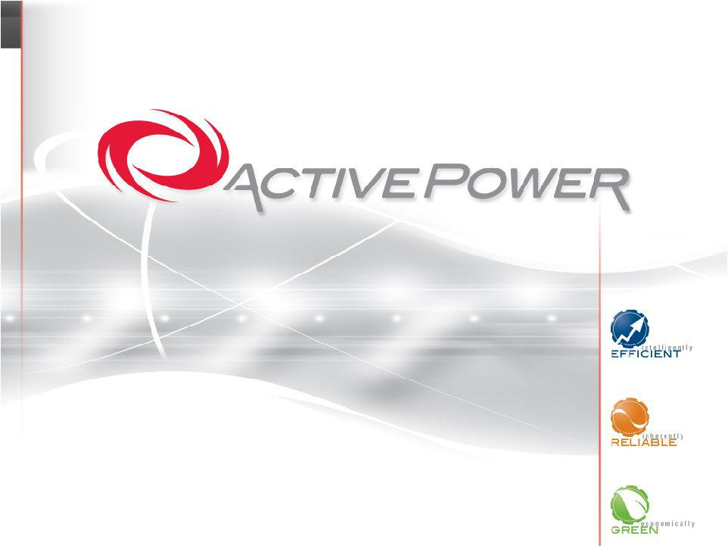
Exhibit 99.2

Management Presentation

August 2007

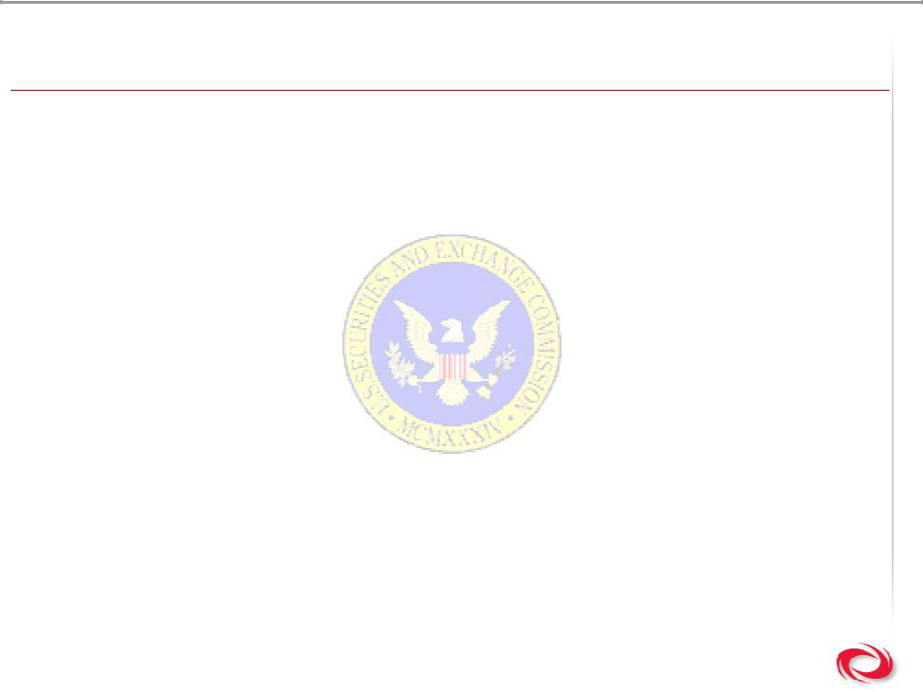
Cautionary Note Regarding Forward Looking Statements

This presentation may contain forward-looking statements, within the meaning of Section 27A of the Securities Act of 1933 and Section 21E of the Securities Act of 1934, that involve risks and uncertainties. The important factors that could cause actual results to differ materially include, but are not limited to, the potential for significant losses to continue; inability to accurately predict revenue and budget for expenses for future periods; fluctuations in revenue and operating results; overall market performance; decreases and/or delays in capital spending; limited product lines; inability to expand our distribution channels; inability to manage new and existing product distribution relationships; our current dependence on our relationship with Caterpillar; delays in research and development; potential Sarbanes-Oxley 404 compliance issues; the acceptance of the new technology in our current and future products by the power quality market; product performance and quality issues; and other risks set forth in the Company’s most recent SEC filings.

2

Copyright © 2007 Active Power, Inc


Management Representatives

Jim Clishem

President & Chief Executive Officer

John Penver

Vice President of Finance & Chief Financial Officer

3

Copyright © 2007 Active Power, Inc

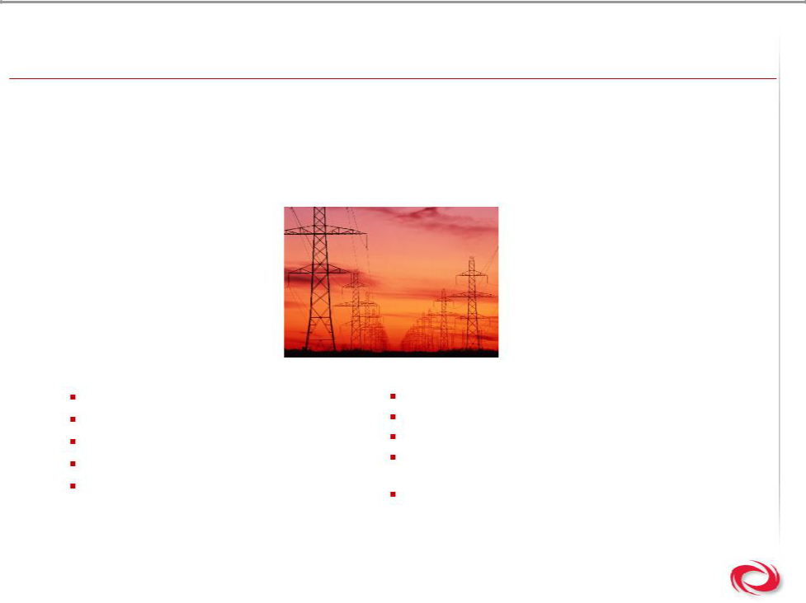
Active Power is …

- A provider of turnkey critical power solutions that provide “power insurance” to global enterprises with zero tolerance for downtime

- A manufacturer of uninterruptible power (UPS) systems that utilize green technology as a renewable energy source

Company Overview:

6 continent sales & service coverage

15 years in business

40+ country implementations

42 patents held

150+ employees

400 MW of pure power provided

1,600+ flywheels shipped worldwide

9001:2000 ISO certification

80,000 square foot manufacturing and operations facility in Austin, Texas

35 million+ hours of field runtime

4

Copyright © 2007 Active Power, Inc

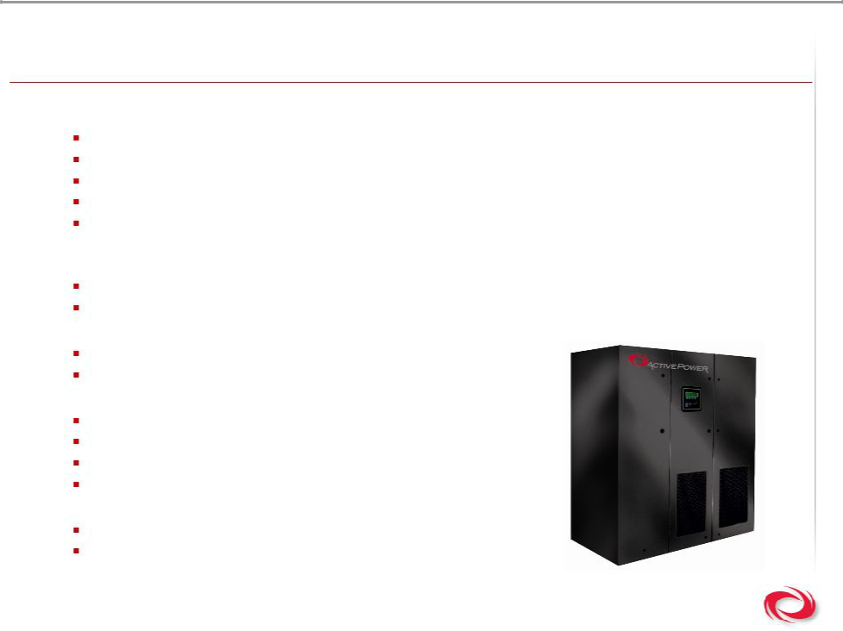
Investment Highlights

- Demonstrating ability to perform

41% revenue growth in 2006

Q2 2007 record revenue performance $9.2M is 68% increase over Q2 2006

3% gross margin in 2006, first year ever achieved

17% gross margin in Q2 2007

Recently announced a multimillion dollar, 7.6 MW order from a European based customer for four Containerized Mobile Power systems

- Differentiated family of products

CleanSource: the most energy & space efficient UPS in the world, and its green!

CoolAir: the world’s only back up power & cooling system, and its green!

- Delivering solutions globally

Over 400 MWs of power delivered via 1600 wheels globally 45 units and 81 wheels sold in Q2 2007

- Establishing a path to profitability

Multiple sales channels strategy developed

Native geographic expansion implemented

Growth of the service business

Focus on higher margin product sales

- Strong & innovative management team

New team transforming the business

Driving towards 125 wheels / quarter for EBITDA breakeven

5

Copyright © 2007 Active Power, Inc

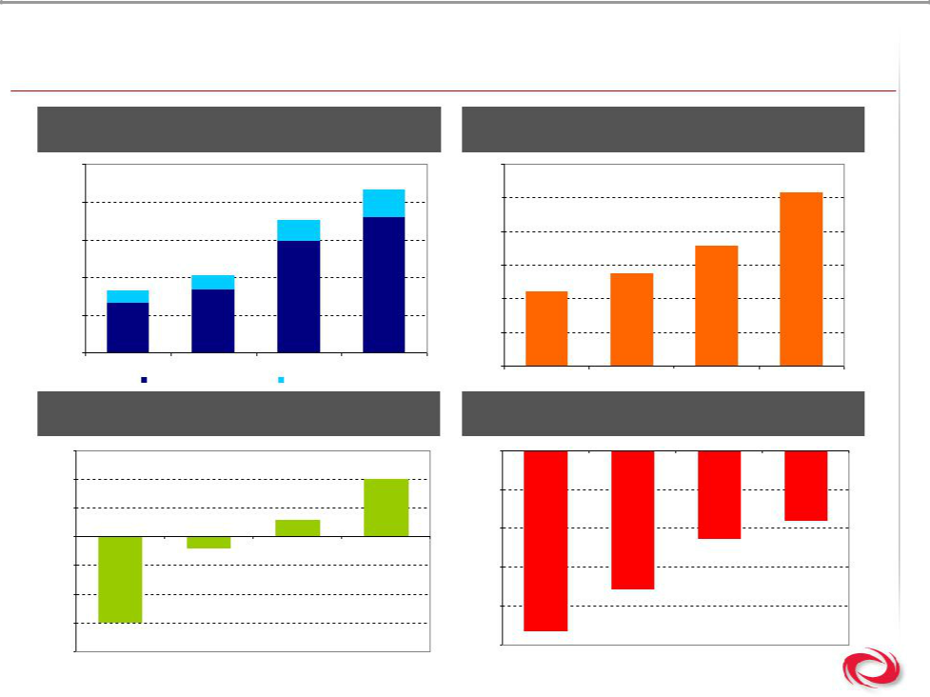
Demonstrating Results

 | Revenue |  |  |  | Average Selling Price per Wheel
$32,500 |  |  |  | $76,000
 |  |  | $29,149 |  |  |  |  | $72,615
$27,500 |  |  |  | $72,000
$27,500 |  | $25,029
$22,500 |  |  |  | $68,000 |  |  | $66,380
 | $17,788 |  |  | $64,000 |  | $63,030
$17,500 | $17,788
$17,500 |  |  |  |  | $60,930
$15,783 |  |  |  |  | $60,930
 |  |  |  | $60,000
$12,500
 |  |  |  | $56,000
$7,500
2004 | 2005 | 2006 | LTM | $52,000
 | Product Revenue | Service Revenue |  |  | 2004 | 2005 | 2006 | LTM
 | Gross Margin |  |  |  |  | Operating Margin
15% |  |  |  | 0%
10% |  |  | 10%
 |  |  |  | -40%
5% |  | 3%
0% |  |  |  | -80% |  |  |  | -72%
 | -2% |  |  |  |  |  | -91%
-5% | -2% |  |  | -120%
-10% |  |  |  |  |  | -142%
 |  |  |  | -160% |  | -142%
-15%
-15% |  |  |  |  | -186%
 |  |  |  | -200% | -186%
-20% |  |  |  | -200%
-20% |  |  |  |  | 2004 | 2005 | 2006 | LTM
2004 | 2005 | 2006 | LTM
- Note: LTM data as of June 30, 2007

Copyright © 2007 Active Power, Inc

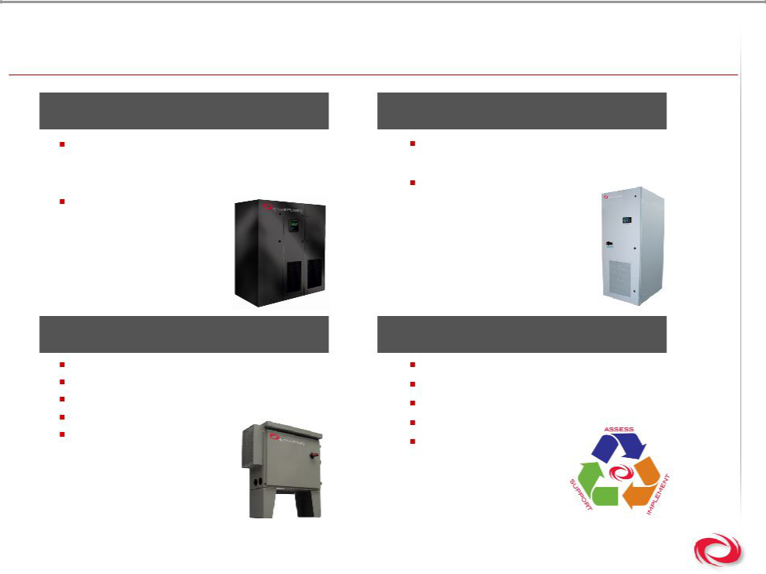
Product Line

CleanSource® | CoolAir™
CleanSource UPS | CoolAir UPS
– 130-3,600 kVA systems | – 50 – 100 kVA systems
– Multi MegaWatt Turnkey solutions | CoolAir DC
CleanSource DC | – 85 kW system
– 250-2,000 kW

Ancillary Products | Services
Containerized Solutions | Design Engineering
GenSTARTTM | Assessment
Monitoring & Control Software | Implementation
Switchgear | Lifecycle & Support
Generators | Lifecycle & Support
Generators | 24 x 7 x 365 Care

7

Copyright © 2007 Active Power, Inc

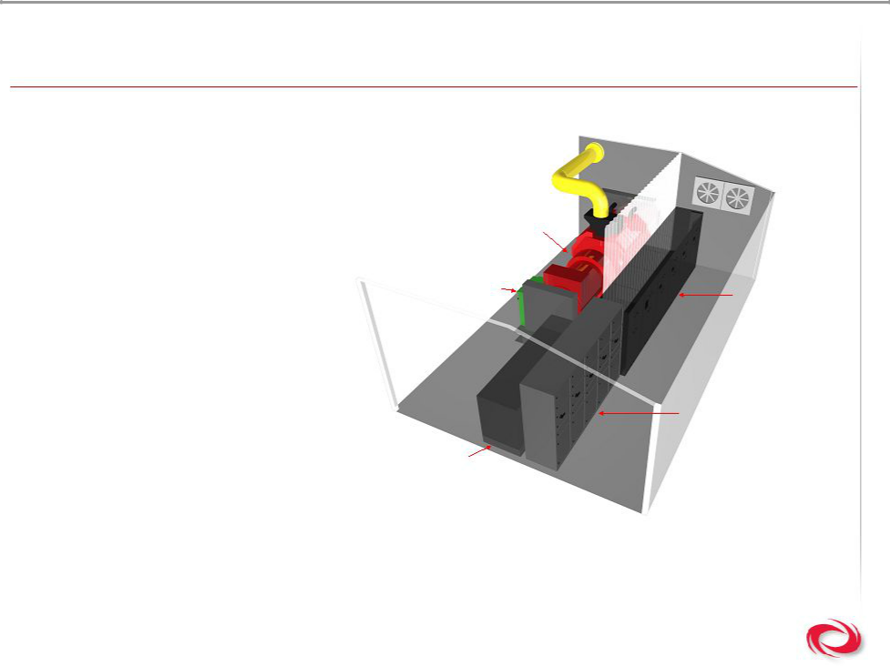
Containerized Turnkey Power System

What is containerization?

- A modular, mission critical Data Center power plant

- Standard dimension 20’, 30’ or 40’ container that can be custom modified by application

Generator
GenSTART | UPS Cabinets

- A purpose made facility-based enclosure to acoustically isolate, thermally protect, weatherproof and/or fireproof power plants

Switchgear

Fuel Tank

8

Copyright © 2007 Active Power, Inc

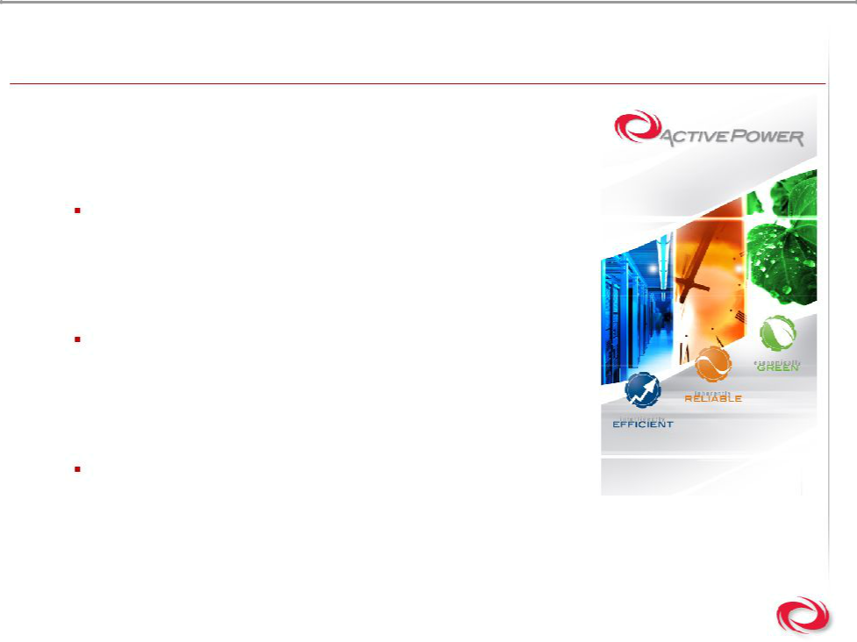
What is Our Value Proposition?

Our Solutions Are:

- Intelligently EFFICIENT

Precision engineered to be up to 98% efficient, delivering real bottom line impact by reducing power consumption costs

- Inherently RELIABLE

Uniquely designed to deliver predictable, consistent backup power with more than 35 million hours of customer runtime on six continents

- Economically GREEN

Environmentally-friendly solution (reduced CO2 emissions) delivered at an economic advantage

9

Copyright © 2007 Active Power, Inc


Who Needs Clean, Reliable, Green Power?

10

Copyright © 2007 Active Power, Inc

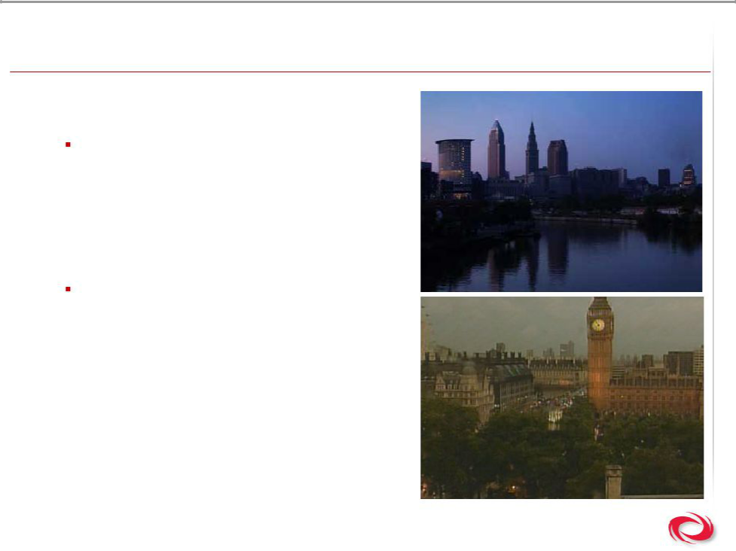
Power Reliability

- Significant blackouts have demonstrated the importance of secure power supply

2007

– June 27: 136,000 people … New York City

– April 26: national blackout in Colombia

– January 16: 200,000 people in Australia

– January 12 - January 26: ~1 million customers from US to Canada due to ice
Other recent blackouts

– November 2006: 5 million customers in Europe
– July 2006: 365,000 customers in Philadelphia

– September 2003: 57 million people in Italy

– September 2003: 4 million people in Copenhagen
– August 2003: 50 million people in New York and an economic loss of $1Billion

11 | (1) Source: ELCON, 2004
Copyright © 2007 Active Power, Inc

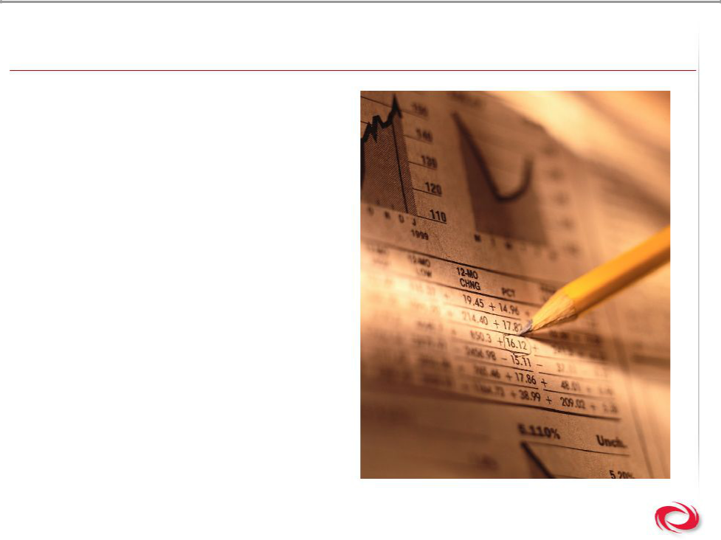
Other Macroeconomic Trends Drive Demand

- Data center market growth

- Rising cost of energy

- Pure demand for energy

- High efficiency

- Unreliable power grid

- Regulatory requirements

- Lack of investment into public infrastructure

- Cost of downtime

12

Copyright © 2007 Active Power, Inc

The Market Opportunity is $6.5 Billion

- Current global UPS market is $6.5 billion with 6% CAGR projected

- Addressable share is $1.5 billion

 |  | Total UPS Market: Unit Shipment and
 | Revenue Forecasts (World), 2002- 2012
9,000 |  |  |  |  |  |  |  |  |  | 45,000
8,000 |  |  |  |  |  |  |  |  |  | 40,000
7,000 |  |  |  |  |  |  |  |  |  | 35,000
6,000 |  |  |  |  |  |  |  |  |  | 30,000
5,000 |  |  |  |  |  |  |  |  |  | 25,000
4,000 |  |  |  |  |  |  |  |  |  | 20,000
3,000 |  |  |  |  |  |  |  |  |  | 15,000
2,000 |  |  |  |  |  |  |  |  |  | 10,000
1,000 |  |  |  |  |  |  |  |  |  | 5,000
0 |  |  |  |  |  |  |  |  |  | 0
2002 | 2003 | 2004 | 2005 | 2006 | 2007 | 2008 | 2009 | 2010 | 2011 | 2012
 |  |  |  | Revenues |  |  | Units

Total UPS Market: Report Segmentation by Power Range (World)

World

UPS Market

Below | 1 to | 20 to | 50 to | 200 kVA +
1 kVA | 20 kVA | 50 kVA | 200 kVA | 200 kVA +
 |  |  | $661M | $867M

- Source: Frost & Sullivan
Copyright © 2007 Active Power, Inc

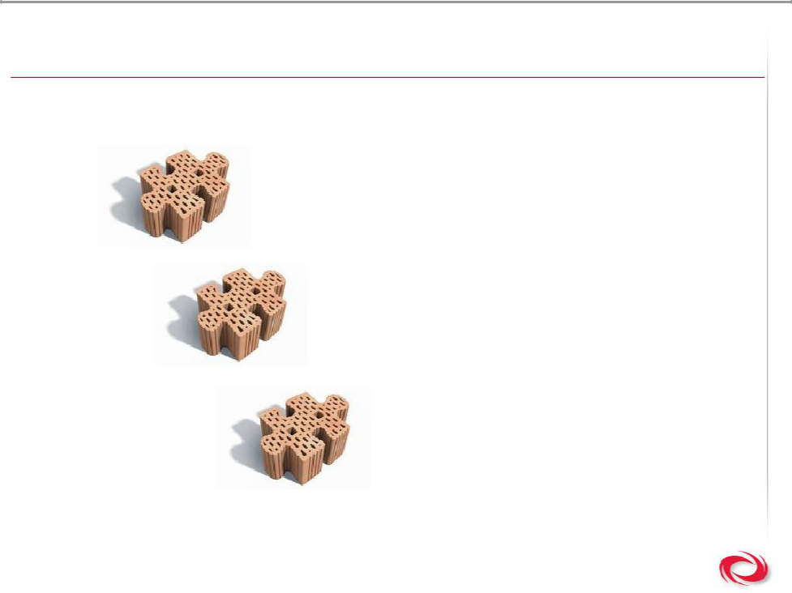
What is the Business Strategy?

Build Brand

Build Distribution

Build for Less

14

Copyright © 2007 Active Power, Inc

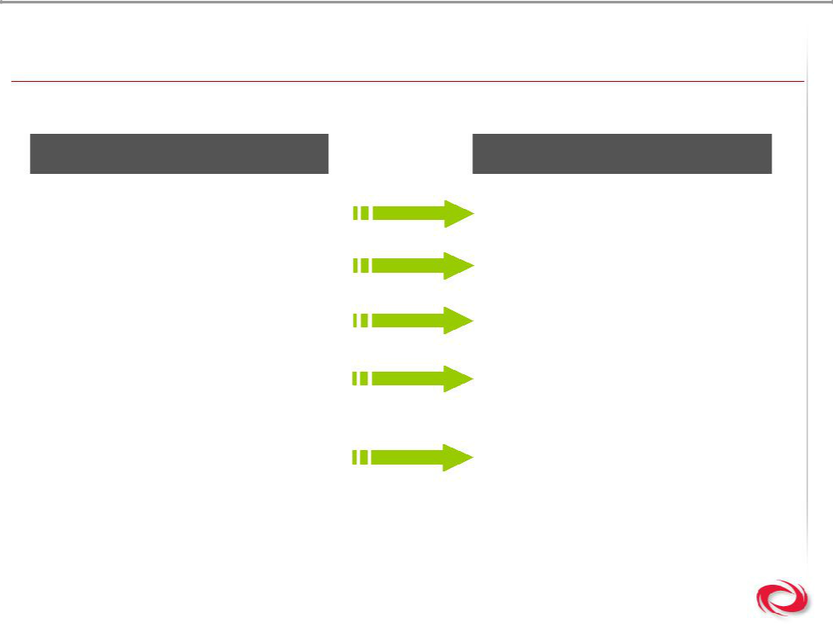
Strategy in Action

Before 2006

Commoditized Component

Valued Supplier

Driven by OEM Sales

Limited Geographical

Coverage

Focus on Engineering

15

Copyright © 2007 Active Power, Inc

After 2006

Differentiated Solution Consultative Partner Driven by Direct Sales
Multinational Distribution

Focus on Market Needs

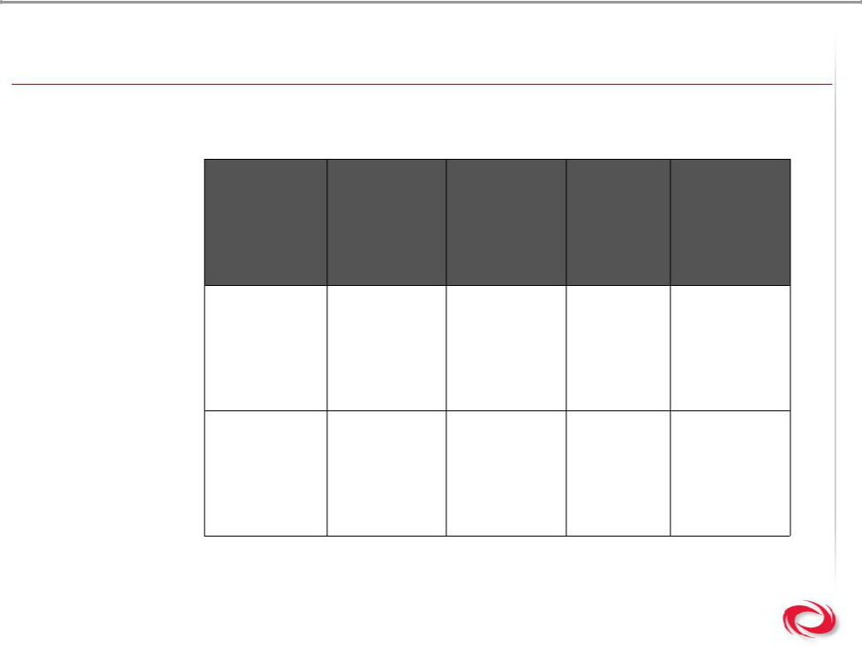
Competitive Landscape

- Our UPS solutions outperform conventional UPS systems

 |  | Operating | Green | Measured
Efficiency ⁽¹⁾ | Footprint ⁽²⁾ | Operating | Product | System
Efficiency ⁽¹⁾ | Footprint ⁽²⁾ | Expenses ⁽³⁾ | Product | System
 |  | Expenses ⁽³⁾ | Offering | Reliability

Active Power | Up to 98% | 89 sq. ft. $15 million | Yes | Yes
Flywheel UPS

Conventional | Up to 92% 190 sq. ft. $32 million | No | No
UPS & Battery | Up to 92% 190 sq. ft. $32 million | No | No

16 | (1) | At 75% load or greater
16 | (2) | Based on 600 kVA UPS
 | (3) | Based on 10 MW deployment over 20-Year Life | Copyright © 2007 Active Power, Inc

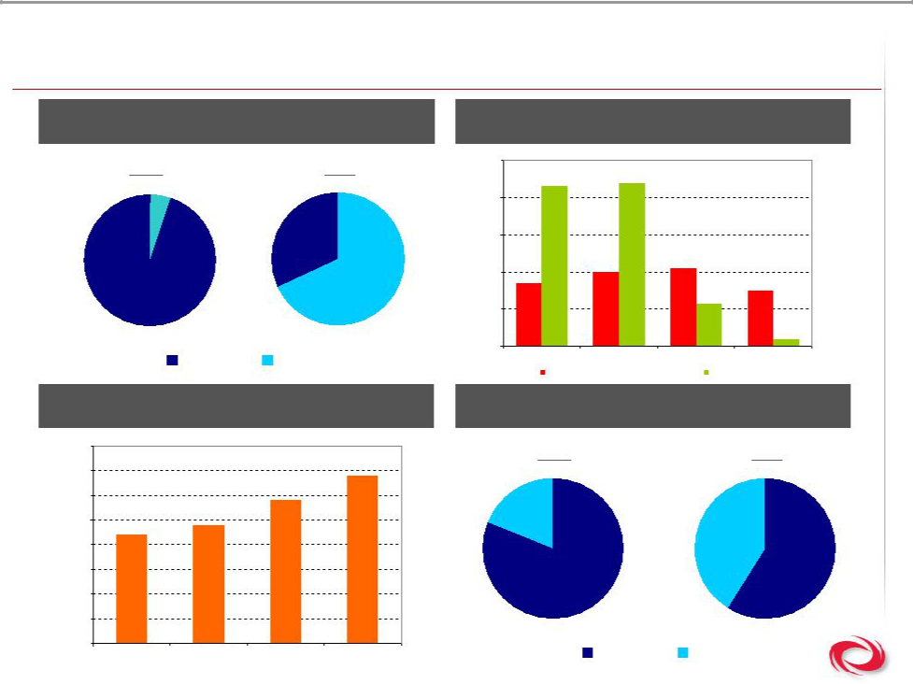
Distribution Overview

Direct v. OEM Sales Sales and Marketing Investment

2002 LTM

5%

32%

70%

63% ^{64%}

60%

50%

_{40%} 41%

40%
37%

35%

 |  |  |  | 68% |  | 31%
 |  |  |  | 30%
 | 95% |  |  |  |  |  | 22%
 |  |  |  | 20%
 |  | OEM | Direct | 2004 | 2005 | 2006 | LTM
 |  |  |  | Sales&Marketing (% of Revenue) |  | R&D (% of Revenue)
 | Direct Sales as % of AP Sales |  |  |  | Geographic Sales
 | 80% |  |  | 2002 |  |  | LTM
 | 70% |  |  | 68%
 |  |  | 58% | 19%
 | 60% |  | 58%
 | 50% | 48%
 | 44% |  |  |  |  | 41%
 | 40%
 | 30% |  |  |  |  |  | 59%
 | 20%
 | 10% |  |  |  | 81%
 | 0% |  |  |  | North | Rest of
17 | 2004 | 2005 | 2006 | LTM | North | Rest of
17 | Note: LTM data as of June 30, 2007 |  |  |  | America | World
Copyright © 2007 Active Power, Inc

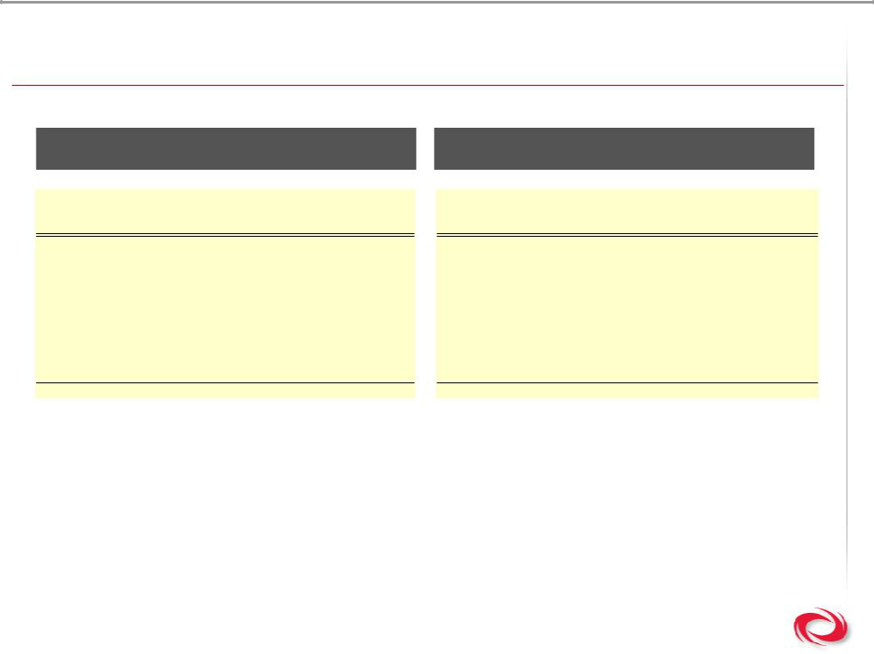
Bookings Trends

2005 Top Ten Bookings 2006 Top Ten Bookings

 | Amount | Application | Territory | Channel | Sale Amount |  | Application | Territory | Channel
$ | 1,035,174 | Printing | North America | OEM | $ | 2,060,154 | Data Center | North America | OEM
$ | 903,478 | Airport | Latin America | Direct | $ | 2,045,219 | Food Processing | Algeria | Direct
$ | 900,000 | Food Processing | Algeria | Direct | $ | 1,282,000 | Airport | Asia | Direct
$ | 680,775 | Data Center | North America | OEM | $ | 1,155,760 | Petrochemical | North America | Direct
$ | 638,250 | Semiconductor | North America | OEM | $ | 966,144 | Health | North America | Direct
$ | 443,702 | Health | North America | OEM | $ | 902,631 | Data Center | Europe | Direct
$ | 403,962 | Dealer Stock | North America | OEM | $ | 885,281 | Broadcast | Europe | Direct
$ | 318,610 | Automotive | Europe | Direct | $ | 879,907 | Data Center | North America | OEM
$ | 313,122 | Plastics | Europe | Direct | $ | 606,238 | Health | North America | Direct
$ | 309,390 | Airport | Middle East | OEM | $ | 590,402 | Education | Europe | Direct
$ | 5,946,463 |  |  |  | $ | 11,373,736

18

Copyright © 2007 Active Power, Inc

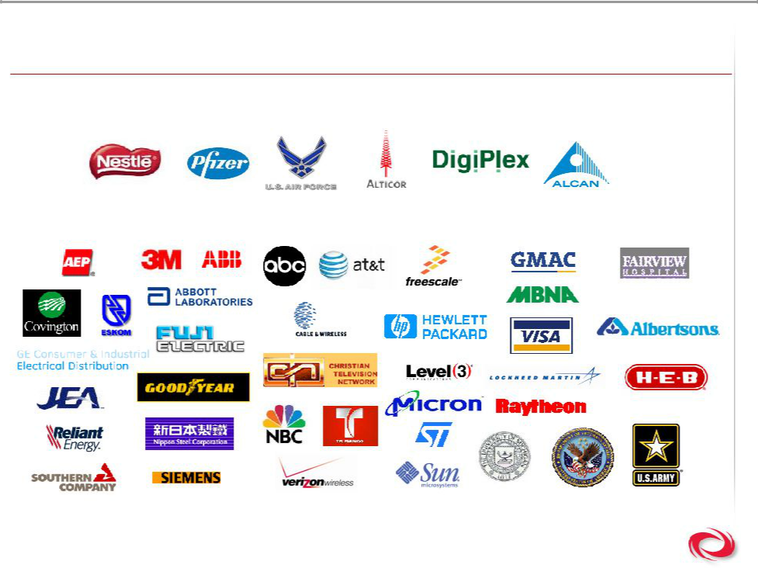
Who Chooses Active Power?

- Recent customer wins

- Organizations we protect

19

Copyright © 2007 Active Power, Inc

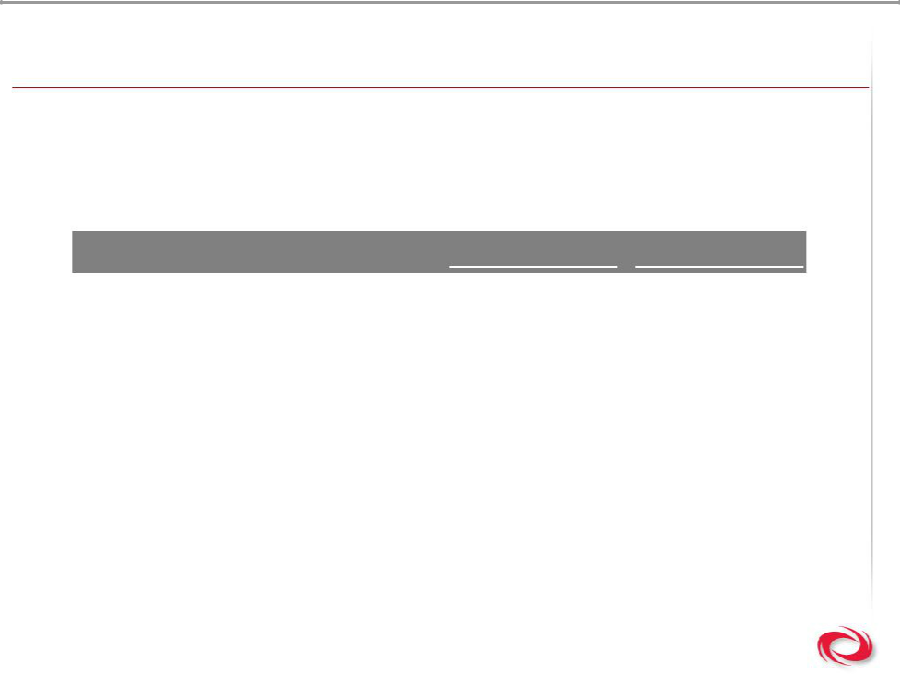
Path to EBITDA Profitability

- EBITDA profitability targets: 125 wheels sold per quarter, combined quarterly service and ancillary revenues > $3 million and an $80,000 average selling price
- 2008 timetable for achieving EBITDA profitability

 | Q2 2007 | Breakeven
Wheel Sales / Quarter | 81 | 125
Average Selling Price | $68,570 | $80,000
Service & Ancillary Revenue / Quarter | $3,436,000 | $3,000,000
Cumulative Wheels Sold | 1,600 | NM

20

Copyright © 2007 Active Power, Inc

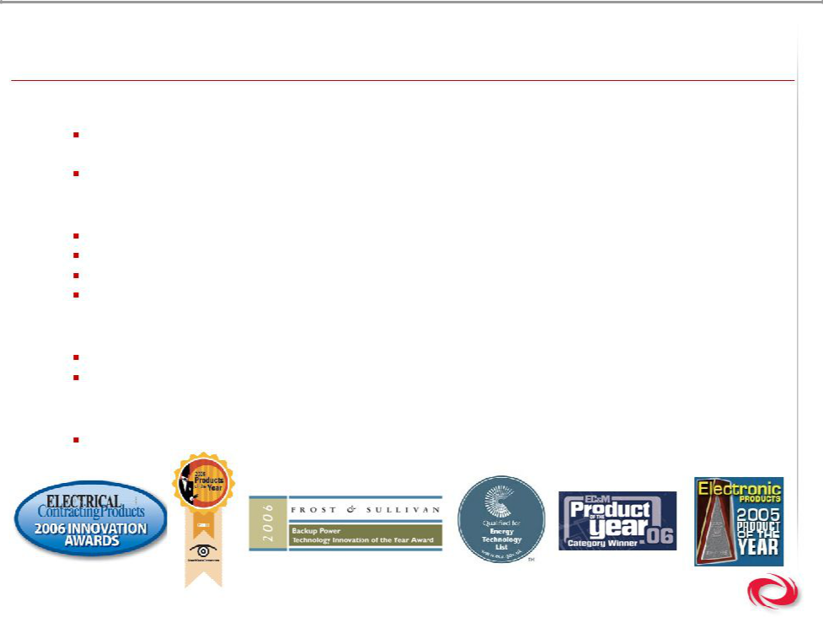
Awards & Acknowledgements

- 2007

Recently awarded ETL certification by Carbon Trust allows Active customers to receive substantial subsidies

Data Centres Europe, Most Innovative New Product Award CSUPS

- 2006

Frost & Sullivan Backup Power Technology Innovation of the Year Award

TechTarget’s SearchDataCenter.com Product of the Year for Data Center Backup Power Electrical Contracting Products Magazine finalist for INNOVATION Award

EC&M Magazine Product of the Year for Power Conditioning Category

- 2005

Electronic Products Magazine Product of the Year

Frost & Sullivan Customer Development Leadership Award

- 2003

Frost & Sullivan Product Line Strategy Award

21

Copyright © 2007 Active Power, Inc

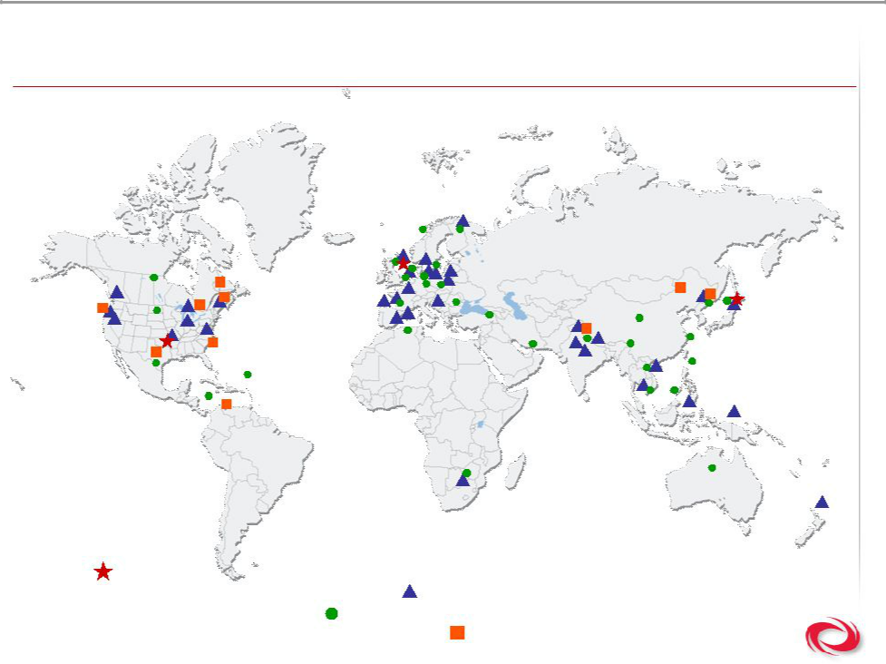
A Growing Active Power

HQ’s

Sales & Service & Demonstration Centers

Customer Installations (Country)
- Manufacturers’ Representatives & Distributors

Copyright © 2007 Active Power, Inc

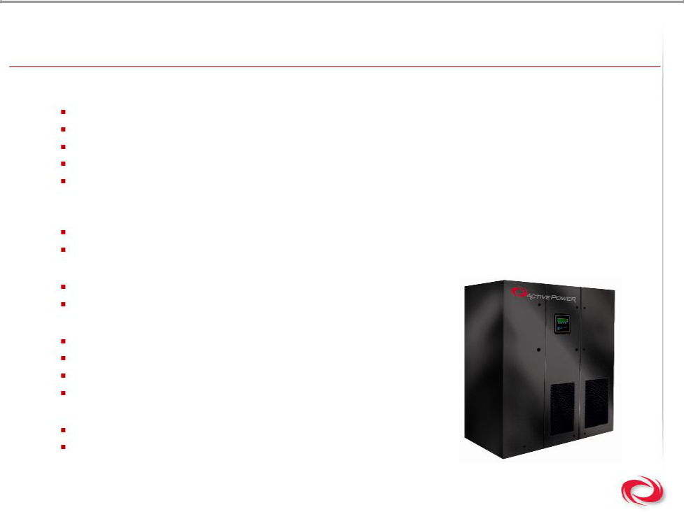
Investment Highlights

- Demonstrating ability to perform

41% revenue growth in 2006

Q2 2007 record revenue performance $9.2M is 68% increase over Q2 2006

3% gross margin in 2006, first year ever achieved

17% gross margin in Q2 2007

Recently announced a multimillion dollar, 7.6 MW order from a European based customer for four Containerized Mobile Power systems

- Differentiated family of products

CleanSource: the most energy & space efficient UPS in the world, and its green!

CoolAir: the world’s only back up power & cooling system, and its green!

- Delivering solutions globally

Over 400 MWs of power delivered via 1600 wheels globally 45 units and 81 wheels sold in Q2 2007

- Establishing a path to profitability

Multiple sales channels strategy developed

Native geographic expansion implemented

Growth of the service business

Focus on higher margin product sales

- Strong & innovative management team

New team transforming the business

Driving towards 125 wheels / quarter for EBITDA breakeven

23

Copyright © 2007 Active Power, Inc

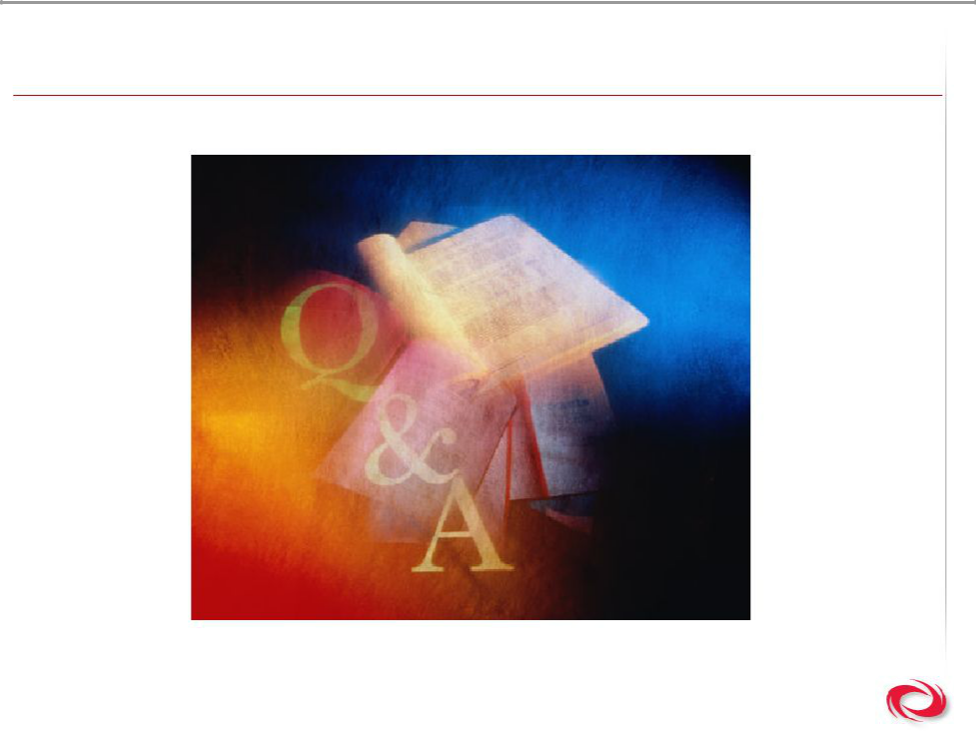
Questions & Answers

24

Copyright © 2007 Active Power, Inc

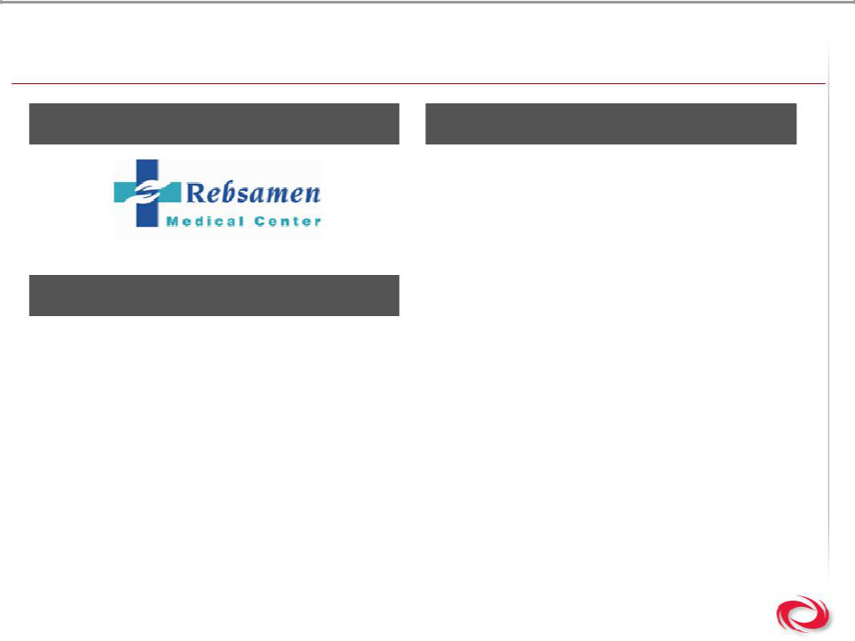
Customer Case Study

Customer Active Power Solution

Jacksonville, Arkansas

Business Challenge

- Rebsamen Medical Center’s acute care facility purchased new MRI and CAT Scan equipment

- This highly sophisticated and expensive diagnostic equipment warranted a highly reliable power source

- “We experience numerous power failures, from a fraction of a second to several hours,” noted Ed Meharg, Director of Engineering for Rebsamen Medical Center. “Even a short power glitch can wreak havoc on our sensitive diagnostic medical equipment.”

- Rebsamen now relies on a Clean Source 300 uninterruptible continuous power system from Active Power

- The system consists of a 300 kVA UPS for short-term outages and power conditioning, and a 350 kW generator set for long-term outages, integrated to provide continuous quality power throughout the hospital facility

- “We are always investigating new methods to address our critical power requirements beyond those required by NFPA, which cover emergency power at healthcare facilities,” notes Meharg

25

Copyright © 2007 Active Power, Inc

