UNITED STATES
SECURITIES AND EXCHANGE COMMISSION
WASHINGTON, D.C. 20549

FORM 8-K

CURRENT REPORT
PURSUANT TO SECTION 13 OR 15(d)
OF THE SECURITIES EXCHANGE ACT OF 1934
Date of report (Date of earliest event reported): May 15, 2023

P10, Inc.
(Exact name of registrant as specified in its charter)

Delaware |  | 001-40937 |  | 87-2908160
(State or other Jurisdiction  of Incorporation) |  | (Commission  File Number) |  | (IRS Employer  Identification No.)
4514 Cole Avenue, Suite 1600
Dallas, Texas 75205
(Address of principal executive offices and Zip Code)
(214) 865-7998
(Registrant’s telephone number, including area code)

Check the appropriate box below if the Form 8-K filing is intended to simultaneously satisfy the filing obligation of the registrant under any of the following provisions (see General Instruction A.2. below):

☐ | Written communications pursuant to Rule 425 under the Securities Act (17 CFR 230.425)

☐ | Soliciting material pursuant to Rule 14a-12 under the Exchange Act (17 CFR 240.14a-12)

☐ | Pre-commencement communications pursuant to Rule 14d-2(b) under the Exchange Act (17 CFR 240.14d-2(b))

☐ | Pre-commencement communications pursuant to Rule 13e-4(c) under the Exchange Act (17 CFR 240.13e-4(c))
Securities registered pursuant to Section 12(b) of the Act:

Title of each class |  | Trading  Symbol(s) |  | Name of each exchange  on which registered
Class A Common Stock, par value $0.001 per share |  | PX |  | New York Stock Exchange LLC
Series A Junior Participating Preferred Stock Purchase Rights
Indicate by check mark whether the registrant is an emerging growth company as defined in Rule 405 of the Securities Act of 1933 (§230.405 of this chapter) or Rule 12b-2 of the Securities Exchange Act of 1934 (§240.12b-2 of this chapter).
Emerging growth company ☒
If an emerging growth company, indicate by check mark if the registrant has elected not to use the extended transition period for complying with any new or revised financial accounting standards provided pursuant to Section 13(a) of the Exchange Act ☐

Item 2.02 | Results of Operations and Financial Condition.
On May 15, 2023, P10, Inc. (the “Company”) issued a press release and detailed presentation announcing its financial results for its first fiscal quarter ended March 31, 2023. A copy of the press release and presentation are furnished as Exhibit 99.1 to this Current Report on Form 8-K and are incorporated by reference into this Item 2.02 as if fully set forth herein.
The Company plans to host a conference call at 5:00 p.m. Eastern Time on Monday, May 15, 2023, to discuss these results.
The information furnished by the Company pursuant to this Item 2.02, including Exhibit 99.1, shall not be deemed “filed” for purposes of Section 18 of the Securities Exchange Act of 1934, as amended (the “Exchange Act”) or otherwise subject to the liability of that section, and shall not be deemed to be incorporated by reference into any Company filing under the Securities Act of 1933, as amended, or the Exchange Act, regardless of any general incorporation language in such filing.

Item 7.01 | Regulation FD Disclosure
On May 15, 2023, P10, Inc. (the “Company”) posted the Q1 2023 Company Overview to its website at https://ir.p10alts.com/. A copy of the Q1 2023 Company Overview is attached as Exhibit 99.2 to this Current Report on Form 8-K.
The information in this Current Report on Form 8-K, including Exhibit 99.2 attached hereto, is being furnished and shall not be deemed “filed” for the purposes of Section 18 of the Exchange, or otherwise subject to the liabilities of that Section, nor shall it be deemed subject to the requirements of amended Item 10 of Regulation S-K, nor shall it be deemed incorporated by reference into any filing of the Company under the Securities Act of 1933, as amended, or the Exchange Act, whether made before or after the date hereof, regardless of any general incorporation language in such filing. The furnishing of this information hereby shall not be deemed an admission as to the materiality of any such information.

Item 9.01 | Financial Statements and Exhibits.
(d) Exhibits

Exhibit  No. |  | Description
99.1 |  | Press Release of P10, Inc., dated May 15, 2023 and Q1 2023 earnings presentation.
99.2 |  | Q1 2023 Company Overview dated May 15, 2023
104 |  | Cover Page Interactive Data File (formatted as inline XBRL)

SIGNATURE
Pursuant to the requirements of the Securities Exchange Act of 1934, the registrant has duly caused this report to be signed on its behalf by the undersigned hereunto duly authorized.

 |  |  |  | P10, INC.
Date: May 15, 2023 |  |  |  | By: |  | /s/ Amanda Coussens
 |  |  |  |  |  | Amanda Coussens
 |  |  |  |  |  | Chief Financial Officer
Exhibit 99.1

 |  |  |  | 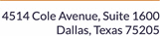
P10 Reports First Quarter 2023 Results
Strong Fundraising and Deployment Drives Double-Digit Revenue Growth
DALLAS, May 15, 2023 (GLOBE NEWSWIRE)  P10, Inc. (NYSE: PX), a leading private markets solutions provider, today reported financial results for the first quarter ended March 31, 2023.
First Quarter 2023 Financial Highlights:

 |  |  | Fee Paying Assets Under Management: $21.6 billion, a 23% increase year over year.

 |  |  | Revenue: $57.3 million, a 32% increase year over year.

 |  |  | GAAP Net Income: $.8 million, a 90% decrease year over year.

 |  |  | Adjusted EBITDA: $28.4 million, a 27% increase year over year.

 |  |  | Adjusted Net Income: $25.5 million, a 14% increase year over year.

 |  |  | Fully diluted GAAP EPS: $.01, an 83% decrease year over year.

 |  |  | Fully diluted ANI per share: $.21, a 17% increase year over year.
A presentation of the quarterly financials may be accessed here and is available on the Companys website.
Declaration of Dividend:
The Company has approved an 8% increase in the annual dividend, from $.12 per share to $.13 per share.
The Board of Directors of the Company has declared a quarterly cash dividend of $.0325 per share of Class A and Class B common stock, payable on June 20, 2023, to the holders of record as of the close of business on May 30, 2023.
Robert Alpert, Chairman and Co-CEO, and Co-CEO Clark Webb said, P10 delivered strong first quarter results amid a challenging macroeconomic environment. We added $911 million to fee paying assets under management. With double-digit growth in revenue, Adjusted EBITDA, and Adjusted Net Income, we believe the company is well positioned for continued growth from an array of complementary and expanding businesses.
The company will host a conference call at 5:00 p.m. Eastern Time on Monday, May 15, 2023. The call may be accessed here. All participants joining by telephone should dial one of the following numbers, followed by the Participant Access Code provided:

 |  | U.S. (toll free): |  | 1-833-470-1428
 |  | International: |  | 1-404-975-4839
 |  | Participant Access Code: |  | 368551

For those unable to participate in the live call, a replay will be made available on P10s investor relations page at www.p10alts.com.
About P10
P10 is a leading multi-asset class private markets solutions provider in the alternative asset management industry. P10s mission is to provide its investors differentiated access to a broad set of investment solutions that address their diverse investment needs within private markets. As of March 31, 2023, P10 has a global investor base of more than 3,300 investors across 50 states, 54 countries, and six continents, which includes some of the worlds largest pension funds, endowments, foundations, corporate pensions, and financial institutions. Visit www.p10alts.com.
Forward-Looking Statements
Some of the statements in this release may constitute forward-looking statements within the meaning of Section 27A of the Securities Act of 1933, Section 21E of the Securities Exchange Act of 1934 and the Private Securities Litigation Reform Act of 1995. Words such as will, expect, believe, estimate, continue, anticipate, intend, plan and similar expressions are intended to identify these forward-looking statements. Forward-looking statements discuss managements current expectations and projections relating to our financial position, results of operations, plans, objectives, future performance, and business. The inclusion of any forward-looking information in this release should not be regarded as a representation that the future plans, estimates, or expectations contemplated will be achieved. Forward-looking statements are subject to various risks, uncertainties, and assumptions. Forward-looking statements reflect managements current plans, estimates, and expectations, and are inherently uncertain. All forward-looking statements are subject to known and unknown risks, uncertainties, and other important factors that may cause actual results to be materially different, including risks relating to: global and domestic market and business conditions; successful execution of business and growth strategies and regulatory factors relevant to our business; changes in our tax status; our ability to maintain our fee structure; our ability to attract and retain key employees; our ability to manage our obligations under our debt agreements; as well as assumptions relating to our operations, financial results, financial condition, business prospects, growth strategy; and our ability to manage the effects of events outside of our control. The foregoing list of factors is not exhaustive. For more information regarding these risks and uncertainties as well as additional risks that we face, you should refer to the Risk Factors included in our annual report on Form 10-K for the year ended December 31, 2022, filed with the U.S. Securities and Exchange Commission (SEC) on March 27, 2023, and in our subsequent reports filed from time to time with the SEC. The forward-looking statements included in this release are made only as of the date hereof. We undertake no obligation to update or revise any forward-looking statement as a result of new information or future events, except as otherwise required by law.

Use of Non-GAAP Financial Measures by P10, Inc.
The non-GAAP financial measures contained in this press release (including, without limitation, Adjusted EBITDA, Adjusted Net Income, and fee-paying assets under management) are not GAAP measures of the Companys financial performance or liquidity and should not be considered as alternatives to net income (loss) as a measure of financial performance or cash flows from operations as measures of liquidity, or any other performance measure derived in accordance with GAAP. A reconciliation of such non-GAAP measures is included in the presentation of the first quarter 2023 results. The Company believes the presentation of these non-GAAP measures provides useful additional information to investors because it provides better comparability of ongoing operating performance to prior periods. It is reasonable to expect that one or more excluded items will occur in future periods, but the amounts recognized can vary significantly from period to period. Fee-paying assets under management reflects the assets from which we earn management and advisory fees. Our vehicles typically earn management and advisory fees based on committed capital, and in certain cases, net invested capital, depending on the fee terms. Management and advisory fees based on committed capital are not affected by market appreciation or depreciation. You are encouraged to evaluate each adjustment to non-GAAP financial measures and the reasons management considers it appropriate for supplemental analysis. Our presentation of these measures should not be construed as an inference that our future results will be unaffected by unusual or non-recurring items.
Ownership Limitations
P10s Certificate of Incorporation contains certain provisions for the protection of tax benefits relating to P10s net operating losses. Such provisions generally void transfers of shares that would result in the creation of a new 4.99% shareholder or result in an existing 4.99% shareholder acquiring additional shares of P10.
P10 Press and Investor Contact:
info@p10alts.com

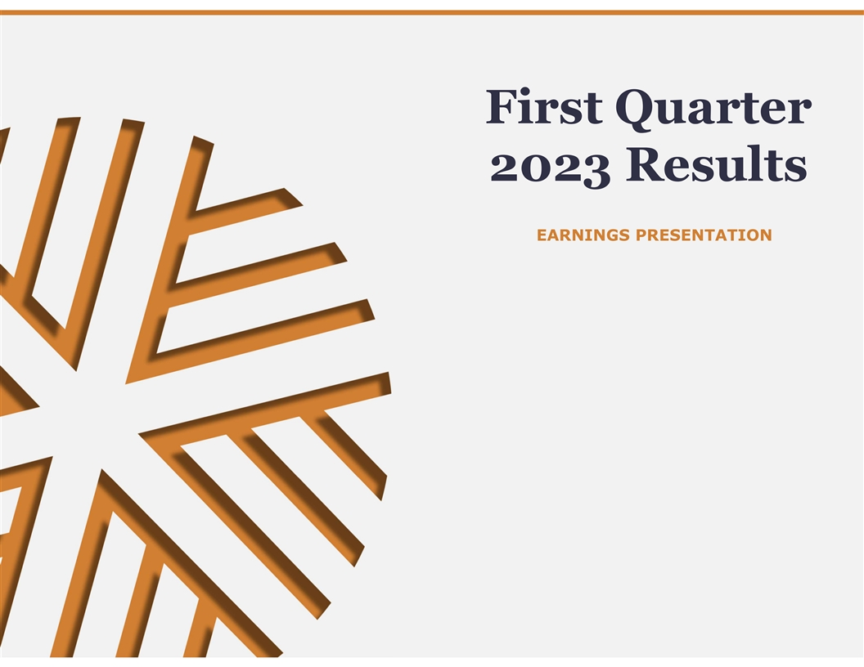
First Quarter 2023 Results EARNINGS PRESENTATION

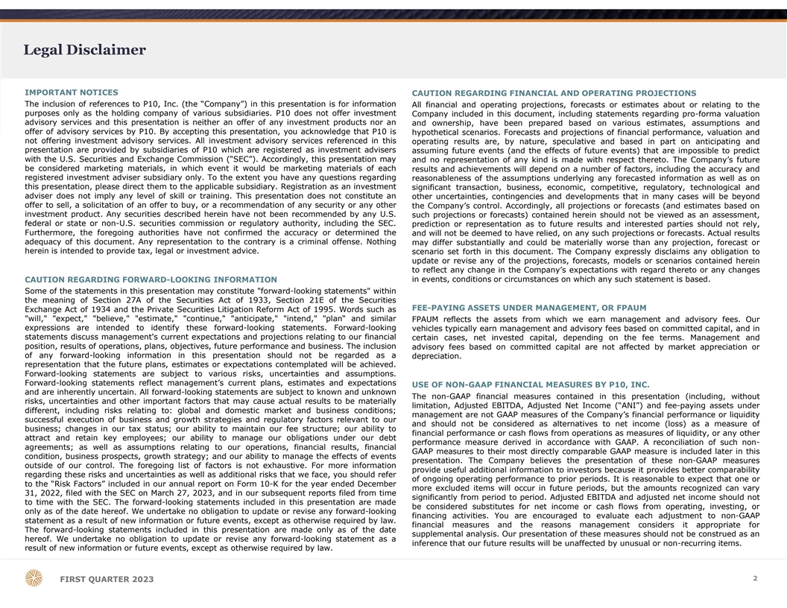
Legal Disclaimer IMPORTANT NOTICES CAUTION REGARDING FINANCIAL AND OPERATING PROJECTIONS The inclusion of references to P10, Inc. (the “Company”) in this presentation is for information All financial and operating projections, forecasts or estimates about or relating to the purposes only as the holding company of various subsidiaries. P10 does not offer investment Company included in this document, including statements regarding pro-forma valuation advisory services and this presentation is neither an offer of any investment products nor an and ownership, have been prepared based on various estimates, assumptions and offer of advisory services by P10. By accepting this presentation, you acknowledge that P10 is hypothetical scenarios. Forecasts and projections of financial performance, valuation and not offering investment advisory services. All investment advisory services referenced in this operating results are, by nature, speculative and based in part on anticipating and presentation are provided by subsidiaries of P10 which are registered as investment advisers assuming future events (and the effects of future events) that are impossible to predict with the U.S. Securities and Exchange Commission (“SEC”). Accordingly, this presentation may and no representation of any kind is made with respect thereto. The Company’s future be considered marketing materials, in which event it would be marketing materials of each results and achievements will depend on a number of factors, including the accuracy and registered investment adviser subsidiary only. To the extent you have any questions regarding reasonableness of the assumptions underlying any forecasted information as well as on this presentation, please direct them to the applicable subsidiary. Registration as an investment significant transaction, business, economic, competitive, regulatory, technological and adviser does not imply any level of skill or training. This presentation does not constitute an other uncertainties, contingencies and developments that in many cases will be beyond offer to sell, a solicitation of an offer to buy, or a recommendation of any security or any other the Company’s control. Accordingly, all projections or forecasts (and estimates based on investment product. Any securities described herein have not been recommended by any U.S. such projections or forecasts) contained herein should not be viewed as an assessment, federal or state or non-U.S. securities commission or regulatory authority, including the SEC. prediction or representation as to future results and interested parties should not rely, Furthermore, the foregoing authorities have not confirmed the accuracy or determined the and will not be deemed to have relied, on any such projections or forecasts. Actual results adequacy of this document. Any representation to the contrary is a criminal offense. Nothing may differ substantially and could be materially worse than any projection, forecast or herein is intended to provide tax, legal or investment advice. scenario set forth in this document. The Company expressly disclaims any obligation to update or revise any of the projections, forecasts, models or scenarios contained herein to reflect any change in the Company’s expectations with regard thereto or any changes CAUTION REGARDING FORWARD-LOOKING INFORMATION in events, conditions or circumstances on which any such statement is based. Some of the statements in this presentation may constitute forward-looking statements within the meaning of Section 27A of the Securities Act of 1933, Section 21E of the Securities FEE-PAYING ASSETS UNDER MANAGEMENT, OR FPAUM Exchange Act of 1934 and the Private Securities Litigation Reform Act of 1995. Words such as will, expect, believe, estimate, continue, anticipate, intend, plan“ and similar FPAUM reflects the assets from which we earn management and advisory fees. Our expressions are intended to identify these forward-looking statements. Forward-looking vehicles typically earn management and advisory fees based on committed capital, and in statements discuss management's current expectations and projections relating to our financial certain cases, net invested capital, depending on the fee terms. Management and position, results of operations, plans, objectives, future performance and business. The inclusion advisory fees based on committed capital are not affected by market appreciation or of any forward-looking information in this presentation should not be regarded as a depreciation. representation that the future plans, estimates or expectations contemplated will be achieved. Forward-looking statements are subject to various risks, uncertainties and assumptions. Forward-looking statements reflect management’s current plans, estimates and expectations USE OF NON-GAAP FINANCIAL MEASURES BY P10, INC. and are inherently uncertain. All forward-looking statements are subject to known and unknown The non-GAAP financial measures contained in this presentation (including, without risks, uncertainties and other important factors that may cause actual results to be materially limitation, Adjusted EBITDA, Adjusted Net Income (“ANI”) and fee-paying assets under different, including risks relating to: global and domestic market and business conditions; management are not GAAP measures of the Company’s financial performance or liquidity successful execution of business and growth strategies and regulatory factors relevant to our and should not be considered as alternatives to net income (loss) as a measure of business; changes in our tax status; our ability to maintain our fee structure; our ability to financial performance or cash flows from operations as measures of liquidity, or any other attract and retain key employees; our ability to manage our obligations under our debt performance measure derived in accordance with GAAP. A reconciliation of such non- agreements; as well as assumptions relating to our operations, financial results, financial GAAP measures to their most directly comparable GAAP measure is included later in this condition, business prospects, growth strategy; and our ability to manage the effects of events presentation. The Company believes the presentation of these non-GAAP measures outside of our control. The foregoing list of factors is not exhaustive. For more information provide useful additional information to investors because it provides better comparability regarding these risks and uncertainties as well as additional risks that we face, you should refer of ongoing operating performance to prior periods. It is reasonable to expect that one or to the “Risk Factors” included in our annual report on Form 10-K for the year ended December more excluded items will occur in future periods, but the amounts recognized can vary 31, 2022, filed with the SEC on March 27, 2023, and in our subsequent reports filed from time significantly from period to period. Adjusted EBITDA and adjusted net income should not to time with the SEC. The forward-looking statements included in this presentation are made be considered substitutes for net income or cash flows from operating, investing, or only as of the date hereof. We undertake no obligation to update or revise any forward-looking financing activities. You are encouraged to evaluate each adjustment to non-GAAP statement as a result of new information or future events, except as otherwise required by law. financial measures and the reasons management considers it appropriate for The forward-looking statements included in this presentation are made only as of the date supplemental analysis. Our presentation of these measures should not be construed as an hereof. We undertake no obligation to update or revise any forward-looking statement as a inference that our future results will be unaffected by unusual or non-recurring items. result of new information or future events, except as otherwise required by law. 2 FIRST QUARTER 2023

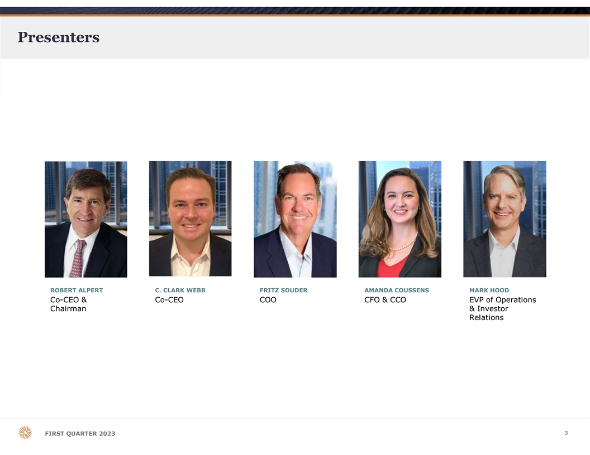
Presenters ROBERT ALPERT C. CLARK WEBB FRITZ SOUDER AMANDA COUSSENS MARK HOOD Co-CEO & Co-CEO COO CFO & CCO EVP of Operations Chairman & Investor Relations 3 FIRST QUARTER 2023

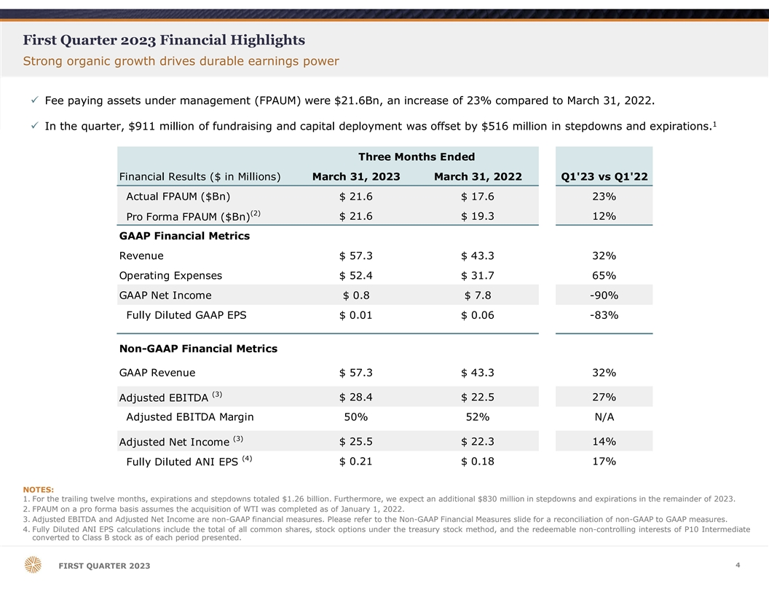
First Quarter 2023 Financial Highlights Strong organic growth drives durable earnings power ü Fee paying assets under management (FPAUM) were $21.6Bn, an increase of 23% compared to March 31, 2022. 1 ü In the quarter, $911 million of fundraising and capital deployment was offset by $516 million in stepdowns and expirations. Three Months Ended Financial Results ($ in Millions) March 31, 2023 March 31, 2022 Q1'23 vs Q1'22 Actual FPAUM ($Bn) $ 21.6 $ 17.6 23% (2) Pro Forma FPAUM ($Bn) $ 21.6 $ 19.3 12% GAAP Financial Metrics Revenue $ 57.3 $ 43.3 32% Operating Expenses $ 52.4 $ 31.7 65% GAAP Net Income $ 0.8 $ 7.8 -90% Fully Diluted GAAP EPS $ 0.01 $ 0.06 -83% Non-GAAP Financial Metrics GAAP Revenue $ 57.3 $ 43.3 32% (3) $ 28.4 $ 22.5 27% Adjusted EBITDA Adjusted EBITDA Margin 50% 52% N/A (3) Adjusted Net Income $ 25.5 $ 22.3 14% (4) $ 0.21 $ 0.18 17% Fully Diluted ANI EPS NOTES: 1. For the trailing twelve months, expirations and stepdowns totaled $1.26 billion. Furthermore, we expect an additional $830 million in stepdowns and expirations in the remainder of 2023. 2. FPAUM on a pro forma basis assumes the acquisition of WTI was completed as of January 1, 2022. 3. Adjusted EBITDA and Adjusted Net Income are non-GAAP financial measures. Please refer to the Non-GAAP Financial Measures slide for a reconciliation of non-GAAP to GAAP measures. 4. Fully Diluted ANI EPS calculations include the total of all common shares, stock options under the treasury stock method, and the redeemable non-controlling interests of P10 Intermediate converted to Class B stock as of each period presented. 4 FIRST QUARTER 2023

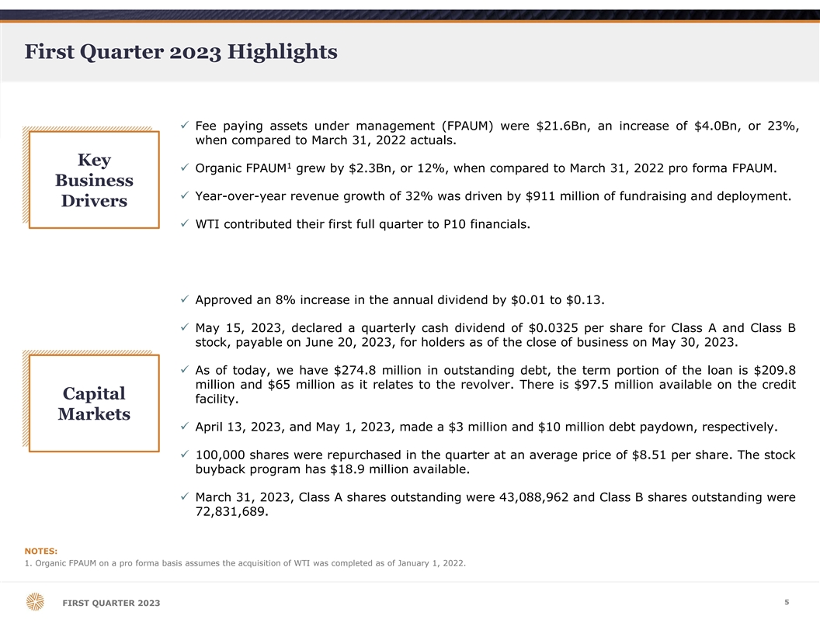
First Quarter 2023 Highlights ü Fee paying assets under management (FPAUM) were $21.6Bn, an increase of $4.0Bn, or 23%, when compared to March 31, 2022 actuals. Key 1 ü Organic FPAUM grew by $2.3Bn, or 12%, when compared to March 31, 2022 pro forma FPAUM. Business ü Year-over-year revenue growth of 32% was driven by $911 million of fundraising and deployment. Drivers ü WTI contributed their first full quarter to P10 financials. ü Approved an 8% increase in the annual dividend by $0.01 to $0.13. ü May 15, 2023, declared a quarterly cash dividend of $0.0325 per share for Class A and Class B stock, payable on June 20, 2023, for holders as of the close of business on May 30, 2023. ü As of today, we have $274.8 million in outstanding debt, the term portion of the loan is $209.8 million and $65 million as it relates to the revolver. There is $97.5 million available on the credit Capital facility. Markets ü April 13, 2023, and May 1, 2023, made a $3 million and $10 million debt paydown, respectively. ü 100,000 shares were repurchased in the quarter at an average price of $8.51 per share. The stock buyback program has $18.9 million available. ü March 31, 2023, Class A shares outstanding were 43,088,962 and Class B shares outstanding were 72,831,689. NOTES: 1. Organic FPAUM on a pro forma basis assumes the acquisition of WTI was completed as of January 1, 2022. 5 FIRST QUARTER 2023

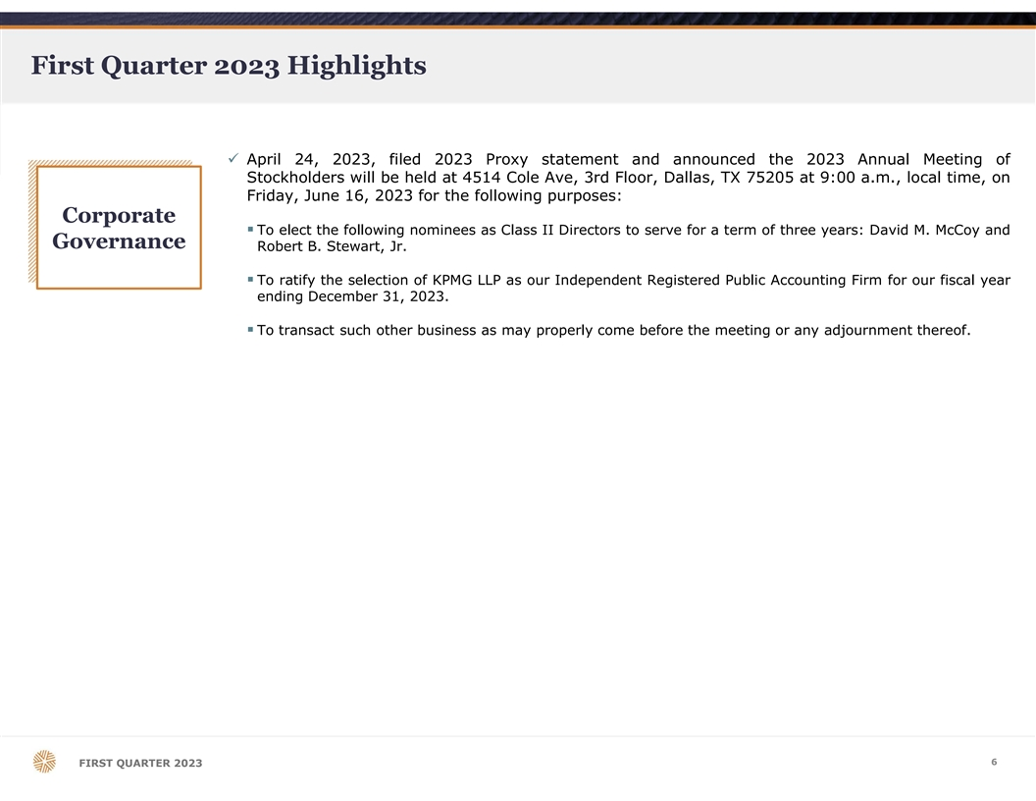
First Quarter 2023 Highlights ü April 24, 2023, filed 2023 Proxy statement and announced the 2023 Annual Meeting of Stockholders will be held at 4514 Cole Ave, 3rd Floor, Dallas, TX 75205 at 9:00 a.m., local time, on Friday, June 16, 2023 for the following purposes: Corporate § To elect the following nominees as Class II Directors to serve for a term of three years: David M. McCoy and Governance Robert B. Stewart, Jr. § To ratify the selection of KPMG LLP as our Independent Registered Public Accounting Firm for our fiscal year ending December 31, 2023. § To transact such other business as may properly come before the meeting or any adjournment thereof. 6 FIRST QUARTER 2023

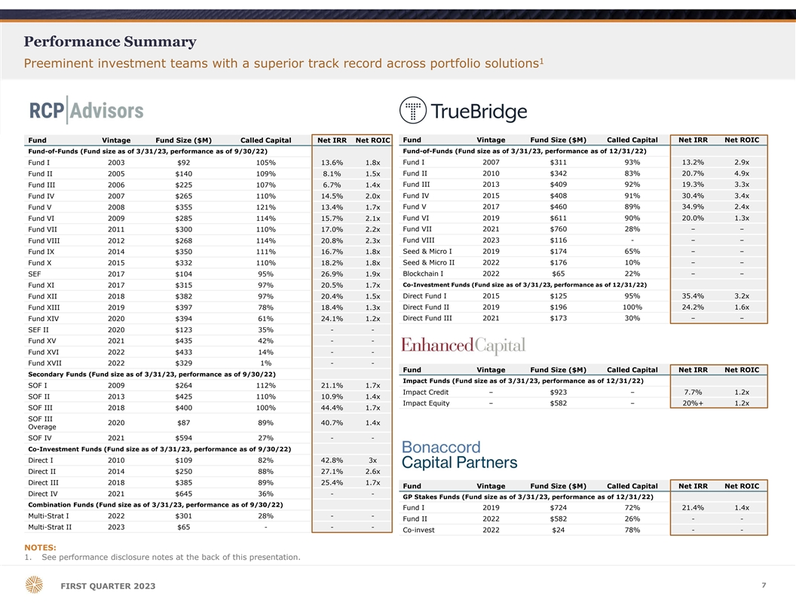
Performance Summary 1 Preeminent investment teams with a superior track record across portfolio solutions Fund Vintage Fund Size ($M) Called Capital Net IRR Net ROIC Fund Vintage Fund Size ($M) Called Capital Net IRR Net ROIC Fund-of-Funds (Fund size as of 3/31/23, performance as of 9/30/22) Fund-of-Funds (Fund size as of 3/31/23, performance as of 12/31/22) Fund I 2003 $92 105% 13.6% 1.8x Fund I 2007 $311 93% 13.2% 2.9x Fund II 2005 $140 109% 8.1% 1.5x Fund II 2010 $342 83% 20.7% 4.9x Fund III 2013 $409 92% 19.3% 3.3x Fund III 2006 $225 107% 6.7% 1.4x Fund IV 2015 $408 91% 30.4% 3.4x Fund IV 2007 $265 110% 14.5% 2.0x Fund V 2017 $460 89% 34.9% 2.4x Fund V 2008 $355 121% 13.4% 1.7x Fund VI 2009 $285 114% 15.7% 2.1x Fund VI 2019 $611 90% 20.0% 1.3x Fund VII 2011 $300 110% 17.0% 2.2x Fund VII 2021 $760 28% – – Fund VIII 2012 $268 114% 20.8% 2.3x Fund VIII 2023 $116 - – – Fund IX 2014 $350 111% 16.7% 1.8x Seed & Micro I 2019 $174 65% – – Fund X 2015 $332 110% 18.2% 1.8x Seed & Micro II 2022 $176 10% – – SEF 2017 $104 95% 26.9% 1.9x Blockchain I 2022 $65 22% – – Fund XI 2017 $315 97% 20.5% 1.7x Co-Investment Funds (Fund size as of 3/31/23, performance as of 12/31/22) Direct Fund I 2015 $125 95% 35.4% 3.2x Fund XII 2018 $382 97% 20.4% 1.5x Direct Fund II 2019 $196 100% 24.2% 1.6x Fund XIII 2019 $397 78% 18.4% 1.3x Direct Fund III 2021 $173 30% – – Fund XIV 2020 $394 61% 24.1% 1.2x SEF II 2020 $123 35% - - Fund XV 2021 $435 42% - - Fund XVI 2022 $433 14% - - Fund XVII 2022 $329 1% - - Fund Vintage Fund Size ($M) Called Capital Net IRR Net ROIC Secondary Funds (Fund size as of 3/31/23, performance as of 9/30/22) Impact Funds (Fund size as of 3/31/23, performance as of 12/31/22) SOF I 2009 $264 112% 21.1% 1.7x Impact Credit – $923 – 7.7% 1.2x SOF II 2013 $425 110% 10.9% 1.4x Impact Equity – $582 – 20%+ 1.2x SOF III 2018 $400 100% 44.4% 1.7x SOF III 2020 $87 89% 40.7% 1.4x Overage SOF IV 2021 $594 27% - - Co-Investment Funds (Fund size as of 3/31/23, performance as of 9/30/22) Direct I 2010 $109 82% 42.8% 3x Direct II 2014 $250 88% 27.1% 2.6x Direct III 2018 $385 89% 25.4% 1.7x Fund Vintage Fund Size ($M) Called Capital Net IRR Net ROIC Direct IV 2021 $645 36% - - GP Stakes Funds (Fund size as of 3/31/23, performance as of 12/31/22) Combination Funds (Fund size as of 3/31/23, performance as of 9/30/22) Fund I 2019 $724 72% 21.4% 1.4x Multi-Strat I 2022 $301 28% - - Fund II 2022 $582 26% - - Multi-Strat II 2023 $65 - - - Co-invest 2022 $24 78% - - NOTES: 1. See performance disclosure notes at the back of this presentation. 7 FIRST QUARTER 2023

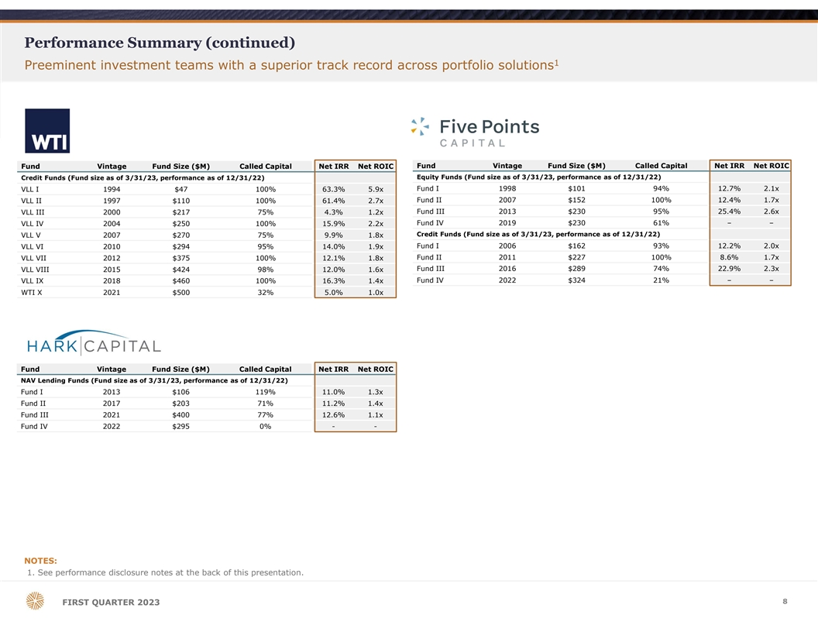
Performance Summary (continued) 1 Preeminent investment teams with a superior track record across portfolio solutions Fund Vintage Fund Size ($M) Called Capital Net IRR Net ROIC Fund Vintage Fund Size ($M) Called Capital Net IRR Net ROIC Equity Funds (Fund size as of 3/31/23, performance as of 12/31/22) Credit Funds (Fund size as of 3/31/23, performance as of 12/31/22) Fund I 1998 $101 94% 12.7% 2.1x VLL I 1994 $47 100% 63.3% 5.9x Fund II 2007 $152 100% 12.4% 1.7x VLL II 1997 $110 100% 61.4% 2.7x Fund III 2013 $230 95% 25.4% 2.6x VLL III 2000 $217 75% 4.3% 1.2x Fund IV 2019 $230 61% – – VLL IV 2004 $250 100% 15.9% 2.2x Credit Funds (Fund size as of 3/31/23, performance as of 12/31/22) VLL V 2007 $270 75% 9.9% 1.8x VLL VI 2010 $294 95% 14.0% 1.9x Fund I 2006 $162 93% 12.2% 2.0x Fund II 2011 $227 100% 8.6% 1.7x VLL VII 2012 $375 100% 12.1% 1.8x Fund III 2016 $289 74% 22.9% 2.3x VLL VIII 2015 $424 98% 12.0% 1.6x Fund IV 2022 $324 21% – – VLL IX 2018 $460 100% 16.3% 1.4x WTI X 2021 $500 32% 5.0% 1.0x Fund Vintage Fund Size ($M) Called Capital Net IRR Net ROIC NAV Lending Funds (Fund size as of 3/31/23, performance as of 12/31/22) Fund I 2013 $106 119% 11.0% 1.3x Fund II 2017 $203 71% 11.2% 1.4x Fund III 2021 $400 77% 12.6% 1.1x Fund IV 2022 $295 0% - - NOTES: 1. See performance disclosure notes at the back of this presentation. 8 FIRST QUARTER 2023

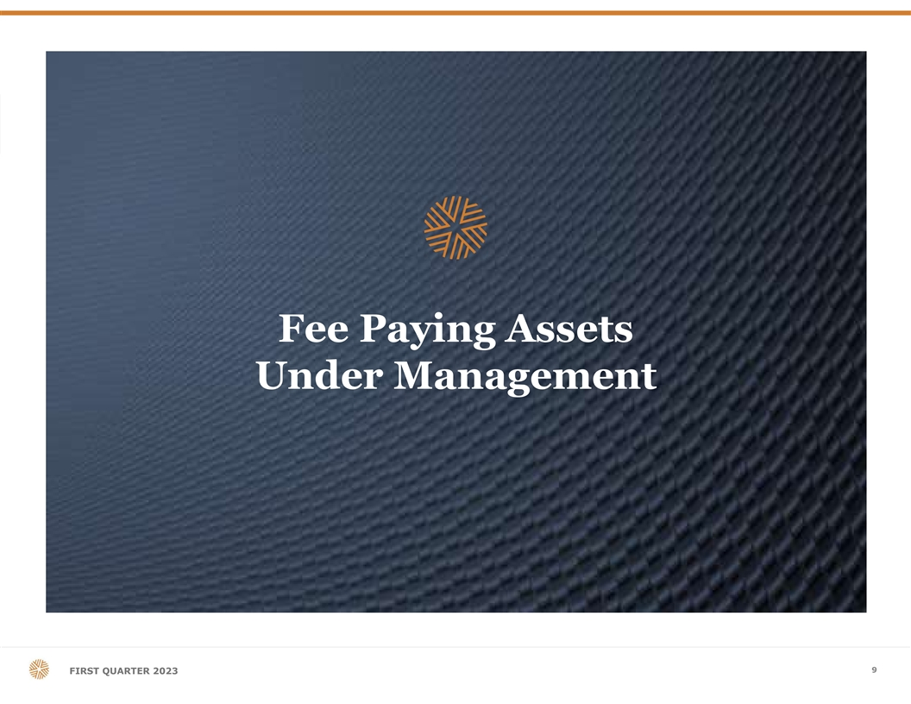
Fee Paying Assets Under Management 9 FIRST QUARTER 2023

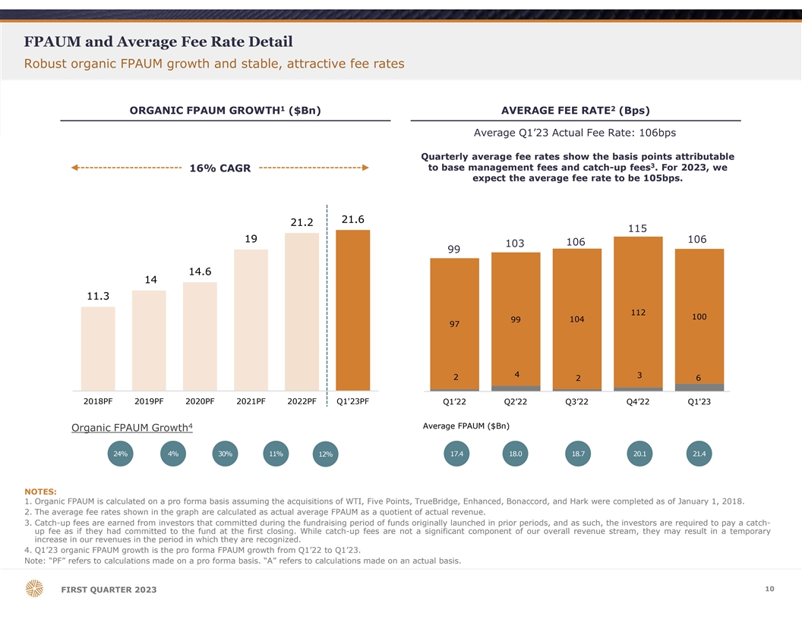
FPAUM and Average Fee Rate Detail Robust organic FPAUM growth and stable, attractive fee rates 1 2 ORGANIC FPAUM GROWTH ($Bn) AVERAGE FEE RATE (Bps) Average Q1’23 Actual Fee Rate: 106bps Quarterly average fee rates show the basis points attributable 3 to base management fees and catch-up fees . For 2023, we 16% CAGR expect the average fee rate to be 105bps. 21.6 21.2 115 19 106 106 103 99 14.6 14 11.3 112 100 99 104 97 4 3 2 2 6 2018PF 2019PF 2020PF 2021PF 2022PF Q1'23PF Q1’22 Q2’22 Q3’22 Q4’22 Q1'23 4 Average FPAUM ($Bn) Organic FPAUM Growth 24% 4% 30% 11% 17.4 18.0 18.7 20.1 21.4 12% NOTES: 1. Organic FPAUM is calculated on a pro forma basis assuming the acquisitions of WTI, Five Points, TrueBridge, Enhanced, Bonaccord, and Hark were completed as of January 1, 2018. 2. The average fee rates shown in the graph are calculated as actual average FPAUM as a quotient of actual revenue. 3. Catch-up fees are earned from investors that committed during the fundraising period of funds originally launched in prior periods, and as such, the investors are required to pay a catch- up fee as if they had committed to the fund at the first closing. While catch-up fees are not a significant component of our overall revenue stream, they may result in a temporary increase in our revenues in the period in which they are recognized. 4. Q1’23 organic FPAUM growth is the pro forma FPAUM growth from Q1’22 to Q1’23. Note: “PF” refers to calculations made on a pro forma basis. “A” refers to calculations made on an actual basis. 10 FIRST QUARTER 2023

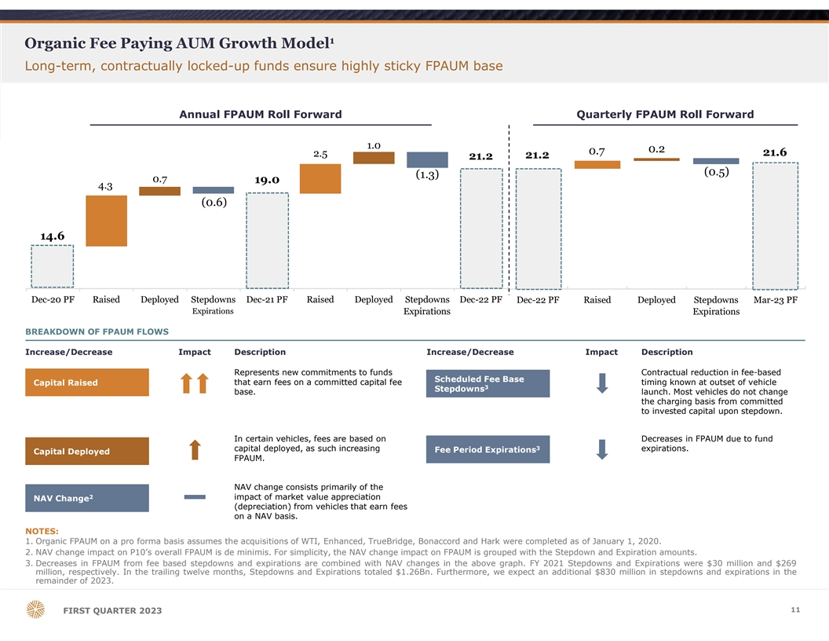
1 Organic Fee Paying AUM Growth Model Long-term, contractually locked-up funds ensure highly sticky FPAUM base Annual FPAUM Roll Forward Quarterly FPAUM Roll Forward 1.0 0.2 0.7 21.6 2.5 21.2 21.2 (0.5) (1.3) 0.7 19.0 4.3 (0.6) 14.6 Dec-20 PF Raised Deployed Stepdowns Dec-21 PF Raised Deployed Stepdowns Dec-22 PF Dec-22 PF Raised Deployed Stepdowns Mar-23 PF Expirations Expirations Expirations BREAKDOWN OF FPAUM FLOWS Increase/Decrease Impact Description Increase/Decrease Impact Description Represents new commitments to funds Contractual reduction in fee-based Scheduled Fee Base Capital Raised that earn fees on a committed capital fee timing known at outset of vehicle 3 Stepdowns base. launch. Most vehicles do not change the charging basis from committed to invested capital upon stepdown. In certain vehicles, fees are based on Decreases in FPAUM due to fund 3 capital deployed, as such increasing expirations. Fee Period Expirations Capital Deployed FPAUM. NAV change consists primarily of the 2 impact of market value appreciation NAV Change (depreciation) from vehicles that earn fees on a NAV basis. NOTES: 1. Organic FPAUM on a pro forma basis assumes the acquisitions of WTI, Enhanced, TrueBridge, Bonaccord and Hark were completed as of January 1, 2020. 2. NAV change impact on P10’s overall FPAUM is de minimis. For simplicity, the NAV change impact on FPAUM is grouped with the Stepdown and Expiration amounts. 3. Decreases in FPAUM from fee based stepdowns and expirations are combined with NAV changes in the above graph. FY 2021 Stepdowns and Expirations were $30 million and $269 million, respectively. In the trailing twelve months, Stepdowns and Expirations totaled $1.26Bn. Furthermore, we expect an additional $830 million in stepdowns and expirations in the remainder of 2023. 11 FIRST QUARTER 2023

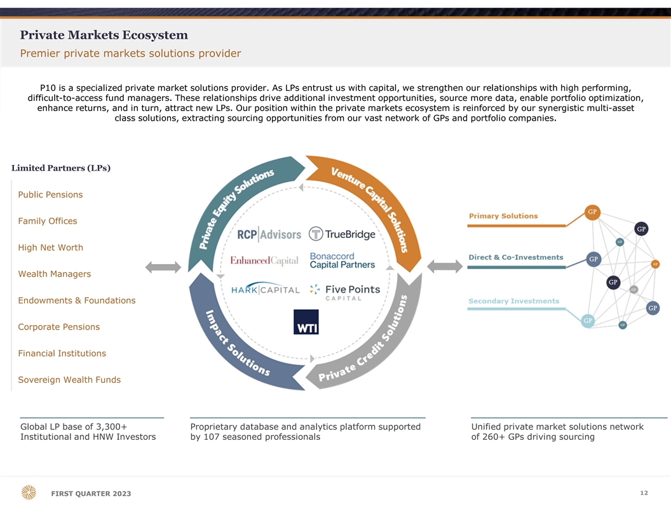
Private Markets Ecosystem Premier private markets solutions provider P10 is a specialized private market solutions provider. As LPs entrust us with capital, we strengthen our relationships with high performing, difficult-to-access fund managers. These relationships drive additional investment opportunities, source more data, enable portfolio optimization, enhance returns, and in turn, attract new LPs. Our position within the private markets ecosystem is reinforced by our synergistic multi-asset class solutions, extracting sourcing opportunities from our vast network of GPs and portfolio companies. Limited Partners (LPs) Public Pensions Family Offices High Net Worth Wealth Managers Endowments & Foundations Corporate Pensions Financial Institutions Sovereign Wealth Funds Global LP base of 3,300+ Proprietary database and analytics platform supported Unified private market solutions network Institutional and HNW Investors by 107 seasoned professionals of 260+ GPs driving sourcing 12 FIRST QUARTER 2023

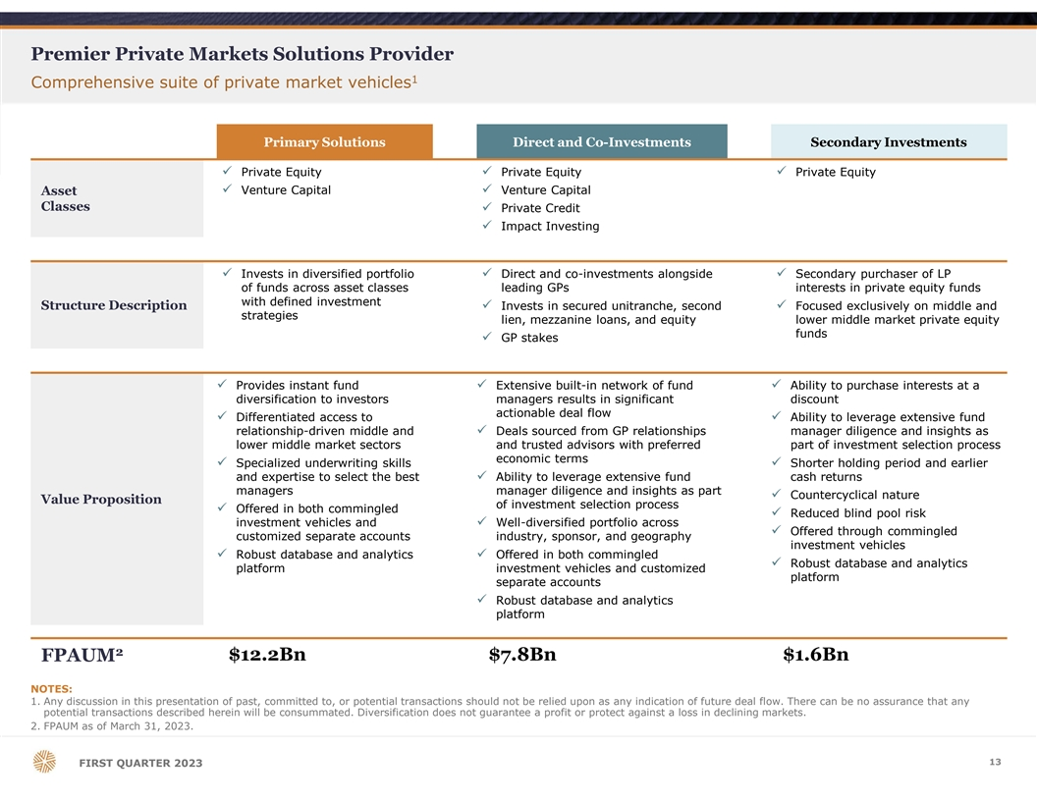
Premier Private Markets Solutions Provider 1 Comprehensive suite of private market vehicles Primary Solutions Direct and Co-Investments Secondary Investments ü Private Equityü Private Equityü Private Equity ü Venture Capitalü Venture Capital Asset Classes ü Private Credit ü Impact Investing ü Invests in diversified portfolio ü Direct and co-investments alongside ü Secondary purchaser of LP of funds across asset classes leading GPs interests in private equity funds with defined investment Structure Descriptionü Invests in secured unitranche, second ü Focused exclusively on middle and strategies lien, mezzanine loans, and equity lower middle market private equity funds ü GP stakes ü Provides instant fund ü Extensive built-in network of fund ü Ability to purchase interests at a diversification to investors managers results in significant discount actionable deal flow ü Differentiated access to ü Ability to leverage extensive fund relationship-driven middle and ü Deals sourced from GP relationships manager diligence and insights as lower middle market sectors and trusted advisors with preferred part of investment selection process economic terms ü Specialized underwriting skills ü Shorter holding period and earlier and expertise to select the best ü Ability to leverage extensive fund cash returns managers manager diligence and insights as part ü Countercyclical nature Value Proposition of investment selection process ü Offered in both commingled ü Reduced blind pool risk investment vehicles and ü Well-diversified portfolio across ü Offered through commingled customized separate accounts industry, sponsor, and geography investment vehicles ü Robust database and analytics ü Offered in both commingled ü Robust database and analytics platform investment vehicles and customized platform separate accounts ü Robust database and analytics platform 2 $12.2Bn $7.8Bn $1.6Bn FPAUM NOTES: 1. Any discussion in this presentation of past, committed to, or potential transactions should not be relied upon as any indication of future deal flow. There can be no assurance that any potential transactions described herein will be consummated. Diversification does not guarantee a profit or protect against a loss in declining markets. 2. FPAUM as of March 31, 2023. 13 FIRST QUARTER 2023

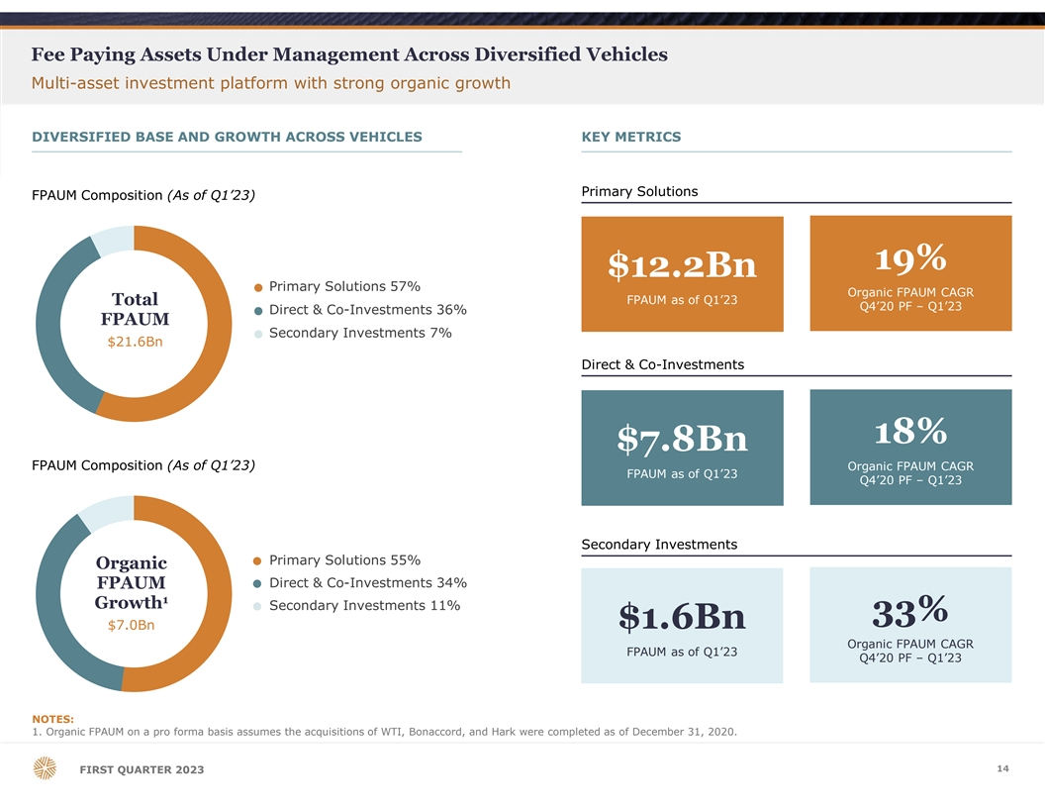
Fee Paying Assets Under Management Across Diversified Vehicles Multi-asset investment platform with strong organic growth DIVERSIFIED BASE AND GROWTH ACROSS VEHICLES KEY METRICS Primary Solutions FPAUM Composition (As of Q1’23) 19% $12.2Bn Primary Solutions 57% ● Organic FPAUM CAGR Total FPAUM as of Q1’23 Q4’20 PF – Q1’23 Direct & Co-Investments 36% ● FPAUM Secondary Investments 7% ● $21.6Bn Direct & Co-Investments 18% $7.8Bn FPAUM Composition (As of Q1’23) Organic FPAUM CAGR FPAUM as of Q1’23 Q4’20 PF – Q1’23 Secondary Investments Primary Solutions 55% ● Organic Direct & Co-Investments 34% FPAUM ● 1 Growth Secondary Investments 11% ● 33% $1.6Bn $7.0Bn Organic FPAUM CAGR FPAUM as of Q1’23 Q4’20 PF – Q1’23 NOTES: 1. Organic FPAUM on a pro forma basis assumes the acquisitions of WTI, Bonaccord, and Hark were completed as of December 31, 2020. 14 FIRST QUARTER 2023

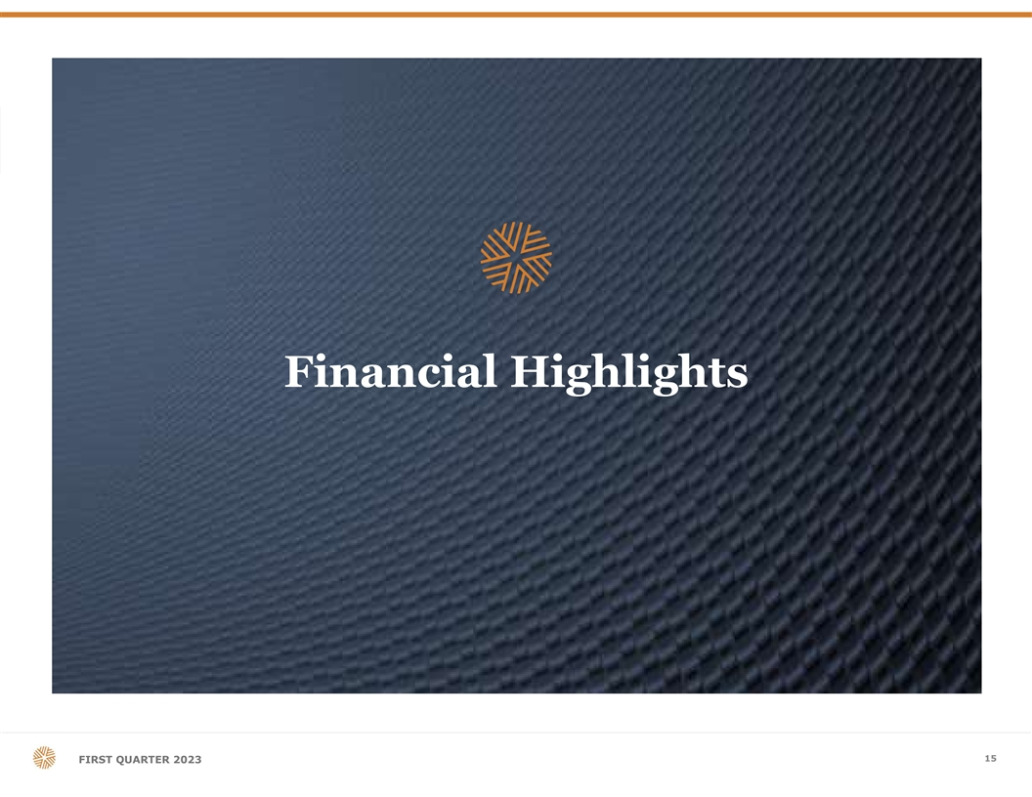
Financial Highlights 15 FIRST QUARTER 2023

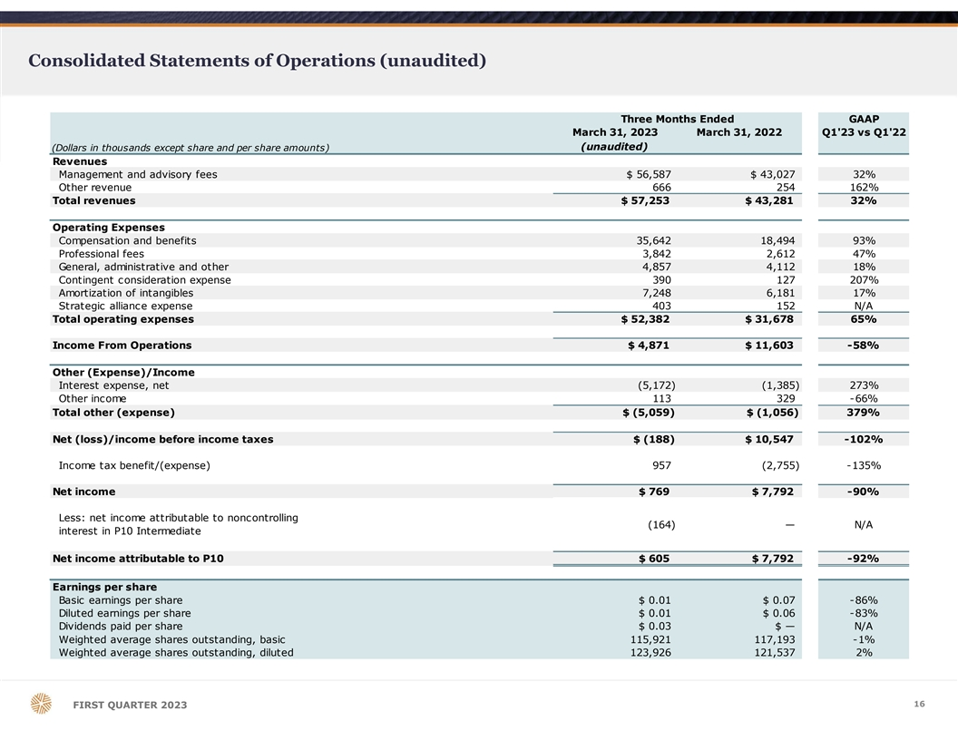
Consolidated Statements of Operations (unaudited) Three Months Ended GAAP March 31, 2023 March 31, 2022 Q1'23 vs Q1'22 (unaudited) (Dollars in thousands except share and per share amounts) Revenues Management and advisory fees $ 56,587 $ 43,027 32% Other revenue 666 2 54 162% Total revenues $ 57,253 $ 43,281 32% Operating Expenses Compensation and benefits 3 5,642 1 8,494 93% Professional fees 3,842 2 ,612 47% General, administrative and other 4,857 4 ,112 18% Contingent consideration expense 390 1 27 207% Amortization of intangibles 7,248 6 ,181 17% Strategic alliance expense 403 1 52 N/A Total operating expenses $ 52,382 $ 31,678 65% Income From Operations $ 4,871 $ 11,603 -58% Other (Expense)/Income Interest expense, net (5,172) (1,385) 273% Other income 113 3 29 -66% Total other (expense) $ (5,059) $ (1,056) 379% Net (loss)/income before income taxes $ (188) $ 10,547 -102% Income tax benefit/(expense) 957 (2,755) -135% Net income $ 769 $ 7,792 -90% Less: net income attributable to noncontrolling ( 164) — N/A interest in P10 Intermediate Net income attributable to P10 $ 605 $ 7,792 -92% Earnings per share Basic earnings per share $ 0.01 $ 0.07 -86% Diluted earnings per share $ 0.01 $ 0.06 -83% Dividends paid per share $ 0.03 $ — N/A Weighted average shares outstanding, basic 115,921 1 17,193 -1% Weighted average shares outstanding, diluted 123,926 1 21,537 2% 16 FIRST QUARTER 2023

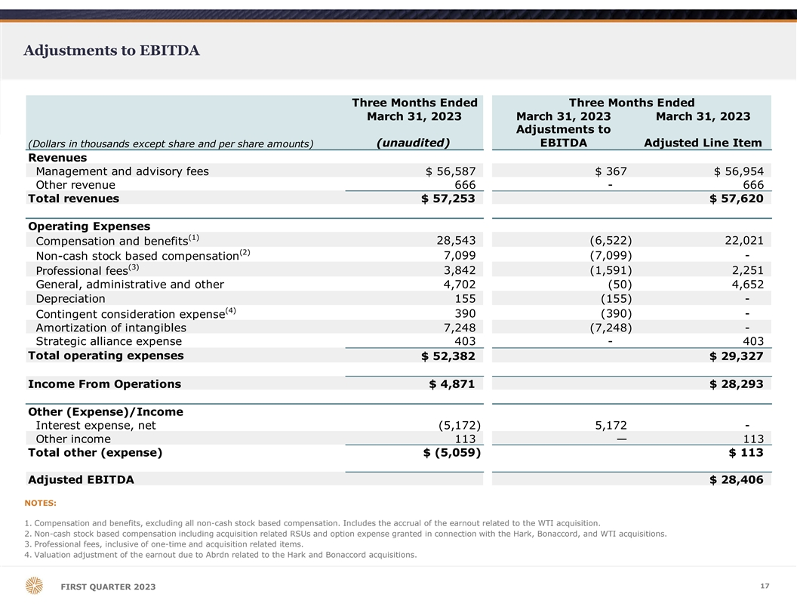
Adjustments to EBITDA Three Months Ended Three Months Ended March 31, 2023 March 31, 2023 March 31, 2023 Adjustments to (unaudited) EBITDA Adjusted Line Item (Dollars in thousands except share and per share amounts) Revenues Management and advisory fees $ 56,587 $ 367 $ 56,954 Other revenue 6 66 - 666 Total revenues $ 57,253 $ 57,620 Operating Expenses (1) 2 8,543 ( 6,522) 2 2,021 Compensation and benefits (2) Non-cash stock based compensation 7,099 (7,099) - (3) Professional fees 3,842 (1,591) 2,251 General, administrative and other 4 ,702 (50) 4,652 Depreciation 1 55 ( 155) - (4) Contingent consideration expense 3 90 ( 390) - Amortization of intangibles 7 ,248 (7,248) - Strategic alliance expense 4 03 - 403 Total operating expenses $ 52,382 $ 29,327 Income From Operations $ 4,871 $ 28,293 Other (Expense)/Income Interest expense, net ( 5,172) 5,172 - Other income 1 13 — 1 13 Total other (expense) $ (5,059) $ 113 Adjusted EBITDA $ 28,406 NOTES: 1. Compensation and benefits, excluding all non-cash stock based compensation. Includes the accrual of the earnout related to the WTI acquisition. 2. Non-cash stock based compensation including acquisition related RSUs and option expense granted in connection with the Hark, Bonaccord, and WTI acquisitions. 3. Professional fees, inclusive of one-time and acquisition related items. 4. Valuation adjustment of the earnout due to Abrdn related to the Hark and Bonaccord acquisitions. 17 FIRST QUARTER 2023

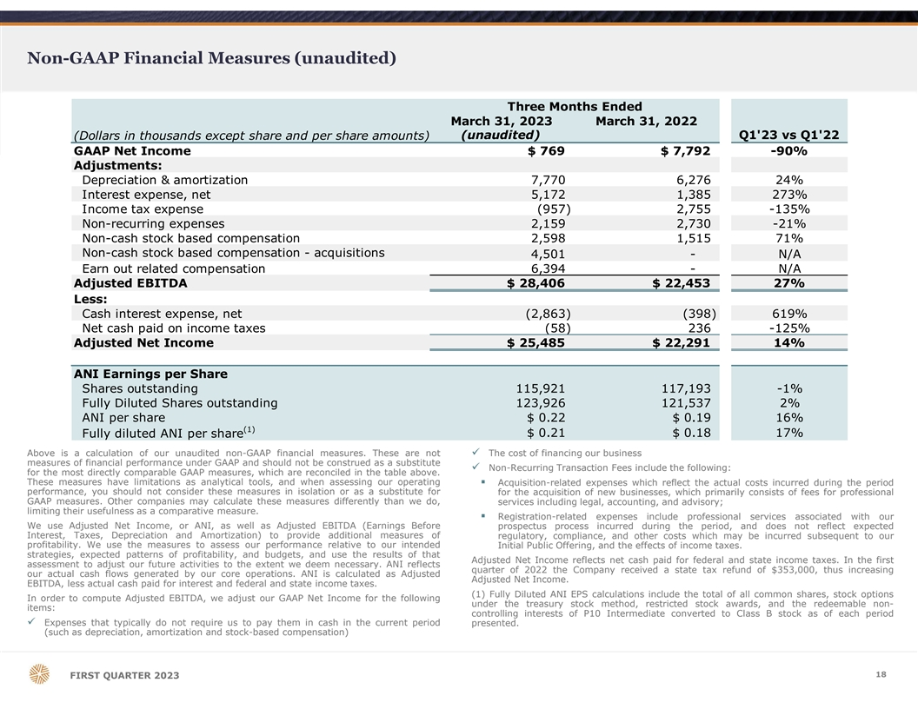
Non-GAAP Financial Measures (unaudited) Three Months Ended March 31, 2023 March 31, 2022 (unaudited) Q1'23 vs Q1'22 (Dollars in thousands except share and per share amounts) GAAP Net Income $ 769 $ 7,792 -90% Adjustments: Depreciation & amortization 7,770 6,276 24% Interest expense, net 5,172 1,385 273% Income tax expense (957) 2,755 -135% Non-recurring expenses 2,159 2,730 -21% Non-cash stock based compensation 2,598 1,515 71% Non-cash stock based compensation - acquisitions 4,501 - N/A Earn out related compensation 6,394 - N/A Adjusted EBITDA $ 28,406 $ 22,453 27% Less: Cash interest expense, net ( 2,863) (398) 619% Net cash paid on income taxes (58) 236 -125% Adjusted Net Income $ 25,485 $ 22,291 14% ANI Earnings per Share Shares outstanding 115,921 117,193 -1% Fully Diluted Shares outstanding 123,926 121,537 2% ANI per share $ 0.22 $ 0.19 16% (1) $ 0.21 $ 0.18 17% Fully diluted ANI per share Above is a calculation of our unaudited non-GAAP financial measures. These are notü The cost of financing our business measures of financial performance under GAAP and should not be construed as a substitute ü Non-Recurring Transaction Fees include the following: for the most directly comparable GAAP measures, which are reconciled in the table above. These measures have limitations as analytical tools, and when assessing our operating§ Acquisition-related expenses which reflect the actual costs incurred during the period performance, you should not consider these measures in isolation or as a substitute for for the acquisition of new businesses, which primarily consists of fees for professional GAAP measures. Other companies may calculate these measures differently than we do, services including legal, accounting, and advisory; limiting their usefulness as a comparative measure. § Registration-related expenses include professional services associated with our We use Adjusted Net Income, or ANI, as well as Adjusted EBITDA (Earnings Before prospectus process incurred during the period, and does not reflect expected Interest, Taxes, Depreciation and Amortization) to provide additional measures of regulatory, compliance, and other costs which may be incurred subsequent to our profitability. We use the measures to assess our performance relative to our intended Initial Public Offering, and the effects of income taxes. strategies, expected patterns of profitability, and budgets, and use the results of that Adjusted Net Income reflects net cash paid for federal and state income taxes. In the first assessment to adjust our future activities to the extent we deem necessary. ANI reflects quarter of 2022 the Company received a state tax refund of $353,000, thus increasing our actual cash flows generated by our core operations. ANI is calculated as Adjusted Adjusted Net Income. EBITDA, less actual cash paid for interest and federal and state income taxes. (1) Fully Diluted ANI EPS calculations include the total of all common shares, stock options In order to compute Adjusted EBITDA, we adjust our GAAP Net Income for the following under the treasury stock method, restricted stock awards, and the redeemable non- items: controlling interests of P10 Intermediate converted to Class B stock as of each period ü Expenses that typically do not require us to pay them in cash in the current period presented. (such as depreciation, amortization and stock-based compensation) 18 FIRST QUARTER 2023

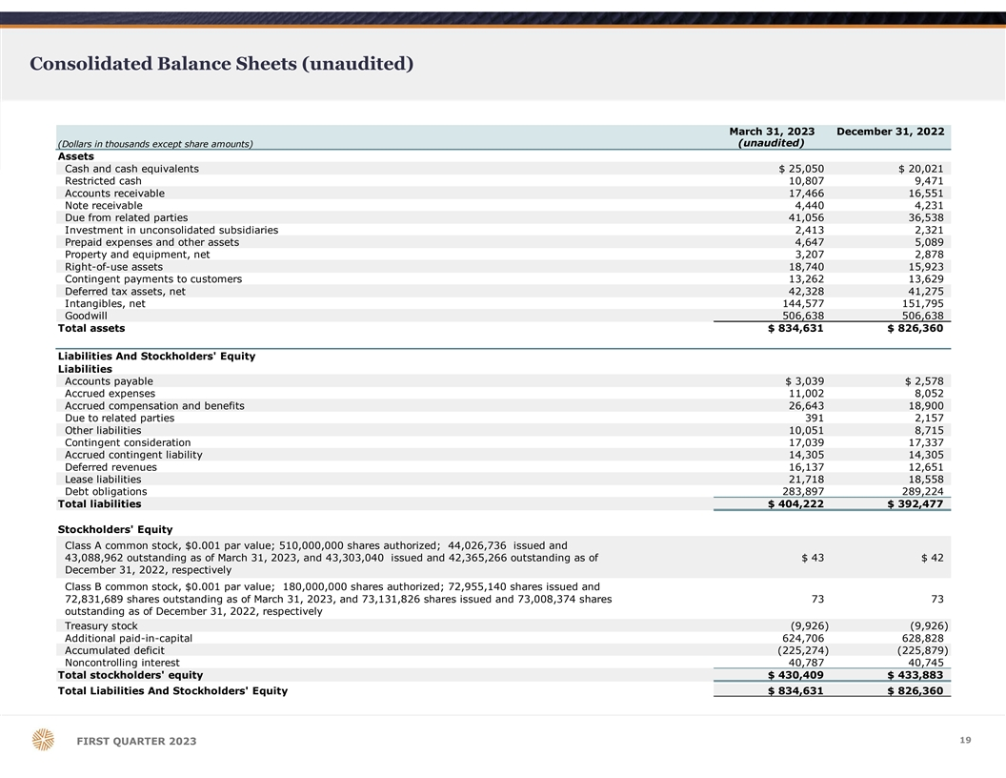
Consolidated Balance Sheets (unaudited) March 31, 2023 December 31, 2022 (unaudited) (Dollars in thousands except share amounts) Assets Cash and cash equivalents $ 25,050 $ 20,021 Restricted cash 10,807 9,471 Accounts receivable 17,466 16,551 Note receivable 4,440 4,231 Due from related parties 41,056 36,538 Investment in unconsolidated subsidiaries 2,413 2,321 Prepaid expenses and other assets 4,647 5,089 Property and equipment, net 3,207 2,878 Right-of-use assets 18,740 15,923 Contingent payments to customers 13,262 13,629 Deferred tax assets, net 42,328 41,275 Intangibles, net 1 44,577 151,795 Goodwill 5 06,638 506,638 Total assets $ 834,631 $ 826,360 Liabilities And Stockholders' Equity Liabilities Accounts payable $ 3,039 $ 2,578 Accrued expenses 11,002 8,052 Accrued compensation and benefits 26,643 18,900 Due to related parties 391 2,157 Other liabilities 10,051 8,715 Contingent consideration 17,039 17,337 Accrued contingent liability 14,305 14,305 Deferred revenues 16,137 12,651 Lease liabilities 21,718 18,558 Debt obligations 2 83,897 289,224 Total liabilities $ 404,222 $ 392,477 Stockholders' Equity Class A common stock, $0.001 par value; 510,000,000 shares authorized; 44,026,736 issued and 43,088,962 outstanding as of March 31, 2023, and 43,303,040 issued and 42,365,266 outstanding as of $ 43 $ 42 December 31, 2022, respectively Class B common stock, $0.001 par value; 180,000,000 shares authorized; 72,955,140 shares issued and 72,831,689 shares outstanding as of March 31, 2023, and 73,131,826 shares issued and 73,008,374 shares 7 3 73 outstanding as of December 31, 2022, respectively Treasury stock (9,926) (9,926) Additional paid-in-capital 624,706 628,828 Accumulated deficit (225,274) ( 225,879) Noncontrolling interest 40,787 40,745 Total stockholders' equity $ 430,409 $ 433,883 Total Liabilities And Stockholders' Equity $ 834,631 $ 826,360 19 FIRST QUARTER 2023

Consolidated Statements of Cash Flows (unaudited) Three Months Ended March 31, 2023 March 31, 2022 (unaudited) (Dollars in thousands) Cash Flows From Operating Activities Net income $ 769 $ 7,792 Adjustments to reconcile net income to net cash provided by operating activities: Stock-based compensation 7,099 1 ,515 Depreciation expense 155 95 Amortization of intangibles 7,248 6 ,181 Amortization of debt issuance costs and debt discount 330 202 Income from unconsolidated subsidiaries ( 114) (326) Deferred tax expense (benefit) (1,053) 2 ,304 Amortization of contingent payment to customers 367 - Remeasurement of contingent consideration 390 127 Post close purchase price adjustment - 11 Change in operating assets and liabilities: Accounts receivable ( 915) (515) Due from related parties (4,518) (5,747) Prepaid expenses and other assets 442 634 Right-of-use assets 658 596 Accounts payable 461 341 Accrued expenses 2,820 (11,372) Accrued compensation and benefits 3,896 (2,854) Due to related parties (1,766) (1,853) Other liabilities 1,337 11,919 Deferred revenues 3,486 (1,024) Lease liabilities ( 315) (404) Net cash provided by operating activities $ 20,777 $ 7,622 Cash Flows From Investing Activities Purchase of intangible assets $ (21) $ — Draw on note receivable ( 211) (231) Proceeds from note receivable 2 7 Proceeds from investments in unconsolidated subsidiaries 22 98 Software capitalization (9) ( 35) Purchases of property and equipment ( 484) (263) Net cash used in investing activities $ (701) $ (424) Cash Flows From Financing Activities Borrowings on debt obligations $ 16,000 $ — Repayments on debt obligations (21,657) (25,000) Repurchase of Class A common stock for employee tax withholding (3,038) - Repurchase of Class B common stock ( 851) - Payments of contingent consideration ( 688) - Dividends paid (3,477) - Debt issuance costs - (8) Net cash used in financing activities $ (13,711) $ (25,008) Net change in cash, cash equivalents and restricted cash $ 6,365 $ (17,810) Cash And Cash Equivalents And Restricted Cash, Beginning of Period $ 29,492 $ 43,482 Cash And Cash Equivalents And Restricted Cash, End of Period $ 35,857 $ 25,672 20 FIRST QUARTER 2023

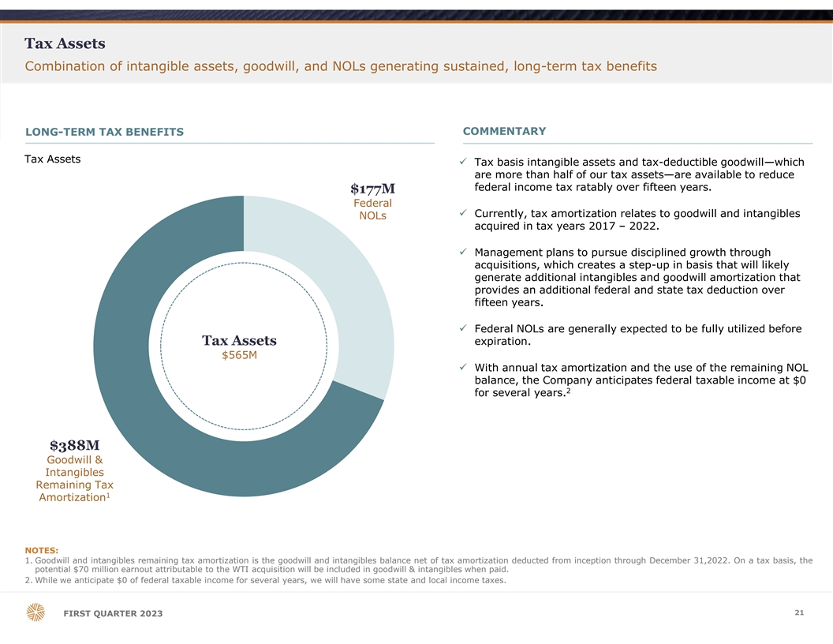
Tax Assets Combination of intangible assets, goodwill, and NOLs generating sustained, long-term tax benefits COMMENTARY LONG-TERM TAX BENEFITS Tax Assets ü Tax basis intangible assets and tax-deductible goodwill—which are more than half of our tax assets—are available to reduce federal income tax ratably over fifteen years. $177M Federal ü Currently, tax amortization relates to goodwill and intangibles NOLs acquired in tax years 2017 – 2022. ü Management plans to pursue disciplined growth through acquisitions, which creates a step-up in basis that will likely generate additional intangibles and goodwill amortization that provides an additional federal and state tax deduction over fifteen years. ü Federal NOLs are generally expected to be fully utilized before Tax Assets expiration. $565M ü With annual tax amortization and the use of the remaining NOL balance, the Company anticipates federal taxable income at $0 2 for several years. $388M Goodwill & Intangibles Remaining Tax 1 Amortization NOTES: 1. Goodwill and intangibles remaining tax amortization is the goodwill and intangibles balance net of tax amortization deducted from inception through December 31,2022. On a tax basis, the potential $70 million earnout attributable to the WTI acquisition will be included in goodwill & intangibles when paid. 2. While we anticipate $0 of federal taxable income for several years, we will have some state and local income taxes. 21 FIRST QUARTER 2023

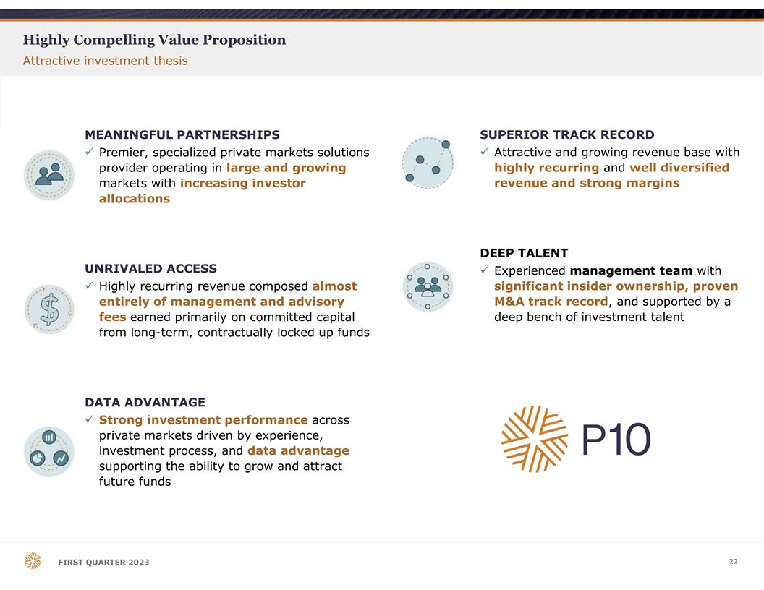
Highly Compelling Value Proposition Attractive investment thesis MEANINGFUL PARTNERSHIPS SUPERIOR TRACK RECORD ü Premier, specialized private markets solutions ü Attractive and growing revenue base with provider operating in large and growing highly recurring and well diversified markets with increasing investor revenue and strong margins allocations DEEP TALENT UNRIVALED ACCESS ü Experienced management team with ü Highly recurring revenue composed almost significant insider ownership, proven entirely of management and advisory M&A track record, and supported by a fees earned primarily on committed capital deep bench of investment talent from long-term, contractually locked up funds DATA ADVANTAGE ü Strong investment performance across private markets driven by experience, investment process, and data advantage supporting the ability to grow and attract future funds 22 FIRST QUARTER 2023

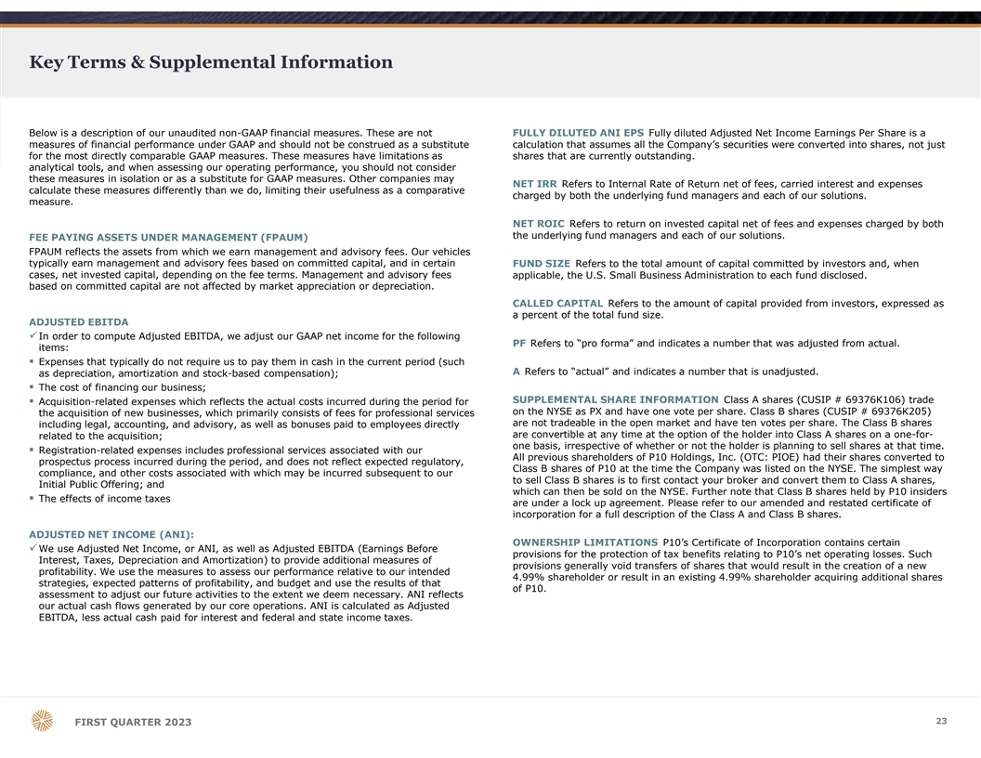
Key Terms & Supplemental Information Below is a description of our unaudited non-GAAP financial measures. These are not FULLY DILUTED ANI EPS Fully diluted Adjusted Net Income Earnings Per Share is a measures of financial performance under GAAP and should not be construed as a substitute calculation that assumes all the Company’s securities were converted into shares, not just for the most directly comparable GAAP measures. These measures have limitations as shares that are currently outstanding. analytical tools, and when assessing our operating performance, you should not consider these measures in isolation or as a substitute for GAAP measures. Other companies may NET IRR Refers to Internal Rate of Return net of fees, carried interest and expenses calculate these measures differently than we do, limiting their usefulness as a comparative charged by both the underlying fund managers and each of our solutions. measure. NET ROIC Refers to return on invested capital net of fees and expenses charged by both the underlying fund managers and each of our solutions. FEE PAYING ASSETS UNDER MANAGEMENT (FPAUM) FPAUM reflects the assets from which we earn management and advisory fees. Our vehicles typically earn management and advisory fees based on committed capital, and in certain FUND SIZE Refers to the total amount of capital committed by investors and, when cases, net invested capital, depending on the fee terms. Management and advisory fees applicable, the U.S. Small Business Administration to each fund disclosed. based on committed capital are not affected by market appreciation or depreciation. CALLED CAPITAL Refers to the amount of capital provided from investors, expressed as a percent of the total fund size. ADJUSTED EBITDA üIn order to compute Adjusted EBITDA, we adjust our GAAP net income for the following PF Refers to “pro forma” and indicates a number that was adjusted from actual. items: § Expenses that typically do not require us to pay them in cash in the current period (such A Refers to “actual” and indicates a number that is unadjusted. as depreciation, amortization and stock-based compensation); § The cost of financing our business; SUPPLEMENTAL SHARE INFORMATION Class A shares (CUSIP # 69376K106) trade § Acquisition-related expenses which reflects the actual costs incurred during the period for on the NYSE as PX and have one vote per share. Class B shares (CUSIP # 69376K205) the acquisition of new businesses, which primarily consists of fees for professional services are not tradeable in the open market and have ten votes per share. The Class B shares including legal, accounting, and advisory, as well as bonuses paid to employees directly are convertible at any time at the option of the holder into Class A shares on a one-for- related to the acquisition; one basis, irrespective of whether or not the holder is planning to sell shares at that time. § Registration-related expenses includes professional services associated with our All previous shareholders of P10 Holdings, Inc. (OTC: PIOE) had their shares converted to prospectus process incurred during the period, and does not reflect expected regulatory, Class B shares of P10 at the time the Company was listed on the NYSE. The simplest way compliance, and other costs associated with which may be incurred subsequent to our to sell Class B shares is to first contact your broker and convert them to Class A shares, Initial Public Offering; and which can then be sold on the NYSE. Further note that Class B shares held by P10 insiders The effects of income taxes § are under a lock up agreement. Please refer to our amended and restated certificate of incorporation for a full description of the Class A and Class B shares. ADJUSTED NET INCOME (ANI): OWNERSHIP LIMITATIONS P10’s Certificate of Incorporation contains certain üWe use Adjusted Net Income, or ANI, as well as Adjusted EBITDA (Earnings Before provisions for the protection of tax benefits relating to P10’s net operating losses. Such Interest, Taxes, Depreciation and Amortization) to provide additional measures of provisions generally void transfers of shares that would result in the creation of a new profitability. We use the measures to assess our performance relative to our intended 4.99% shareholder or result in an existing 4.99% shareholder acquiring additional shares strategies, expected patterns of profitability, and budget and use the results of that of P10. assessment to adjust our future activities to the extent we deem necessary. ANI reflects our actual cash flows generated by our core operations. ANI is calculated as Adjusted EBITDA, less actual cash paid for interest and federal and state income taxes. 2 23 3 FIRST QUARTER 2023

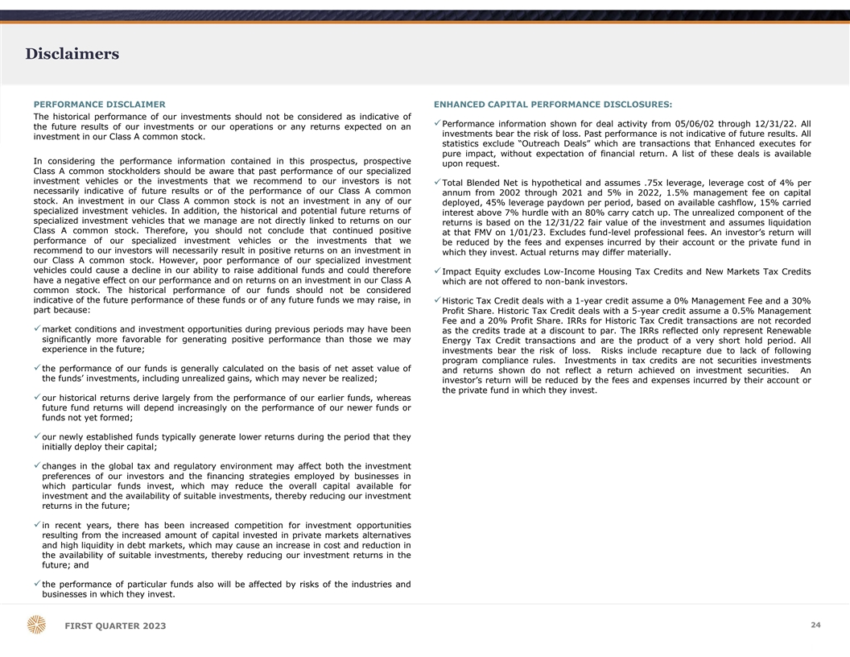
Disclaimers PERFORMANCE DISCLAIMER ENHANCED CAPITAL PERFORMANCE DISCLOSURES: The historical performance of our investments should not be considered as indicative of üPerformance information shown for deal activity from 05/06/02 through 12/31/22. All the future results of our investments or our operations or any returns expected on an investments bear the risk of loss. Past performance is not indicative of future results. All investment in our Class A common stock. statistics exclude “Outreach Deals” which are transactions that Enhanced executes for pure impact, without expectation of financial return. A list of these deals is available In considering the performance information contained in this prospectus, prospective upon request. Class A common stockholders should be aware that past performance of our specialized investment vehicles or the investments that we recommend to our investors is not üTotal Blended Net is hypothetical and assumes .75x leverage, leverage cost of 4% per necessarily indicative of future results or of the performance of our Class A common annum from 2002 through 2021 and 5% in 2022, 1.5% management fee on capital stock. An investment in our Class A common stock is not an investment in any of our deployed, 45% leverage paydown per period, based on available cashflow, 15% carried specialized investment vehicles. In addition, the historical and potential future returns of interest above 7% hurdle with an 80% carry catch up. The unrealized component of the specialized investment vehicles that we manage are not directly linked to returns on our returns is based on the 12/31/22 fair value of the investment and assumes liquidation Class A common stock. Therefore, you should not conclude that continued positive at that FMV on 1/01/23. Excludes fund-level professional fees. An investor’s return will performance of our specialized investment vehicles or the investments that we be reduced by the fees and expenses incurred by their account or the private fund in recommend to our investors will necessarily result in positive returns on an investment in which they invest. Actual returns may differ materially. our Class A common stock. However, poor performance of our specialized investment vehicles could cause a decline in our ability to raise additional funds and could therefore üImpact Equity excludes Low-Income Housing Tax Credits and New Markets Tax Credits have a negative effect on our performance and on returns on an investment in our Class A which are not offered to non-bank investors. common stock. The historical performance of our funds should not be considered indicative of the future performance of these funds or of any future funds we may raise, in üHistoric Tax Credit deals with a 1-year credit assume a 0% Management Fee and a 30% part because: Profit Share. Historic Tax Credit deals with a 5-year credit assume a 0.5% Management Fee and a 20% Profit Share. IRRs for Historic Tax Credit transactions are not recorded ümarket conditions and investment opportunities during previous periods may have been as the credits trade at a discount to par. The IRRs reflected only represent Renewable significantly more favorable for generating positive performance than those we may Energy Tax Credit transactions and are the product of a very short hold period. All experience in the future; investments bear the risk of loss. Risks include recapture due to lack of following program compliance rules. Investments in tax credits are not securities investments üthe performance of our funds is generally calculated on the basis of net asset value of and returns shown do not reflect a return achieved on investment securities. An the funds’ investments, including unrealized gains, which may never be realized; investor’s return will be reduced by the fees and expenses incurred by their account or the private fund in which they invest. üour historical returns derive largely from the performance of our earlier funds, whereas future fund returns will depend increasingly on the performance of our newer funds or funds not yet formed; üour newly established funds typically generate lower returns during the period that they initially deploy their capital; üchanges in the global tax and regulatory environment may affect both the investment preferences of our investors and the financing strategies employed by businesses in which particular funds invest, which may reduce the overall capital available for investment and the availability of suitable investments, thereby reducing our investment returns in the future; üin recent years, there has been increased competition for investment opportunities resulting from the increased amount of capital invested in private markets alternatives and high liquidity in debt markets, which may cause an increase in cost and reduction in the availability of suitable investments, thereby reducing our investment returns in the future; and üthe performance of particular funds also will be affected by risks of the industries and businesses in which they invest. 2 24 4 FIRST QUARTER 2023

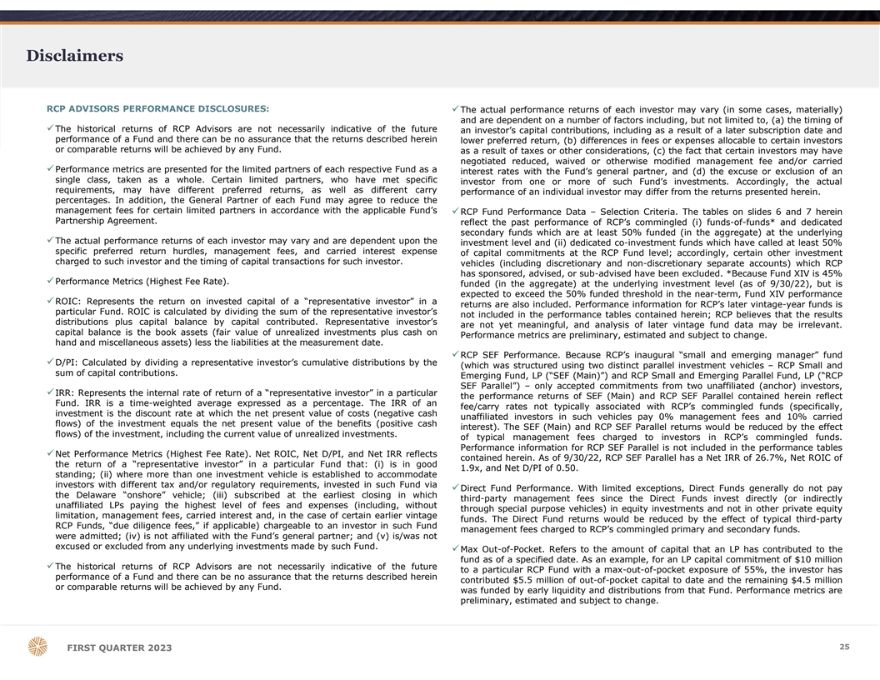
Disclaimers RCP ADVISORS PERFORMANCE DISCLOSURES: üThe actual performance returns of each investor may vary (in some cases, materially) and are dependent on a number of factors including, but not limited to, (a) the timing of üThe historical returns of RCP Advisors are not necessarily indicative of the future an investor’s capital contributions, including as a result of a later subscription date and performance of a Fund and there can be no assurance that the returns described herein lower preferred return, (b) differences in fees or expenses allocable to certain investors or comparable returns will be achieved by any Fund. as a result of taxes or other considerations, (c) the fact that certain investors may have negotiated reduced, waived or otherwise modified management fee and/or carried üPerformance metrics are presented for the limited partners of each respective Fund as a interest rates with the Fund’s general partner, and (d) the excuse or exclusion of an single class, taken as a whole. Certain limited partners, who have met specific investor from one or more of such Fund’s investments. Accordingly, the actual requirements, may have different preferred returns, as well as different carry performance of an individual investor may differ from the returns presented herein. percentages. In addition, the General Partner of each Fund may agree to reduce the management fees for certain limited partners in accordance with the applicable Fund’s üRCP Fund Performance Data – Selection Criteria. The tables on slides 6 and 7 herein Partnership Agreement. reflect the past performance of RCP’s commingled (i) funds-of-funds* and dedicated secondary funds which are at least 50% funded (in the aggregate) at the underlying üThe actual performance returns of each investor may vary and are dependent upon the investment level and (ii) dedicated co-investment funds which have called at least 50% specific preferred return hurdles, management fees, and carried interest expense of capital commitments at the RCP Fund level; accordingly, certain other investment charged to such investor and the timing of capital transactions for such investor. vehicles (including discretionary and non-discretionary separate accounts) which RCP has sponsored, advised, or sub-advised have been excluded. *Because Fund XIV is 45% üPerformance Metrics (Highest Fee Rate). funded (in the aggregate) at the underlying investment level (as of 9/30/22), but is expected to exceed the 50% funded threshold in the near-term, Fund XIV performance üROIC: Represents the return on invested capital of a “representative investor” in a returns are also included. Performance information for RCP’s later vintage-year funds is particular Fund. ROIC is calculated by dividing the sum of the representative investor’s not included in the performance tables contained herein; RCP believes that the results distributions plus capital balance by capital contributed. Representative investor’s are not yet meaningful, and analysis of later vintage fund data may be irrelevant. capital balance is the book assets (fair value of unrealized investments plus cash on Performance metrics are preliminary, estimated and subject to change. hand and miscellaneous assets) less the liabilities at the measurement date. üRCP SEF Performance. Because RCP’s inaugural “small and emerging manager” fund üD/PI: Calculated by dividing a representative investor’s cumulative distributions by the (which was structured using two distinct parallel investment vehicles – RCP Small and sum of capital contributions. Emerging Fund, LP (“SEF (Main)”) and RCP Small and Emerging Parallel Fund, LP (“RCP SEF Parallel”) – only accepted commitments from two unaffiliated (anchor) investors, üIRR: Represents the internal rate of return of a “representative investor” in a particular the performance returns of SEF (Main) and RCP SEF Parallel contained herein reflect Fund. IRR is a time-weighted average expressed as a percentage. The IRR of an fee/carry rates not typically associated with RCP’s commingled funds (specifically, investment is the discount rate at which the net present value of costs (negative cash unaffiliated investors in such vehicles pay 0% management fees and 10% carried flows) of the investment equals the net present value of the benefits (positive cash interest). The SEF (Main) and RCP SEF Parallel returns would be reduced by the effect flows) of the investment, including the current value of unrealized investments. of typical management fees charged to investors in RCP’s commingled funds. Performance information for RCP SEF Parallel is not included in the performance tables üNet Performance Metrics (Highest Fee Rate). Net ROIC, Net D/PI, and Net IRR reflects contained herein. As of 9/30/22, RCP SEF Parallel has a Net IRR of 26.7%, Net ROIC of the return of a “representative investor” in a particular Fund that: (i) is in good 1.9x, and Net D/PI of 0.50. standing; (ii) where more than one investment vehicle is established to accommodate investors with different tax and/or regulatory requirements, invested in such Fund via üDirect Fund Performance. With limited exceptions, Direct Funds generally do not pay the Delaware “onshore” vehicle; (iii) subscribed at the earliest closing in which third-party management fees since the Direct Funds invest directly (or indirectly unaffiliated LPs paying the highest level of fees and expenses (including, without through special purpose vehicles) in equity investments and not in other private equity limitation, management fees, carried interest and, in the case of certain earlier vintage funds. The Direct Fund returns would be reduced by the effect of typical third-party RCP Funds, “due diligence fees,” if applicable) chargeable to an investor in such Fund management fees charged to RCP’s commingled primary and secondary funds. were admitted; (iv) is not affiliated with the Fund’s general partner; and (v) is/was not excused or excluded from any underlying investments made by such Fund. üMax Out-of-Pocket. Refers to the amount of capital that an LP has contributed to the fund as of a specified date. As an example, for an LP capital commitment of $10 million üThe historical returns of RCP Advisors are not necessarily indicative of the future to a particular RCP Fund with a max-out-of-pocket exposure of 55%, the investor has performance of a Fund and there can be no assurance that the returns described herein contributed $5.5 million of out-of-pocket capital to date and the remaining $4.5 million or comparable returns will be achieved by any Fund. was funded by early liquidity and distributions from that Fund. Performance metrics are preliminary, estimated and subject to change. 2 25 5 FIRST QUARTER 2023

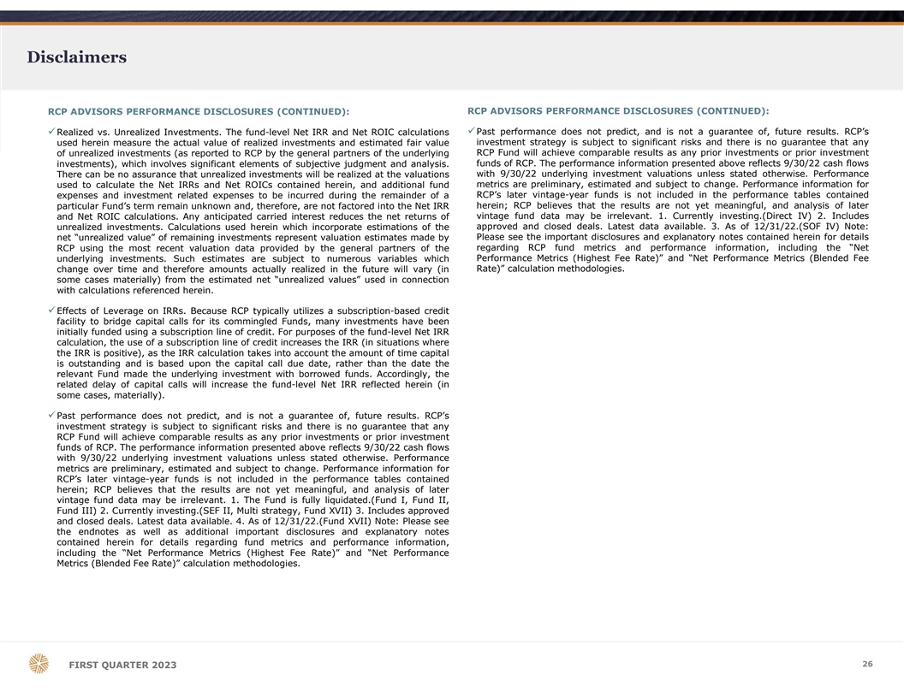
Disclaimers RCP ADVISORS PERFORMANCE DISCLOSURES (CONTINUED): RCP ADVISORS PERFORMANCE DISCLOSURES (CONTINUED): üPast performance does not predict, and is not a guarantee of, future results. RCP’s üRealized vs. Unrealized Investments. The fund-level Net IRR and Net ROIC calculations investment strategy is subject to significant risks and there is no guarantee that any used herein measure the actual value of realized investments and estimated fair value of unrealized investments (as reported to RCP by the general partners of the underlying RCP Fund will achieve comparable results as any prior investments or prior investment funds of RCP. The performance information presented above reflects 9/30/22 cash flows investments), which involves significant elements of subjective judgment and analysis. with 9/30/22 underlying investment valuations unless stated otherwise. Performance There can be no assurance that unrealized investments will be realized at the valuations metrics are preliminary, estimated and subject to change. Performance information for used to calculate the Net IRRs and Net ROICs contained herein, and additional fund expenses and investment related expenses to be incurred during the remainder of a RCP’s later vintage-year funds is not included in the performance tables contained particular Fund’s term remain unknown and, therefore, are not factored into the Net IRR herein; RCP believes that the results are not yet meaningful, and analysis of later vintage fund data may be irrelevant. 1. Currently investing.(Direct IV) 2. Includes and Net ROIC calculations. Any anticipated carried interest reduces the net returns of approved and closed deals. Latest data available. 3. As of 12/31/22.(SOF IV) Note: unrealized investments. Calculations used herein which incorporate estimations of the net “unrealized value” of remaining investments represent valuation estimates made by Please see the important disclosures and explanatory notes contained herein for details RCP using the most recent valuation data provided by the general partners of the regarding RCP fund metrics and performance information, including the “Net Performance Metrics (Highest Fee Rate)” and “Net Performance Metrics (Blended Fee underlying investments. Such estimates are subject to numerous variables which Rate)” calculation methodologies. change over time and therefore amounts actually realized in the future will vary (in some cases materially) from the estimated net “unrealized values” used in connection with calculations referenced herein. üEffects of Leverage on IRRs. Because RCP typically utilizes a subscription-based credit facility to bridge capital calls for its commingled Funds, many investments have been initially funded using a subscription line of credit. For purposes of the fund-level Net IRR calculation, the use of a subscription line of credit increases the IRR (in situations where the IRR is positive), as the IRR calculation takes into account the amount of time capital is outstanding and is based upon the capital call due date, rather than the date the relevant Fund made the underlying investment with borrowed funds. Accordingly, the related delay of capital calls will increase the fund-level Net IRR reflected herein (in some cases, materially). üPast performance does not predict, and is not a guarantee of, future results. RCP’s investment strategy is subject to significant risks and there is no guarantee that any RCP Fund will achieve comparable results as any prior investments or prior investment funds of RCP. The performance information presented above reflects 9/30/22 cash flows with 9/30/22 underlying investment valuations unless stated otherwise. Performance metrics are preliminary, estimated and subject to change. Performance information for RCP’s later vintage-year funds is not included in the performance tables contained herein; RCP believes that the results are not yet meaningful, and analysis of later vintage fund data may be irrelevant. 1. The Fund is fully liquidated.(Fund I, Fund II, Fund III) 2. Currently investing.(SEF II, Multi strategy, Fund XVII) 3. Includes approved and closed deals. Latest data available. 4. As of 12/31/22.(Fund XVII) Note: Please see the endnotes as well as additional important disclosures and explanatory notes contained herein for details regarding fund metrics and performance information, including the “Net Performance Metrics (Highest Fee Rate)” and “Net Performance Metrics (Blended Fee Rate)” calculation methodologies. 2 26 6 FIRST QUARTER 2023

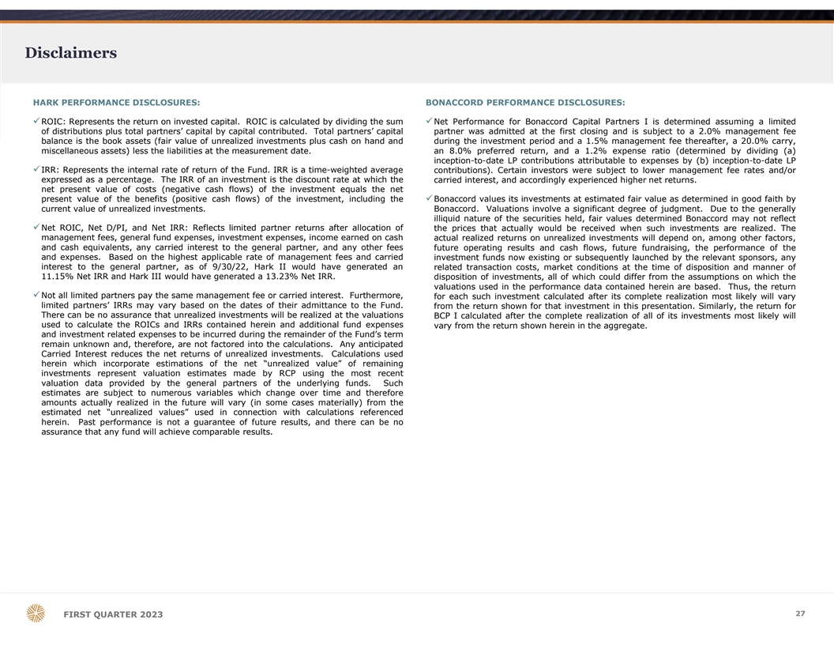
Disclaimers HARK PERFORMANCE DISCLOSURES: BONACCORD PERFORMANCE DISCLOSURES: üROIC: Represents the return on invested capital. ROIC is calculated by dividing the sumüNet Performance for Bonaccord Capital Partners I is determined assuming a limited of distributions plus total partners’ capital by capital contributed. Total partners’ capital partner was admitted at the first closing and is subject to a 2.0% management fee balance is the book assets (fair value of unrealized investments plus cash on hand and during the investment period and a 1.5% management fee thereafter, a 20.0% carry, miscellaneous assets) less the liabilities at the measurement date. an 8.0% preferred return, and a 1.2% expense ratio (determined by dividing (a) inception-to-date LP contributions attributable to expenses by (b) inception-to-date LP üIRR: Represents the internal rate of return of the Fund. IRR is a time-weighted average contributions). Certain investors were subject to lower management fee rates and/or expressed as a percentage. The IRR of an investment is the discount rate at which the carried interest, and accordingly experienced higher net returns. net present value of costs (negative cash flows) of the investment equals the net present value of the benefits (positive cash flows) of the investment, including theüBonaccord values its investments at estimated fair value as determined in good faith by current value of unrealized investments. Bonaccord. Valuations involve a significant degree of judgment. Due to the generally illiquid nature of the securities held, fair values determined Bonaccord may not reflect üNet ROIC, Net D/PI, and Net IRR: Reflects limited partner returns after allocation of the prices that actually would be received when such investments are realized. The management fees, general fund expenses, investment expenses, income earned on cash actual realized returns on unrealized investments will depend on, among other factors, and cash equivalents, any carried interest to the general partner, and any other fees future operating results and cash flows, future fundraising, the performance of the and expenses. Based on the highest applicable rate of management fees and carried investment funds now existing or subsequently launched by the relevant sponsors, any interest to the general partner, as of 9/30/22, Hark II would have generated an related transaction costs, market conditions at the time of disposition and manner of 11.15% Net IRR and Hark III would have generated a 13.23% Net IRR. disposition of investments, all of which could differ from the assumptions on which the valuations used in the performance data contained herein are based. Thus, the return üNot all limited partners pay the same management fee or carried interest. Furthermore, for each such investment calculated after its complete realization most likely will vary limited partners’ IRRs may vary based on the dates of their admittance to the Fund. from the return shown for that investment in this presentation. Similarly, the return for There can be no assurance that unrealized investments will be realized at the valuations BCP I calculated after the complete realization of all of its investments most likely will used to calculate the ROICs and IRRs contained herein and additional fund expenses vary from the return shown herein in the aggregate. and investment related expenses to be incurred during the remainder of the Fund’s term remain unknown and, therefore, are not factored into the calculations. Any anticipated Carried Interest reduces the net returns of unrealized investments. Calculations used herein which incorporate estimations of the net “unrealized value” of remaining investments represent valuation estimates made by RCP using the most recent valuation data provided by the general partners of the underlying funds. Such estimates are subject to numerous variables which change over time and therefore amounts actually realized in the future will vary (in some cases materially) from the estimated net “unrealized values” used in connection with calculations referenced herein. Past performance is not a guarantee of future results, and there can be no assurance that any fund will achieve comparable results. 2 27 7 FIRST QUARTER 2023


DALLAS OFFICE 4514 Cole Avenue Suite 1600 Dallas, Texas 75205 214.865.7998 info@p10alts.com 28 FIRST QUARTER 2023
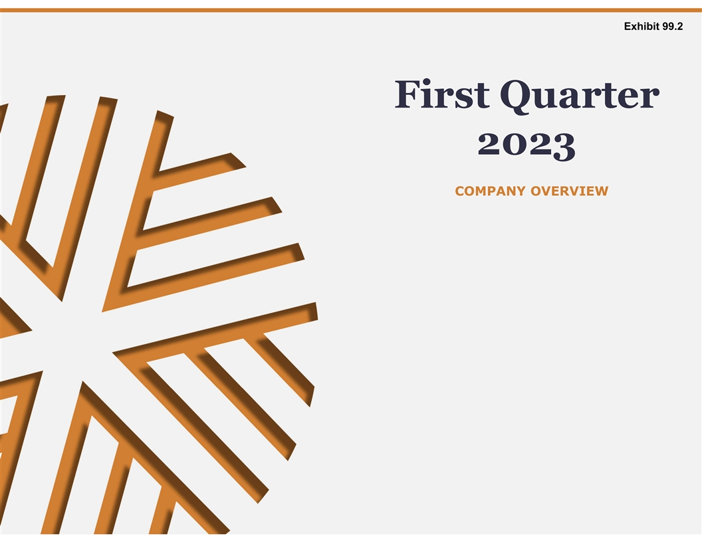
Exhibit 99.2 First Quarter 2023 COMPANY OVERVIEW

Legal Disclaimer IMPORTANT NOTICES CAUTION REGARDING FINANCIAL AND OPERATING PROJECTIONS The inclusion of references to P10, Inc. (the “Company”) in this presentation is for information All financial and operating projections, forecasts or estimates about or relating to the purposes only as the holding company of various subsidiaries. P10 does not offer investment Company included in this document, including statements regarding pro-forma valuation advisory services and this presentation is neither an offer of any investment products nor an and ownership, have been prepared based on various estimates, assumptions and offer of advisory services by P10. By accepting this presentation, you acknowledge that P10 is hypothetical scenarios. Forecasts and projections of financial performance, valuation and not offering investment advisory services. All investment advisory services referenced in this operating results are, by nature, speculative and based in part on anticipating and presentation are provided by subsidiaries of P10 which are registered as investment advisers assuming future events (and the effects of future events) that are impossible to predict with the U.S. Securities and Exchange Commission (“SEC”). Accordingly, this presentation may and no representation of any kind is made with respect thereto. The Company’s future be considered marketing materials, in which event it would be marketing materials of each results and achievements will depend on a number of factors, including the accuracy and registered investment adviser subsidiary only. To the extent you have any questions regarding reasonableness of the assumptions underlying any forecasted information as well as on this presentation, please direct them to the applicable subsidiary. Registration as an investment significant transaction, business, economic, competitive, regulatory, technological and adviser does not imply any level of skill or training. This presentation does not constitute an other uncertainties, contingencies and developments that in many cases will be beyond offer to sell, a solicitation of an offer to buy, or a recommendation of any security or any other the Company’s control. Accordingly, all projections or forecasts (and estimates based on investment product. Any securities described herein have not been recommended by any U.S. such projections or forecasts) contained herein should not be viewed as an assessment, federal or state or non-U.S. securities commission or regulatory authority, including the SEC. prediction or representation as to future results and interested parties should not rely, Furthermore, the foregoing authorities have not confirmed the accuracy or determined the and will not be deemed to have relied, on any such projections or forecasts. Actual results adequacy of this document. Any representation to the contrary is a criminal offense. Nothing may differ substantially and could be materially worse than any projection, forecast or herein is intended to provide tax, legal or investment advice. scenario set forth in this document. The Company expressly disclaims any obligation to update or revise any of the projections, forecasts, models or scenarios contained herein to reflect any change in the Company’s expectations with regard thereto or any changes CAUTION REGARDING FORWARD-LOOKING INFORMATION in events, conditions or circumstances on which any such statement is based. Some of the statements in this presentation may constitute forward-looking statements within the meaning of Section 27A of the Securities Act of 1933, Section 21E of the Securities FEE-PAYING ASSETS UNDER MANAGEMENT, OR FPAUM Exchange Act of 1934 and the Private Securities Litigation Reform Act of 1995. Words such as will, expect, believe, estimate, continue, anticipate, intend, plan“ and similar FPAUM reflects the assets from which we earn management and advisory fees. Our expressions are intended to identify these forward-looking statements. Forward-looking vehicles typically earn management and advisory fees based on committed capital, and in statements discuss management's current expectations and projections relating to our financial certain cases, net invested capital, depending on the fee terms. Management and position, results of operations, plans, objectives, future performance and business. The inclusion advisory fees based on committed capital are not affected by market appreciation or of any forward-looking information in this presentation should not be regarded as a depreciation. representation that the future plans, estimates or expectations contemplated will be achieved. Forward-looking statements are subject to various risks, uncertainties and assumptions. Forward-looking statements reflect management’s current plans, estimates and expectations USE OF NON-GAAP FINANCIAL MEASURES BY P10, INC. and are inherently uncertain. All forward-looking statements are subject to known and unknown The non-GAAP financial measures contained in this presentation (including, without risks, uncertainties and other important factors that may cause actual results to be materially limitation, Adjusted EBITDA, Adjusted Net Income (“ANI”) and fee-paying assets under different, including risks relating to: global and domestic market and business conditions; management are not GAAP measures of the Company’s financial performance or liquidity successful execution of business and growth strategies and regulatory factors relevant to our and should not be considered as alternatives to net income (loss) as a measure of business; changes in our tax status; our ability to maintain our fee structure; our ability to financial performance or cash flows from operations as measures of liquidity, or any other attract and retain key employees; our ability to manage our obligations under our debt performance measure derived in accordance with GAAP. A reconciliation of such non- agreements; as well as assumptions relating to our operations, financial results, financial GAAP measures to their most directly comparable GAAP measure is included later in this condition, business prospects, growth strategy; and our ability to manage the effects of events presentation. The Company believes the presentation of these non-GAAP measures outside of our control. The foregoing list of factors is not exhaustive. For more information provide useful additional information to investors because it provides better comparability regarding these risks and uncertainties as well as additional risks that we face, you should refer of ongoing operating performance to prior periods. It is reasonable to expect that one or to the “Risk Factors” included in our annual report on Form 10-K for the year ended December more excluded items will occur in future periods, but the amounts recognized can vary 31, 2022, filed with the SEC on March 27, 2023, and in our subsequent reports filed from time significantly from period to period. Adjusted EBITDA and adjusted net income should not to time with the SEC. The forward-looking statements included in this presentation are made be considered substitutes for net income or cash flows from operating, investing, or only as of the date hereof. We undertake no obligation to update or revise any forward-looking financing activities. You are encouraged to evaluate each adjustment to non-GAAP statement as a result of new information or future events, except as otherwise required by law. financial measures and the reasons management considers it appropriate for The forward-looking statements included in this presentation are made only as of the date supplemental analysis. Our presentation of these measures should not be construed as an hereof. We undertake no obligation to update or revise any forward-looking statement as a inference that our future results will be unaffected by unusual or non-recurring items. result of new information or future events, except as otherwise required by law. 2 FIRST QUARTER 2023

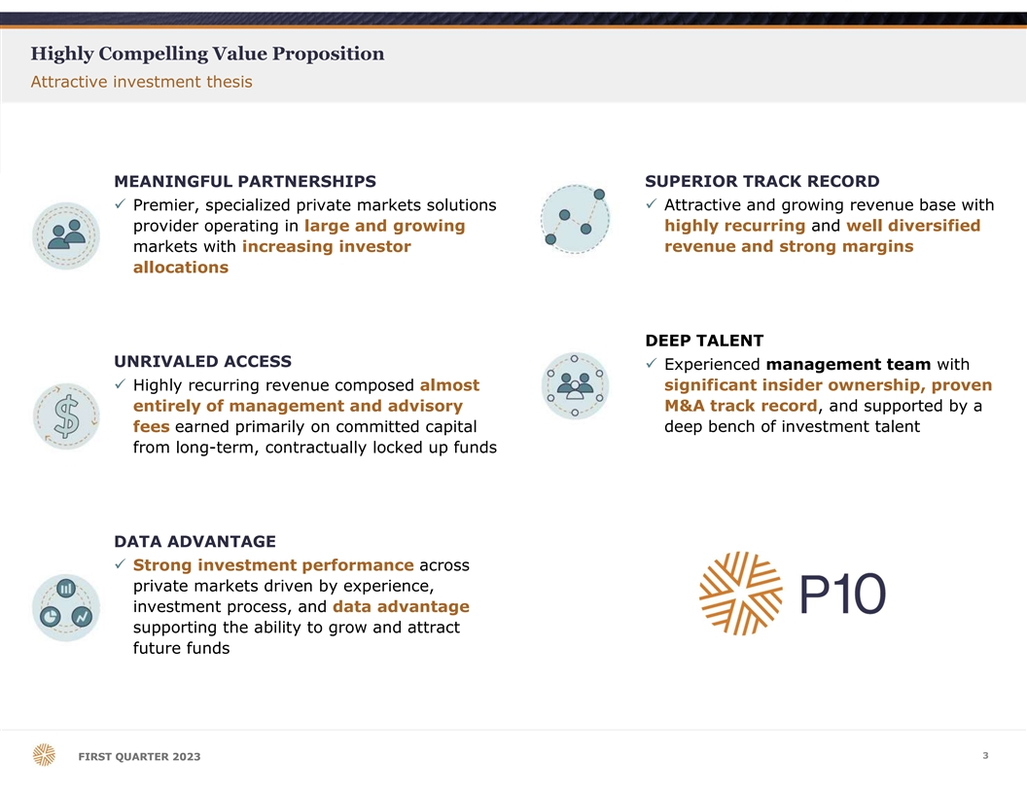
Highly Compelling Value Proposition Attractive investment thesis MEANINGFUL PARTNERSHIPS SUPERIOR TRACK RECORD ü Premier, specialized private markets solutions ü Attractive and growing revenue base with provider operating in large and growing highly recurring and well diversified markets with increasing investor revenue and strong margins allocations DEEP TALENT UNRIVALED ACCESS ü Experienced management team with ü Highly recurring revenue composed almost significant insider ownership, proven entirely of management and advisory M&A track record, and supported by a fees earned primarily on committed capital deep bench of investment talent from long-term, contractually locked up funds DATA ADVANTAGE ü Strong investment performance across private markets driven by experience, investment process, and data advantage supporting the ability to grow and attract future funds 3 F FI IR RS ST T Q QU UA AR RT TE ER R 2 20 02 23 3

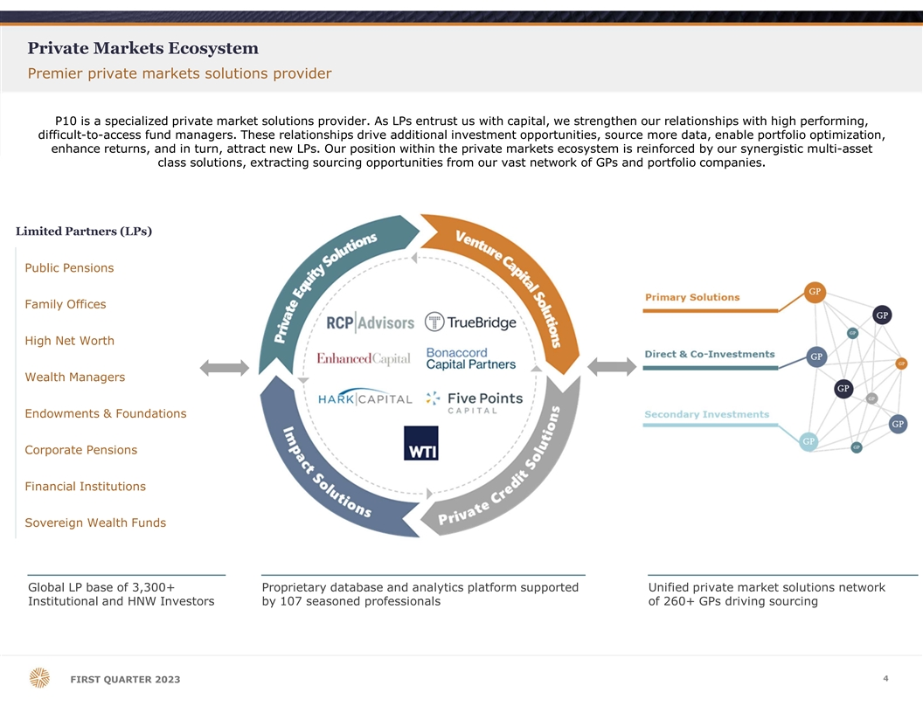
Private Markets Ecosystem Premier private markets solutions provider P10 is a specialized private market solutions provider. As LPs entrust us with capital, we strengthen our relationships with high performing, difficult-to-access fund managers. These relationships drive additional investment opportunities, source more data, enable portfolio optimization, enhance returns, and in turn, attract new LPs. Our position within the private markets ecosystem is reinforced by our synergistic multi-asset class solutions, extracting sourcing opportunities from our vast network of GPs and portfolio companies. Limited Partners (LPs) Public Pensions Family Offices High Net Worth Wealth Managers Endowments & Foundations Corporate Pensions Financial Institutions Sovereign Wealth Funds Global LP base of 3,300+ Proprietary database and analytics platform supported Unified private market solutions network Institutional and HNW Investors by 107 seasoned professionals of 260+ GPs driving sourcing 4 FIRST QUARTER 2023

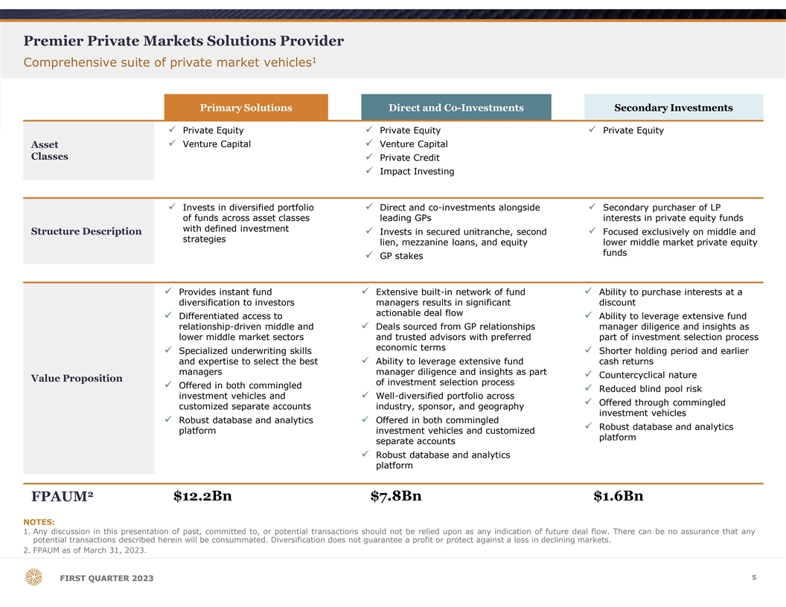
Premier Private Markets Solutions Provider 1 Comprehensive suite of private market vehicles Primary Solutions Direct and Co-Investments Secondary Investments ü Private Equityü Private Equityü Private Equity ü Venture Capitalü Venture Capital Asset Classes ü Private Credit ü Impact Investing ü Invests in diversified portfolio ü Direct and co-investments alongside ü Secondary purchaser of LP of funds across asset classes leading GPs interests in private equity funds with defined investment Structure Descriptionü Invests in secured unitranche, second ü Focused exclusively on middle and strategies lien, mezzanine loans, and equity lower middle market private equity funds ü GP stakes ü Provides instant fund ü Extensive built-in network of fund ü Ability to purchase interests at a diversification to investors managers results in significant discount actionable deal flow ü Differentiated access to ü Ability to leverage extensive fund relationship-driven middle and ü Deals sourced from GP relationships manager diligence and insights as lower middle market sectors and trusted advisors with preferred part of investment selection process economic terms ü Specialized underwriting skills ü Shorter holding period and earlier and expertise to select the best ü Ability to leverage extensive fund cash returns managers manager diligence and insights as part ü Countercyclical nature Value Proposition of investment selection process ü Offered in both commingled ü Reduced blind pool risk investment vehicles and ü Well-diversified portfolio across ü Offered through commingled customized separate accounts industry, sponsor, and geography investment vehicles ü Robust database and analytics ü Offered in both commingled ü Robust database and analytics platform investment vehicles and customized platform separate accounts ü Robust database and analytics platform 2 $12.2Bn $7.8Bn $1.6Bn FPAUM NOTES: 1. Any discussion in this presentation of past, committed to, or potential transactions should not be relied upon as any indication of future deal flow. There can be no assurance that any potential transactions described herein will be consummated. Diversification does not guarantee a profit or protect against a loss in declining markets. 2. FPAUM as of March 31, 2023. 5 F FI IR RS ST T Q QU UA AR RT TE ER R 2 20 02 23 3

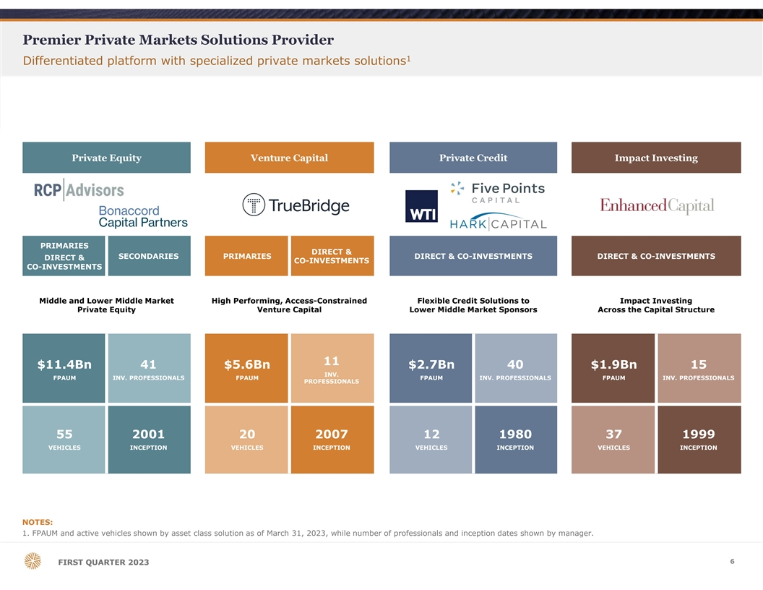
Premier Private Markets Solutions Provider 1 Differentiated platform with specialized private markets solutions Private Equity Venture Capital Private Credit Impact Investing PRIMARIES DIRECT & SECONDARIES PRIMARIES DIRECT & CO-INVESTMENTS DIRECT & CO-INVESTMENTS DIRECT & CO-INVESTMENTS CO-INVESTMENTS Middle and Lower Middle Market High Performing, Access-Constrained Flexible Credit Solutions to Impact Investing Private Equity Venture Capital Lower Middle Market Sponsors Across the Capital Structure 11 $11.4Bn 41 $5.6Bn $2.7Bn 40 $1.9Bn 15 INV. FPAUM INV. PROFESSIONALS FPAUM FPAUM INV. PROFESSIONALS FPAUM INV. PROFESSIONALS PROFESSIONALS 55 2001 20 2007 12 1980 37 1999 VEHICLES INCEPTION VEHICLES INCEPTION VEHICLES INCEPTION VEHICLES INCEPTION NOTES: 1. FPAUM and active vehicles shown by asset class solution as of March 31, 2023, while number of professionals and inception dates shown by manager. 6 F FI IR RS ST T Q QU UA AR RT TE ER R 2 20 02 23 3

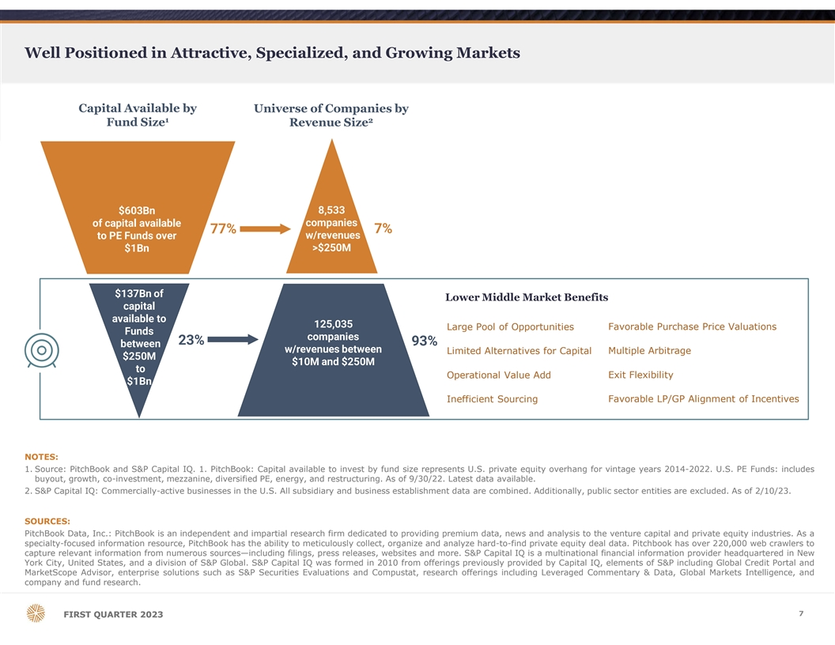
Well Positioned in Attractive, Specialized, and Growing Markets Capital Available by Universe of Companies by 1 2 Fund Size Revenue Size $603Bn 8,533 of capital available companies 7% 77% to PE Funds over w/revenues $1Bn >$250M $137Bn of Lower Middle Market Benefits capital available to 125,035 Large Pool of Opportunities Favorable Purchase Price Valuations Funds companies 23% 93% between w/revenues between Limited Alternatives for Capital Multiple Arbitrage $250M $10M and $250M to Operational Value Add Exit Flexibility $1Bn Inefficient Sourcing Favorable LP/GP Alignment of Incentives NOTES: 1. Source: PitchBook and S&P Capital IQ. 1. PitchBook: Capital available to invest by fund size represents U.S. private equity overhang for vintage years 2014-2022. U.S. PE Funds: includes buyout, growth, co-investment, mezzanine, diversified PE, energy, and restructuring. As of 9/30/22. Latest data available. 2. S&P Capital IQ: Commercially-active businesses in the U.S. All subsidiary and business establishment data are combined. Additionally, public sector entities are excluded. As of 2/10/23. SOURCES: PitchBook Data, Inc.: PitchBook is an independent and impartial research firm dedicated to providing premium data, news and analysis to the venture capital and private equity industries. As a specialty-focused information resource, PitchBook has the ability to meticulously collect, organize and analyze hard-to-find private equity deal data. Pitchbook has over 220,000 web crawlers to capture relevant information from numerous sources—including filings, press releases, websites and more. S&P Capital IQ is a multinational financial information provider headquartered in New York City, United States, and a division of S&P Global. S&P Capital IQ was formed in 2010 from offerings previously provided by Capital IQ, elements of S&P including Global Credit Portal and MarketScope Advisor, enterprise solutions such as S&P Securities Evaluations and Compustat, research offerings including Leveraged Commentary & Data, Global Markets Intelligence, and company and fund research. 7 F FI IR RS ST T Q QU UA AR RT TE ER R 2 20 02 23 3

Distinct Market Access, Deal Flow, and Data Analytics to Navigate Private Markets Long-standing industry relationships and extensive proprietary analytics drive unparalleled market access Private Equity Venture Capital Private Credit Impact Investing 850+ 50+ 1,900+ 260+ 1,000+ 70+ 300+ 100+ Relationships BUSINESSES ACTIVE SPONSOR INVESTORS FUND MANAGERS INVESTORS FUND MANAGERS INVESTORS INVESTORS SUPPORTED and RELATIONSHIPS PROJECTS 2,100+ 12,000+ 45+ $3,500M 1,600M 490+ 75+ $9,800M+ Scale PORTFOLIO PORTFOLIO PLATFORM CAPITAL DEPLOYED IN KWH FUNDS DIRECT INVESTMENTS CAPITAL DEPLOYED 1 COMPANIES COMPANIES INVESTMENTS IMPACT CREDIT GENERATED 24+ 22+ 23+ 22+ 41 11 40 15 AVG. YEARS AVG. YEARS AVG. YEARS AVG. YEARS Experience INVESTMENT INVESTMENT INVESTMENT INVESTMENT OF OF OF OF PROFESSIONALS PROFESSIONALS PROFESSIONALS PROFESSIONALS MGMT. EXPERIENCE MGMT. EXPERIENCE MGMT. EXPERIENCE MGMT. EXPERIENCE NOTES: 1. Since 2015. Carbon abatement is calculated using the EPA Greenhouse Gas Equivalencies Calculator which uses the AVoided Emissions and geneRation Tool (AVERT) US national weighted average CO2 marginal. Emission rate to convert reductions of kilowatt-hours into avoided units of carbon dioxide emissions. As of June 30, 2022. 8 F FI IR RS ST T Q QU UA AR RT TE ER R 2 20 02 23 3

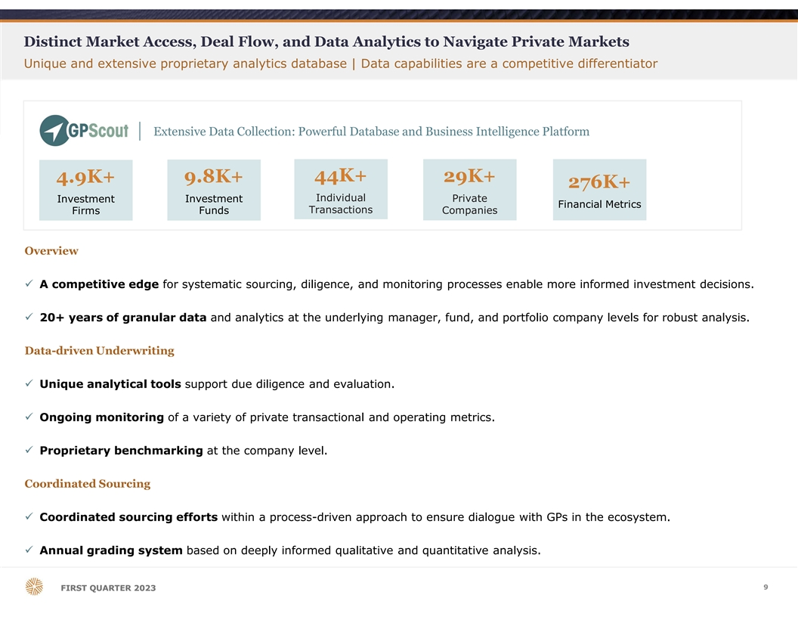
Distinct Market Access, Deal Flow, and Data Analytics to Navigate Private Markets Unique and extensive proprietary analytics database | Data capabilities are a competitive differentiator Extensive Data Collection: Powerful Database and Business Intelligence Platform 44K+ 4.9K+ 9.8K+ 29K+ 276K+ Individual Private Investment Investment Financial Metrics Funds Transactions Companies Firms Overview ü A competitive edge for systematic sourcing, diligence, and monitoring processes enable more informed investment decisions. ü 20+ years of granular data and analytics at the underlying manager, fund, and portfolio company levels for robust analysis. Data-driven Underwriting ü Unique analytical tools support due diligence and evaluation. ü Ongoing monitoring of a variety of private transactional and operating metrics. ü Proprietary benchmarking at the company level. Coordinated Sourcing ü Coordinated sourcing efforts within a process-driven approach to ensure dialogue with GPs in the ecosystem. ü Annual grading system based on deeply informed qualitative and quantitative analysis. 9 F FI IR RS ST T Q QU UA AR RT TE ER R 2 20 02 23 3

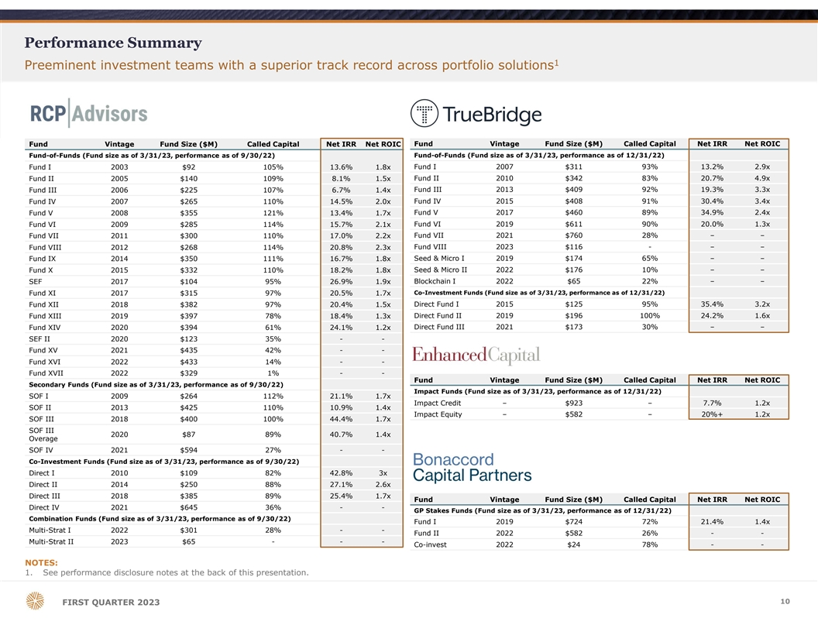
Performance Summary 1 Preeminent investment teams with a superior track record across portfolio solutions Fund Vintage Fund Size ($M) Called Capital Net IRR Net ROIC Fund Vintage Fund Size ($M) Called Capital Net IRR Net ROIC Fund-of-Funds (Fund size as of 3/31/23, performance as of 9/30/22) Fund-of-Funds (Fund size as of 3/31/23, performance as of 12/31/22) Fund I 2003 $92 105% 13.6% 1.8x Fund I 2007 $311 93% 13.2% 2.9x Fund II 2005 $140 109% 8.1% 1.5x Fund II 2010 $342 83% 20.7% 4.9x Fund III 2013 $409 92% 19.3% 3.3x Fund III 2006 $225 107% 6.7% 1.4x Fund IV 2015 $408 91% 30.4% 3.4x Fund IV 2007 $265 110% 14.5% 2.0x Fund V 2017 $460 89% 34.9% 2.4x Fund V 2008 $355 121% 13.4% 1.7x Fund VI 2009 $285 114% 15.7% 2.1x Fund VI 2019 $611 90% 20.0% 1.3x Fund VII 2011 $300 110% 17.0% 2.2x Fund VII 2021 $760 28% – – Fund VIII 2012 $268 114% 20.8% 2.3x Fund VIII 2023 $116 - – – Fund IX 2014 $350 111% 16.7% 1.8x Seed & Micro I 2019 $174 65% – – Fund X 2015 $332 110% 18.2% 1.8x Seed & Micro II 2022 $176 10% – – SEF 2017 $104 95% 26.9% 1.9x Blockchain I 2022 $65 22% – – Fund XI 2017 $315 97% 20.5% 1.7x Co-Investment Funds (Fund size as of 3/31/23, performance as of 12/31/22) Direct Fund I 2015 $125 95% 35.4% 3.2x Fund XII 2018 $382 97% 20.4% 1.5x Direct Fund II 2019 $196 100% 24.2% 1.6x Fund XIII 2019 $397 78% 18.4% 1.3x Direct Fund III 2021 $173 30% – – Fund XIV 2020 $394 61% 24.1% 1.2x SEF II 2020 $123 35% - - Fund XV 2021 $435 42% - - Fund XVI 2022 $433 14% - - Fund XVII 2022 $329 1% - - Fund Vintage Fund Size ($M) Called Capital Net IRR Net ROIC Secondary Funds (Fund size as of 3/31/23, performance as of 9/30/22) Impact Funds (Fund size as of 3/31/23, performance as of 12/31/22) SOF I 2009 $264 112% 21.1% 1.7x Impact Credit – $923 – 7.7% 1.2x SOF II 2013 $425 110% 10.9% 1.4x Impact Equity – $582 – 20%+ 1.2x SOF III 2018 $400 100% 44.4% 1.7x SOF III 2020 $87 89% 40.7% 1.4x Overage SOF IV 2021 $594 27% - - Co-Investment Funds (Fund size as of 3/31/23, performance as of 9/30/22) Direct I 2010 $109 82% 42.8% 3x Direct II 2014 $250 88% 27.1% 2.6x Direct III 2018 $385 89% 25.4% 1.7x Fund Vintage Fund Size ($M) Called Capital Net IRR Net ROIC Direct IV 2021 $645 36% - - GP Stakes Funds (Fund size as of 3/31/23, performance as of 12/31/22) Combination Funds (Fund size as of 3/31/23, performance as of 9/30/22) Fund I 2019 $724 72% 21.4% 1.4x Multi-Strat I 2022 $301 28% - - Fund II 2022 $582 26% - - Multi-Strat II 2023 $65 - - - Co-invest 2022 $24 78% - - NOTES: 1. See performance disclosure notes at the back of this presentation. 10 FIRST QUARTER 2023

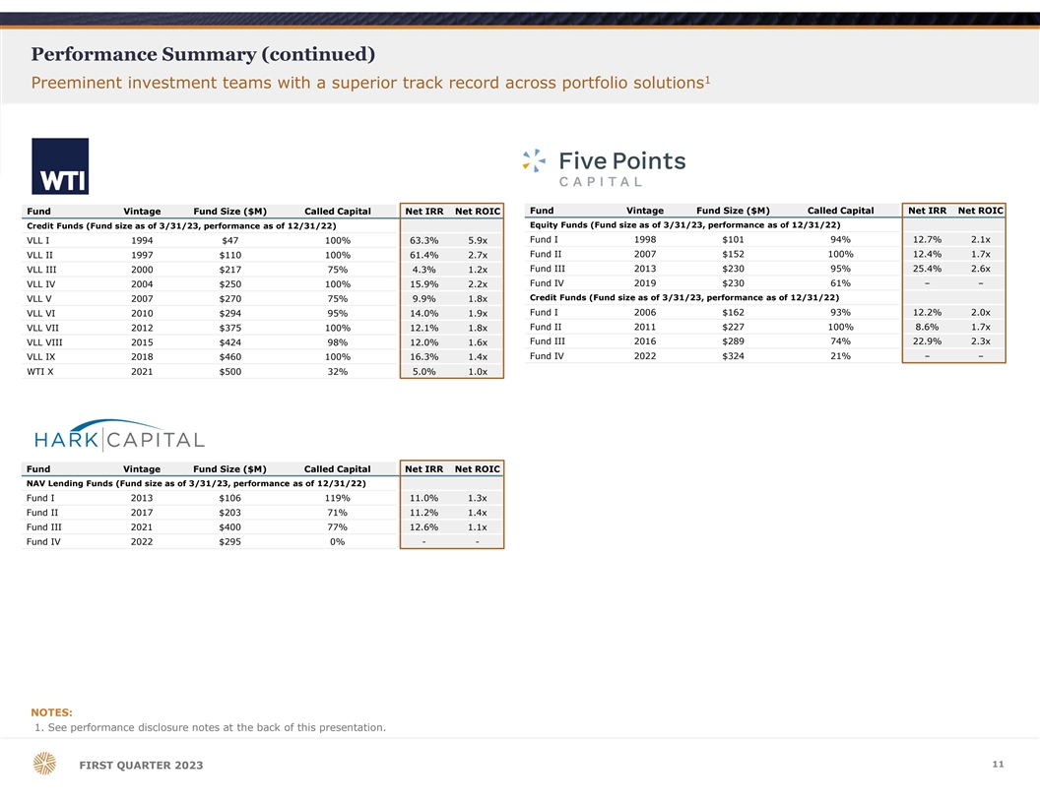
Performance Summary (continued) 1 Preeminent investment teams with a superior track record across portfolio solutions Fund Vintage Fund Size ($M) Called Capital Net IRR Net ROIC Fund Vintage Fund Size ($M) Called Capital Net IRR Net ROIC Equity Funds (Fund size as of 3/31/23, performance as of 12/31/22) Credit Funds (Fund size as of 3/31/23, performance as of 12/31/22) Fund I 1998 $101 94% 12.7% 2.1x VLL I 1994 $47 100% 63.3% 5.9x Fund II 2007 $152 100% 12.4% 1.7x VLL II 1997 $110 100% 61.4% 2.7x Fund III 2013 $230 95% 25.4% 2.6x VLL III 2000 $217 75% 4.3% 1.2x Fund IV 2019 $230 61% – – VLL IV 2004 $250 100% 15.9% 2.2x Credit Funds (Fund size as of 3/31/23, performance as of 12/31/22) VLL V 2007 $270 75% 9.9% 1.8x VLL VI 2010 $294 95% 14.0% 1.9x Fund I 2006 $162 93% 12.2% 2.0x Fund II 2011 $227 100% 8.6% 1.7x VLL VII 2012 $375 100% 12.1% 1.8x Fund III 2016 $289 74% 22.9% 2.3x VLL VIII 2015 $424 98% 12.0% 1.6x Fund IV 2022 $324 21% – – VLL IX 2018 $460 100% 16.3% 1.4x WTI X 2021 $500 32% 5.0% 1.0x Fund Vintage Fund Size ($M) Called Capital Net IRR Net ROIC NAV Lending Funds (Fund size as of 3/31/23, performance as of 12/31/22) Fund I 2013 $106 119% 11.0% 1.3x Fund II 2017 $203 71% 11.2% 1.4x Fund III 2021 $400 77% 12.6% 1.1x Fund IV 2022 $295 0% - - NOTES: 1. See performance disclosure notes at the back of this presentation. 11 FIRST QUARTER 2023

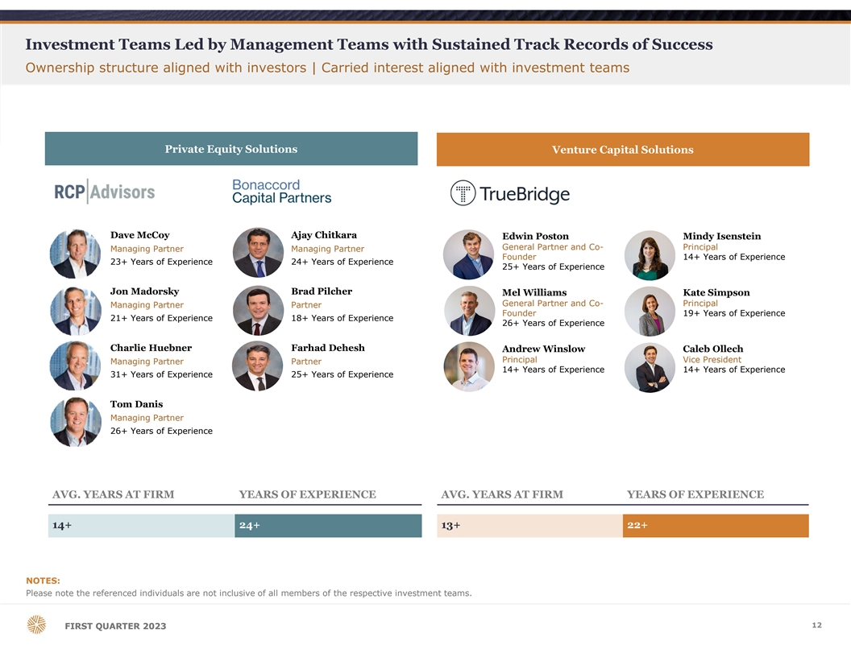
Investment Teams Led by Management Teams with Sustained Track Records of Success Ownership structure aligned with investors | Carried interest aligned with investment teams Private Equity Solutions Venture Capital Solutions Dave McCoy Ajay Chitkara Edwin Poston Mindy Isenstein General Partner and Co- Principal Managing Partner Managing Partner Founder 14+ Years of Experience 23+ Years of Experience 24+ Years of Experience 25+ Years of Experience Jon Madorsky Brad Pilcher Mel Williams Kate Simpson General Partner and Co- Principal Managing Partner Partner Founder 19+ Years of Experience 21+ Years of Experience 18+ Years of Experience 26+ Years of Experience Charlie Huebner Farhad Dehesh Andrew Winslow Caleb Ollech Principal Vice President Managing Partner Partner 14+ Years of Experience 14+ Years of Experience 31+ Years of Experience 25+ Years of Experience Tom Danis Managing Partner 26+ Years of Experience AVG. YEARS AT FIRM YEARS OF EXPERIENCE AVG. YEARS AT FIRM YEARS OF EXPERIENCE 14+ 24+ 13+ 22+ NOTES: Please note the referenced individuals are not inclusive of all members of the respective investment teams. 12 F FI IR RS ST T Q QU UA AR RT TE ER R 2 20 02 23 3

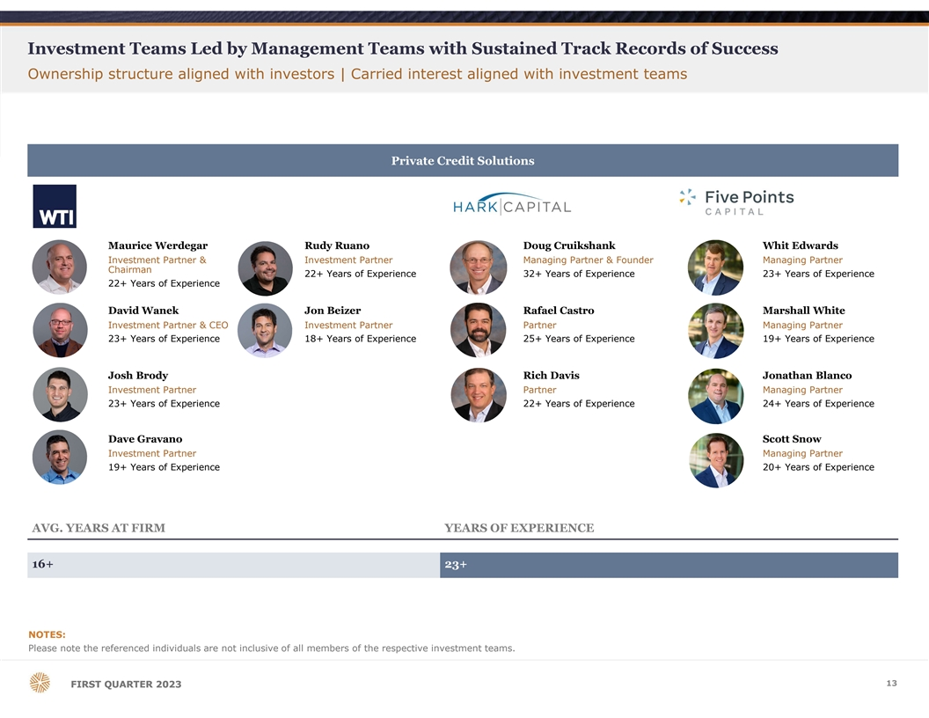
Investment Teams Led by Management Teams with Sustained Track Records of Success Ownership structure aligned with investors | Carried interest aligned with investment teams Private Credit Solutions Maurice Werdegar Rudy Ruano Doug Cruikshank Whit Edwards Investment Partner & Investment Partner Managing Partner & Founder Managing Partner Chairman 22+ Years of Experience 32+ Years of Experience 23+ Years of Experience 22+ Years of Experience David Wanek Jon Beizer Rafael Castro Marshall White Investment Partner & CEO Investment Partner Partner Managing Partner 23+ Years of Experience 18+ Years of Experience 25+ Years of Experience 19+ Years of Experience Josh Brody Rich Davis Jonathan Blanco Investment Partner Partner Managing Partner 23+ Years of Experience 22+ Years of Experience 24+ Years of Experience Dave Gravano Scott Snow Investment Partner Managing Partner 19+ Years of Experience 20+ Years of Experience AVG. YEARS AT FIRM YEARS OF EXPERIENCE 16+ 23+ NOTES: Please note the referenced individuals are not inclusive of all members of the respective investment teams. 13 F FI IR RS ST T Q QU UA AR RT TE ER R 2 20 02 23 3

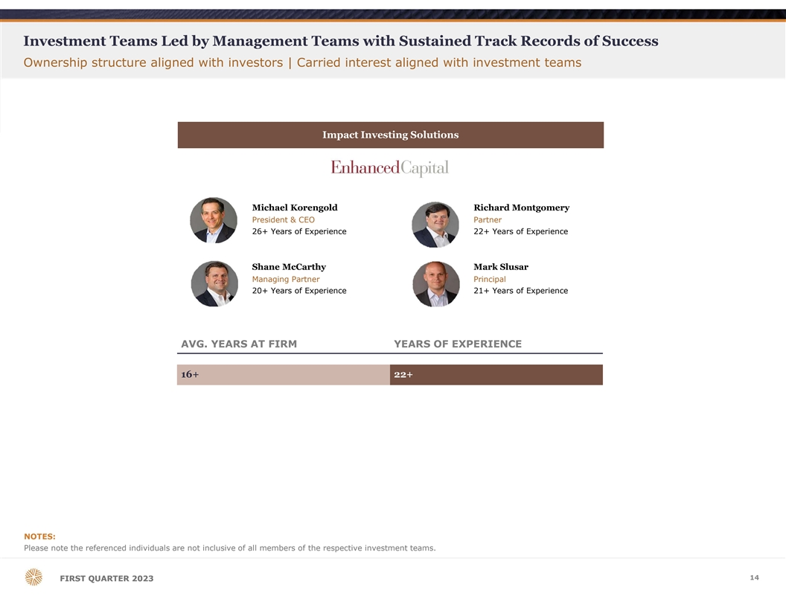
Investment Teams Led by Management Teams with Sustained Track Records of Success Ownership structure aligned with investors | Carried interest aligned with investment teams Impact Investing Solutions Michael Korengold Richard Montgomery President & CEO Partner 26+ Years of Experience 22+ Years of Experience Shane McCarthy Mark Slusar Managing Partner Principal 20+ Years of Experience 21+ Years of Experience AVG. YEARS AT FIRM YEARS OF EXPERIENCE 16+ 22+ NOTES: Please note the referenced individuals are not inclusive of all members of the respective investment teams. 14 F FI IR RS ST T Q QU UA AR RT TE ER R 2 20 02 23 3

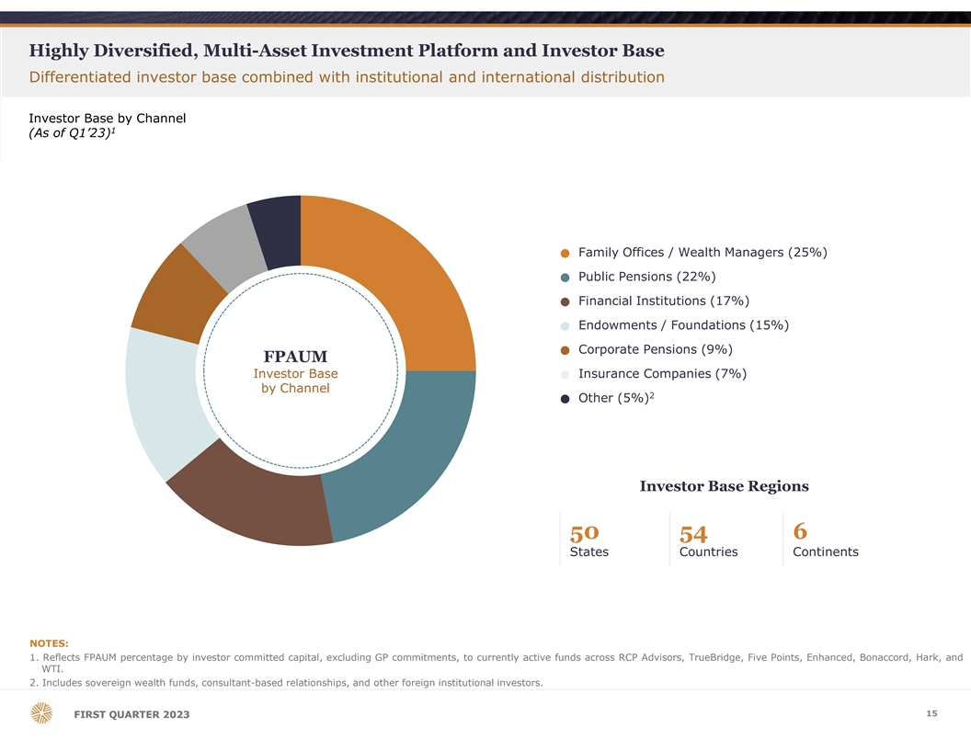
Highly Diversified, Multi-Asset Investment Platform and Investor Base Differentiated investor base combined with institutional and international distribution Investor Base by Channel 1 (As of Q1’23) Family Offices / Wealth Managers (25%) ● Public Pensions (22%) ● Financial Institutions (17%) ● Endowments / Foundations (15%) ● Corporate Pensions (9%) ● FPAUM Investor Base Insurance Companies (7%) ● by Channel 2 Other (5%) ● Investor Base Regions 50 54 6 States Countries Continents NOTES: 1. Reflects FPAUM percentage by investor committed capital, excluding GP commitments, to currently active funds across RCP Advisors, TrueBridge, Five Points, Enhanced, Bonaccord, Hark, and WTI. 2. Includes sovereign wealth funds, consultant-based relationships, and other foreign institutional investors. 15 F FI IR RS ST T Q QU UA AR RT TE ER R 2 20 02 23 3

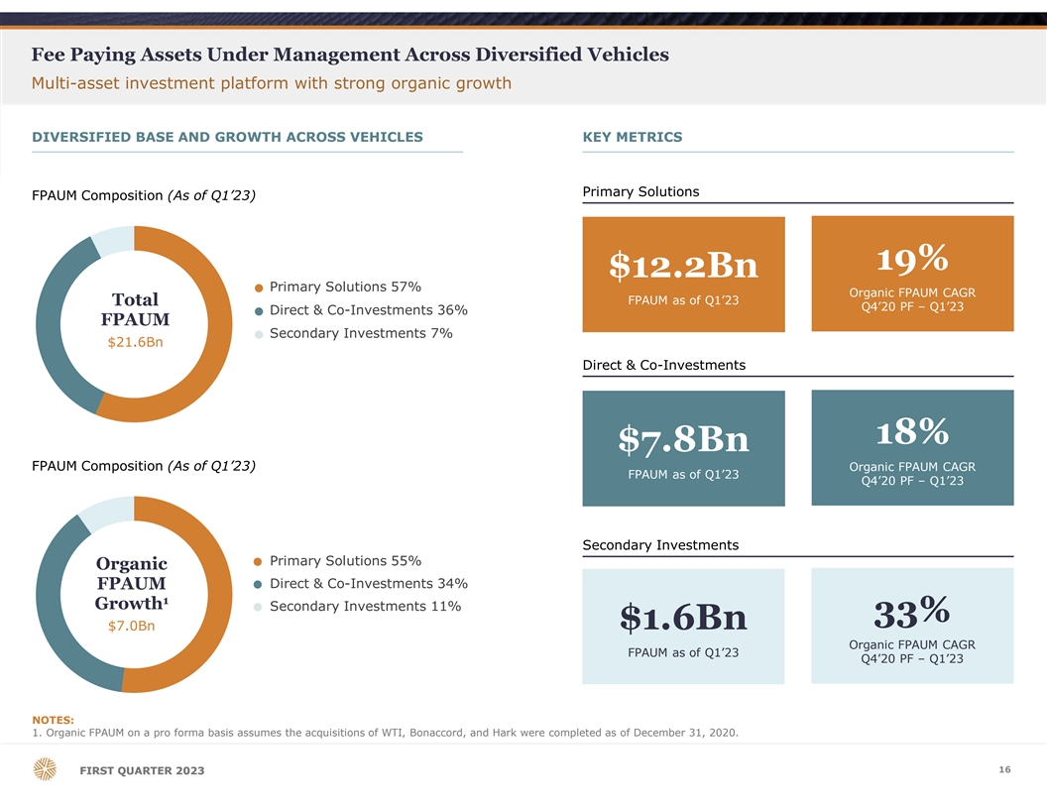
Fee Paying Assets Under Management Across Diversified Vehicles Multi-asset investment platform with strong organic growth DIVERSIFIED BASE AND GROWTH ACROSS VEHICLES KEY METRICS Primary Solutions FPAUM Composition (As of Q1’23) 19% $12.2Bn Primary Solutions 57% ● Organic FPAUM CAGR Total FPAUM as of Q1’23 Q4’20 PF – Q1’23 Direct & Co-Investments 36% ● FPAUM Secondary Investments 7% ● $21.6Bn Direct & Co-Investments 18% $7.8Bn FPAUM Composition (As of Q1’23) Organic FPAUM CAGR FPAUM as of Q1’23 Q4’20 PF – Q1’23 Secondary Investments Primary Solutions 55% ● Organic Direct & Co-Investments 34% FPAUM ● 1 Growth Secondary Investments 11% ● 33% $1.6Bn $7.0Bn Organic FPAUM CAGR FPAUM as of Q1’23 Q4’20 PF – Q1’23 NOTES: 1. Organic FPAUM on a pro forma basis assumes the acquisitions of WTI, Bonaccord, and Hark were completed as of December 31, 2020. 16 F FI IR RS ST T Q QU UA AR RT TE ER R 2 20 02 23 3

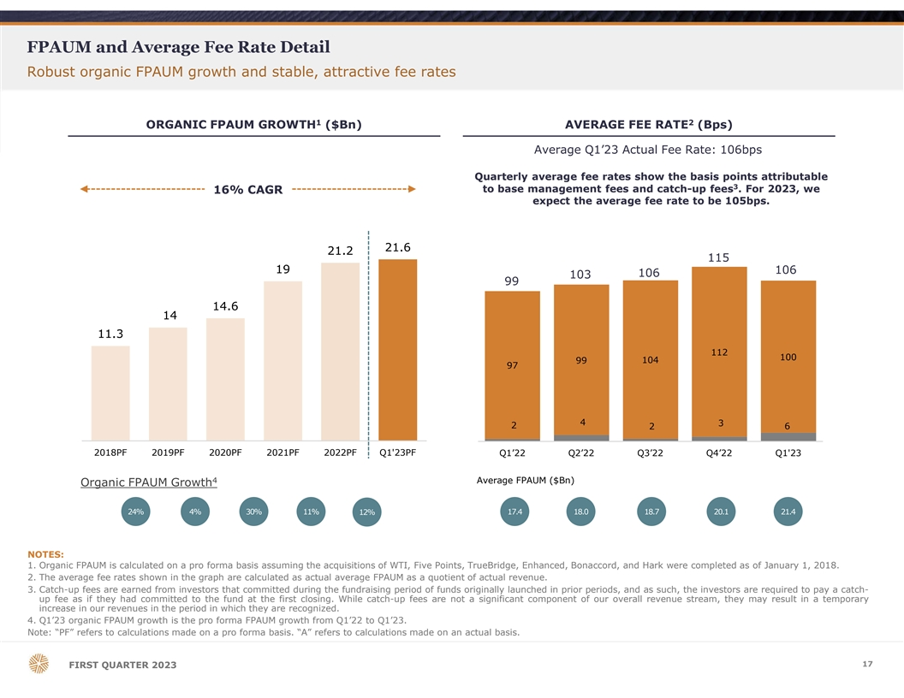
FPAUM and Average Fee Rate Detail Robust organic FPAUM growth and stable, attractive fee rates 1 2 ORGANIC FPAUM GROWTH ($Bn) AVERAGE FEE RATE (Bps) Average Q1’23 Actual Fee Rate: 106bps Quarterly average fee rates show the basis points attributable 3 to base management fees and catch-up fees . For 2023, we 16% CAGR expect the average fee rate to be 105bps. 21.6 21.2 115 19 106 106 103 99 14.6 14 11.3 112 100 99 104 97 4 3 2 2 6 2018PF 2019PF 2020PF 2021PF 2022PF Q1'23PF Q1’22 Q2’22 Q3’22 Q4’22 Q1'23 4 Average FPAUM ($Bn) Organic FPAUM Growth 24% 4% 30% 11% 17.4 18.0 18.7 20.1 21.4 12% NOTES: 1. Organic FPAUM is calculated on a pro forma basis assuming the acquisitions of WTI, Five Points, TrueBridge, Enhanced, Bonaccord, and Hark were completed as of January 1, 2018. 2. The average fee rates shown in the graph are calculated as actual average FPAUM as a quotient of actual revenue. 3. Catch-up fees are earned from investors that committed during the fundraising period of funds originally launched in prior periods, and as such, the investors are required to pay a catch- up fee as if they had committed to the fund at the first closing. While catch-up fees are not a significant component of our overall revenue stream, they may result in a temporary increase in our revenues in the period in which they are recognized. 4. Q1’23 organic FPAUM growth is the pro forma FPAUM growth from Q1’22 to Q1’23. Note: “PF” refers to calculations made on a pro forma basis. “A” refers to calculations made on an actual basis. 17 FIRST QUARTER 2023

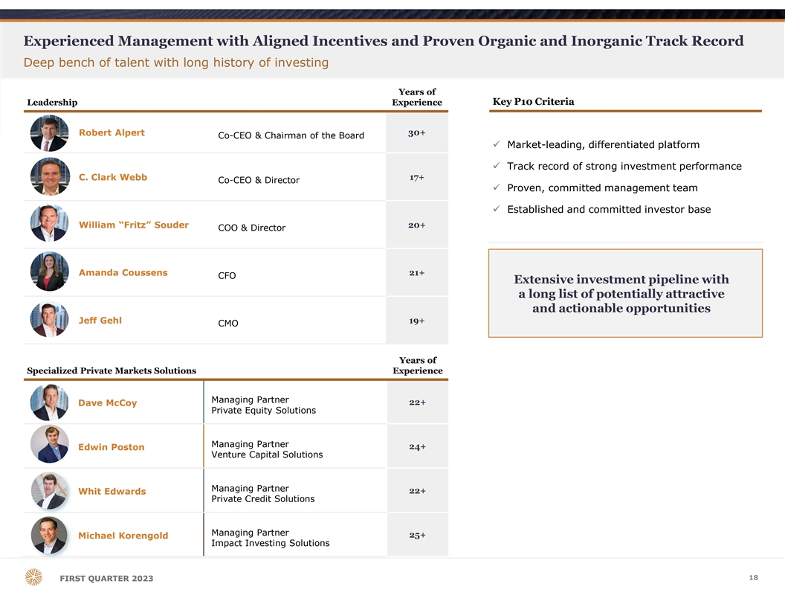
Experienced Management with Aligned Incentives and Proven Organic and Inorganic Track Record Deep bench of talent with long history of investing Years of Leadership Experience Key P10 Criteria Robert Alpert 30+ Co-CEO & Chairman of the Board ü Market-leading, differentiated platform ü Track record of strong investment performance C. Clark Webb 17+ Co-CEO & Director ü Proven, committed management team ü Established and committed investor base William “Fritz” Souder 20+ COO & Director Amanda Coussens 21+ CFO Extensive investment pipeline with a long list of potentially attractive and actionable opportunities Jeff Gehl 19+ CMO Years of Specialized Private Markets Solutions Experience Managing Partner 22+ Dave McCoy Private Equity Solutions Managing Partner 24+ Edwin Poston Venture Capital Solutions Managing Partner 22+ Whit Edwards Private Credit Solutions Managing Partner 25+ Michael Korengold Impact Investing Solutions 18 F FI IR RS ST T Q QU UA AR RT TE ER R 2 20 02 23 3

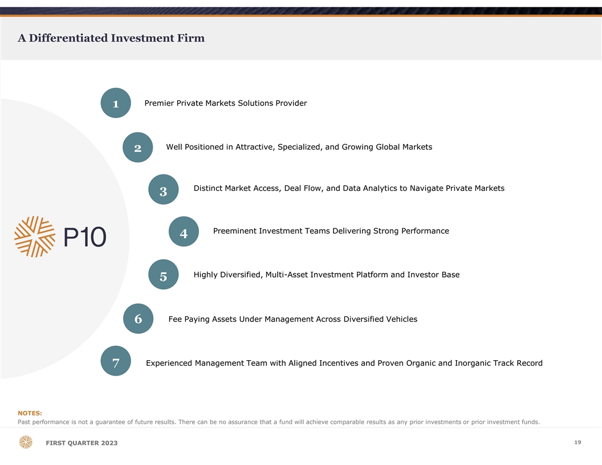
A Differentiated Investment Firm Premier Private Markets Solutions Provider 1 Well Positioned in Attractive, Specialized, and Growing Global Markets 2 Distinct Market Access, Deal Flow, and Data Analytics to Navigate Private Markets 3 Preeminent Investment Teams Delivering Strong Performance 4 Highly Diversified, Multi-Asset Investment Platform and Investor Base 5 Fee Paying Assets Under Management Across Diversified Vehicles 6 7 Experienced Management Team with Aligned Incentives and Proven Organic and Inorganic Track Record NOTES: Past performance is not a guarantee of future results. There can be no assurance that a fund will achieve comparable results as any prior investments or prior investment funds. 19 F FI IR RS ST T Q QU UA AR RT TE ER R 2 20 02 23 3

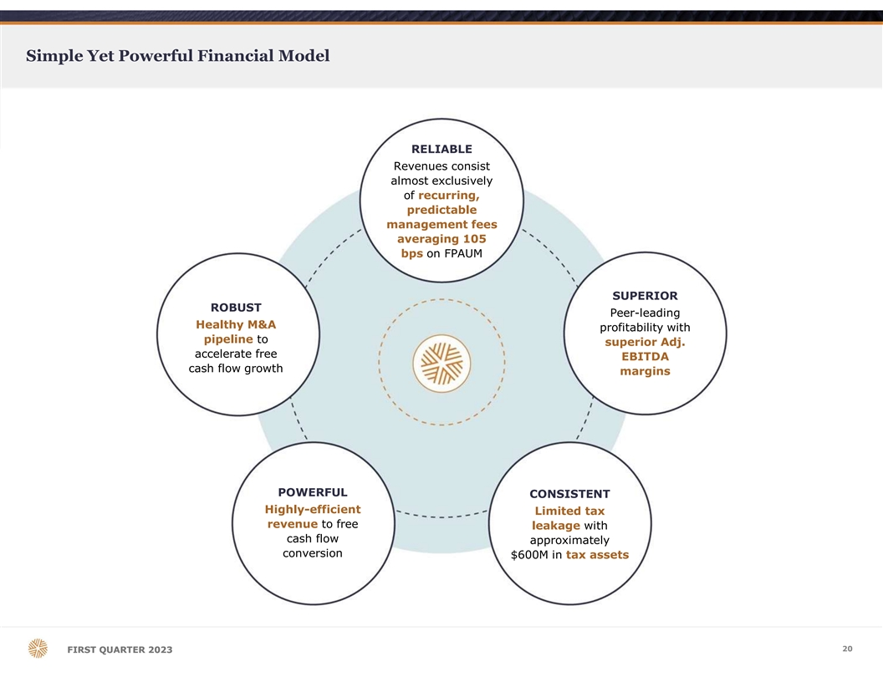
Simple Yet Powerful Financial Model RELIABLE Revenues consist almost exclusively of recurring, predictable management fees averaging 105 bps on FPAUM SUPERIOR ROBUST Peer-leading Healthy M&A profitability with pipeline to superior Adj. accelerate free EBITDA cash flow growth margins POWERFUL CONSISTENT Highly-efficient Limited tax revenue to free leakage with cash flow approximately conversion $600M in tax assets 20 F FI IR RS ST T Q QU UA AR RT TE ER R 2 20 02 23 3

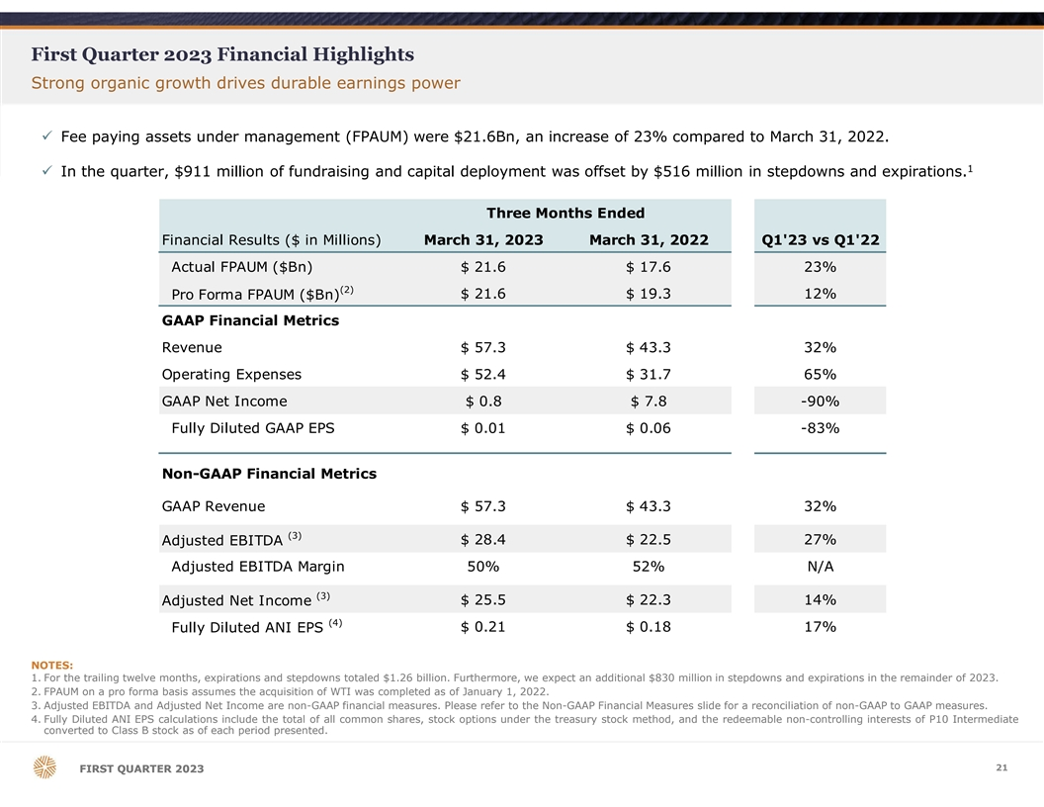
First Quarter 2023 Financial Highlights Strong organic growth drives durable earnings power ü Fee paying assets under management (FPAUM) were $21.6Bn, an increase of 23% compared to March 31, 2022. 1 ü In the quarter, $911 million of fundraising and capital deployment was offset by $516 million in stepdowns and expirations. Three Months Ended Financial Results ($ in Millions) March 31, 2023 March 31, 2022 Q1'23 vs Q1'22 Actual FPAUM ($Bn) $ 21.6 $ 17.6 23% (2) Pro Forma FPAUM ($Bn) $ 21.6 $ 19.3 12% GAAP Financial Metrics Revenue $ 57.3 $ 43.3 32% Operating Expenses $ 52.4 $ 31.7 65% GAAP Net Income $ 0.8 $ 7.8 -90% Fully Diluted GAAP EPS $ 0.01 $ 0.06 -83% Non-GAAP Financial Metrics GAAP Revenue $ 57.3 $ 43.3 32% (3) $ 28.4 $ 22.5 27% Adjusted EBITDA Adjusted EBITDA Margin 50% 52% N/A (3) Adjusted Net Income $ 25.5 $ 22.3 14% (4) $ 0.21 $ 0.18 17% Fully Diluted ANI EPS NOTES: 1. For the trailing twelve months, expirations and stepdowns totaled $1.26 billion. Furthermore, we expect an additional $830 million in stepdowns and expirations in the remainder of 2023. 2. FPAUM on a pro forma basis assumes the acquisition of WTI was completed as of January 1, 2022. 3. Adjusted EBITDA and Adjusted Net Income are non-GAAP financial measures. Please refer to the Non-GAAP Financial Measures slide for a reconciliation of non-GAAP to GAAP measures. 4. Fully Diluted ANI EPS calculations include the total of all common shares, stock options under the treasury stock method, and the redeemable non-controlling interests of P10 Intermediate converted to Class B stock as of each period presented. 21 F FI IR RS ST T Q QU UA AR RT TE ER R 2 20 02 23 3

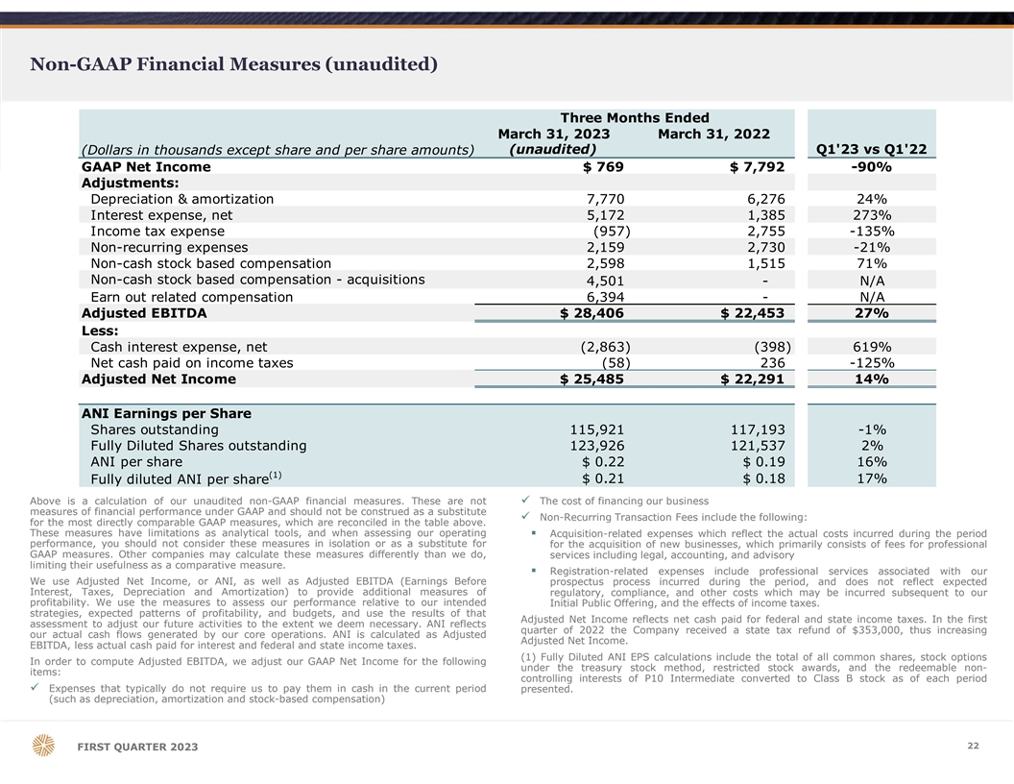
Non-GAAP Financial Measures (unaudited) Three Months Ended March 31, 2023 March 31, 2022 (unaudited) Q1'23 vs Q1'22 (Dollars in thousands except share and per share amounts) GAAP Net Income $ 769 $ 7,792 -90% Adjustments: Depreciation & amortization 7,770 6,276 24% Interest expense, net 5,172 1,385 273% Income tax expense (957) 2,755 -135% Non-recurring expenses 2,159 2,730 -21% Non-cash stock based compensation 2,598 1,515 71% Non-cash stock based compensation - acquisitions 4,501 - N/A Earn out related compensation 6,394 - N/A Adjusted EBITDA $ 28,406 $ 22,453 27% Less: Cash interest expense, net ( 2,863) (398) 619% Net cash paid on income taxes (58) 236 -125% Adjusted Net Income $ 25,485 $ 22,291 14% ANI Earnings per Share Shares outstanding 115,921 117,193 -1% Fully Diluted Shares outstanding 123,926 121,537 2% ANI per share $ 0.22 $ 0.19 16% (1) $ 0.21 $ 0.18 17% Fully diluted ANI per share Above is a calculation of our unaudited non-GAAP financial measures. These are notü The cost of financing our business measures of financial performance under GAAP and should not be construed as a substitute ü Non-Recurring Transaction Fees include the following: for the most directly comparable GAAP measures, which are reconciled in the table above. These measures have limitations as analytical tools, and when assessing our operating§ Acquisition-related expenses which reflect the actual costs incurred during the period performance, you should not consider these measures in isolation or as a substitute for for the acquisition of new businesses, which primarily consists of fees for professional GAAP measures. Other companies may calculate these measures differently than we do, services including legal, accounting, and advisory limiting their usefulness as a comparative measure. § Registration-related expenses include professional services associated with our We use Adjusted Net Income, or ANI, as well as Adjusted EBITDA (Earnings Before prospectus process incurred during the period, and does not reflect expected Interest, Taxes, Depreciation and Amortization) to provide additional measures of regulatory, compliance, and other costs which may be incurred subsequent to our profitability. We use the measures to assess our performance relative to our intended Initial Public Offering, and the effects of income taxes. strategies, expected patterns of profitability, and budgets, and use the results of that Adjusted Net Income reflects net cash paid for federal and state income taxes. In the first assessment to adjust our future activities to the extent we deem necessary. ANI reflects quarter of 2022 the Company received a state tax refund of $353,000, thus increasing our actual cash flows generated by our core operations. ANI is calculated as Adjusted Adjusted Net Income. EBITDA, less actual cash paid for interest and federal and state income taxes. (1) Fully Diluted ANI EPS calculations include the total of all common shares, stock options In order to compute Adjusted EBITDA, we adjust our GAAP Net Income for the following under the treasury stock method, restricted stock awards, and the redeemable non- items: controlling interests of P10 Intermediate converted to Class B stock as of each period ü Expenses that typically do not require us to pay them in cash in the current period presented. (such as depreciation, amortization and stock-based compensation) 22 FIRST QUARTER 2023

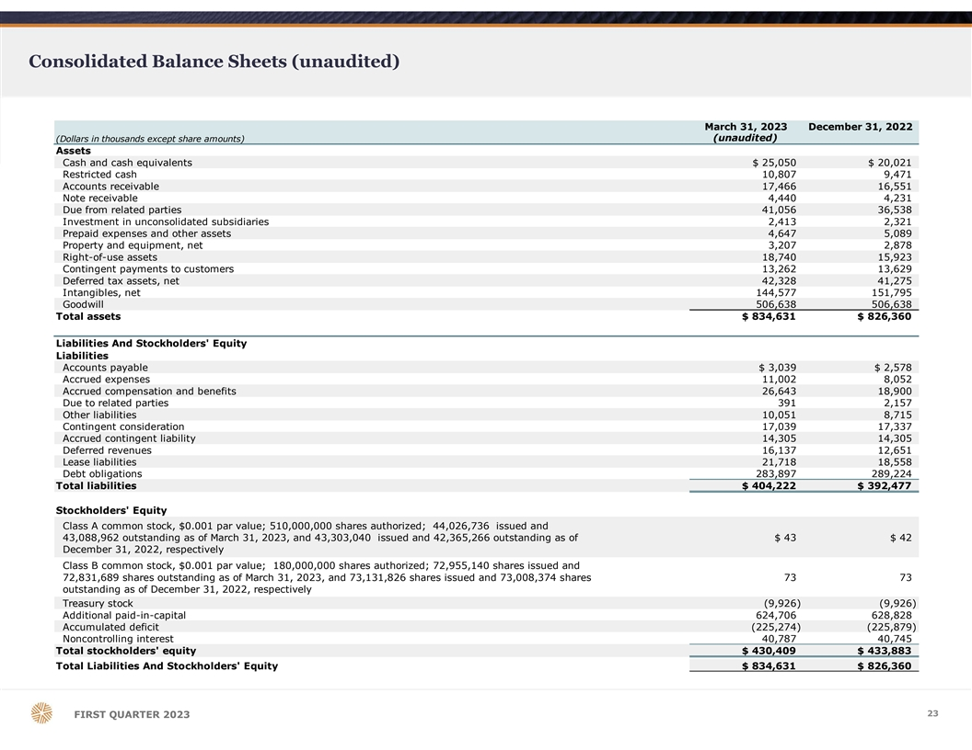
Consolidated Balance Sheets (unaudited) March 31, 2023 December 31, 2022 (unaudited) (Dollars in thousands except share amounts) Assets Cash and cash equivalents $ 25,050 $ 20,021 Restricted cash 10,807 9,471 Accounts receivable 17,466 16,551 Note receivable 4,440 4,231 Due from related parties 41,056 36,538 Investment in unconsolidated subsidiaries 2,413 2,321 Prepaid expenses and other assets 4,647 5,089 Property and equipment, net 3,207 2,878 Right-of-use assets 18,740 15,923 Contingent payments to customers 13,262 13,629 Deferred tax assets, net 42,328 41,275 Intangibles, net 1 44,577 151,795 Goodwill 5 06,638 506,638 Total assets $ 834,631 $ 826,360 Liabilities And Stockholders' Equity Liabilities Accounts payable $ 3,039 $ 2,578 Accrued expenses 11,002 8,052 Accrued compensation and benefits 26,643 18,900 Due to related parties 391 2,157 Other liabilities 10,051 8,715 Contingent consideration 17,039 17,337 Accrued contingent liability 14,305 14,305 Deferred revenues 16,137 12,651 Lease liabilities 21,718 18,558 Debt obligations 2 83,897 289,224 Total liabilities $ 404,222 $ 392,477 Stockholders' Equity Class A common stock, $0.001 par value; 510,000,000 shares authorized; 44,026,736 issued and 43,088,962 outstanding as of March 31, 2023, and 43,303,040 issued and 42,365,266 outstanding as of $ 43 $ 42 December 31, 2022, respectively Class B common stock, $0.001 par value; 180,000,000 shares authorized; 72,955,140 shares issued and 72,831,689 shares outstanding as of March 31, 2023, and 73,131,826 shares issued and 73,008,374 shares 7 3 73 outstanding as of December 31, 2022, respectively Treasury stock (9,926) (9,926) Additional paid-in-capital 624,706 628,828 Accumulated deficit (225,274) ( 225,879) Noncontrolling interest 40,787 40,745 Total stockholders' equity $ 430,409 $ 433,883 Total Liabilities And Stockholders' Equity $ 834,631 $ 826,360 23 FIRST QUARTER 2023

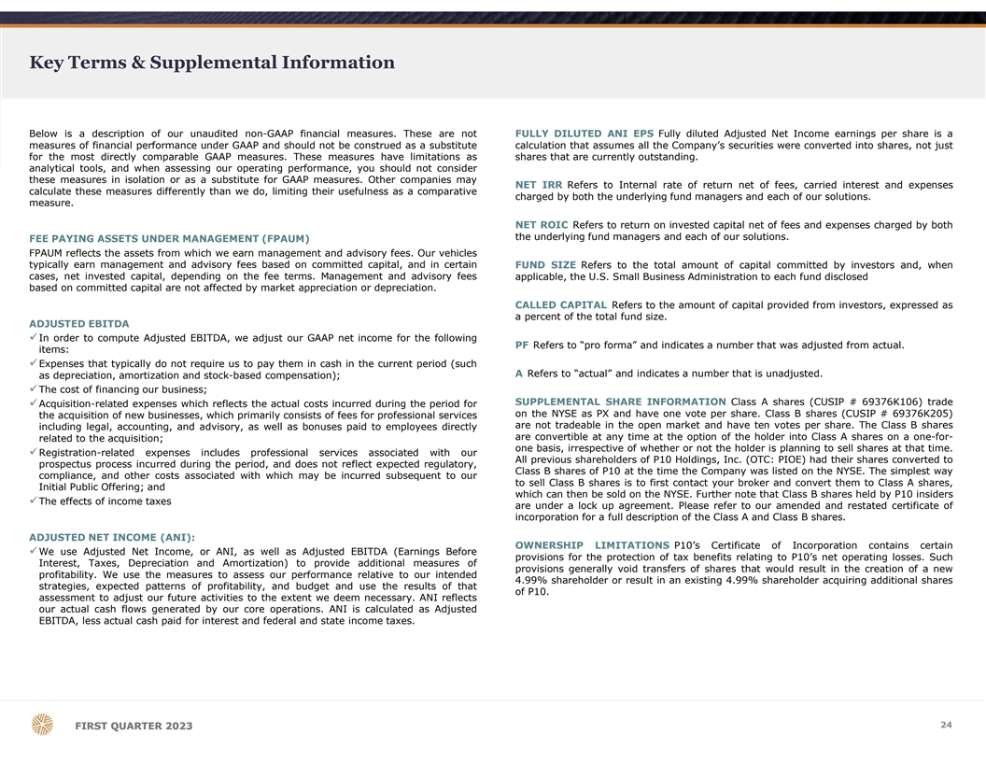
Key Terms & Supplemental Information Below is a description of our unaudited non-GAAP financial measures. These are not FULLY DILUTED ANI EPS Fully diluted Adjusted Net Income earnings per share is a measures of financial performance under GAAP and should not be construed as a substitute calculation that assumes all the Company’s securities were converted into shares, not just for the most directly comparable GAAP measures. These measures have limitations as shares that are currently outstanding. analytical tools, and when assessing our operating performance, you should not consider these measures in isolation or as a substitute for GAAP measures. Other companies may NET IRR Refers to Internal rate of return net of fees, carried interest and expenses calculate these measures differently than we do, limiting their usefulness as a comparative charged by both the underlying fund managers and each of our solutions. measure. NET ROIC Refers to return on invested capital net of fees and expenses charged by both the underlying fund managers and each of our solutions. FEE PAYING ASSETS UNDER MANAGEMENT (FPAUM) FPAUM reflects the assets from which we earn management and advisory fees. Our vehicles typically earn management and advisory fees based on committed capital, and in certain FUND SIZE Refers to the total amount of capital committed by investors and, when cases, net invested capital, depending on the fee terms. Management and advisory fees applicable, the U.S. Small Business Administration to each fund disclosed based on committed capital are not affected by market appreciation or depreciation. CALLED CAPITAL Refers to the amount of capital provided from investors, expressed as a percent of the total fund size. ADJUSTED EBITDA üIn order to compute Adjusted EBITDA, we adjust our GAAP net income for the following PF Refers to “pro forma” and indicates a number that was adjusted from actual. items: üExpenses that typically do not require us to pay them in cash in the current period (such A Refers to “actual” and indicates a number that is unadjusted. as depreciation, amortization and stock-based compensation); üThe cost of financing our business; SUPPLEMENTAL SHARE INFORMATION Class A shares (CUSIP # 69376K106) trade üAcquisition-related expenses which reflects the actual costs incurred during the period for on the NYSE as PX and have one vote per share. Class B shares (CUSIP # 69376K205) the acquisition of new businesses, which primarily consists of fees for professional services are not tradeable in the open market and have ten votes per share. The Class B shares including legal, accounting, and advisory, as well as bonuses paid to employees directly are convertible at any time at the option of the holder into Class A shares on a one-for- related to the acquisition; one basis, irrespective of whether or not the holder is planning to sell shares at that time. üRegistration-related expenses includes professional services associated with our All previous shareholders of P10 Holdings, Inc. (OTC: PIOE) had their shares converted to prospectus process incurred during the period, and does not reflect expected regulatory, Class B shares of P10 at the time the Company was listed on the NYSE. The simplest way compliance, and other costs associated with which may be incurred subsequent to our to sell Class B shares is to first contact your broker and convert them to Class A shares, Initial Public Offering; and which can then be sold on the NYSE. Further note that Class B shares held by P10 insiders The effects of income taxes ü are under a lock up agreement. Please refer to our amended and restated certificate of incorporation for a full description of the Class A and Class B shares. ADJUSTED NET INCOME (ANI): OWNERSHIP LIMITATIONS P10’s Certificate of Incorporation contains certain üWe use Adjusted Net Income, or ANI, as well as Adjusted EBITDA (Earnings Before provisions for the protection of tax benefits relating to P10’s net operating losses. Such Interest, Taxes, Depreciation and Amortization) to provide additional measures of provisions generally void transfers of shares that would result in the creation of a new profitability. We use the measures to assess our performance relative to our intended 4.99% shareholder or result in an existing 4.99% shareholder acquiring additional shares strategies, expected patterns of profitability, and budget and use the results of that of P10. assessment to adjust our future activities to the extent we deem necessary. ANI reflects our actual cash flows generated by our core operations. ANI is calculated as Adjusted EBITDA, less actual cash paid for interest and federal and state income taxes. 24 F FI IR RS ST T Q QU UA AR RT TE ER R 2 20 02 23 3

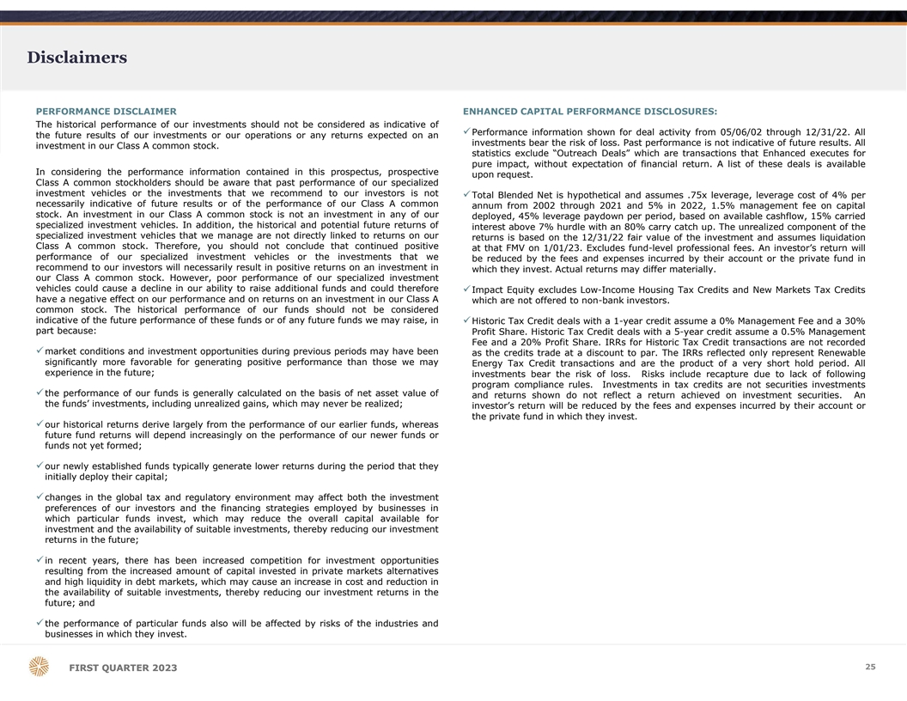
Disclaimers PERFORMANCE DISCLAIMER ENHANCED CAPITAL PERFORMANCE DISCLOSURES: The historical performance of our investments should not be considered as indicative of üPerformance information shown for deal activity from 05/06/02 through 12/31/22. All the future results of our investments or our operations or any returns expected on an investments bear the risk of loss. Past performance is not indicative of future results. All investment in our Class A common stock. statistics exclude “Outreach Deals” which are transactions that Enhanced executes for pure impact, without expectation of financial return. A list of these deals is available In considering the performance information contained in this prospectus, prospective upon request. Class A common stockholders should be aware that past performance of our specialized investment vehicles or the investments that we recommend to our investors is not üTotal Blended Net is hypothetical and assumes .75x leverage, leverage cost of 4% per necessarily indicative of future results or of the performance of our Class A common annum from 2002 through 2021 and 5% in 2022, 1.5% management fee on capital stock. An investment in our Class A common stock is not an investment in any of our deployed, 45% leverage paydown per period, based on available cashflow, 15% carried specialized investment vehicles. In addition, the historical and potential future returns of interest above 7% hurdle with an 80% carry catch up. The unrealized component of the specialized investment vehicles that we manage are not directly linked to returns on our returns is based on the 12/31/22 fair value of the investment and assumes liquidation Class A common stock. Therefore, you should not conclude that continued positive at that FMV on 1/01/23. Excludes fund-level professional fees. An investor’s return will performance of our specialized investment vehicles or the investments that we be reduced by the fees and expenses incurred by their account or the private fund in recommend to our investors will necessarily result in positive returns on an investment in which they invest. Actual returns may differ materially. our Class A common stock. However, poor performance of our specialized investment vehicles could cause a decline in our ability to raise additional funds and could therefore üImpact Equity excludes Low-Income Housing Tax Credits and New Markets Tax Credits have a negative effect on our performance and on returns on an investment in our Class A which are not offered to non-bank investors. common stock. The historical performance of our funds should not be considered indicative of the future performance of these funds or of any future funds we may raise, in üHistoric Tax Credit deals with a 1-year credit assume a 0% Management Fee and a 30% part because: Profit Share. Historic Tax Credit deals with a 5-year credit assume a 0.5% Management Fee and a 20% Profit Share. IRRs for Historic Tax Credit transactions are not recorded ümarket conditions and investment opportunities during previous periods may have been as the credits trade at a discount to par. The IRRs reflected only represent Renewable significantly more favorable for generating positive performance than those we may Energy Tax Credit transactions and are the product of a very short hold period. All experience in the future; investments bear the risk of loss. Risks include recapture due to lack of following program compliance rules. Investments in tax credits are not securities investments üthe performance of our funds is generally calculated on the basis of net asset value of and returns shown do not reflect a return achieved on investment securities. An the funds’ investments, including unrealized gains, which may never be realized; investor’s return will be reduced by the fees and expenses incurred by their account or the private fund in which they invest. üour historical returns derive largely from the performance of our earlier funds, whereas future fund returns will depend increasingly on the performance of our newer funds or funds not yet formed; üour newly established funds typically generate lower returns during the period that they initially deploy their capital; üchanges in the global tax and regulatory environment may affect both the investment preferences of our investors and the financing strategies employed by businesses in which particular funds invest, which may reduce the overall capital available for investment and the availability of suitable investments, thereby reducing our investment returns in the future; üin recent years, there has been increased competition for investment opportunities resulting from the increased amount of capital invested in private markets alternatives and high liquidity in debt markets, which may cause an increase in cost and reduction in the availability of suitable investments, thereby reducing our investment returns in the future; and üthe performance of particular funds also will be affected by risks of the industries and businesses in which they invest. 25 F FI IR RS ST T Q QU UA AR RT TE ER R 2 20 02 23 3

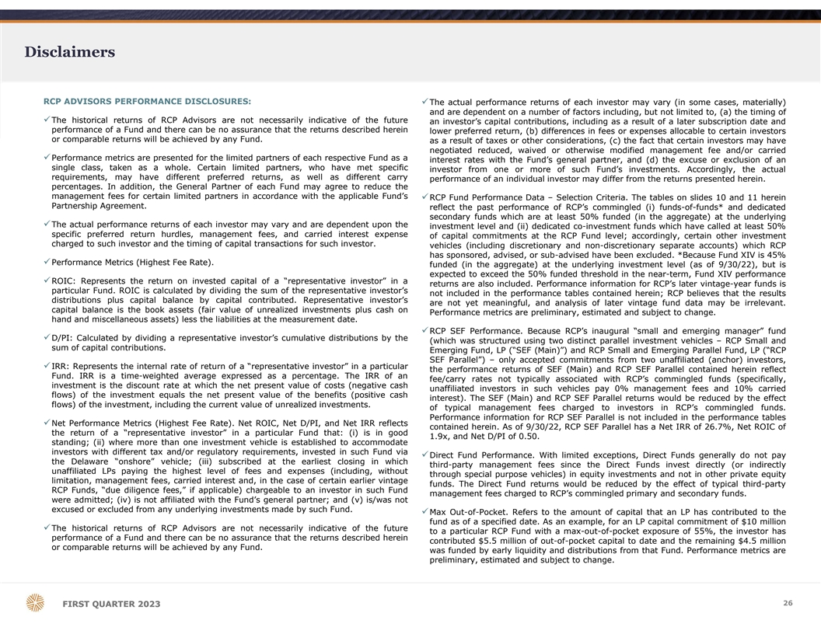
Disclaimers RCP ADVISORS PERFORMANCE DISCLOSURES: üThe actual performance returns of each investor may vary (in some cases, materially) and are dependent on a number of factors including, but not limited to, (a) the timing of üThe historical returns of RCP Advisors are not necessarily indicative of the future an investor’s capital contributions, including as a result of a later subscription date and performance of a Fund and there can be no assurance that the returns described herein lower preferred return, (b) differences in fees or expenses allocable to certain investors or comparable returns will be achieved by any Fund. as a result of taxes or other considerations, (c) the fact that certain investors may have negotiated reduced, waived or otherwise modified management fee and/or carried üPerformance metrics are presented for the limited partners of each respective Fund as a interest rates with the Fund’s general partner, and (d) the excuse or exclusion of an single class, taken as a whole. Certain limited partners, who have met specific investor from one or more of such Fund’s investments. Accordingly, the actual requirements, may have different preferred returns, as well as different carry performance of an individual investor may differ from the returns presented herein. percentages. In addition, the General Partner of each Fund may agree to reduce the management fees for certain limited partners in accordance with the applicable Fund’s üRCP Fund Performance Data – Selection Criteria. The tables on slides 10 and 11 herein Partnership Agreement. reflect the past performance of RCP’s commingled (i) funds-of-funds* and dedicated secondary funds which are at least 50% funded (in the aggregate) at the underlying üThe actual performance returns of each investor may vary and are dependent upon the investment level and (ii) dedicated co-investment funds which have called at least 50% specific preferred return hurdles, management fees, and carried interest expense of capital commitments at the RCP Fund level; accordingly, certain other investment charged to such investor and the timing of capital transactions for such investor. vehicles (including discretionary and non-discretionary separate accounts) which RCP has sponsored, advised, or sub-advised have been excluded. *Because Fund XIV is 45% üPerformance Metrics (Highest Fee Rate). funded (in the aggregate) at the underlying investment level (as of 9/30/22), but is expected to exceed the 50% funded threshold in the near-term, Fund XIV performance üROIC: Represents the return on invested capital of a “representative investor” in a returns are also included. Performance information for RCP’s later vintage-year funds is particular Fund. ROIC is calculated by dividing the sum of the representative investor’s not included in the performance tables contained herein; RCP believes that the results distributions plus capital balance by capital contributed. Representative investor’s are not yet meaningful, and analysis of later vintage fund data may be irrelevant. capital balance is the book assets (fair value of unrealized investments plus cash on Performance metrics are preliminary, estimated and subject to change. hand and miscellaneous assets) less the liabilities at the measurement date. üRCP SEF Performance. Because RCP’s inaugural “small and emerging manager” fund üD/PI: Calculated by dividing a representative investor’s cumulative distributions by the (which was structured using two distinct parallel investment vehicles – RCP Small and sum of capital contributions. Emerging Fund, LP (“SEF (Main)”) and RCP Small and Emerging Parallel Fund, LP (“RCP SEF Parallel”) – only accepted commitments from two unaffiliated (anchor) investors, üIRR: Represents the internal rate of return of a “representative investor” in a particular the performance returns of SEF (Main) and RCP SEF Parallel contained herein reflect Fund. IRR is a time-weighted average expressed as a percentage. The IRR of an fee/carry rates not typically associated with RCP’s commingled funds (specifically, investment is the discount rate at which the net present value of costs (negative cash unaffiliated investors in such vehicles pay 0% management fees and 10% carried flows) of the investment equals the net present value of the benefits (positive cash interest). The SEF (Main) and RCP SEF Parallel returns would be reduced by the effect flows) of the investment, including the current value of unrealized investments. of typical management fees charged to investors in RCP’s commingled funds. Performance information for RCP SEF Parallel is not included in the performance tables üNet Performance Metrics (Highest Fee Rate). Net ROIC, Net D/PI, and Net IRR reflects contained herein. As of 9/30/22, RCP SEF Parallel has a Net IRR of 26.7%, Net ROIC of the return of a “representative investor” in a particular Fund that: (i) is in good 1.9x, and Net D/PI of 0.50. standing; (ii) where more than one investment vehicle is established to accommodate investors with different tax and/or regulatory requirements, invested in such Fund via üDirect Fund Performance. With limited exceptions, Direct Funds generally do not pay the Delaware “onshore” vehicle; (iii) subscribed at the earliest closing in which third-party management fees since the Direct Funds invest directly (or indirectly unaffiliated LPs paying the highest level of fees and expenses (including, without through special purpose vehicles) in equity investments and not in other private equity limitation, management fees, carried interest and, in the case of certain earlier vintage funds. The Direct Fund returns would be reduced by the effect of typical third-party RCP Funds, “due diligence fees,” if applicable) chargeable to an investor in such Fund management fees charged to RCP’s commingled primary and secondary funds. were admitted; (iv) is not affiliated with the Fund’s general partner; and (v) is/was not excused or excluded from any underlying investments made by such Fund. üMax Out-of-Pocket. Refers to the amount of capital that an LP has contributed to the fund as of a specified date. As an example, for an LP capital commitment of $10 million üThe historical returns of RCP Advisors are not necessarily indicative of the future to a particular RCP Fund with a max-out-of-pocket exposure of 55%, the investor has performance of a Fund and there can be no assurance that the returns described herein contributed $5.5 million of out-of-pocket capital to date and the remaining $4.5 million or comparable returns will be achieved by any Fund. was funded by early liquidity and distributions from that Fund. Performance metrics are preliminary, estimated and subject to change. 26 F FI IR RS ST T Q QU UA AR RT TE ER R 2 20 02 23 3

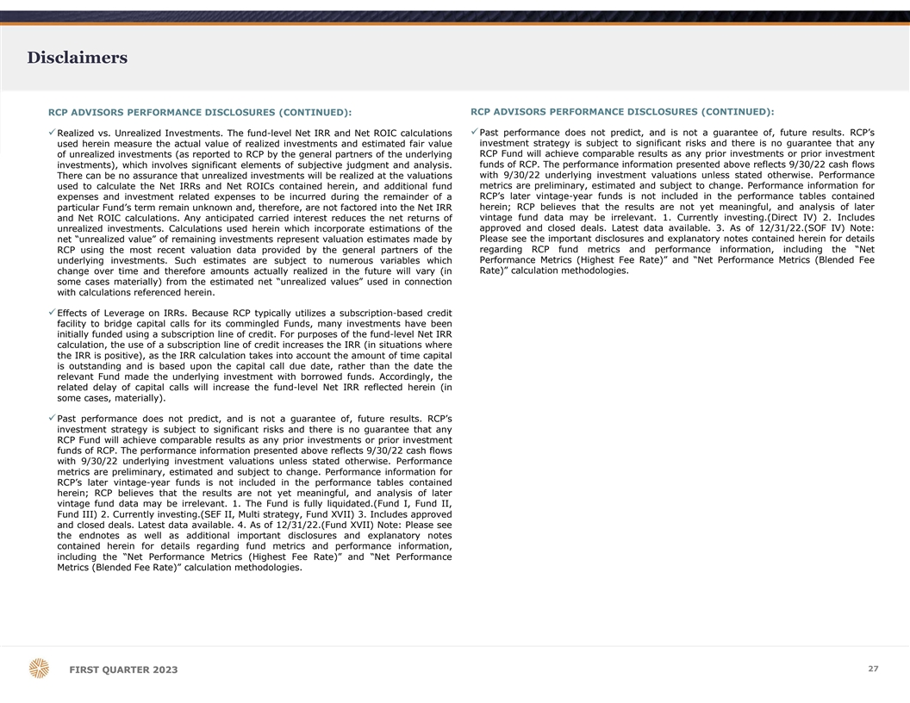
Disclaimers RCP ADVISORS PERFORMANCE DISCLOSURES (CONTINUED): RCP ADVISORS PERFORMANCE DISCLOSURES (CONTINUED): üPast performance does not predict, and is not a guarantee of, future results. RCP’s üRealized vs. Unrealized Investments. The fund-level Net IRR and Net ROIC calculations investment strategy is subject to significant risks and there is no guarantee that any used herein measure the actual value of realized investments and estimated fair value of unrealized investments (as reported to RCP by the general partners of the underlying RCP Fund will achieve comparable results as any prior investments or prior investment funds of RCP. The performance information presented above reflects 9/30/22 cash flows investments), which involves significant elements of subjective judgment and analysis. with 9/30/22 underlying investment valuations unless stated otherwise. Performance There can be no assurance that unrealized investments will be realized at the valuations metrics are preliminary, estimated and subject to change. Performance information for used to calculate the Net IRRs and Net ROICs contained herein, and additional fund expenses and investment related expenses to be incurred during the remainder of a RCP’s later vintage-year funds is not included in the performance tables contained particular Fund’s term remain unknown and, therefore, are not factored into the Net IRR herein; RCP believes that the results are not yet meaningful, and analysis of later vintage fund data may be irrelevant. 1. Currently investing.(Direct IV) 2. Includes and Net ROIC calculations. Any anticipated carried interest reduces the net returns of approved and closed deals. Latest data available. 3. As of 12/31/22.(SOF IV) Note: unrealized investments. Calculations used herein which incorporate estimations of the net “unrealized value” of remaining investments represent valuation estimates made by Please see the important disclosures and explanatory notes contained herein for details RCP using the most recent valuation data provided by the general partners of the regarding RCP fund metrics and performance information, including the “Net Performance Metrics (Highest Fee Rate)” and “Net Performance Metrics (Blended Fee underlying investments. Such estimates are subject to numerous variables which Rate)” calculation methodologies. change over time and therefore amounts actually realized in the future will vary (in some cases materially) from the estimated net “unrealized values” used in connection with calculations referenced herein. üEffects of Leverage on IRRs. Because RCP typically utilizes a subscription-based credit facility to bridge capital calls for its commingled Funds, many investments have been initially funded using a subscription line of credit. For purposes of the fund-level Net IRR calculation, the use of a subscription line of credit increases the IRR (in situations where the IRR is positive), as the IRR calculation takes into account the amount of time capital is outstanding and is based upon the capital call due date, rather than the date the relevant Fund made the underlying investment with borrowed funds. Accordingly, the related delay of capital calls will increase the fund-level Net IRR reflected herein (in some cases, materially). üPast performance does not predict, and is not a guarantee of, future results. RCP’s investment strategy is subject to significant risks and there is no guarantee that any RCP Fund will achieve comparable results as any prior investments or prior investment funds of RCP. The performance information presented above reflects 9/30/22 cash flows with 9/30/22 underlying investment valuations unless stated otherwise. Performance metrics are preliminary, estimated and subject to change. Performance information for RCP’s later vintage-year funds is not included in the performance tables contained herein; RCP believes that the results are not yet meaningful, and analysis of later vintage fund data may be irrelevant. 1. The Fund is fully liquidated.(Fund I, Fund II, Fund III) 2. Currently investing.(SEF II, Multi strategy, Fund XVII) 3. Includes approved and closed deals. Latest data available. 4. As of 12/31/22.(Fund XVII) Note: Please see the endnotes as well as additional important disclosures and explanatory notes contained herein for details regarding fund metrics and performance information, including the “Net Performance Metrics (Highest Fee Rate)” and “Net Performance Metrics (Blended Fee Rate)” calculation methodologies. 27 F FI IR RS ST T Q QU UA AR RT TE ER R 2 20 02 23 3

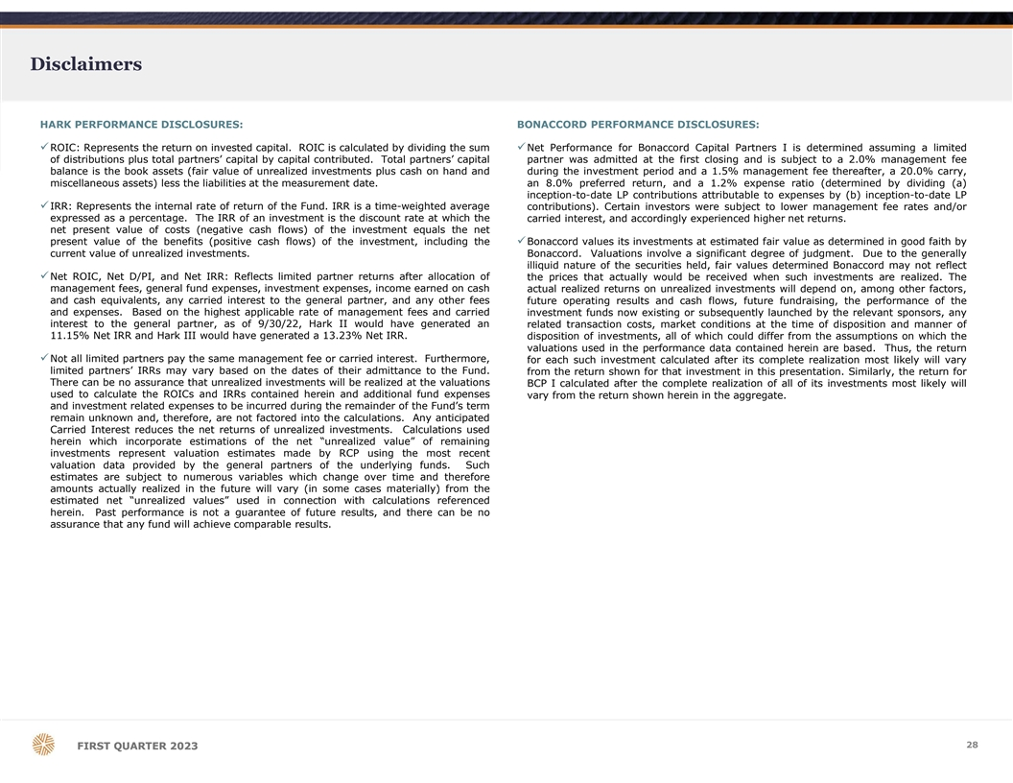
Disclaimers HARK PERFORMANCE DISCLOSURES: BONACCORD PERFORMANCE DISCLOSURES: üROIC: Represents the return on invested capital. ROIC is calculated by dividing the sumüNet Performance for Bonaccord Capital Partners I is determined assuming a limited of distributions plus total partners’ capital by capital contributed. Total partners’ capital partner was admitted at the first closing and is subject to a 2.0% management fee balance is the book assets (fair value of unrealized investments plus cash on hand and during the investment period and a 1.5% management fee thereafter, a 20.0% carry, miscellaneous assets) less the liabilities at the measurement date. an 8.0% preferred return, and a 1.2% expense ratio (determined by dividing (a) inception-to-date LP contributions attributable to expenses by (b) inception-to-date LP üIRR: Represents the internal rate of return of the Fund. IRR is a time-weighted average contributions). Certain investors were subject to lower management fee rates and/or expressed as a percentage. The IRR of an investment is the discount rate at which the carried interest, and accordingly experienced higher net returns. net present value of costs (negative cash flows) of the investment equals the net present value of the benefits (positive cash flows) of the investment, including theüBonaccord values its investments at estimated fair value as determined in good faith by current value of unrealized investments. Bonaccord. Valuations involve a significant degree of judgment. Due to the generally illiquid nature of the securities held, fair values determined Bonaccord may not reflect üNet ROIC, Net D/PI, and Net IRR: Reflects limited partner returns after allocation of the prices that actually would be received when such investments are realized. The management fees, general fund expenses, investment expenses, income earned on cash actual realized returns on unrealized investments will depend on, among other factors, and cash equivalents, any carried interest to the general partner, and any other fees future operating results and cash flows, future fundraising, the performance of the and expenses. Based on the highest applicable rate of management fees and carried investment funds now existing or subsequently launched by the relevant sponsors, any interest to the general partner, as of 9/30/22, Hark II would have generated an related transaction costs, market conditions at the time of disposition and manner of 11.15% Net IRR and Hark III would have generated a 13.23% Net IRR. disposition of investments, all of which could differ from the assumptions on which the valuations used in the performance data contained herein are based. Thus, the return üNot all limited partners pay the same management fee or carried interest. Furthermore, for each such investment calculated after its complete realization most likely will vary limited partners’ IRRs may vary based on the dates of their admittance to the Fund. from the return shown for that investment in this presentation. Similarly, the return for There can be no assurance that unrealized investments will be realized at the valuations BCP I calculated after the complete realization of all of its investments most likely will used to calculate the ROICs and IRRs contained herein and additional fund expenses vary from the return shown herein in the aggregate. and investment related expenses to be incurred during the remainder of the Fund’s term remain unknown and, therefore, are not factored into the calculations. Any anticipated Carried Interest reduces the net returns of unrealized investments. Calculations used herein which incorporate estimations of the net “unrealized value” of remaining investments represent valuation estimates made by RCP using the most recent valuation data provided by the general partners of the underlying funds. Such estimates are subject to numerous variables which change over time and therefore amounts actually realized in the future will vary (in some cases materially) from the estimated net “unrealized values” used in connection with calculations referenced herein. Past performance is not a guarantee of future results, and there can be no assurance that any fund will achieve comparable results. 28 F FI IR RS ST T Q QU UA AR RT TE ER R 2 20 02 23 3

DALLAS OFFICE 4514 Cole Avenue Suite 1600 Dallas, Texas 75205 214.865.7998 info@p10alts.com FIRST QUARTER 2023

